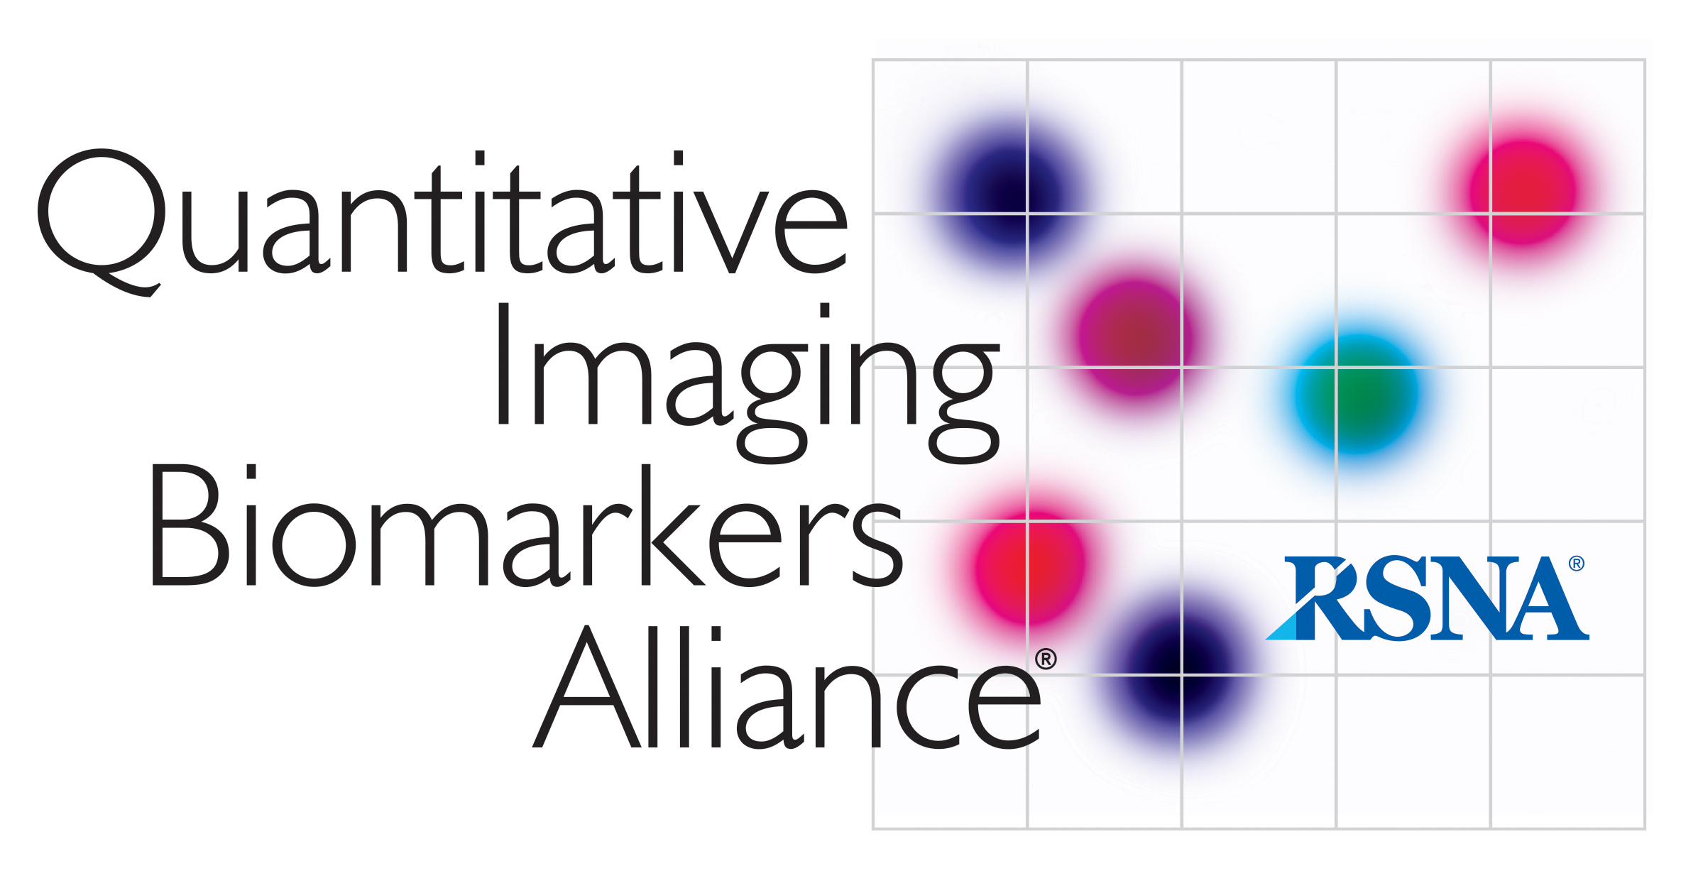

AIUM/QIBA
Ultrasound Volume Blood Flow Biomarker
Profile Development Task Group

CALL SUMMARY

Attendance:
Oliver Kripfgans, Mary Jean T., Paul Carson, John Rubin, Mark Lockhart, Steven P.
Kathi Minton – AIUM Staff

I. Review of Agenda
- Reviewed
  - Update on phantom specifications – compromise between what is doable and what is best phantom that we could achieve. Compromise between getting a phantom in a realistic time frame and a very high output. Would have been great on the fistulers. Liter and a half per minute. Concerns not having a pump being able to do this and seeing formation of bubbles at high flow rate of 12 mm per second. Stick to the 12 mm per second and do measurement and if there is a need for phantom with higher flow rate we will address in the future.
  - Update on starting with the phantom. Thinks that complication rate of phantom is not very high. Due to RSNA it will be delayed. We will not see the phantom this year. Not enough time.
II. RSNA Poster
- Discussed poster and finished on time. Poster is on the QIBA website. All committee members listed and affiliations as well as labs and vendors who participated.
- Poster presented in a way that would allow those who don’t know much about volume flow to understand it.
III. Additional items
- Schedule of Sessions for posters
  - Need volunteers
    - Half hour slot to talk about the poster especially Thursday.
    - Mark volunteered
- Update from Toshiba
  - Working on implementing access to the data. Todd Eperdling discussed with Oliver.
  - Volume flow measurements coming from Siemens too. Start with Philips and GE.

