Table of Contents
Table of Contents
1. Introduction 2
2. Study Objectives 4
3. Study Design 4
3.1. Procedures 4
3.1.1. Synthetic Nodules 4
3.1.2. Phantom Imaging Protocols 5
3.1.3. Reading Protocol 6
3.2. Primary and secondary endpoints 7
3.3. Secondary investigations (future) 7
4. Statistics - Characterizing Performance of Absolute Volume Estimation where Ground Truth is Known 7
5. Implementation of the study 7
6. References 8

Introduction
The majority of lung cancers are diagnosed at an advanced stage, with a dismal prognosis. Survival rates in lung cancer vary significantly by stage; overall, less than 15% of newly diagnosed patients will survive for 5 years. Survival rates approach 70% for the earliest stage (IA). When patients are diagnosed at stage IIA and IIIA, survival rates fall dramatically 34% and 13%, respectively. This difference underscores the need for early detection in lung cancer. Recently, the National Cancer Institute terminated the National Lung Screening Trial (NSLT), because a significant difference was identified with regard to the primary endpoint (lung cancer mortality) between the chest radiograph (CXR) and low-dose CT screening arms. Mortality was reduced by 20% in the CT arm compared with CXR (246 vs. 308 deaths per 100,000 person years, respectively).
The vast majority of suspicious CT scans are due to lung nodules, and most are relatively small (less than 1 cm). Additionally ground-glass nodules (GGN) are encountered during screening CT. The widespread availability of multi-detector CT (MDCT) imaging and abundance of new information obtained especially from low-dose CT lung cancer screening programs, have increased our understanding of the management and types of small peripheral lung nodules encountered in daily clinical practice, in particular, the importance and prevalence of sub-solid pulmonary nodules. Sub-solid nodules include both pure ground glass nodules (GGN) and part-solid nodules. GGNs are defined as focal nodular areas of increased lung attenuation through which normal parenchymal structures such as airways, vessels, and interlobular septa can be defined. Sub-solid nodules are now known to frequently represent the histologic spectrum of peripheral adenocarcinomas. Thin section CT has emerged as a new biomarker for lung adenocarcinoma subtypes. GGN correlates with lepidic growth and better clinical outcome than part-solid or solid nodules. Pure GGNs are typically FDG-PET negative(1-4). The risk of malignancy increases with nodule size or development or with an increase in size of the solid portion of part-solid nodules. Part-Solid nodules (PSN) have much higher malignancy rate (62.5 %) than GGN (19%) or solid nodules (7%) (5).
Standard guidelines require that all nodules should be followed to assess growth in those at risk for cancer by repeated CT or other tests. There is inter- and intra-reader variability reported in measurement of solid nodules (6-8). A small series of phantom ground glass opacities has been reported resulting in a measurement error of between 51% and 85% in nodules less than 3 mm (9). This study will further clarify these findings, by employing a greater number of readers as well as the addition of simulated lobulated lesions. Incidentally, Gavrielides, Kinnard, Myers and Petrick state that “a small number of authors have reported volumetric measurement results on nonsolid nodules” although details are not available at this time (10). It is likely that there will be greater reader variability in the measurement of part-solid nodules. This project compares the reader variability in measurement of part-solid nodules using manual and semi-automated volumetric methods and with solid nodules (as controls).

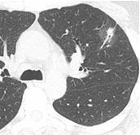 | 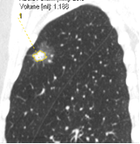 | 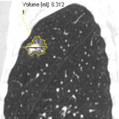
(a) | (b) | (c)
Figure 1. Invasive Adenocarcinoma. Axial CT image (a) shows a part solid nodule in the left upper lobe. Corresponding sagittal CT images (b) and (c) show automated estimation of the volume of solid component (1.188 ml) the entire lesion (8.312 ml) . In this case, if tumor size were measured only by the invasive component, the size T factor would change from T2a to T1a.
In summary, this project is motivated by the following:
- Early detection of lung cancer significantly impacts patient five-year survival. Accurate measurement of nodules is required for informed decision making in patient management.
- Lung nodules in early disease are often small (less than 1cm), part-solid or sub-solid, and are challenging to quantify in terms of longest diameter and volume.
- Lung nodules in early disease are routinely imaged using low dose CT screening protocols, which may further complicate quantitative assessment due to increased noise.
- Semi-automated measurement tools exist to perform nodule segmentation, but their inter- and intra-reader variability has not been assessed for part-solid nodules imaged with low dose CT.
- Therefore it makes sense to evaluate reader performance using manual and semi-automated measurement tools on phantom data (ground truth) to determine measurement variability and accuracy.

Study Objectives
The primary objective of this study is to extend characterization of solid nodule measurement performance to the part-solid case in low-dose and standard dose CT acquisitions. Hypotheses that will be investigated include:
- The absolute percent error in part-solid nodule tumor measurements will be less than or equal to 15% (the QIBA Solid Nodule > 10mm claim).
- Dose and slice thickness will not significantly affect the percent error measurement.
- Part-solid nodules will exhibit increased inter-reader, intra-reader and inter-algorithm measurement variability, compared to solid nodule studies.

Study Design

Procedures
The LUNGMAN anthropomorphic phantom, with part-solid nodules as designed by Dr. Nicholas Petrick’s group, will be used in this study. The primary comparison is accuracy and variability of part-solid measurement, with covariates being dose, slice thickness, algorithm and reader.

Synthetic Nodules
  - Part solid, spherical nodules per FDA molds with CIRS (10 and 20 mm outer diameter at -630 HU, 5 and 10 mm inner diameter at -10HU and +100 HU, total of 8).
  - Image all nodules at once, one position per nodule as illustrated in Figure 1, below.
  - Include 5 and 10 mm solid, spherical nodules (HU +100) as controls.
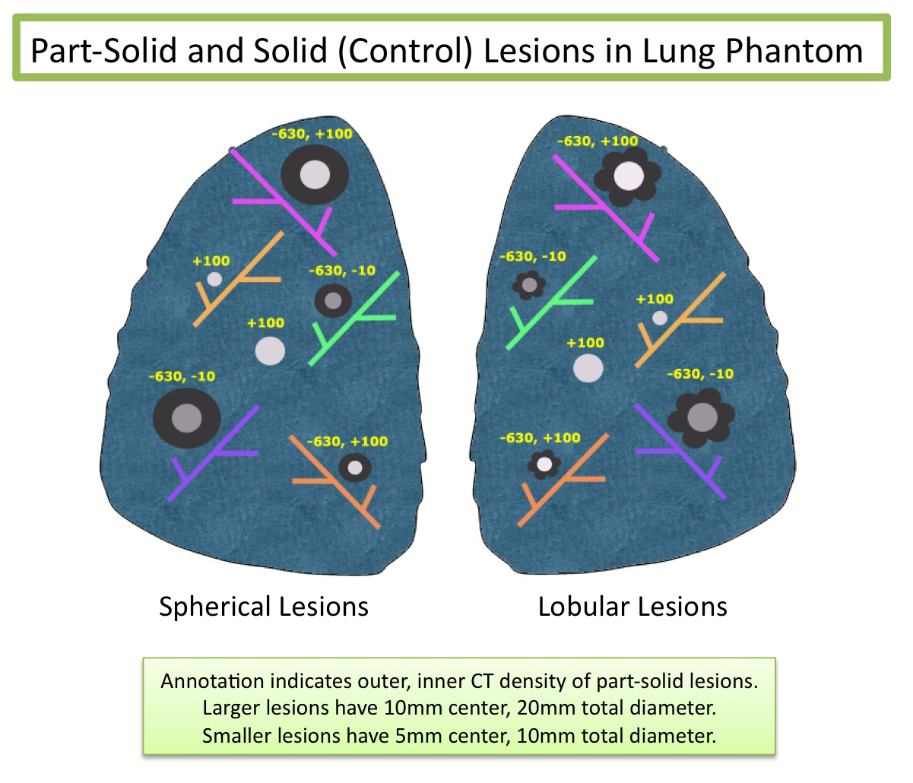
Figure 1. Illustration of lesion placement in Phantom

Phantom Imaging Protocols
Imaging will be performed on a Siemens Sensation 64 scanner utilizing two acquisition techniques that differ primarily by dose, a “low dose” and a “standard dose” protocol. Other acquisition parameters are chosen to be consistent with the proposed QIBA protocol, “QIBA Profile. Computed Tomography: Change Measurements in the Volumes of Solid Tumors, Version 2.0” (REF) as detailed below:

Contrast Preparation and Administration

PARAMETER | LOW DOSE AND STANDARD DOSE QIBA
Use of intravenous or oral contrast | No contrast will be used
Image Header | The Acquisition Device shall record that no contrast has been used, in the image header.

Subject Positioning

PARAMETER | LOW DOSE AND STANDARD DOSE QIBA
Subject Positioning | The phantom will be positioned supine, arms abducted.
Table Height | The phantom will be positioned centrally aligned with the gantry isocenter
Image Header | The Acquisition Device shall record the Table Height in the image header

Image Data Acquisition

PARAMETER | LOW DOSE QIBA | STANDARD DOSE QIBA
Scan Duration | 3.6 cm/sec | 3.6cm/sec
Anatomic Coverage | Lung apices through lung bases. | Lung apices through lung bases.
Scan Plane | Axial | Axial
Total Collimation Width | 40 | 40
IEC Pitch | 1 | 1
Tube Potential | 120 | 120
Single Collimation Width | .6 | .6
Image Header | The Acquisition Device shall record actual Anatomic Coverage, Field of View, Scan Duration, Scan Plane, Scan Pitch, Tube Potential and Slice Width in the image header. | The Acquisition Device shall record actual Anatomic Coverage, Field of View, Scan Duration, Scan Plane, Scan Pitch, Tube Potential and Slice Width in the image header.
Effective mAs | 40 | 200
Gantry Rotation Time in Seconds | 0.5 sec | 0.5 sec
Scan FOV | 500 | 500
Collimation (on Operator Console) | 64 x 0.6 (Z-flying focal spot) | 64 x 0.6 (Z-flying focal spot)

Image Data Reconstruction

PARAMETER | LOW DOSE AND STANDARD DOSE QIBA
Spatial Resolution | >=6 lp/cm
Voxel Noise | Voxel noise SD < 5HU in 20 cm water phantom.
Reconstruction Field of View | Spanning entire extent of phantom but no greater than required to image the entire phantom circumference
Slice Thickness | 1.0 and 2.0 mm
Reconstruction Interval | Contiguous
Reconstruction Overlap | 0
Reconstruction Kernal Characteristics | B60, B30 (for future work)
Image Header | The Reconstruction Software shall record actual Spatial Resolution, Noise, Pixel Spacing, Reconstruction Interval, Reconstruction Overlap, Reconstruction Kernal Characteristics, as well as the model-specific Reconstruction Software parameters utilized to achieve compliance with these metrics in the image header

Reading Protocol
  - 80 datasets {1 scanner * 2 doses * 2 thickness * 2 repeats * 10 (8 part solid, 2 solid)}
  - 4 radiologists will measure each nodule, in two different reading sessions
    - 2 reading sessions per dataset, separated by 2-3 weeks
    - Randomized worklist for each radiologist
    - Radiologist provided with the location of each lesion
    - Lesion size measurements
      - Manual (McKesson PACS) measure of nodule longest diameter, in plane.
      - Semiautomatic measure of nodule volume with Vitrea using a single seed-based algorithm for the solid nodule portion and manual adjustment of the contour for the sub-solid portion.
      - Semiautomatic measure of nodule volume with Siemens Oncology using a single seed-based algorithm / threshold for the part-solid nodule and a separate seed-based algorithm / threshold for the solid-only portion.
    - Collected Metrics (solid and solid + part-solid components)
      - Nodule longest diameters in plane
      - Nodule volumes (semiautomatic techniques)
      - Mean CT density (semiautomatic techniques)
      - Qualitative Characterization of manual intervention in the semiautomatic method used:
      - No image / boundary modification
      - Limited image / boundary modification
      - Moderate image / boundary modification
      - Extensive image / boundary modification
    - Quantitative assessment of manual intervention
  - Reading time for manual interaction
  - Volume change from manual interaction

Primary and secondary endpoints
For phantom data the primary endpoints include accuracy, bias and variability relative to the known nodule volume. Covariates will include nodule composition, size, measurement algorithm, mean CT value, and slice thickness.
Secondary endpoints include intra-and inter-reader variability and accuracy measures as outlined above, with the exception that the metrics will be separated into solid and sub-solid components.

Secondary investigations (future)
Secondary investigations may include examining the stability of mean CT values for solid and sub-solid nodule components across scanners. The establishment of reader variability using soft tissue (B30) algorithm versus B60 algorithm and different imaging planes may be considered. Raw data will be made available for public use to encourage the development of a larger database of readers and sites. This could enable reader evaluation training and programs once statistically reliable standards are achieved. In addition, more hardware and software applications may evolve from this pilot study.

Statistics - Characterizing Performance of Absolute Volume Estimation where Ground Truth is Known
In addition to the global analysis we will perform subset analysis based on nodule size.
Part-solid nodules will exhibit increased variability in volume, but not sufficiently large to invalidate the QIBA profile.
Low dose studies of part-solid nodules will not differ in volume bias with respect to solid nodules, but will exhibit increased variability.
Measurement metrics are under discussion.

Implementation of the study
The timeline will be used in the study.
- 0-3 Months
Determine collaborative group members and initial meetings.
Expedited IRB Approval
Phantom Purchase
Purchase nodules

- 3 – 6 Months
Scan phantom.
Prepare datasets, including randomization of cases for readers.

- 6 – 11 Months
Finish measurements
Prepare data

- Month 12
Data reporting – variability measures and statistical analysis.
Data download to QIBA

References
- National Lung Screening Trial Research Team, etal. Reduced Lung-Cancer Mortality with Low-Dose Computed Tomographic Screening. N Eng J Med (2011).
- MacMahon H, Austin JH, Gamsu G, Herold CJ, Jett JR, Naidich DP, et al. Guidelines for management of small pulmonary nodules detected on CT scans: a statement from the Fleischner Society. Radiology 2005 Nov;237(2):395-400.
- Xu DM, van der Zaag-Loonen HJ, Oudkerk M, Wang Y, Vliegenthart R, Scholten ET, et al. Smooth or attached solid indeterminate nodules detected at baseline CT screening in the NELSON study: cancer risk during 1 year of follow-up. Radiology 2009 Jan;250(1):264-72.
- Godoy MC, Naidich DP. Subsolid pulmonary nodules and the spectrum of peripheral adenocarcinomas of the lung: recommended interim guidelines for assessment and management. Radiology 2009 Dec;253(3):606-22.
- van Klaveren RJ, Oudkerk M, Prokop M, et al. Management of lung nodules detected by volume CT scanning. N Engl J Med 2009; 361:2221-9.
- Henschke C, et al. AJR Am J Roentgenol 2002;178(5):1053–1057.
- Travis W, Brambilla E, Noguchi M, et al. IASLC/ATS/ERS International multidisciplinary classification of lung adenocarcinoma. J Thoracic Oncol 2011;6:244-285
- Gierada, Nath H, Garg K, Fagerstrom RM, Strollo DC,. Low-Dose CT Screening for Lung Cancer: Interobserver Agreement on the Interpretaton of Pulmonary Findings. Radiology 2008. 246 (1):265-272
- Oda S, Awai K, Murao K et al. Computer-Aided Volumetry of Pulmonary Nodules Exhibiting Ground-Glass Opacity at MDCT. AJR 2010;194:398-406.
- Gavrielides M, Kinnard L, Meyers K et al. Noncalcified Lung Nodules: Volumetric Assessment with Thoracic CT. Radiology 2009. 251 (1):26-37.
- Singh S, Pinsky P, Fineberg N, Gierada D, Garg K, Sun Y, Nath H. Evaluation of Reader Variability in the Interpretation of Follow-up CT Scans at Lung Cancer Screening. Radiology 2011;259:263-270
- http://qibawiki.rsna.org/images/9/9d/QIBA_Exp1B_CoffeeBreak_Descriptive_Statistics_24Sep10.pdf (accessed 6/15/2011)

