QIBA DWI Profile:

- Clinical context (Michael)
  - Gain insight into microstructural and compositional changes in tumors due to treatment via DWI and ADC mapping
- Claims (Michael)
  - Using in vivo water tissue mobility can be characterized by measurement of the apparent diffusion coefficient (ADC). ADC is determined with MRI by applying different b-values to a subject and fitting the resulting signal intensities to an exponential decay.
  - At isocenter, ADC measurements of an ice water phantom should exhibit minimum bias, within 5% of the gold standard value of 1.1 x 10⁻⁹ m²/s, regardless of coil type and field strength.
  - When acquiring ADC values in solid tumors greater than 1 cm in diameter or twice the slice thickness (whichever is greater), one can characterize in vivo diffusion with at least a 15% test/retest coefficient of variation, intrascanner and intrareader.
- Profile detail/protocol
  - Executive Summary (Michael)
    - Word about what is the state of the art in research and clinical trials
    - Why would standardization help
    - Few sentences what this profile is for.
  - Clinical Context (Thorsten)
Tumor tissues normally demonstrate an abnormal microstructure and physiology, which might be related to their specific tumor microenvironment and biologic aggressiveness.

Cytotoxic agents and novel molecular tumor therapies early affect the tumor microstructure and physiology, and might result under effective treatment in a tumor necrosis and shrinkage. However, early changes of the tumor microstructure and physiology will not necessarily reflected by classical measurements of size changes (e.g. RECIST), and response classification by these conventional criteria will need several weeks (routinely first follow-up acquired 6-8 weeks after treatment initiation). Since most tumor therapies also cause side effects, and novel molecular drugs are expensive in the preclinical development and daily clinical use, robust non-invasive biomarkers are strongly needed for early assessment of treatment response for patient care, drug discovery, and economic reasons.

Role of DWI in a response to therapy assessment
Diffusion- weighted imaging (DWI) provides qualitative and quantitative information of the tumor microstructure, cellularity, and integrity of the cellular membrane.

Cancer could be detected due to an increased cell density (e.g. lymphoma or prostate cancer), and the calculated "apparent diffusion coefficient" (ADC) might predict tumor aggressiveness and therapy response at baseline. DWI can also detect relatively small changes in tumor microstructure at the cellular level allowing for quantification of early treatment-induced changes. Very soon, hours to days after therapy initiation, cellular edema could occur, resulting in a transient decrease of the ADC. A few days to weeks after effective therapy, tumor necrosis with a loss of cell membrane integrity and an increase of the extracellular space typically result in an increasing ADC measurement. During the following weeks and months, the tumor may show a shrinkage with a resorption of the free extracellular fluid and fibrotic conversion leading to a decrease of the ADC. However, tumor relapse and regrowth could also result in an ADC reduction, but are typically associated with unchanged or increasing tumor size.

  - Site selection, Qualification and training (Tom)
    - Phantom studies, other pre-requisites for being able to do the studies mentioned in this profile
      - Equipment
      - Phantom
      - Process of site qualification
      - Mechanism in place to train and educate the site on
  - Challenges to profile use (Alex)
    - Necrotic components
    - Hemorrhages
    - Lipid-rich tumors
    - Mucin-rich tumors
    - Susceptibility effects
  - Subject scheduling (Thorsten)
Baseline examinations should be ideally within 14 days, but at least within 30 days prior to treatment start. DWI should not be performed within 14 days after biopsy, and there should be no other tumor treatment at the meantime. Otherwise measured tumor tissue cellularity may not reflect the status of the tumor prior to initiation of therapy.
Intervals between follow-up examinations should be generally for early treatment monitoring more 24- 48 hours after therapy initiation and for severe therapy related changes more than 2- 4 weeks, but as defined by the clinical trial of the new treatment and determined by current standards for GCP.
  - Subject preparation (Thorsten)
For DWI patients should prepared according to the local standard of care (e.g. removal of all metal objects and electronic devices), but no specific patient preparation procedures are required. Patients should be comfortably positioned, in appropriate attire to minimize patient motion and stress, which might affect the imaging results.
  - Imaging Procedure
    - b-values (Michael)
      - Number and choice of b-values
        - Preferred: 3 b-value minimum (constant TE)
        - Acceptable: 2 b-value (0, and high)
      - Number of averages per b-value
    - Detailed description of imaging protocols, based on area of body
      - Motion (Marko)

Respiratory motion compensation in DWI

Three approaches in motion compensated acquisition strategies in body (abdomen and whole body) were reported in the literature review: breath hold, free breathing, respiratory-triggered and navigated.

Breath-hold single shot EPI

The key advantage of breath-hold acquisition is short acquisition time. The entire liver can be covered in one or two breath-holds of up to 20 seconds. Parallel imaging with the EPI sequence allows for short TE (~40-70 ms), thus preserving SNR (1). Theoretically breath hold scans are more effective for evaluating lesion heterogeneity and small lesion ADC. However, single-shot sequences are inherently noisy. Motion artifacts are reduced, but pulsatile flow & motion artifacts remain. Some authors advise combining with cardiac pulse triggering (1), but triggering prolongs scan time. Cardiac pulsations are reported to increase ADC in left lobe of the liver (1). For good SNR thicker slices are needed (6-8 mm). Breath-hold scans are limited in resolution and in number of b values per breath hold, which may impact ADC accuracy, or limit multi-exponential analysis.

Free breathing with multiple averaging

Free breathing allows multiple b values and thinner slices (4-5 mm), with 3 to 6 minutes scan time for whole liver evaluation (2). Free breathing scans are typically acquired with a higher number of averages (4 to 6) resulting in higher SNR. Cyclical breathing is a coherent motion which doesn’t attenuate signal in liver (2). It is possible to perform MPR and MIP for qualitative evaluation and fusion with anatomical images to combine functional and anatomical information (1).
However, multiple averaging causes slight image blurring. Small lesion ADC and heterogeneity are less accurate because of motion averaging. The shortcomings of free breathing with multiple averaging raises interest in respiratory (1) and cardiac triggering to improve image registration for ADC measurement.
Free breathing DWI can be extended to multiple stations for whole body DWI, also known as DWIBS (diffusion weighted whole body imaging with background body signal suppression). DWIBS is easier to perform with dedicated whole-body coils (commercially available TIM, dStream for example). Otherwise images can be acquired with the quadrature body coil (with no parallel imaging) or using coil/table sliding solutions (X-Tend Table™ for example).

Respiratory triggering and navigation

Respiratory-triggered scans are acquired using respiratory bellow controls or respiratory navigation with a 2D navigator excitation.
High quality images are acquired with good anatomical detail (2). Liver detection is improved compared to breath-hold DWI (4). Image quality, SNR, and ADC quantification are improved. Better CNR and decreased scattering of ADC is reported (1).
The penalty of respiratory-triggered acquisition is increased scan time (-> 5-6 minutes), and thus increased chance of patient motion. Risk of pseudo-anisotropy artifact can lead to errors in ADC (5). Cardiac motion causes spin dephasing artifacts in left liver lobe (2). Cardiac triggering can reduce the cardiac pulsation artifacts (1, 7).
In addition to respiratory triggering using respiratory belts, a navigator echo technique can be used for motion compensation. A pencil-beam excitation pre-pulse is placed at the interface of liver and lung. The diaphragm position is determined from the navigator signal. The diaphragm position can be used to trigger the acquisition in end-expiration, but also to adjust the acquired slice displacement according to the diaphragm position.
In order to circumvent the increased scan due respiratory triggering, Takahara et al (8) introduced a modified, “tracking-only” (TRON) navigated DWI acquisition. With TRON the navigator echo is used only to track and correct for tissue displacement, and not for gating. Thus slices are acquired during the entire breathing cycle. This technique was implement at 1.5T (8) and 3T (9) field strengths.

References
- Koh DM , Takahara T , Imai Y , Collins DJ. Practical aspects of assessing tumors using clinical diffusion-weighted imaging in the body . Magn Reson Med Sci 2007; 6 : 211 –224.
- Taouli & Koh, Radiology: Volume 254: Number 1—January 2010
- Kwee TC , Takahara T , Ochiai R , Nievelstein RA , Luijten PR . Diffusion-weighted whole body imaging with background body signal suppression (DWIBS): features and potential applications in oncology . Eur Radiol 2008; 18 : 1937 – 1952.
- Parikh T , Drew SJ , Lee VS , et al . Focal liver lesion detection and characterization with diffusion-weighted MR imaging: comparison with standard breath-hold T2-weighted imaging. Radiology 2008; 246 : 812 – 822 .
- Nasu K , Kuroki Y , Fuji H , Minami M . Hepatic pseudo-anisotropy: a specific c artifact in hepatic diffusion-weighted images obtained with respiratory triggering . MAGMA 2007; 20 : 205 – 211.
- Influence of cardiac motion on diffusion-weighted magnetic resonance imaging of the liver.
- Kwee TC, Takahara T, Niwa T, Ivancevic MK, Herigault G, Van Cauteren M, Luijten PR. MAGMA. 2009 Oct;22(5):319-25.
- Takahara T, Kwee TC, Van Leeuwen MS, Ogino T, Horie T, Van Cauteren M, Herigault G, Imai Y, Mali WP, Luijten PR, Diffusion-weighted magnetic resonance imaging of the liver using tracking only navigator echo: feasibility study. Invest Radiol. 2010 Feb; 45(2):57-63.
- Ivancevic MK, Kwee TC, Takahara T, Ogino T, Hussain HK, Liu PS, Chenevert TL. Diffusion-weighted MR imaging of the liver at 3.0 Tesla using TRacking Only Navigator echo (TRON): a feasibility study. J Magn Reson Imaging. 2009 Nov;30(5):1027-33.

      - Sequence type (Dave [Siemens], Greg [Philips], Sandeep [GE] for 2-8)
      - FOV, matrix size, slice thickness
      - 3 orthogonal gradients for each b-value>0
      - Single vs double echo
      - Single vs multishot
      - Parallel imaging
      - Fat-suppression techniques, per region, 1.5 vs 3 T
    - Imaging post-processing (Brendan Whicker, Hendrik)
      - Image distortion correction
      - Motion
  - Image Analysis (Brendan, Hendrik)
    - ROI protocol
      - Contrast bolus administration, if necessary
      - T2W ROI
      - Use of DWI image for ROI
      - Challenges
    - Obtaining an ADC value
      - Fit
      - Pixelwise, whole Tumor Mean/Median, histogram
  - Image interpretation (Alex, Mark)
    - Statistics to calculate from resulting maps
    - Tumor segmentation
    - Single operator
    - ADC changes with treatment
  - Archival and distribution of data (Michael)
    - Archiving segmentations
    - Saving segmentation masks (numeric)
  - Quality control (Tom Chenevert, Martin Buechert)
X. Quality Control
The following section deals with all aspects of quality control in DWI-MRI studies. Primary objectives of a DWI QA/QC program are: (a) to confirm DWI acquisition protocol compatibility and compliance across participating centers; (b) assess performance of each MRI system in measuring key DWI/ADC quantities; (c) certification of systems/sites to meet quantitative performance thresholds or identify source of performance deficiency; and (d) establish ongoing quality control. This includes selection of imaging centers and specific scanners. In addition, the use of DWI phantom imaging and analysis of phantom data are discussed. Finally, post DWI acquisition quality assessment is described. Details of these procedures will necessarily vary for the specifics of each trial thus need adjustment, although the common framework is shared.
Guidelines for appropriate patient selection, tumor selection, and post processing are also discussed below.
X.1 Selection of appropriate imaging centers for DWI studies
Typically sites are selected based on a record of competence in clinical oncology and access to a sufficiently large patient population under consideration in the clinical trial. Sites should also be competent in standard MRI procedures, DWI methodology applied to the relevant anatomical area(s), other advanced MR procedures that may be employed in the trial (eg. MRS, DCE-MRI), as well as access to quality-maintained clinical MRI systems. In order to ensure high quality DWI results, it is essential to implement procedures that ensure quality assurance of the scanning equipment and reliable image acquisition methodology. These processes must be established at study outset and maintained for the duration of the study. A site “imaging capability assessment” is required and should include evaluation of:
- Appropriate MR equipment and standard QC processes
- Experienced MR technologists
- Experienced MR radiologists
- Experienced MR physicists or MR imaging scientists
- Procedures to assure protocol compliance during the trial
X.1.1 DWI acquisition scanner
DWI studies targeted by this profile require a 1.5T or 3T scanner. The scanner software/hardware versions should be identified and tracked with time over the course of a clinical trial. Sites often have multiple scanners at the same or variable software/hardware platforms. It is beneficial to identify and qualify multiple scanners at a given site if such are available in the event a study-eligible scanner is temporarily unavailable. However, adherence by the site to a use of a specific scanner or pool of scanners for trial subjects must be established by study design. Likewise, rules for serial scanning a given trial subject on one or multiple systems must be clearly established. Means to confirm adherence to study design, in terms of eligible scanner for each patient and time point, should utilize specific scanner identifiers available in the DICOM header.
The MRI scanner must undergo routine QA/QC processes and have a service plan that includes a preventative maintenance schedule appropriate for standard clinical MR applications. In addition, to assure adequate quantitative MR imaging results study-specific quality control measures are required as detailed below.
X.1.2 Site personnel performing DWI studies
(Analogous to DCE profile)
X.1.3 MR Radiologist or other anatomic experts
(Analogous to DCE profile)
X.1.4 Site protocol compliance
(Analogous to DCE profile)

X.2 Site qualification process
X.2.1 Site readiness
(Analogous to DCE profile)
X.2.2 Scanner qualification
(Analogous to DCE profile)
X.2.3 Phantom imaging
To qualify the MRI scanner a DWI phantom imaging procedure is required. The DWI phantom must contain one or multiple media having known properties of: (a) diffusion coefficient(s), (b) b-value dependence, and (c) isotropy/anisotropy. Molecular mobility is a function of temperature (eg. water mobility varies ~2.4%/Cº), therefore quantitative diffusion coefficient values require knowledge or control of internal phantom temperature. DWI phantoms at room temperature are convenient for scanning, although the range in room temperature (~10 Cº) requires calibrated internal temperature readouts recorded with phantom scans for look-up-table conversion to known diffusion coefficient values. Alternatively, phantoms designed with an ice-water bath surrounding diffusion media provide an economical means to establish and maintain temperature control at 0Cº for several hours. A test compartment of water at 0Cº has a precisely known diffusion coefficient = 1.1x10⁻³mm²/s, which is comparable to the ADC value of tissue. However, ice-water phantoms are less convenient since they require on-site preparation.

X.2.4 Phantom imaging data analysis
Phantom data should be analyzed in a uniform manner and preferably by a central analysis site. Assurance should be made by the analysis center that the phantom scan orientation is correct, and appropriate phantom positioning was performed.
Clinical DWI protocols may require controlled ranges in geometry values (eg. FOV, slice thickness, quantity of slices) to accommodate a range in patient body habitus. The DWI phantom physical characteristics and imaging protocol can be designed for similarity with the clinical study protocol, but range in all acquisition settings must be minimized. A small parameter range for DWI phantom scanning may still be required for protocol compatibility across scanner platforms.
The following performance metrics should be measured via DWI phantom images acquired on each candidate MRI system. Quantitative performance thresholds of these metrics must be established beforehand, and sites need to meet/exceed these thresholds as an essential step for qualification. Assuming DWI phantom images are acquired across multiple platforms (i.e. manufacturers and software/hardware versions), the central analysis site must be able to derive performance measures regardless of imaging platform source. While DICOM offers some uniformity in image format, the stored order of DW images is variable and complicates derivation of ADC values from subsets of images extracted from DWI series. The phantom QC processing center must be able to import and fully process DWI series from all sources, regardless of image order. One solution is to customize the image import software module for each platform-specific/order-specific condition for conversion to a common internal structure format. Once converted, all subsequent analysis routines are independent of image source.
X.2.4.1 ADC bias error
In tissue the “apparent” diffusion coefficient (ADC) represents the distillation of complex biophysical processes so that the concept of a “true” ADC is overly simplistic. In addition, the relative influence of various biophysical processes depends on data acquisition conditions. An essential first step to assess ADC bias error of an MRI system is measurement of a medium of precisely known diffusion coefficient. In addition, the functional dependence of mobility on DWI sequence b-value and diffusion time must be known. In this regard, simple self-diffusion media having no b-value or diffusion time dependence are preferred. For such media, the standard formula, ADC_{0,b} = { [ln(DWI₀/DWI_{b})] / b } can be used to generate ADC maps over the b-value range 0 to b. It is appropriate to first apply a noise threshold filter to mask low SNR pixels that otherwise lead to unreliable ADC results. Phantom scan b-value(s) are set per protocol, but must at least encompass the range used in the associated clinical trial. Mean and standard deviation from standard-shaped (round, square, rectangle), fixed-sized ROIs defined in test sample compartments are recorded for each ADC map. Multiple ROIs over slices or regions on the maps for a given test compartment can be combined to create a volume of interest (VOI) to more fully sample the compartment. ADC Bias Error is derived from the mean ADC measured over the VOI compared to the known diffusion coefficient (DC_{true}) of the medium as,
.

X.2.4.2 ADC random error
ADC Random Error is the standard deviation of ADC pixel values measured over each VOI expressed as a percentage of the VOI mean ADC. A systematic difference between ADC measured in widely separated VOIs would inflate this metric, therefore ADC Random Error should only be derived from single-region VOIs as,
.

X.2.4.3 ADC b-value dependence
If by first-principles, molecular mobility of the diffusing medium is known to not have b-value or diffusion time dependence, any significant difference in DWI phantom ADC value with b-value is artifactual. Assuming the DWI phantom protocol is designed to measure ADC over multiple b-value intervals, say b=0→b1 and b=0→b2, the level of artifactual b-value dependence is quantified as,
,
Where b2>b1 and the ADC values represent select VOI means.

X.2.4.4 ADC spatial dependence
MRI systems may have a spatial dependence in measured ADC due to systematic imperfections such as gradient nonlinearity. These errors should be relatively small and nearly symmetric relative to distance from magnet isocenter. Susceptibility of a study to error due to ADC spatial dependence varies with the expected range of locations for target tissues, as well as reliability in patient positioning. It is therefore useful to sample the ADC spatial dependence of MRI systems over a relevant range for the clinical trial. This can be expressed as the percent range in ADC values for widely separated VOIs, say VOI1 and VOI2, that are within the spatial range anticipated for the clinical study as,
.

X.2.4.5 SNR of DWI
Lastly, overall signal-to-noise of the source DW images is an important performance parameter. While “signal” is relatively straightforward to measure by the mean pixel intensity within an ROI or VOI, “noise” is more difficult. Often the standard deviation of pixel intensity within an ROI or VOI drawn in the background (ie. air) is used as an estimate of noise. Unfortunately, the image background regions are often heavily modulated by MRI reconstruction and filter routines, especially when parallel imaging and intensity normalization techniques are employed. The nature and degree of background modulation is variable across MRI platforms and it is difficult to enforce standardization. An alternative to deriving noise from background is to acquire immediately sequential serial images acquired under identical conditions then estimate noise of each pixel by the square root of temporal variance measured over the multiple serial passes. Note, this measure of variance will also include short-term system instability. Full 3D noise images are created for each b-value image set. Identical VOIs are then applied to the signal and noise images to estimate SNR at each DWI b-value as,
.
If only two serial passes are available, the noise image is derived from the pixel-by-pixel subtraction of the two passes, and the SNR statistic is defined as,
For comparative purposes, noise can also be estimated by the pixel standard deviation in a large ROI defined in a ghost-free air background region; although as mentioned this metric is potentially compromised by image intensity modulation routines employed on some systems.

X.2.4.6 Spatial distortions due to B0 inhomogeneity and eddy currents
X.2.4.7 Fat suppression effectiveness and uniformity
X.2.4.8 DWI phantom protocol compliance
The established DWI phantom protocol, including allowed parameter ranges, must be tabulated and compared to acquisition settings used for the MRI system being evaluated. A DICOM parameter “compare” software module is preferred to automate compliance assessment. Protocol compliance or points of violation must be documented in a report. A Sample QC report is provided in Figure XXX and YYY.
X.2.5 Ongoing MRI scanner quality control
The initial set of DWI phantom images from each site/system are used for certification that the system met or exceeded performance standards set for the clinical trial. Sites that desire to use multiple MRI scanners for the study, must have each scanner certified. Once certified, each MRI system must be re-evaluated by the same DWI phantom test procedure at established intervals.
X.3 Quality control of DWI studies
X.3.1 Determination of suitable tumor lesions
(Analogous to DCE profile)
X.3.2 Selection of target lesion
(Analogous to DCE profile)
X.3.3 Determination of subjects unsuitable for DWI analysis
(Analogous to DCE profile)
X.3.4 Determination of DWI exams unsuitable for DWI analysis
(Analogous to DCE profile)
X.3.5 DWI exam protocol compliance
The established clinical trial DWI protocol, including allowed parameter ranges, must be tabulated and compared to acquisition settings used for each trial DWI dataset submitted for evaluation. A DICOM parameter “compare” software module is preferred to automate compliance assessment. Protocol compliance or points of violation must be documented in a report. A Sample QC report is provided in Figure XXX and YYY.

X.3.6 Editing DWI exams prior to DWI analysis
(Analogous to DCE profile)

Material below are sample tables only …………..
Target performance levels for site certification are summarized as follows:
Sample Table 1: DWI Phantom Target Performance Standards §
ADC Bias  Error  (ADC vs True Value) | ADC b-value Dependence  (ADC₀₋₆₀₀ vs ADC₀₋₈₀₀) | ADC Spatial Dependence  (Right- vs Left- VOIs) | ADC Random  Error  (single-side VOI) | SNR of  High b-value DWI
< 10% | < 2% | < 5% | < 5% | > 75:1
§ See section X for metric definitions

- Test Procedure – DWI Acquisition
The core DWI test sequence was designed for commonality with the ACRIN 6698 DWI sequence used on patients. Greater details of the QC protocol are provided in Appendix I, although main acquisition elements of the DWI scan are summarized here.
Sample Table 2: DWI QC test sequence:
Sequence | TR (ms) | TE (ms) | No. of Averages | Parallel Imaging
3-axes DW  Single-Shot EPI | >8000 | 80 → 100 | 2 | Factor 2 @ 1.5T  Factor 3 @ 3T
FOV (mm) | Matrix | Slice Geometry | Encoding | b-values (s/mm²)
320 x 320 | 160 x 160 acq.  256 x 256 recon. | Bilateral axial  30 slices,  4mm thick, 0 gap | Freq axis = A/P  Phase axis = R/L | 0, 100, 600, 800
An important aspect of the QC protocol involves collection of four sequential DWI “passes”, where each pass is approximately 3minutes. This design serves two purposes. Multiple measurements spanning 12minutes are used to confirm the phantom was at thermal equilibrium. A clear trend of decreasing ADC with each pass suggests the phantom was not at thermal equilibrium. Secondly, repeated DWI scans provide an estimate of noise in each DWI pixel by the temporal variance of signal.

- Submission of DWI Phantom Images
Do not de-identify DWI phantom images. Submit all DWI phantom images, including non-DWI scans and screen-shots to the ACRIN Imaging Core Laboratory via TRIAD. It is important to note that all images must be in DICOM format.

QC Report Generation: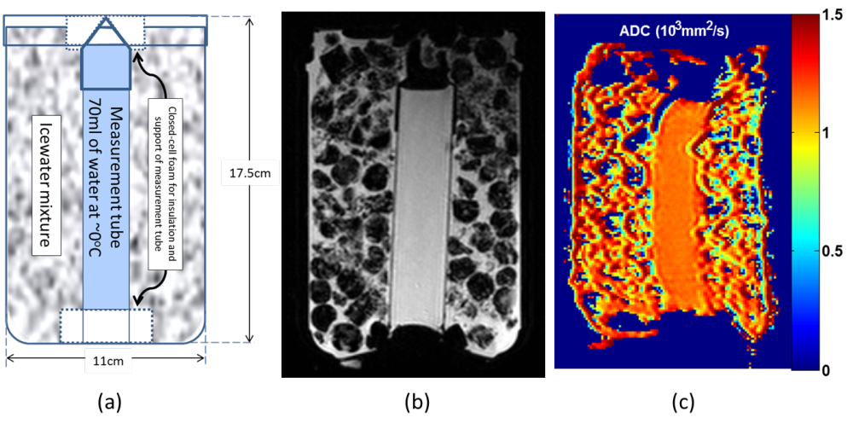Figure 1: (a) Schematic of DWI phantom; (b) MRI through central plane of phantom; (c) ADC map on quantitative color scale. Diffusion coefficient of water at 0 ºC ≈ 1.1 x10⁻³ mm²/s.
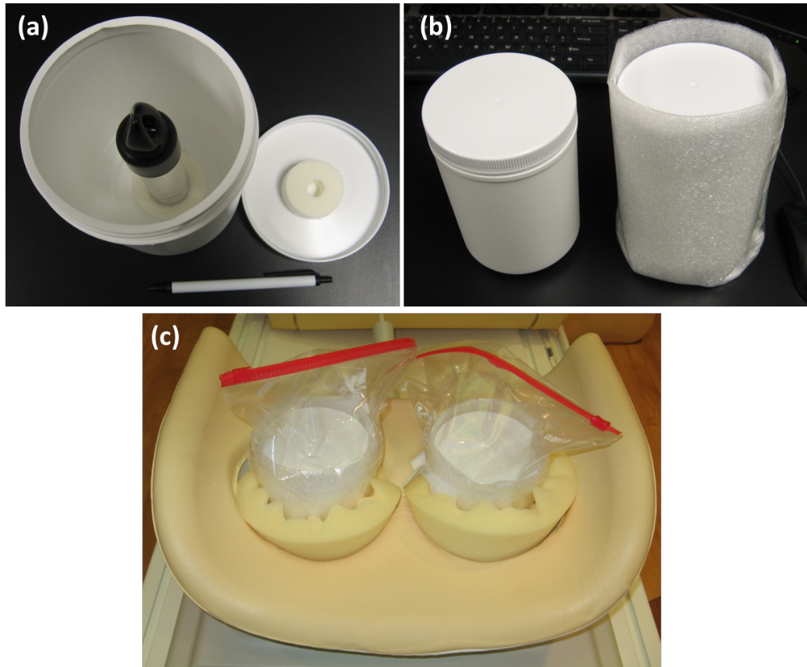
Figure 2: Photographs of DWI phantoms (a) before filling with icewater; (b) insulating foam envelope; (c) positioned in bilateral breast coil.

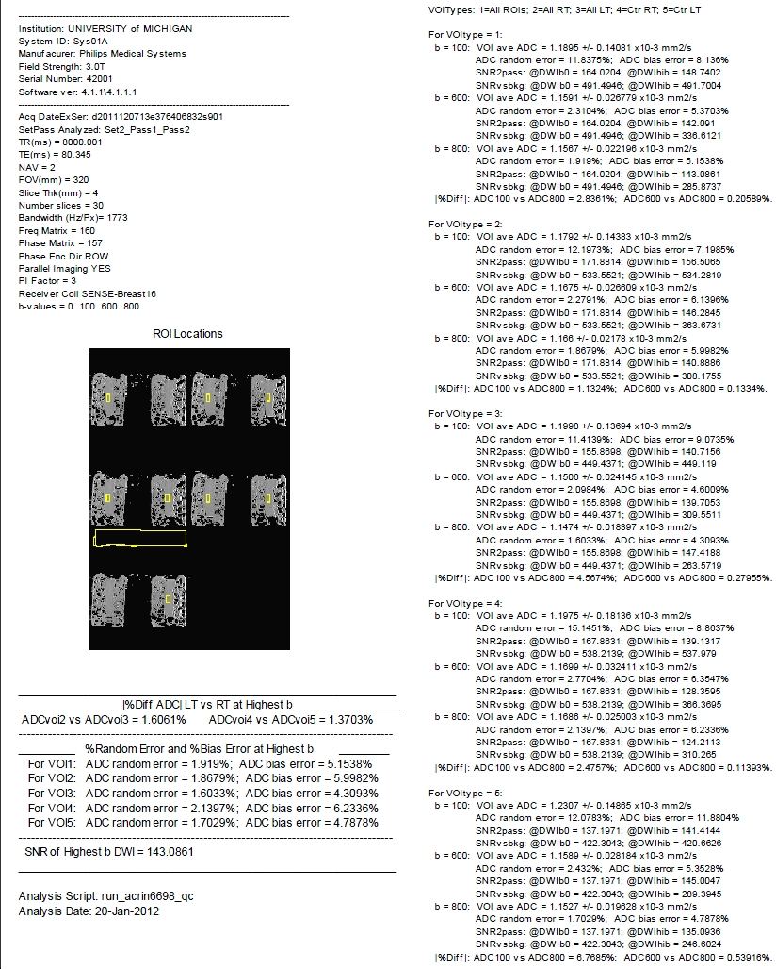
Figure XXX: Example of QC Report generated by UM Core Lab scripts.

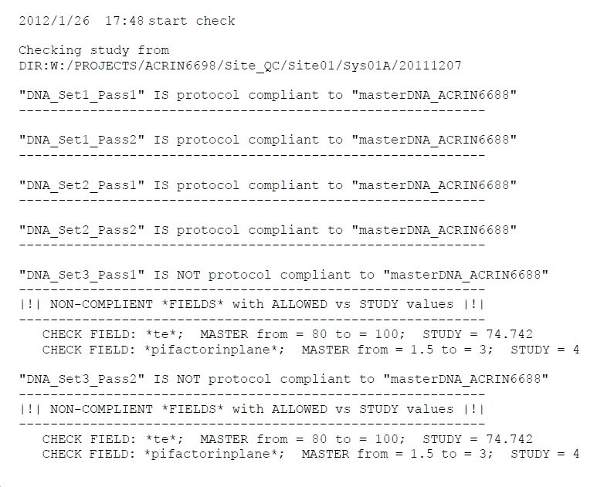
Figure YYY: Example of QC protocol conformance check. Dicom headers with values outside of allowed range per protocol are flagged as noncompliant.

    - List all sources of artifact and variation and procedures to mitigate them
      - Prospective
        - Perfusion at low b-value
        - Subject motion
        - Acq. Plane
        - Image artifacts (wrap, metal, etc…)
      - Retrospective
        - Registration methods
        - Adherence to imaging protocols
  - Imaging-associated risks and risk management (MIchael)
- Compliance
  - Site
  - Scanner
  - Software
- Appendices
  - perfusion effects in various tissues

QIBA DWI Profile QC Section DRAFT version Nov28, 2012

