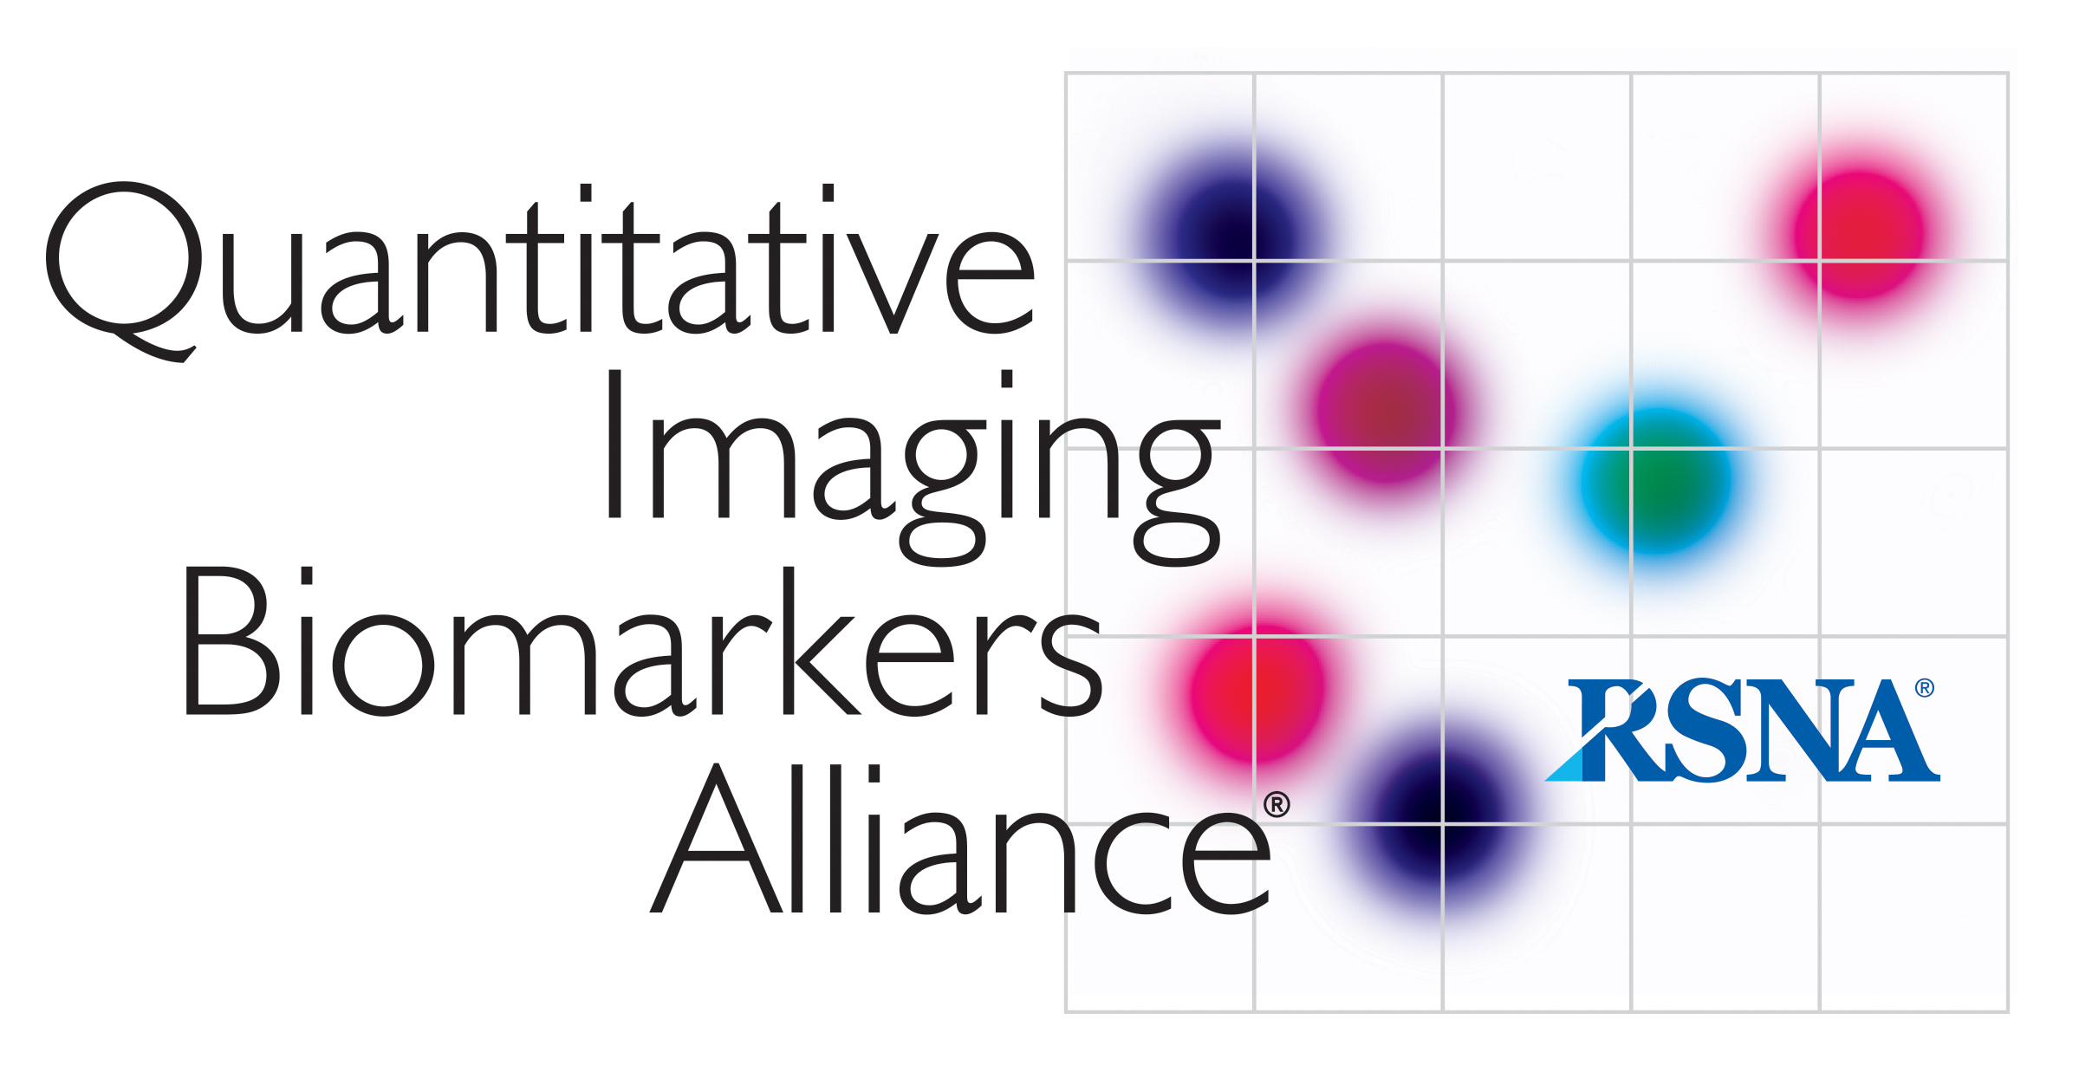
AIUM/QIBA
Ultrasound Volume Blood Flow Biomarker

MINUTES 2018-03-05

Attendance:
P. Carson, B. Fowlkes, J. Gao, O. Kripfgans, R. Managuli, K. Minton, S. Pinter, M. Robbin, J. Rubin, J. Zagzebski

I. Review of Existing Scanning Platforms
- Resolution is not as important as penetration
- Visualization of flow does not equal quantification of flow
- A live c-plane would be very helpful when setting up the scanner for volume flow
- Scan speed is ultimately in issue

II. Discussion of Flow Phantom
- Phantom needs to be shallower for mimicking AV fistulas

III. AIUM schedule
We are planning face-to-face meetings on Saturday, March 24 for each of the QIBA working groups starting at 9 am, 10:30 am and noon. Kathi will check on this schedule, then we will notify RSNA. Will also be sent out to other committee chairs to confirm the selected times.
IV. KUDOS
Kudos to everyone that helped with the RSNA poster and that was manning it during the convention.

