AIUM/QIBA
Ultrasound Volume Blood Flow Biomarker

MINUTES 2016-08-15

Attendance:
K. Akaki, C. Baiu, V. Devaraju, D. Dubberstein, T. Erpelding, B. Fowlkes, J. Zagzebski, T. Hall, O. Kripfgans, T. Lynch, K. Minton, S. Pinter, J. Rubin, R. Tadross, M. Trew

I. Status of QIBA grant submission
Steering committee voted to fund our project! Funding will likely be available mid September or October.
II. QIBA – RSNA poster presentation
The coming RSNA meeting has a poster session for QIBA work. A member of the committee will present work on phantom design and pre-testing as well as definition of the decided in vivo target. Identify and list the participating vendors.
III. Discussion of requirements for ultrasound scanners to yield volume flow compatible data
The committee discussed the type of data required to perform volume flow measurements. Below is a draft description of this data set and its origin (Appendix I).
IV. Prototype Phantom Testing
The committee discussed the visit of Marijean Trew and Cristel Baiu (Gammex) at the University of Michigan and the phantom evaluation that was performed. Results are shown in Appendix II.

Appendix I
QIBA Data Set Description

The basic requirements are the availability of:
(1) 3D B-mode (not an absolute must but very helpful for targeting),
(2) 3D color flow and simultaneous 3D power of the color flow firings
(3) coordinate information.
On top of that the color and power voxel data should be in the native firing coordinates not in a scan converted orthogonal x-y-z volume.
The typical native coordinate system of a mechanically swept aperture is shown below. The linear array has a beam spacing of a. The elevational tilt has a radius of curvature of r, and a start depth of d1 (depth of first voxel) and end depth of d2 (last voxel). The elevational angle is alpha. The coordinates of a given voxel are therefore:
X = axial = sin(alpha)* (d1 + nx*Δd)
Y = lateral = a * ny
Z = elevational = cos(alpha)* (d1 + nx*Δd)
Here nx, ny are the voxel number in the axial and lateral direction. Alpha is computed from the elevational pixel number and the angular step size of the dataset.
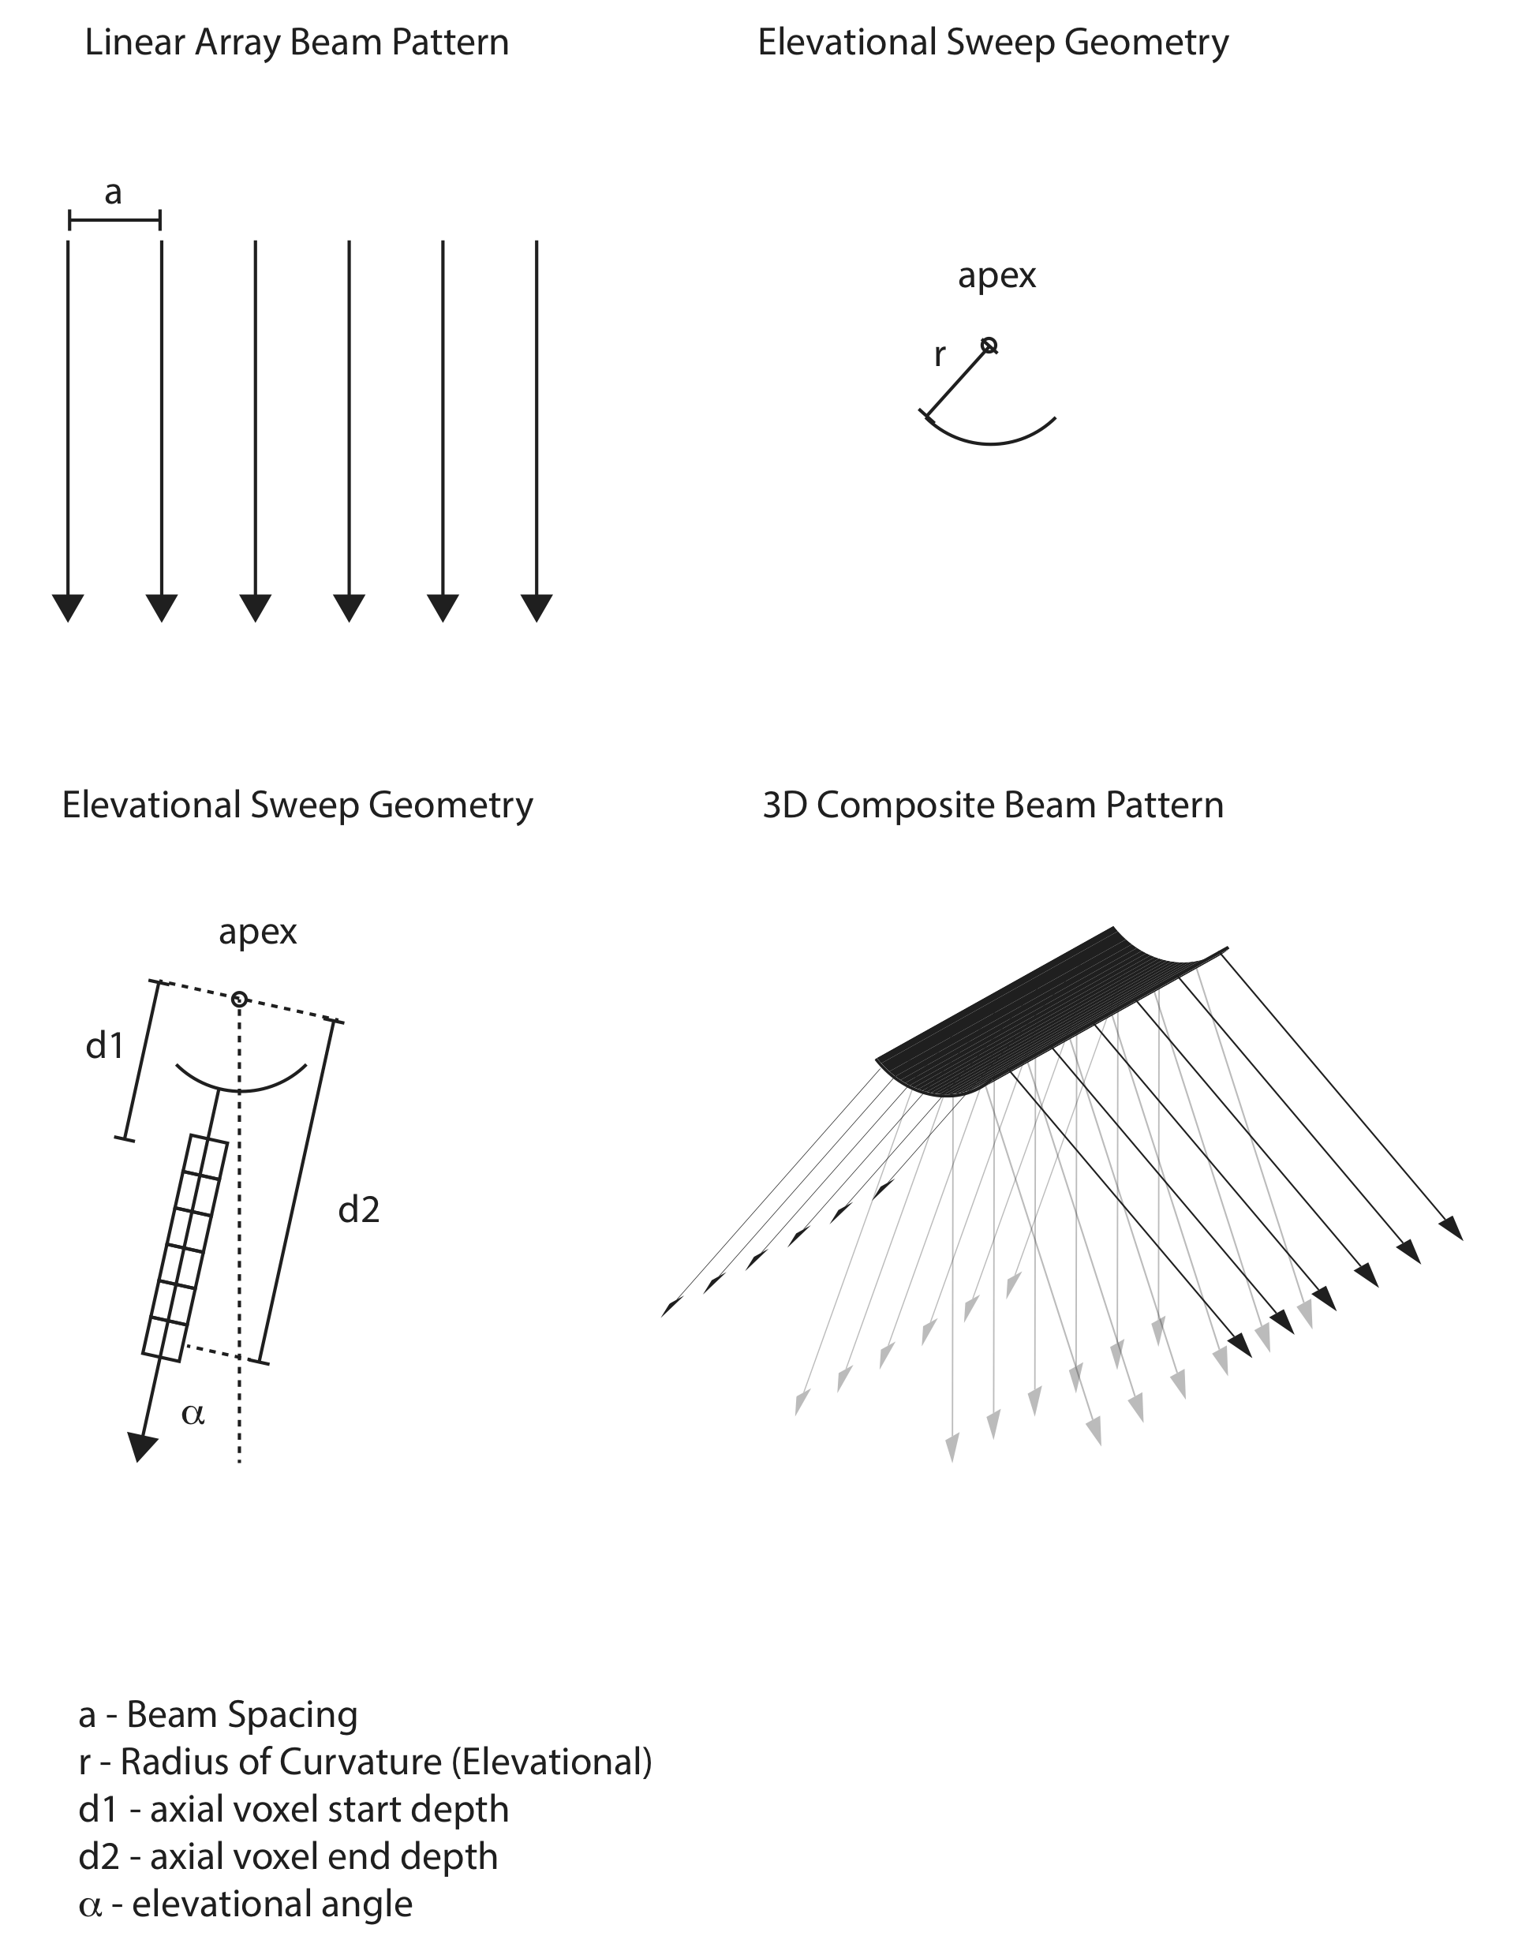

Appendix II
Prototype Phantom Testing Results

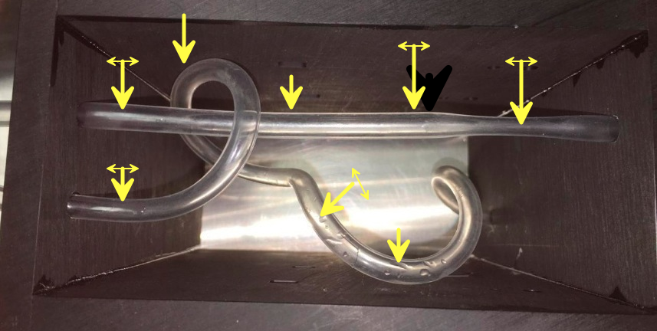
Figure 1. Visual top-down view of QIBA phantom. Landmarks are illustrated by yellow arrows, left to right, top first (5), then bottom (3). Currently flow is left to right in the straight tube on the top, with a stenosis towards the right, last arrow on top. A loop outside the left end of the phantom connects the straight tube (top) and the curved tube (bottom arrows). Thus the flow originates on the bottom right of the phantom and progresses from the curved tubing section to the straight tubing section, to then exit on the top right.

Figure 2. Proto-type Gammex Volume Flow phantom assessment using an Epiq 7 and X6-1 (2D array) scan head. Straight tubing section. Series 1 is standard 3D color flow processing using partial volume flow correction for estimation of flow. Series 2 is non-partial volume corrected flow. Dashed lines represent ±10% relative to true flow and given equation is linear fit with y=0 at x=0 constraint. Flow is constant at 700 mL/min.

Figure 3. Same as Figure 2, but pulsatile flow at a rate of up to 350 mL/min.

Figure 4. Same as Figure 2, but curved tubing section. Constant flow at a rate of up to 530 mL/min. Overestimate of 23%. NOTE: Line fits are only shown to illustrate the estimate relative to the actual pump flow. Y at x=0 is forced to zero.

Figure 5. Same a Figure 2, imaging in the stenosis (top) and post stenosis (bottom). Not shown are series 2 values out of range one >1400 (top) and the other >1800 mL/min (bottom). NOTE: Line fits are only shown to illustrate the estimate relative to the actual pump flow. Y at x=0 is forced to zero.

