

QIBA Profile. FDG-PET/CT as an Imaging Biomarker Measuring Response to Cancer Therapy
Version 1.10
Publicly Reviewed Version
December 11, 2013
Copyright © 2013: RSNA
Note to users – when referencing this QIBA Profile document, please use the following format:
FDG-PET/CT Technical Committee. FDG-PET/CT as an Imaging Biomarker Measuring Response to Cancer Therapy, Quantitative Imaging Biomarkers Alliance, Version 1.05, Publicly Reviewed Version. QIBA, December 11, 2013. Available from: RSNA.ORG/QIBA.

Table of Contents
1. Executive Summary 3
Summary for Clinical Trial Use 4
2. Clinical Context and Claims 5
Applications and Endpoints for Clinical Trials 5
Claim: Measure Change in SUV 6
3. Profile Details 7
3.1. Subject Handling 8
3.2. Image Data Acquisition 14
3.3. Imaging Data Reconstruction and Post-Processing 21
3.4. Image Analysis (UPICT Section 9) 24
3.5. Image Interpretation and Reporting (UPICT Section 10) 25
3.6. Quality Control 25
4. Compliance 35
4.1. Image Acquisition Site 35
4.2. PET/CT Acquisition Device 37
4.3. Reconstruction Software 43
4.4. Image Analysis Workstation 44
4.5. Software Version Tracking 48
References 48
Appendices 51
Appendix A: Acknowledgements and Attributions 51
Appendix B: Background Information for Claim 54
Appendix C: Conventions and Definitions 57
Appendix D: Model-specific Instructions and Parameters 62
Appendix E: Data Fields to be Recorded in the Common Data Format Mechanism 66
Appendix F: Testing PET/CT Display and Analysis Systems with the FDG-PET/CT DRO 67
Appendix G: Vendor-neutral Pseudo-codes for SUV Calculation 71
Appendix H: Consensus Formula for Computing Lean-Body-Mass Normalization for SUVs 73

1. Executive Summary
This QIBA Profile documents specifications and requirements to provide comparability and consistency for quantitative FDG-PET across scanners in oncology. It can be applied to both clinical trial use as well as individual patient management. This document organizes acquisition, reconstruction and post-processing, analysis and interpretation as steps in a pipeline that transforms data to information to knowledge.
The document, developed through the efforts of the QIBA FDG-PET Technical Subcommittee, has shared content with the FDG-PET UPICT protocol, as well as additional material focused on the devices used to acquire and analyze the FDG-PET data.
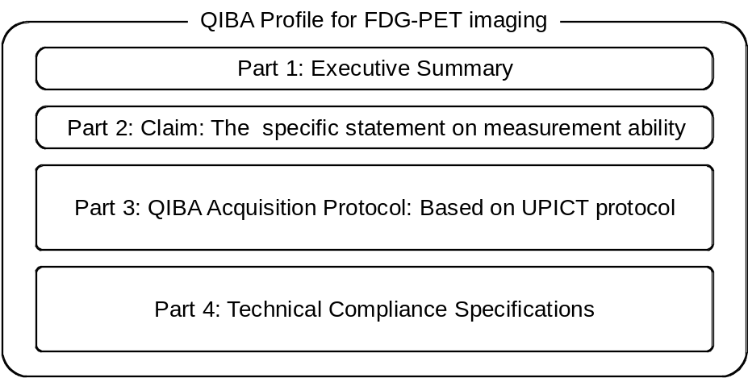
Figure 1: Illustration of the Profile components
The Profile Part 3 is largely derived from the FDG-PET UPICT protocol for FDG PET imaging in clinical trials. In the UPICT protocol, there is a carefully developed hierarchy with tiered levels of protocol compliance. This reflects the recognition that there are valid reasons to perform trials using different levels of rigor, even for the same disease/intervention combination. For example, a high level of image measurement precision may be needed in small, early-phase trials whereas a less rigorous level of precision may be acceptable in large, late-phase trials of the same drug in the same disease setting.
The three levels of compliance for UPICT protocols are defined as:
ACCEPTABLE: failing to meet this specification will result in data that is likely unacceptable for the intended use of this protocol.
TARGET: meeting this specification is considered to be achievable with reasonable effort and equipment and is expected to provide better results than meeting the ACCEPTABLE specification.
IDEAL: meeting this specification may require unusual effort or equipment, but is expected to provide better results than meeting the TARGET.
ACCEPTABLE values are always provided for each parameter in a UPICT Protocol. When there is no reason to expect better results (e.g. in terms of higher image quality, greater consistency, lower radiation dose, etc.), TARGET and IDEAL values are not provided.
This Profile draws on the ACCEPTABLE components of the UPICT Protocol. Later revisions of this Profile are expected to draw on the Target and then Ideal categories of the UPICT Protocol. The Target and Ideal categories are intended to account for advances in the field and the evolving state-of-the-art of FDG-PET/CT imaging. These concepts are illustrated in Figure 2 below.

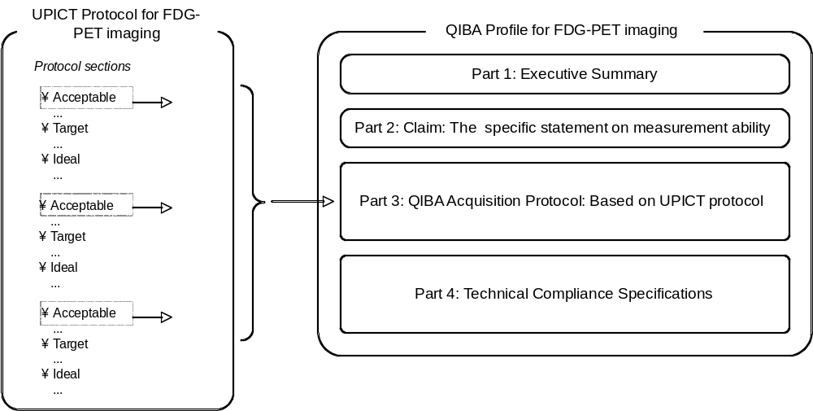
Figure 2. Relationship between the UPICT Protocol and the Profile.

Summary for Clinical Trial Use
The QIBA FDG-PET/CT Profile defines the technical and behavioral performance levels and quality control specifications for whole-body FDG-PET/CT scans used in single- and multi-center clinical trials of oncologic therapies. While the emphasis is on clinical trials, this process is also intended to apply for clinical practice. The specific claims for accuracy are detailed below in the Claims.
The specifications that must be met to achieve compliance with this Profile correspond to acceptable levels specified in the FDG-PET UPICT Protocol. The aim of the QIBA Profile specifications is to minimize intra- and inter-subject, intra- and inter-platform, and inter-institutional variability of quantitative scan data due to factors other than the intervention under investigation. FDG-PET/CT studies performed according to the technical specifications of this QIBA Profile in clinical trials can provide qualitative and/or quantitative data for single time point assessments (e.g., diagnosis, staging, eligibility assessment, investigation of predictive and/or prognostic biomarker(s)) and/or for multi-time point comparative assessments (e.g., response assessment, investigation of predictive and/or prognostic biomarkers of treatment efficacy).
A motivation for the development of this Profile is that while a typical PET/CT scanner measurement system (including all supporting devices) may be stable over days or weeks, this stability cannot be expected over the time that it take to complete a clinical trial. In addition there are well known differences between scanners and or the operation of the same type of scanner at different imaging sites.
The intended audiences of this document include:
- Technical staff of software and device manufacturers who create products for this purpose.
- Biopharmaceutical companies, oncologists, and clinical trial scientists designing trials with imaging endpoints.
- Clinical research professionals.
- Radiologists, nuclear medicine physicians, technologists, physicists and administrators at healthcare institutions considering specifications for procuring new PET/CT equipment.
- Radiologists, nuclear medicine physicians, technologists, and physicists designing PET/CT acquisition protocols.
- Radiologists, nuclear medicine physicians, and other physicians making quantitative measurements from PET/CT images.
- Regulators, nuclear medicine physicians, oncologists, and others making decisions based on quantitative image measurements.
Note that specifications stated as 'requirements' in this document are only requirements to achieve the claim, not 'requirements on standard of care.' Specifically, meeting the goals of this Profile is secondary to properly caring for the patient.

2. Clinical Context and Claims
FDG is a glucose analogue. The rationale for its use in oncology is based on the typically increased rate of glycolysis in tumors compared to normal tissue. FDG is transported into tumor cells via glucose transport proteins, usually up-regulated in tumor cells. Once internalized FDG is phosphorylated to FDG-6-phosphate; it does not progress any further along the glycolytic pathway and becomes substantially metabolically trapped. FDG uptake is not specific for tumor cells and there are some normal tissues and other processes with increased glucose turnover, e.g. infection and inflammation that show elevated uptake or accumulation of FDG.

Applications and Endpoints for Clinical Trials
FDG-PET/CT imaging can be used for a wide range of clinical indications and research questions. These are addressed more completely in the FDG-PET/CT UPICT Protocol (UPICT section 1.1). This QIBA Profile specifically addresses the requirements for measurement of tumor FDG uptake with PET/CT as an imaging biomarker for evaluating therapeutic response.
Biomarkers useful in clinical research for patient stratification or evaluation of therapeutic response would be useful subsequently in clinical practice for the analogous purposes of initial choice of therapy and then individualization of therapeutic regimen based on the extent and degree of response as quantified by FDG-PET/CT.
The technical specifications described in the Profile are appropriate for quantification of tumor FDG uptake and measuring longitudinal changes within subjects. However, many of the Profile details are generally applicable to quantitative FDG-PET/CT imaging in other applications.
FDG-PET scans are sensitive and specific for detection of most malignant tumors [Fletcher 2008]. Coverage for oncology imaging procedures in the US by the Centers for Medicare and Medicaid Services are explicitly listed in the National Coverage Determination (NCD) for Positron Emission Tomography (PET) Scans (220.6). FDG-PET scans reliably reflect glucose metabolic activity of cancers and this metabolic activity can be measured with high reproducibility over time. Longitudinal changes in tumor 18F-FDG accumulation during therapy often can predict clinical outcomes earlier than changes in standard anatomic measurements [Weber 2009]. Therefore, tumor metabolic response or progression as determined by tumor FDG uptake can serve as a pharmacodynamic endpoint in well-controlled Phase I and Phase IIA studies as well as an efficacy endpoint in Phase II and III studies. In tumor/drug settings where the preceding phase II trials have shown a statistically significant relationship between FDG-PET response and an independent measure of outcome, changes in tumor FDG activity may serve as the primary efficacy endpoint for regulatory drug approval in registration trials.

Claim: Measure Change in SUV
If Profile criteria are met, then tumor glycolytic activity as reflected by the maximum standardized uptake value (SUVmax) should be measurable from FDG-PET/CT with a within-subject coefficient of variation of 10-12%.
The following important considerations are noted:
1. This Claim applies only to tumors that are considered evaluable with PET. In practice this means tumors of a minimum size and baseline SUVmax (e.g. [Wahl 2009, de Langen 2012]). More details on what tumors are evaluable (minimum size and SUVmax) are described in section 3.6.5.3.
2. Details of the claim were derived from a review of the literature and are summarized in Appendix B. In these reports [Nakamoto 2002, Krak 2004, Velasquez 2009, Hatt 2010], it was assumed that the repeatability of SUVmax could be described by a fixed percentage of the baseline measurement. This assumption may not be applicable over the full range of clinically relevant SUVs and combinations of relative and absolute SUV changes have been proposed [de Langen 2012].
3. A within-subject coefficient of variation of 12% implies a limit of repeatability of ±33%, that is, separate SUVmax measurements derived from test-retest PET/CT studies will differ by less than 33% for 95% of the observations. Note that asymmetric limits of repeatability have also been reported, e.g. -27 % to +37 % [Velasquez 2009].
4. This Claim is applicable for single-center studies using the same scanner. For multi-center studies, if FDG-PET/CT imaging is performed using the same scanner and protocol for each patient at each time point (as described in the Profile), then it is anticipated that this Claim will be met.
5. This Claim is based on SUVmax due to the evidence provided in the scientific literature. However, the use of SUV metrics derived from larger regions-of-interest (e.g. SUVpeak) are to be encouraged, as they may provide improved repeatability. In addition the use of automated and/or centralized analysis methods will further improve SUV repeatability. Note that while relative limits appear to be appropriate for SUVmax measures, it may be that absolute limits may be more appropriate for SUVs based on mean values for volumetric ROIs [Nahmias and Wahl 2008].
While the Claim has been informed by an extensive review of the literature, it is currently a consensus Claim that has not yet been substantiated by studies that strictly conform to the specifications given here. In addition we note that this Claim should be re-assessed for technology changes, such as PSF (point spread function) based reconstruction or TOF (time of flight) imaging that were not utilized in published test-retest studies. A standard utilized by a sufficient number of studies does not exist to date. The expectation is that from future studies and/or field testing, data will be collected and changes made to this Claim or the Profile specifications accordingly.

3. Profile Details
The following figure provides a graphical depiction that describes the marker at a technical level.
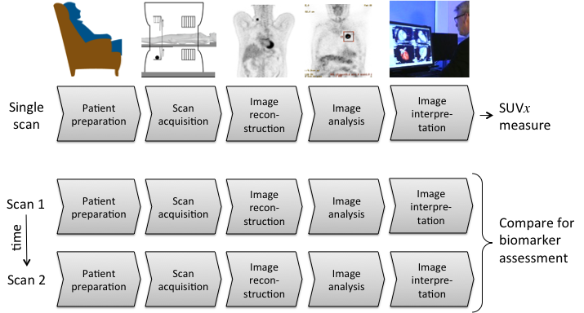
Figure 3: The assay method for computing and interpreting glycolytic metabolic activity using PET/CT may be viewed as a pipeline using either one or two or more scan sequences. The measure SUVx refers to one of several possible SUV measures, such as SUVmax, SUVmean or SUVpeak, with normalization by body weight or lean body mass.
Patients may be selected or referred for FDG-PET/CT imaging though a variety of mechanisms. In addition, patients are often required to undergo screening according to pre-scan requirements such as fasting levels and/or serum glucose levels as described below.
The imaging steps corresponding to Figure 1 are:
- Patients or subjects are prepared for scanning (e.g. 6 hr fasting). FDG is administered. Patient waits quietly for bio-distribution and uptake of FDG (typically 60 min)
- Scan data from the PET and CT exams is acquired.
- Data correction terms are estimated and PET (and CT) images are reconstructed.
- Quantitative measurements are performed.
- Images are reviewed for qualitative interpretation.
Note that steps 4 and 5 may occur in either order or at the same time. More details on the requirements are given below.
Images may be obtained at multiple time points over days or weeks, notably at a minimum of two time points before and after therapeutic intervention for a response assessment as is considered by this document. The change in FDG uptake is typically assessed as a percentage according to the formula:
[(post-treatment metabolic activity – pre-treatment metabolic activity) / pre-treatment metabolic activity] x 100%. Response criteria are then applied to categorize the response assessment. These response criteria are beyond the scope of this document, but are discussed in the PERCIST proposal [Wahl 2009].
The following sections describe the major components illustrated in Figure 3:
Section | Title | Performed by
3.1 | Subject Handling | Personnel, (including Technologists and Schedulers) at an Image Acquisition Facility
3.2 | Image Data Acquisition | Technologist, at an Image Acquisition Facility using an Acquisition Device
3.3 | Image Data Reconstruction | Technologist, at an Image Acquisition Facility using Reconstruction Software
3.4 | Image Analysis | Imaging Physician or Image Analyst using one or more Analysis Software tools
3.5 | Image Interpretation | Imaging Physician before or after information obtained by Image Analysis using a pre-defined Response Assessment Criteria
Image data acquisition, reconstruction and post-processing are considered to address the collection and structuring of new data from the subject. Image analysis is primarily considered to be a computational step that transforms the data into information, extracting important values. Interpretation is primarily considered to be judgment that transforms the information into knowledge.

3.1. Subject Handling
This Profile will refer primarily to 'subjects', keeping in mind that the recommendations apply to patients in general, and that subjects are often patients too.

3.1.1 Subject Selection, Timing, and Blood Glucose Levels
The study protocol should include specific directions as to the management of subjects with abnormal fasting blood glucose measurements whether known to be diabetic or not. While it is known that high levels of circulating blood glucose reduce FDG uptake, there is a paucity of scientific data to suggest a specific cutoff for abnormally high blood glucose measurements or if these subjects should be excluded from clinical trials that use FDG-PET/CT scan data. It is important to define how such subjects and the data from their imaging studies will be managed to ensure comparability of imaging data within and among clinical trials. Specifically, consideration should be given to the exclusion of subjects with abnormal fasting blood glucose when quantitative FDG-PET/CT is being used as the study’s primary endpoint. Refer to the FDG-PET/CT UPICT Protocol for Diabetic Scheduling and Management discussion (UPICT Section 4.2.2). It is also recommended that the study specifies what level of within subject variability in serum glucose levels is acceptable across time points and how subjects that fall outside that range will be interpreted.

3.1.1.1 Timing of Imaging Test Relative to Intervention Activity (UPICT Section 1.2)
The study protocol should specifically define an acceptable time interval that should separate the performance of the FDG-PET/CT scan from both (1) the index intervention and (2) other interventions (e.g. chemotherapy, radiotherapy or prior treatment). This initial scan (or time point) is referred to as the “baseline” scan (or time point). The time interval between the baseline scan and the initiation of treatment should be specified as well as the time intervals between subsequent FDG-PET studies and cycles of treatment. Additionally, the study protocol should specifically define an acceptable timing variance for performance of FDG-PET/CT around each time point at which imaging is specified (i.e., the acceptable window of time during which the imaging may be obtained “on schedule”). The timing interval and window are dependent upon 1) the utility for the FDG-PET/CT imaging within the clinical trial, 2) the clinical question that is being investigated and 3) the specific intervention under investigation. Suggested parameters for timing of FDG-PET/CT within oncologic trials are more completely addressed in the FDG-PET/CT UPICT Protocol section 1.2.

3.1.1.2. Timing Relative to Confounding Activities (UPICT Section 3.2)
Activities, tests and interventions that might increase the chance for false positive and/or false negative FDG-PET/CT studies should be avoided prior to scanning. The allowable interval between the potentially confounding event and the FDG-PET/CT exam will be dependent on the nature of the confounding variable. For example, inflammation may cause focally increased FDG-PET activity (e.g. from a percutaneous or excisional biopsy of a suspicious mass) or might lead to the appearance of a non-malignant mass (e.g., hematoma) on the CT portion of the study. A percutaneous ablation procedure of a known malignant focus may cause focally increased FDG-PET activity and/or an immediate post-ablation increase in the apparent volume of the ablated target lesion. The time of onset and the duration of the increased FDG-PET activity and/or the change in lesion volume might be different for these two confounding factors.
If iodinated contrast is to be used for the CT portion of the PET/CT study, conflict with other tests and treatments should be avoided congruent with community standards of care (e.g., thyroid scan).

3.1.1.3. Timing Relative to Ancillary Testing (UPICT Section 3.3)
Avoid scheduling tests that might confound the qualitative or quantitative results of the FDG-PET/CT study within the time period prior to the scan. For example, a glucose tolerance test should not be scheduled during the 24 hours prior to the performance of FDG-PET/CT. Similarly, other tests that might involve increasing plasma glucose, insulin, or corticosteroid levels should also be avoided. Exercise cardiac stress testing should be avoided during the twenty-four (24) hours prior to the performance of FDG-PET/CT. Similarly, other tests that might involve vigorous exercise and thereby increase muscle metabolic function should also be avoided.

3.1.2 Subject Preparation (UPICT Section 4)
Management of the subject can be considered in terms of three distinct time intervals (1) prior to the imaging session (prior to arrival and upon arrival), (2) during the imaging session and (3) post imaging session completion. The pre-imaging session issues are contained in this section while the intra-imaging issues are contained in section 3.2.1 on image data acquisition.

3.1.2.1. Prior to Arrival (UPICT Section 4.1)
The main purpose of subject preparation is to reduce tracer uptake in normal tissue (kidneys, bladder, skeletal muscle, myocardium, brown fat) while maintaining and optimizing tracer uptake in the target structures (tumor tissue). For more detail, refer to the FDG PET UPICT Protocol (Section 4.1) that addresses (1) Dietary, (2) Fluid Intake, and (3) Other activities that may affect tissue FDG uptake.
- Dietary
  - Diabetic management – Refer to FDG-PET/CT UPICT Protocol sections 1.7.2 and 4.2.2
  - Fasting status - Subjects should not eat any food (either oral or parenteral) for at least six hours prior to the anticipated time of FDG administration.
- Fluid Intake: Adequate hydration (before and after FDG administration) is important both to ensure a sufficiently low FDG concentration in urine (fewer artifacts) and to reduce radiation exposure to the bladder. Adequate hydration is especially important when contrast CT imaging will be used. Whichever hydration strategy is used (how much and when to administer), the protocol should be uniform among sites during a trial. Specific hydration recommendations are presented in the FDG-PET/CT UPICT Protocol (reference Section 4.2.1). The fluid administered should not contain glucose or caffeine.
- Other Activities: To minimize FDG uptake in muscle, the subject should avoid strenuous or extreme exercise before the PET exam for at least 6 hours (preferably for a time period of 24 hours).
The compliance issues around these parameters are dependent upon adequate communication and oversight of the Scheduler or Technologist at the Image Acquisition Facility with the subject. Communication with the subject and confirmation of compliance should be documented.

3.1.2.2. Upon Arrival (UPICT Section 4.2)
Upon arrival 1) confirmation of subject compliance with pre-procedure instructions and 2) the occurrence of potentially confounding events (see listing in Section 4.2.1 of FDG-PET/CT UPICT Protocol) should be documented on the appropriate case report forms.
There should be documentation of subject-specific risk factors including, but not limited to, previous contrast reactions (if iodinated contrast is to be used).

3.1.2.3 Preparation for Exam (UPICT Section 4.2.3)
In order to avoid heterogeneous physiological distribution of the FDG, it is critical that subject preparation after arrival and prior to imaging is standardized among all sites and subjects throughout the conduct of the clinical trial.
- The waiting and preparation rooms should be relaxing and warm (> 75° F or 22° C) during the entire uptake period (and for as long as reasonably practicable prior to injection, at least 15 minutes is suggested as acceptable). Blankets should be provided if necessary.
- The subject should remain recumbent or may be comfortably seated; activity and conversation should be kept to an absolute minimum. For example, the subject should be asked to refrain from speaking, chewing, or reading during the uptake period. For brain imaging the subject should be in a room that is dimly lit and quiet for FDG administration and subsequent uptake period.
- After FDG injection, the subject may use the toilet, preferably not for the initial 30 minutes immediately after injection of FDG, primarily to avoid muscular uptake during the biodistribution phase of FDG-uptake. The subject should void immediately (within 5 – 10 minutes) prior to the FDG-PET/CT image acquisition phase of the examination.
- Bladder catheterization is not routinely necessary; but if deemed necessary (e.g., for the evaluation of a subject with a pelvic tumor such as cervical or prostate cancer), the catheter should be placed prior to injection of FDG. If bladder catheterization is performed, additional strategies to avoid trapping high activity pockets of activity within the bladder should be considered such as retrograde filling of the bladder to dilute the residual activity.
- Following the administration of FDG, the subject should drink 500 ml of water (or receive by intravenous administration 250 - 500 ml of non-glucose containing fluid). Fluid intake may need to be modified for those subjects on fluid restriction.
- For specific areas of anatomic interest (e.g., tumors located in the lower abdomen, pelvis or kidney) intravenous diuretic agents may be used (e.g., 20 – 40 mg of furosemide given 15 minutes after the administration of FDG). If bladder catheterization is performed, IV diuretics should be administered as described here so as to ensure that the concentration of activity in the renal collecting systems and bladder is relatively dilute.
- Sedation is not routinely required, but is not contraindicated provided that the sedative used does not interfere with the uptake of FDG. Sedation may have utility in specific clinical circumstances such as in subjects with brain, head and neck tumors or breast cancer, claustrophobic subjects, or children. The sedative effect should last for the duration of image acquisition; detailed specifications are dependent upon the medication used and the route of administration.
- The amount of fluid intake and use of all medications (e.g., diuretic, sedative) must be documented on the appropriate case report form.
- Subjects undergoing a CT scan should empty their pockets and remove any clothing containing metal and any metallic jewelry from the body parts to be scanned, changing into a hospital gown if necessary.
Parameter | Entity/Actor | Specification
Height and Weight | Imaging Technologist | The Technologist shall measure and document subject height and weight and enter this information into the scanner during the PET/CT acquisition.  Subject body weight shall be measured at the time of each PET/CT scan with standardized measurement devices and with the subject in an examination gown or light clothing. Subject height shall be measured and documented at the time of baseline FDG-PET scan with standardized measurement device. Measurement of subject height is not required at each subsequent time point unless other subject-centric factors (e.g. growth in pediatric population or shrinkage in elderly population) are relevant in combination with a prolonged interval between imaging time points such that a change in height might be significant.  If subject cannot be moved from the bed, the date and source of information should be documented.
Height and Weight | Imaging Technologist | The Technologist shall measure subject height and weight and enter this information into a common data format mechanism used for recording all needed information (Appendix E).
- Diabetic Monitoring and Management (UPICT Section 4.2.2)
The subject’s blood glucose level should be measured [using CLIA-approved, CLIA cleared, or equivalent (outside US) glucose measurement device or laboratory] within the preceding 2 hours (ideally within 1 hour, especially in subjects with diabetes) of FDG administration and documented.
Parameter | Entity/Actor | Specification
Blood glucose level measurement | Imaging Technologist or Lab Technologist | Within 2 hours preceding FDG administration, shall measure and document time of subject blood glucose collection. Glucose measurement should be performed using a CLIA approved, CLIA cleared, or equivalent (outside US) glucose measurement device. If the measurement is always performed at injection time or otherwise according to a protocol relative to injection time, this may be documented in the protocol.  Deviations from this process shall be documented.
Blood glucose level documentation | Imaging Technologist or Lab Technologist | Shall enter the results of the blood glucose assay and the time of blood draw on a case report form or similar subject information sheet.
Blood glucose level documentation | Imaging Technologist or Lab Technologist | Shall enter the results of the blood glucose assay into a common format mechanism used for recording all needed information (Appendix E).
Blood glucose level Threshold | Imaging Technologist | Shall enforce the glucose thresholds for imaging as defined in the Protocol; if not, then reason for non-compliance shall be provided and documented on case report form or similar subject information sheet.
Blood glucose level Threshold | Imaging Technologist | Shall document any information on non-compliance with the protocol into a common format mechanism used for recording all needed information (Appendix E).

3.1.3. Imaging-related Substance Preparation and Administration (UPICT Section 5)

3.1.3.1. Radiotracer Preparation and Administration

3.1.3.1.1 Radiotracer Description and Purpose
FDG should be of high quality and purity. For example, the FDG radiopharmaceutical must be produced under Current Good Manufacturing Practice as specified by the FDA, EU, European Pharmacopea or other appropriate national regulatory agency. U.S. regulations such as 21CFR212 or USP<823> Radiopharmaceuticals for Positron Emission Tomography must be followed in the U.S. or for trials submitted to US Regulatory. For example, in the US, for clinical practice, FDG production under NDA or ANDA or under IND for research purposes is mandatory.

3.1.3.1.2 Radiotracer Activity Calculation and/or Schedule (UPICT Section 5.2)
The 18F-FDG activity administered ranges between about 185 – 740MBq (5 – 20 mCi). The administered activity typically depends upon the local imaging protocol. The local protocol may require fixed activity, or the activity may vary as a function of various parameters including but not limited to subject size or age, scanner model, scanning mode, or percentage of scan bed (slice) overlap. To date there are no data providing evidence of superiority of parameter-dependent administered activity protocols. The exact activity and the time at which activity is calibrated should be recorded. Residual activity remaining in the tubing, syringe or automated administration system or any activity spilled during injection should be recorded. The objective is to record the net amount of FDG radiotracer injected into the subject to provide accurate factors for the calculation of the SUV. The use of automated activity measurement and injection devices is allowed if accuracy is verified.
Parameter | Entity/Actor | Specification
Administered FDG Radiotracer Activity | Imaging Technologist | The Technologist shall  - Assay the pre-injection FDG activity (i.e. radioactivity) and time of measurement,  - Inject the FDG as prescribed in the protocol, within the range defined in the protocol.  - Record the time that FDG was injected into the subject,  - Assay the residual activity in the syringe (and readily available tubing and components) after injection and record the time of measurement.  These values shall be entered into the scanner during the PET/CT acquisition.  For scanners that do not provide for entry of residual activity information, the net injected radioactivity should be manually calculated by decay correcting all measurements to the time of injection and then subtracting the residual radioactivity from the pre-injection radioactivity. The net injected radioactivity is then entered into the scanner during the PET/CT acquisition.  All data described herein on activity administration shall be documented.
Administered FDG Radiotracer Activity | Imaging Technologist | All data should be entered into the common data format mechanism (Appendix E).

3.1.3.1.3 Radiotracer Administration Route (UPICT Section 5.4)
FDG should be administered intravenously through a large bore (24 gauge or larger) indwelling catheter placed anatomically remote (e.g., contralateral extremity to site of disease if at all possible) to any site(s) of suspected pathology, preferably in an antecubital vein. Intravenous ports should not be used, unless no other venous access is available. If a port is used, an additional flush volume should be used. As reproducible and correct administration of FDG is required for quantification purposes, extravasation or paravenous administration should be avoided. If an infiltration or extraneous leakage is suspected, the event and expected quantity should be recorded and the infiltration site should be imaged. The approximate amount of infiltration should be estimated from the images where possible. If the infiltration is greater than 5% of the administered activity and the quantitative result from the FDG-PET/CT study is a primary or secondary endpoint, the data point might be censored from review or the subject might not be included in the study. The anatomical location of the injection site should be documented on the appropriate case report form or in the Common Data Format Mechanism (Appendix E).
Presuming that the IV access is properly functioning, the same route of administration may be used for iodinated contrast as is used for FDG.
Parameter | Entity/Actor | Specification
FDG Administration | Technologist | Technologist shall administer FDG intravenously through a large bore (24 gauge or larger) indwelling catheter placed anatomically remote to any sites of suspected pathology, preferably in an antecubital vein. Intravenous ports should not be used, unless no other venous access is available.  In the case of manual administration, a three-way valve system should be attached to the intravenous cannula so as to allow at least a 10 cc normal (0.9% NaCl) saline flush following FDG injection. For automated injection devices alternate flushing mechanisms are allowed.
Suspected infiltration or extraneous leakage | Technologist and/or Physician or Physicist | Technologist shall document any suspected infiltration, leakage, or external contamination and consider scanning the injection site and/or contaminated materials.
Suspected infiltration or extraneous leakage | Technologist and/or Physician or Physicist | Record the event and expected amount of FDG into the common data format mechanism (Appendix E).

3.1.3.2 CT Contrast Material Preparation and Administration
The use of CT contrast material during FDG-PET/CT imaging is complex and analyzed in detail in the UPICT FDG-PET Protocol (Section 3.2). In summary, the presence of IV and/or oral contrast material improves the detection of lesions with CT and may improve the anatomic localization, interpretation, and analysis of the FDG-PET/CT exam. However, the presence of contrast material may affect the attenuation correction of the PET scan with consequent bias in measured SUVs.
Parameter | Entity/Actor | Specification
CT Contrast Agent | Technologist | Technologist shall record the type and amount of CT Contrast Agent.  1. Was oral contrast used: Type [Positive, Negative], amount (volume in cc).  2. Was IV contrast used?, amount (volume in cc), time of injection.
CT Contrast Agent | Technologist | Record the event and expected amount of CT Contrast Agent into the common data format mechanism (Appendix E).

3.2. Image Data Acquisition
This section summarizes the imaging protocols and procedures that shall be performed for an FDG-PET/CT exam. Detailed descriptions are included in the referenced FDG-PET/CT UPICT protocol sections.
The motivation for controlling the image acquisition as tightly as described here is that over the course of a trial, hardware and software updates will occur. The intent of the Profile is to ensure that the instrument gives the same results over the duration of the trial.
For consistency, clinical trial subjects should be imaged on the same device over the entire course of a study. If the imaging requirements are qualitative i.e. for relative quantitation, for example the presence or absence of a lesion or a lesion SUV relative to a reference region, then a replacement scanner may be used if it is properly qualified. It is imperative, however, that the trial sponsor be notified of scanner substitution if it occurs.
For clinical trials with quantitative imaging requirements, a subject should have all scans performed on only one scanner unless quantitative equivalence with a replacement scanner can be clearly demonstrated. However, it should be noted that there are currently no accepted criteria for demonstrating quantitative equivalence between scanners. It is anticipated that future version of this Profile will provide such criteria.
The follow up scans should be performed with identical acquisition parameters as the first (baseline), inclusive of all the parameters required for both the CT and PET acquisitions.
The FDG-PET/CT UPICT Protocol (Section 7.1.1) describes scanning strategies that can be used in a clinical trial. For strategy 1, there is no intent to obtain a diagnostic CT scan at the FDG-PET imaging session, however a low-dose CT scan is needed for attenuation correction. For strategy 2, a diagnostic CT scan is obtained. There are further considerations that must be followed for each of the two strategies. The workflow chosen for a given protocol should be described in the protocol and should be tailored commensurate to the level of expectation of the obtained data (e.g. qualitative or quantitative SUV analysis).
Strategy 1: For FDG-PET/CT in which the CT is used for attenuation correction and localization only (not intended as a clinically diagnostic CT):
- CT Scout (i.e. topogram or scanogram etc.), followed by
- CT for anatomic localization and attenuation correction, followed by
- PET Emission scan acquisition
Strategy 2: For FDG-PET/CT in which a clinically diagnostic CECT is also required, ONE of the following options should be used. Strategy 2a is preferable since it avoids any, all be it possibly minimal, impact of IV contrast enhancement on attenuation correction and therefore SUV determination.
Strategy 2a
- Follow Strategy 1 (above)
- Acquire an additional IV contrast-enhanced diagnostic CT scan
Strategy 2b
- Perform an IV contrast-enhanced diagnostic CT scan
- Follow Strategy 1 (above)

Parameter | Entity/Actor | Specification
Scanning Strategy (Workflow) | Technologist | Technologist shall follow Profile compliant workflow strategy, which will be compatible with Acquisition Device capability. The same workflow used at baseline shall be used at all subsequent time points.

For both strategies, there are several common issues specific to the CT exam that may have an impact on quantitative FDG-PET output, which need attention and protocol specification. These include (1) contrast material administration, (2) respiratory motion management instructions and (3) CT scanning technique (kVp, mAs and pitch). Below is a summary of the acceptable level of behavior/procedure for each of these three issues.
At a minimum, all these issues should be addressed in the clinical trial protocol, ideally with consistency across all sites and all subjects (both inter-subject, and intra- and inter-facility) with the target of consistency across all time points for each given subject. The actual details of imaging for each subject at each time point should always be recorded. Any particular clinical trial should NOT allow some sites to implement one strategy and other sites to implement the alternative.
CT Exam Variables and Specifications:
Contrast Agents - The presence of a positive contrast agent (IV or oral), by affecting the CT attenuation map, may affect SUV quantitation [Mawlawi 2006]. If this were the only consideration, then ideal would be to prohibit CT contrast administration. However, in some clinical situations (dependent upon tumor type, tumor behavior or level of anatomic interest), the benefit of CT contrast agents may outweigh the small errors induced in SUV measurement that may include increased SUV variability. Each protocol should specify the desired approach for the given study. Most importantly, for each subject, the same approach should be followed for all imaging time points.
In cases where CT contrast agents are used, there are two main strategies:
Strategy 1: No IV; dilute positive oral contrast allowed
Strategy 2: Use negative or dilute positive oral contrast for the non-attenuation CT scan. Ensure that the diagnostic CT acquisition (which may be performed with IV contrast) is performed consistently for a given subject across all time points.
Parameter | Entity/Actor | Specification
CT Contrast agent | Technologist | CT contrast agents shall be given commensurate with the workflow strategy as selected from above.

3.2.1 Imaging Procedure

The PET/CT exam consists of two components, the PET emission scan and the CT transmission scan (which may have multiple components). From these data sets, the non-attenuation-corrected PET images may be reconstructed for quality control purposes and attenuation-corrected PET images are reconstructed for qualitative interpretation and quantitative analysis. Instrument specifications relevant to the Acquisition Device are included in Section 4 Compliance – Acquisition Device.

3.2.1.1 Timing of Image Data Acquisition
FDG uptake into both tumors and other body tissues is a dynamic process that may increase at different rates and peak at various time points dependent upon multiple variables. Therefore, it is extremely important that (1) in general, the time interval between FDG administration and the start of emission scan acquisition is consistent and (2) when repeating a scan on the same subject, it is essential to use the same interval between injection and acquisition in scans performed across different time points.
While the “target” tracer uptake time is 60 minutes, the “acceptable” window is from 55 to 75 minutes to ensure that imaging does not begin prematurely so as to allow adequate tumor uptake of FDG and to account for the practicality of work flow that can result in delays in imaging later than 60 minutes after FDG injection. The exact time of injection must be recorded; the time of injection initiation should be used as the time to be recorded as the radiotracer injection time. The injection and flush should be completed within one minute with the rate of injection appropriate to the quality of the vein accessed for FDG administration so as to avoid compromising the integrity of the injection vein
When performing a follow-up scan on the same subject, especially in the context of therapy response assessment, it is essential to apply the same time interval with target window of ± 10 minutes provided that the scan must not begin prior to 55 minutes after the injection of FDG. While there is majority view of the committee that a tighter (narrower) time window, e.g. +/- 5 minutes, is better, the current performance specification is written to balance practical and ideal. If a limited anatomy scan is obtained at follow-up after a whole body scan was performed at baseline, one should consider adjusting the timing of the follow up scan to be congruent with the timing for the same anatomic region as achieved during the baseline study.
If, for scientific reasons, an alternate time (between activity administration and scan acquisition) is specified in a specific protocol, then the rationale for this deviation should be stated; inter-time point consistency must still be followed.
Parameter | Entity/Actor | Specification
Tracer Injection Time | Technologist | The time of FDG injection shall be entered into PET/CT scanner console during the acquisition.
Tracer Uptake Time: | Technologist | The Technologist shall ensure that the tracer uptake time for the baseline scan is 60 minutes, with an acceptable range of 55 to 75 minutes.  When repeating a scan on the same subject, especially in the context of therapy response assessment, the Technologist shall apply the same time interval ±10 minutes provided that the scan must not begin prior to 55 minutes after the injection of FDG.
The following sections describe the imaging procedure.

3.2.1.2 Subject Positioning (UPICT Section 7.2.1)
Consistent positioning avoids unnecessary variance in attenuation, changes in gravity-induced shape and fluid distribution, or changes in anatomical shape due to posture, contortion, etc. During PET-CT, subjects should be positioned in the center of the field of view (FOV), preferably with the subjects’ arms positioned over head for whole-body imaging (to minimize beam hardening and FOV truncation artifacts). In the case of dedicated brain or head/neck scans, the arms should be positioned down along the body. If the subject is physically unable to maintain arms above head for the entire whole-body examination then the arms can be positioned along the side before the start of the scan, unless the protocol specifically excludes such subjects. Arm positioning in a particular subject should be consistent between the PET emission and CT transmission scans at each time point and should be as consistent as possible across all time points.
Respiratory motion causes SUV errors by two mechanisms: motion blurring and errors in attenuation correction due to mismatches between CT-based attenuation map and emission data [Liu 2009]. Various strategies could be used to minimize, document and compensate for respiratory motion. Shallow breathing shall be performed during CT AC acquisition (see UPICT Protocol section 7.1.1). The subject should (a) be monitored and if breathing pattern is not consistent with shallow breathing expectation, coached in the breathing protocol and (b) remain motionless throughout the scan. Alternate CT strategies for achieving PET/CT match may be considered if it can be verified that PET AC artifacts in the vicinity of the diaphragm are routinely minimal. It is of utmost importance that the patient not be in end-inspiration phase during CT for PET/CT.
The Technologist shall document factors that adversely influence subject positioning or limit the ability to comply with instructions (e.g. breath-hold, shallow breathing, remaining motionless, etc.).

Parameter | Entity/Actor | Specification
Subject Positioning | Technologist | The Technologist shall position the subject according to the UPICT specifications and/or specific protocol specifications consistently for all scans.

Positioning Non-compliance | Technologist | The Technologist shall document issues regarding subject non-compliance with positioning.
Positioning Non-compliance | Technologist | The Technologist shall document issues regarding subject non-compliance with breathing and positioning using the common data format mechanism (Appendix E).

Parameter | Entity/Actor | Specification
Respiratory motion minimization | Technologist | If the patient is observed to take a deep breath during the CT scan it should be documented and a repeat CT study should be considered.
Respiratory motion minimization | PET/CT Scanner | The PET/CT scanner shall provide methods to minimize the PET image errors introduced by respiratory motion.

Parameter | Entity/Actor | Specification
Breathing and motion non-compliance | Technologist | The Technologist shall document issues regarding subject non-compliance with breathing and motion.
Breathing and motion non-compliance | Technologist | The Technologist shall document issues regarding subject non-compliance with breathing and motion using the common data format mechanism (Appendix E).

3.2.1.3 Scanning Coverage and Direction (UPICT Section 7.1.1)
For most Oncology indications, anatomic coverage should include from the skull base (external auditory meatus) to the mid-thigh. If other ranges are used, which may be appropriate for specific clinical trials, then the clinical trial protocol should provide specific instructions with justification. Multiple factors affect the decision regarding the scan direction. For example, scanning caudocranial minimizes effects from increasing bladder activity during the scan, important for image quality in the pelvis. For some tumors located in the head, neck, or upper thorax it may be more important to start at the head to minimize head and arm motion between PET and CT. Scanning direction should be specified in the clinical trial protocol. It is critical that for a given subject, scanning direction on baseline scans be duplicated at follow-up time points.
Parameter | Entity/Actor | Specification
Scanning Direction | Technologist | The Technologist shall scan the subject caudocranial for whole body examination unless otherwise specified by the protocol. Each patient should be scanned consistently (in the same direction) over all time points.
Scanning Direction | Technologist | The scanning direction shall be entered into the PET/CT console during the acquisition and will be recorded by the scanner into the appropriate DICOM field.
Anatomic Coverage | Technologist | The Technologist shall perform the scan such that the anatomic coverage is acquired according to the protocol specifications and the same for all time points.

3.2.1.4 Scanner Acquisition Mode Parameters
We define acquisition mode parameters as those that are specified by the Technologist at the start of the actual PET/CT scan. These include the acquisition time per bed position, the bed overlap, the acquisition mode (2D or 3D), with or without cardiac and/or respiratory gating and CT technique. These parameters do not include aspects of the acquisition that occur earlier (e.g. injected amount of 18F-FDG or uptake duration, CT contrast agent injection) or later (e.g. reconstruction parameters) in the overall scan process.
PET Acquisition

Parameter | Entity/Actor | Specification
PET acquisition mode | Study Sponsor | The key PET acquisition mode parameters (e.g., time per bed position, acquisition mode, with or without gating) shall be specified in a manner that is expected to produce acceptably low image noise regardless of the scanner make and model.
PET acquisition mode | Study Sponsor | The key acquisition mode parameters shall be specified according to pre-determined harmonization parameters.
PET acquisition mode | Technologist | The key PET acquisition mode parameters (e.g., time per bed position, acquisition mode, with or without gating) shall be set as specified by study protocol and used consistently for all patient scans.

CT Acquisition
For the CT acquisition component of the PET/CT scan, this Profile only addresses the aspects related to the quantitative accuracy of the PET image. In other words aspects of CT diagnostic accuracy are not addressed in this Profile. In principle any CT technique (parameters include kVp, mAs, pitch, and collimation) will suffice for accurate corrections for attenuation and scatter. However, it has been shown that for estimating PET tracer uptake in bone, lower kVp CT acquisitions can be more biased. Thus higher kVp CT acquisitions are recommended in general. In addition if there is the potential for artifacts in the CT image due to the choice of acquisition parameters (e.g. truncation of the CT field of view), then these parameters should be selected appropriately to minimize propagation of artifacts into the PET image through CT-based attenuation and scatter correction. Finally, extremely low x-ray flux can lead to a bias in CT images. Protocols should allow high enough mAs to avoid this artifact.

Parameter | Entity/Actor | Specification
CT acquisition mode | Study Sponsor | The key CT acquisition mode parameters (kVp, mAs, pitch, and collimation) shall be specified in a manner that is expected to produce comparable results regardless of the scanner make and model and with appropriate radiation doses consistent for the role of the CT scan: diagnostic CT scan, anatomical localization, or accurate corrections for attenuation and scatter.
CT acquisition mode | Study Sponsor | CT dose reduction techniques may be used if demonstrated to retain quantitative accuracy.
CT acquisition mode | Technologist | The key CT acquisition mode parameters (kVp, mAs, pitch, and collimation) shall be set as specified by study protocol and used consistently for all subject scans.

Parameter | Entity/Actor | Specification

Regarding CT radiation exposure, the lowest radiation dose necessary to achieve the diagnostic objective should be used. For a given protocol, the purpose of performing the CT scan (with the intent of attenuation correction only or attenuation correction and anatomic localization versus one intended for diagnostic CT purposes with contrast and breath-hold) should be determined. The CT technique (tube current, rotation speed, pitch, collimation, kVp, and slice thickness) used should result in as low as reasonably achievable exposure needed to achieve the necessary PET image quality. The technique used for an imaging session should be repeated for that subject for all subsequent time points assuming it was properly performed on the first study.

3.3. Imaging Data Reconstruction and Post-Processing

3.3.1 Imaging Data Reconstruction (UPICT Section 7.3)
Reconstructed image data is the PET image exactly as produced by the reconstruction process on the PET/CT scanner, i.e. a PET image volume with no processing other than that occurring during image reconstruction. This is always a stack of DICOM slices/files constituting a PET image volume that can be analyzed on one or more of the following: PET scanner console, PET image display workstation, PACS system, etc. See Section 4 Compliance – Image Reconstruction Software for specifications.
The PET reconstruction parameters include the choice of reconstruction algorithm, number of iterations and subsets (for iterative algorithms), the type and amount of smoothing, the field of view and voxel size. The quantitative accuracy of the PET image should be independent of the choice of CT reconstruction parameters, although this has not been uniformly validated. In addition if there is the potential for artifacts in the CT image due to the choice of processing parameters (e.g. compensation for truncation of the CT field of view), then these parameters should be selected appropriately to minimize propagation of artifacts into the PET image through CT-based attenuation and scatter correction.

Parameter | Entity/Actor | Specification
PET image reconstruction | Study Sponsor | The key PET reconstruction parameters (algorithm, iterations, smoothing, field of view, voxel size) shall be specified. The image voxel size should be <5 mm (strongly prefer 3 – 4 mm), with <3 mm voxels for head and neck imaging.
PET image reconstruction | Study Sponsor | The key PET image reconstruction parameters shall be specified according to pre-determined harmonization parameters.
PET image reconstruction | Technologist | The key PET reconstruction parameters (algorithm, iterations, smoothing, field of view, voxel size) shall be followed and set as specified.
Correction factors | Technologist | All quantitative corrections shall be applied during the image reconstruction process. These include attenuation, scatter, randoms, dead-time, and efficiency normalizations.
Calibration factors | Scanner | All necessary calibration factors needed to output PET images in units of Bq/ml shall be automatically applied during the image reconstruction process.

As part of the image reconstruction and analysis, correction factors for known deviations from the acquisition protocol can potentially be applied. These corrections can include, for example, compensation for mistakes in data entry [Kinahan 2010], variations in FDG uptake period [Beaulieu 2003], and errors in scanner calibration factors [Lockhart 2011]. Corrections for known data entry errors and errors in scanner calibration factors should be corrected prior to the generation of the reconstructed images, or immediately afterwards. Corrections that are more ad-hoc in nature, e.g. corrections for variations in FDG uptake period or plasma glucose levels or partial volume correction, should only be applied as part of the image analysis step. That is, not used to modify the reconstructed PET image.

3.3.2 Image Data Post-processing (UPICT Section 8)
Processed image data are images that have been transformed in some manner, including but not limited to: smoothing, image zoom, rotation/translation, resampling, interpolation, slice averaging, MIP, etc. This is typically a stack of DICOM slices/files constituting a PET image volume. If image registration or interpolation is required, then where applicable, perform the ROI analysis on the original PET image set using appropriately modified ROIs. The intent is to preserve the numerical accuracy of the true PET image values.
Standard whole-body FDG-PET oncology studies typically include all necessary data corrections and processing within the reconstruction process and do not require additional processing other than (e.g.) data de-identification. More advanced studies such as those including dynamic imaging may require additional processing as specified in the individual protocol.
Briefly described here are concepts presented in UPICT Section 8.2.3 regarding difference between ‘visualized data’ and ‘data used for quantification’. At the acceptable level, for visual inspection/interpretation of PET/CT data using the display workstation, bi-linear or tri-linear interpolation and zooming may be used to display the images in a different matrix size than the original data. In addition, so-called maximum intensity projections (MIP) may be generated as they may facilitate localization and detection of lesions. Additional processing, such as zooming, re-binning, reorientation and filtering may be applied upon user request only. User should be able to manipulate color scale settings (window/level and color table). It should always be possible to revert to the default orientation, zoom and bin size (preferably a ‘revert to default’ button is available).

3.3.3 Imaging Data Storage and Transfer
Discussions of archiving PET data often mention 'raw data'. This is an ambiguous term as it can refer to: scanner raw data (i.e., sinograms or list-mode) or image raw data. To avoid confusion, the term raw data should not be used without making it clear which form is under discussion.
Image raw data is the image data exactly as produced by the reconstruction process on the PET or PET/CT scanner, i.e., a stack of DICOM slices/files constituting a PET image volume with no processing other than that occurring during image reconstruction. This is always a stack of DICOM slices/files constituting a PET image volume that can be analyzed on one or more of the following: PET scanner console, PET image display workstation, PACS system, etc.
Post-processed image data are images that have been transformed after reconstruction in some manner, including but not limited to: smoothing, image zoom, rotation/translation, resampling, interpolation, slice averaging, MIP, etc. Such images may be only produced for temporary analysis and display, or they may be saved as DICOM slices/files, and can still be analyzed on one or more of the following: PET scanner console, PET image display workstation, PACS system, etc.
For archiving at the local site or imaging core lab (if relevant), the most important data are the original images, i.e., the image raw data. In the unlikely event that the scanner raw data (which should be archived by the local site) is required for later reprocessing; this should be made clear in the protocol.

Parameter | Entity/Actor | Specification
Data archiving | Technologist | The originally reconstructed PET images (image raw data), with and without attenuation correction, and CT images shall always be archived at the local site.  If processed PET images are required, they shall be archived as separate secondary datasets.  If scanner raw data need to be archived for future reprocessing, this should be defined prospectively in the Protocol.

3.4. Image Analysis (UPICT Section 9)
The Image Analyst, through interaction with the Workstation Analysis tools, shall be able to perform specified measurements. Image Analysis has qualitative and quantitative tasks. Both require consistency and images of sufficient quality. Quantitative imaging requires additional system characteristics described further in this Profile.

3.4.1 Input Data
The output images of Reconstruction, but not Post processing, are considered the input for Image Analysis. If the Image Analyst alters input data (e.g. zoom), the original input data will be maintained as a separate file, both to be stored. (See Section 3.2)

3.4.2 Methods to Be Used
Each tissue/organ to be investigated quantitatively (either tumor lesion or normal tissue) is characterized by defining a region-of-interest (ROI) and calculating a parameter such as the maximum SUV within the ROI. The image analyst will use tools (as defined in Section 4.4 Compliance – Image Analysis Workstation) to define ROIs and measure SUVs.

3.4.3 Required Characteristics of Resulting Data (UPICT Section 9.3)
The specific trial protocol shall prospectively define the SUV parameter that is required for each lesion, or normal tissue, which will be used for the imaging endpoint. Some studies may also compare different metrics and will require recording multiple parameters. SUV measures (and the analysis tools used to obtain them, including software version) shall be specified for each protocol and shall be used consistently across all subjects and across all sequential lesion measurements.
SUV’s are intended as a measure of relative uptake and in that sense, can be regarded as dimensionless (unitless); however, using strict interpretation of the units for the common calculation of body weight normalization, this yields units of g/ml. Under the assumption that on average 1 ml of tissue weighs 1 gm (e.g., water), a dimensionless SUV would be obtained. Display system manufactures typically, but not always, indicate units of g/ml if images are scaled to SUVs with a body weight normalization. This is presumably to differentiate between body weight (or lean-body-mass) and body-surface-area normalizations, which would show different units (and values). Based on the lack of consensus and that many display systems already use units, the recommendation below is to use units of g/ml.

It should be clear which values belong to which lesion. This can be done by capturing DICOM coordinates along with the SUV or secondary screen captures of the ROI for identification. It should be reported which SUV measure is used, i.e. statistic and type of normalization.
If a reference tissue (e.g. liver) SUV is measured, then, that SUV should be reported along with lesion SUV data.
The analysis software should generate a report.

3.5. Image Interpretation and Reporting (UPICT Section 10)
No QIBA Profile specification can be provided for image interpretation at this time. Image Interpretation is considered to be beyond the scope of this document. Refer to FDG-PET/CT UPICT Protocol (Section 10). In addition, further interpretation of the quantitative results (e.g. PERCIST [Wahl 2009]) and/or normalizing SUV to reference tissue values (e.g. liver or blood pool) can also be specified as part of a specific trial protocol.
Typically the trial protocol will state how quantitative response is measured. For example, response can be based on the hottest lesion, but sometimes the change of the sum of SUVs is used. In other words, how quantitative response is measure should be specified a priori by the trial itself. This also applies to target lesion selection.

Parameter | Entity/Actor | Specification
Image Reporting | Imaging Facility | Imaging reports shall be populated from DICOM header information using structured reporting.

3.6. Quality Control
The following section deals with multiple aspects of quality control in FDG-PET/CT studies. (See FDG-PET/CT UPICT Protocol Section 12 for additional information). This includes selecting and qualifying a PET/CT imaging facility, imaging personnel and PET/CT scanners and ancillary equipment. In addition, the use of phantom imaging (prior to study initiation and ongoing) is discussed as well as identifying subjects whose data may need to be censored due to lack of data integrity. Finally, post-image-acquisition quality assessment is detailed.

3.6.1 Imaging Facility
It is essential to implement quality processes that ensure reliable performance of the scanner and consistent image acquisition methodology. These processes must be in place prior to subject imaging and be followed for the duration of the trial. A facility “imaging capability assessment” is a prerequisite to facility selection for participation in any clinical trial involving the use of FDG-PET/CT as an imaging biomarker. This imaging capability assessment will include:

Identification of appropriate imaging equipment intended for use in the trial

Documented performance of required quality control procedures of the scanner and ancillary equipment (e.g. dose calibrator, glucose meter, etc.)

Radiotracer quality control procedures

Experience of key personnel (technologists, radiologists, physicists and/or other imaging experts)

Procedures to ensure imaging protocol compliance during the trial

3.6.1.1 Site Accreditation/Qualification Maintenance
Whilst imaging facility accreditation is generally considered to be adequate for routine clinical practice purposes (e.g., ACR, IAC, and TJC), facility qualification (e.g., SNM-CTN, ACRIN, and imaging core labs) is required for clinical research/clinical trial participation. In order to be considered to be compliant with this Profile, an imaging scanner/facility must provide documentation of current qualified status. Appropriate forms, checklists or other process documents should be maintained and presented upon request to verify that ongoing quality control procedures are being performed in a timely manner as dictated by specific clinical study requirements. If exceptions to any of the performance standards stated below occur and cannot be remediated on site, the site should promptly communicate the issue to the appropriate internal overseer for advice as to how the irregularity should be managed. In addition to documenting the level of performance required for this Profile (and the level of performance achieved), the frequency of facility accreditation/qualification also needs to be described.
It is important to note that that imaging facility Accreditation and/or Qualification, as defined in this Profile, are considered necessary, but are not sufficient for compliance with this Profile. For compliance with the Profile, and thus to support the claims of the Profile, all normative requirements must be met.
Parameter | Entity/Actor | Specification
Accreditation / Qualification | Imaging Site & Image Acquisition Device | Shall maintain and document Accredited status for clinical practice (ACR, IAC, TJC, etc.) or Qualified status for clinical trials (e.g. ACRIN, SNM-CTN, CALGB, CROs, etc.).

3.6.2 Imaging Facility Personnel
For each of the personnel categories described below, there should be training, credentialing, continuing education and peer review standards defined. Guidelines for training/credentialing for each resource category are summarized below (UPICT Protocol Section 2.1).
Parameter | Entity/Actor | Specification
Personnel Roster | Imaging Facility Coordinator | Each site shall, at the time of trial activation and prior to subject accrual, have the support of certified technologists, physicists, and physicians (as defined below), experienced in the use of FDG-PET/CT in the conduct of oncological clinical trials.
Technologist | Imaging Facility Coordinator | Technologist certification shall be equivalent to the recommendations published by the representatives from the Society of Nuclear Medicine Technologists Section (SNMTS) and the American Society of Radiologic Technologists (ASRT) and should also meet all local, regional, and national regulatory requirements for the administration of ionizing radiation to patients.
Medical Physicist | Imaging Facility Coordinator | Medical physicists shall be certified in Medical Nuclear Physics or Radiological Physics by the American Board of Radiology (ABR); in Nuclear Medicine Physics by the American Board of Science in Nuclear Medicine (ABSNM); in Nuclear Medicine Physics by the Canadian College of Physicists in Medicine; or equivalent certification in other countries; or have 3 years of PET experience. Regardless of certification, the physicist should have specific experience in PET and its quantitative use.
Physician | Imaging Facility Coordinator | Physicians overseeing and interpreting PET/CT scans shall be qualified by the ABR (Diagnostic and/or Nuclear Radiology) or American Board of Nuclear Medicine (ABNM) or equivalent within the United States or an equivalent entity appropriate for the geographic location in which the imaging study(ies) will be performed and/or interpreted.

3.6.3 FDG-PET/CT Acquisition Scanner
FDG-PET/CT studies as described in this Profile require a dedicated PET/CT scanner. PET/CT scanners should be identified based on manufacturer, name and model. Hardware specifications should be documented. Scanner software name and version should be documented at the time of trial initiation and at the time of any and all updates or upgrades.
The PET/CT scanner must undergo routine quality assurance and quality control processes (including preventive maintenance schedules) appropriate for clinical PET/CT applications, as defined by professional and/or regulatory agencies. In order to assure adequate quantitative accuracy and precision of PET/CT imaging results, additional quality assurance measures are required, as discussed below.
Parameter | Entity/Actor | Specification
Physical Inspection | Technologist | Shall, on a daily basis, check gantry covers in tunnel and subject handling system.
QA/QC Checks | Technologist | All QA/QC procedures recommended by the manufacturer shall be performed at the frequency recommended by the manufacturer and documented. A table of QA/QC procedures for a subset of specific PET/CT scanners from each vendor is included in Appendix G.2.  Daily QA procedures shall be performed prior to any subject scan.

3.6.3.1 Ancillary Equipment

3.6.3.1.1 Dose Calibrator
The following guidelines are collected from ANSI standard N42.13, 2004 and IAEA Technical Report Series TRS-454. All requirements assume measurements on unit doses of FDG and that calibration sources are in the 'syringe' geometry (i.e., no bulk doses).
The Constancy test ensures reproducibility of an activity measurement over a long period of time by measuring a long-lived source of known activity.
The Accuracy test ensures that the activity values determined by the dose calibrator are correct and traceable to national or international standards within reported uncertainties.
The Linearity test confirms that, for an individual radionuclide, the same calibration setting can be applied to obtain the correct activity readout over the range of use for that dose calibrator.

Parameter | Entity/Actor | Specification
Constancy | Technologist | Shall be evaluated daily (or after any dose calibrator event) using a NIST-traceable (or equivalent) simulated F-18, Cs-137, or Co-57 dose calibrator standard and confirmed that net measured activity on the F-18 setting differs by no greater than ±2.5 % from day to day.
Accuracy | Technologist | Shall be evaluated monthly (or after any dose calibrator event) with a NIST-traceable (or equivalent) Cs-137, Co-57, or simulated F-18 dose calibrator standard. Shall confirm that net measured activities differ no greater than ±2.5% from expected value.
Accuracy | Technologist | The scanner calibration shall be tested using a NIST-traceable (or equivalent) simulated F-18 source object, e.g. a uniform cylinder, large enough to avoid partial volume effects or other resolution losses.
Accuracy | Technologist | Shall be evaluated monthly (or after any dose calibrator event) with a NIST-traceable (or equivalent) simulated F-18 dose calibrator standard. Shall confirm that net measured activities differ no greater than ±2.5% from expected value.
Linearity | Technologist or Radiation safety officer or Qualified Medical Physicist | Shall be evaluated at least annually (or after any dose calibrator event) and should be within ±2.5 % of the true value over an operating range of 37-1110 MBq (1 to 30 mCi).
PET Radiation Dose | Dose Calibrator | Shall record the radiation dose from the administered activity and accompanying information in a DICOM Radiopharmaceutical Administration Radiation Dose Structured Report.

3.6.3.1.2 Scales and stadiometers
Scales and stadiometers should be inspected and calibrated at installation and annually.

Parameter | Entity/Actor | Specification
Scales and stadiometers | Approved personnel | Shall be evaluated annually or after any repair by qualified personnel.  Shall be confirmed that error is less than +/- 2.5% from expected values using NIST-traceable or equivalent standards.

3.6.3.1.3 Blood glucose level measurement device
Glucose measurements should be made using a CLIA-approved, CLIA-cleared, or equivalent (outside the US) glucose measurement technique.
Parameter | Entity/Actor | Specification
Blood glucose level measurement device | Approved personnel | Shall have QA/QC testing and calibration performed using a CLIA-approved, CLIA-cleared, or equivalent (outside US) procedure.

3.6.3.1.4 Clocks and timing devices
PET/CT scanner computer and all clocks in an imaging facility used to record activity/injection measurements should be synchronized to standard time reference within +/-1 minute. These include any clocks or timekeeping systems that are connected with a subject’s FDG-PET/CT study, in particular those associated with the dose calibrator, the injection room, the scanner, and the acquisition computer(s). The synchronization of all clocks (to date, time of day and to time zone) should be monitored periodically as part of ongoing QA program. In particular, clocks should be inspected immediately after power outages or civil changes for Daylight Savings (NA) or Summer Time (Eur). Correct synchronization could be achieved using the Consistent Time Integration Profile as defined in the IHE IT Infrastructure Technical Framework. The Consistent Time Profile requires the use of the Network Time Protocol (NTP) (www.NTP.org).
Parameter | Entity/Actor | Specification
Scanner and site clocks | Approved personnel | PET/CT scanner computer and all clocks in an Imaging facility used to record activity/injection measurements shall be synchronized to standard time reference within +/-1 minute.  Synchronization of all clocks used in the conduct of the FDG-PET/CT study shall be checked weekly and after power outages or civil changes for Daylight Savings (NA) or Summer Time (Eur)
Scanner and site clocks | Specific Device | Provide time synchronization as per the IHE Consistent Time Integration Profile.
Dose calibrator clock | Dose Calibrator | Electronic record of output from a dose calibrator shall be synchronized with other time keeping devices.

3.6.4 Phantom Imaging
To qualify the PET/CT scanner for clinical practice or for a clinical trial, a phantom imaging procedure is required. In addition to certain generally available, commonly used phantoms, purpose-specific phantoms may be provided to simulate certain types of cancers or anatomic locations and therefore might vary from trial to trial based on the need to evaluate particular diagnostic, staging and/or treatment response performance and/or anatomic location. Options that might be considered on a per-protocol basis include, but are not limited to:
- each site uses a single phantom for the duration of the trial but not necessarily the same model of phantom used at other sites
- all sites use phantoms of the same model for the duration of the trial
- all sites use phantoms built to precise specifications for the duration of the trial
- all sites share a single phantom for the duration of the trial.
The phantom scans and performance evaluation should be performed prior to the start of a trial and repeated during the course of the trial as specified by the individual protocol. Any changes to scanner equipment, either hardware or software, should be immediately reported to the trial sponsor and/or imaging CRO and may result in the need for re-qualification prior to imaging additional trial subjects. In particular, it is strongly recommended that subjects in a longitudinal study be scanned on the same PET/CT system with the same software version whenever possible.
Image noise levels are measured using an anthropomorphic phantom (e.g. NEMA, ACR, SNM, EANM) with a uniform area to assess image ‘noise’ by means of the coefficient of variation (COV), also known as the relative standard deviation (%RSD), which is expressed as a percentage and is defined as COV = (SD / Mean) x 100, for the voxel values within a specified volume of interest (VOI). The phantom should be filled such that the activity concentration in the uniform area is approximately 3.7 – 7.4 kBq/ml (0.1 to 0.2 uCi/ml), similar to the expected average normal tissue concentration at the time of imaging in an average weight (70-80 kg) subject in combination with the intended FDG dosage. The phantom should be scanned using the minimal time per bed specified in the trial protocol or using the routinely applied time per bed in the local clinical setting. Moreover, image reconstruction methods and settings should equal those specified in the trial protocol or equal those routinely applied in the local clinical setting. A region of interest (ROI) should be positioned entirely within the phantom’s uniform area and as much as possible centrally located within the phantom. The ROI should be a cubical or rectangular volume, with the length of each side as close as possible to, but no less than, 3 cm. A sphere measuring no less than 3 cm. in diameter may also be used as the ROI on systems that have the capability to accommodate this strategy. The COV of the voxel values thus determined should be recorded and should be below 15%. If the COV of the voxel values thus determined is above 15%, the acquisition time should be increased accordingly.
The normative list below is based on the NEMA Image Quality, ACR, and uniform cylinder phantoms as appropriate.
Parameter | Entity/Actor | Specification
Phantom tests: Frequency | Imaging Site | Shall perform and document results of the following tests no less than quarterly.
Phantom tests: cross calibration with dose calibrator | Imaging Site | Shall perform quarterly and after scanner upgrades, maintenance or repairs, new setups and modifications to the dose calibrator.
Phantom tests: SUV measurements | Imaging Site | Using ACR or uniform cylinder phantom or equivalent shall obtain an SUV for a large central ROI of 1.0 with an acceptable range of 0.9 to 1.1.
Phantom tests: SUV measurements | Imaging Site | Using ACR or uniform cylinder phantom or equivalent shall obtain an SUV for a large central ROI of 1.0 with an acceptable range of 0.95 to 1.05.
Phantom tests: axial uniformity measurements | Imaging Site | Using uniform cylinder phantom or equivalent shall obtain a slice-to-slice variability of less than 10% for the slices within the central 80% of the axial FOV
Phantom tests: axial uniformity measurements | Imaging Site | Using uniform cylinder phantom or equivalent shall obtain a slice-to-slice variability of less than 5% for the slices within the central 80% of the axial FOV
Phantom tests: resolution measurements | Imaging Site | Shall perform and successfully obtain phantom imaging results for cold and hot object imaging as described. For cold object imaging, the test phantom will be the ACR PET phantom or the Deluxe Jasczak phantom (or equivalent) with six sets of acrylic rods arranged in a pie-shaped pattern with the following diameters: 4.8, 6.4, 7.9, 9.5, 11.1, and 12.7 mm. The 9.5, 11.1, and 12.7 mm diameter rods must be visible; if necessary up to 1 cm slice averaging can be used.  For hot object resolution, the fillable 12 mm diameter ‘hot’ cylinder for the ACR phantom must be visible; for CTN phantom, all hot objects greater than 10 mm must be visible and for NEMA phantom, 13 mm sphere must be visible. Also see Section 3.6.4.2."
Phantom tests: resolution measurements | Imaging Site | Harmonized image reconstruction protocols are available. (i.e., known recovery coefficients versus size for a given test object such as the modified NEMA NU-2 Image Quality phantom
Phantom tests: noise measurements | Imaging Site | The phantom shall be filled with an FDG concentration of activity concentration in the uniform area is (approximately 0.1 to 0.2 μC/ml) and scanned using the intended acquisition protocol. Using a rectangular or spherical region as close as possible to, but no smaller than, 3cm to a side, the COV of the voxel values within the region should be below 15%, for the slices within the central 80% of the axial FOV.

3.6.4.1 Uniformity and Calibration
Verification of scanner normalization with a uniform phantom is a minimum requirement for all scanners used in clinical trials including those that only have qualitative endpoints. For trials with quantitative PET measurements, this assessment should also include a comparison against a dose calibrator to ensure quantitative accuracy; that is, a comparison of the absolute activity measured versus the measured amount injected should be performed. This comparison is particularly important after software or hardware upgrades. If the trial requires absolute quantification in baseline images or absolute changes in longitudinal studies, it should be considered to include an image quality and/or contrast recovery QC assessment as part of the routine QC procedures and/or scanner validation process, see Appendix E of the UPICT Protocol. Clinical trials using only relative changes in longitudinal studies may not require contrast recovery assessments provided there is appropriate consideration for the minimum size of target lesions based on the partial volume effect.
An essential requirement for extracting quantitative data from images is that there be known calibration accuracy and precision and/or cross calibration of the PET/CT system against the (locally) used dose calibrator (within 10%). The QC procedures should utilize the same acquisition/reconstruction protocol, software and settings that are used for the subject scans.
Parameter | Entity/Actor | Specification
Uniformity QC | Technologist or Physicist | At least quarterly and following software upgrades, shall assess transverse and axial uniformity across the central 80% of image planes by imaging a uniform cylinder phantom.  - The standard deviation of a large central 2D ROI shall be compared with similar previous scans to check for measurable differences.  - The mean values of a large central 2D ROI for these image slices shall be compared with similar previous scans to check for measurable differences.
Cross Calibration | Technologist or physicist | At least quarterly and following software upgrades or changes to the dose calibrator, shall perform checks to monitor and identify discrepancies between the PET scanner and dose calibrator.

3.6.4.2 Resolution (UPICT Section 12.1.1.11)
The assessment of adequate resolution should include both a qualitative evaluation (using clinical images) and quantitative assessment (using phantom-defined criteria). The phantom-defined requirements are more completely described in UPICT protocol Section 12.1.1.11.
Parameter | Entity/Actor | Specification
Resolution | Nuclear Medicine Physician | Shall perform, on at least an annual basis, and document a qualitative resolution QC test by using the routine image processing protocols and demonstrating resolution of normal gross anatomic features within clinical images of the brain, heart and abdomen.
Resolution | Medical Physicist | Shall perform (on at least an annual basis) and document performance of a quantitative assessment (using a phantom with differing size defined targets such as the ACR or NEMA IQ phantoms processed with routine image reconstruction protocols) for lesion resolution.

3.6.4.3 Noise (UPICT Section 12.1.1.12)
Parameter | Entity/Actor | Specification
Noise | Medical Physicist | Shall perform qualitative or quantitative assessment of image noise in phantom images to be of consistent and acceptable quality.

3.6.4.4 Phantom imaging data analysis
For PET image analysis, there are many combinations of hardware and software that are used. The software alone comprises multiple layers including the operating system, several base modules for input and display, and the components that draw/calculate ROIs and calculate SUVs. It has been demonstrated that even changes in the underlying operating system can produce changes in the quantitative output produced by the display and analysis system [Gronenschild 2012]. Surprisingly little effort (outside manufacturer's internal processes) has been applied to testing or validating the quantitative accuracy of SUV measurements produced by display and analysis methods.
To provide a method for testing and validating quantitative accuracy of SUV measurements produced by display and analysis methods, the QIBA FDG-PET/CT Technical Committee has developed an FDG-PET/CT digital reference object (DRO), which is a synthetic test object comprised of stacked DICOM images representing an FDG-PET image volume and an aligned CT image volume. The PET and CT images are based on the NEMA/MITA NU-2 Image Quality phantom. The DRO has pre-determined test objects to evaluate ROI functionality and pre-determined DICOM header information to test SUV calculations. Since the DRO is created synthetically, any image display software is expected to reproduce the known values exactly, except for the insignificant machine precision errors. Further details are given in Appendix F. Recommended versions of vendor-neutral pseudo-codes for SUV calculation are given in Appendix G. All software used for image analysis should be verified by the procedures in 4.4.3.
Image Analysis Software | Imaging site. | All software used for image analysis shall be verified by the procedures in 4.4.3.

3.6.5 Quality Control of FDG-PET/CT studies

3.6.5.1 Data Integrity
The integrity of DICOM image headers should be reviewed and confirmed for DICOM standard compliance, regulatory compliance (including privacy protection, such as may be required by such rules as the HIPAA Privacy Rule if applicable), protocol compliance, sufficiency for the intended analysis (e.g., to compute SUV) and consistency with source data such as CRFs. In some cases, internal references such as the liver can be used for quality control to confirm acceptable ranges of SUVs.

3.6.5.2 Determination of Image Quality
CT images should be reviewed by the Image Analyst for assessment of image quality and for potential artifacts such as beam hardening, metal objects, and motion. PET images should be compared to the CT images for proper image registration and potential attenuation correction artifacts. Both uncorrected and attenuation corrected images may need to be assessed to identify any artifacts caused by contrast agents, metal implants and/or subject motion. For example, movement or mis-registration can lead to poor quality quantitative data and invalid numbers. Some images may be too poor in quality to quantify. Statistical quality of images is important to report, but not a full substitute for quality. Liver noise assessment as defined per PERCIST [Wahl 2009] is considered a reasonable start.

3.6.5.3 Determination of Evaluable Tumor Lesions
The definition of specific tumors that are evaluable should be addressed prospectively in the clinical trial protocol. Protocol-specific guidelines should document whether or not minimum size criteria and/or minimum baseline SUV criteria for target lesion qualifications are used, and if so, how such criteria will be used.
The criteria below represent the best known practices based on published data, and can provide a guideline for determining evaluability.
Selection of Target Lesions (UPICT Section 10.2.1.1)
The lesion to be measured should be free of artifacts, for example, from nearby intense FDG containing structures (like the bladder) or due to motion or attenuation correction artifacts.
Minimum Baseline SUV (UPICT Section 10.2.1.1.1)
From the SNM Global Harmonization Summit (2010) and in the meta-analysis by de Langen et al (2012), there was consensus that to reliably measure a change in the FDG uptake of a lesion, a high baseline FDG uptake is necessary. For illustration, a 30% decrease in lesion uptake may be more reliably measured, and potentially more meaningful, if the initial lesion uptake had an SUV of 5 g/ml as opposed to an SUV of 2 g/ml.
UPICT Acceptable level: A minimum FDG-avidity is required and should be specified in the clinical trial protocol. This can be determined by either a subject-specific threshold as proposed with PERCIST [Wahl 2009] or as a general cutoff. For a general cutoff, a SUVmax of 4 is suggested for all target lesions, although in some settings a lower minimum SUVmax may be acceptable, such as in the lung or breast. Alternative methods have been proposed [Lodge and Wahl 2013].
The measurement for mean liver SUV is made using a 3-cm diameter spherical ROI placed in the right lobe of the liver at the level of main portal vein and equidistant between the porta hepatis and lateral liver margin. Care should be taken to avoid placing the ROI close to the edge of the liver [Subramaniam 2012]. Further details are given in UPICT Section 10.2.1.1.1. If the liver is not in the field of view or is abnormal to a degree that normal liver cannot be assessed, then the alternate comparator is to use a minimum threshold level of 2.0 x mean SUV of blood pool in a 3D ROI defined as a 1 cm diameter cylinder in the descending thoracic aorta extending over 2 cm, tracking the long axis of the aortic lumen, avoiding the wall of the aorta or areas of plaque or calcification. If the descending aorta is not evaluable a VOI of the same volume should be measured from elsewhere in the thoracic aorta.
Minimum Lesion Size
The SNM Global Harmonization Summit suggests that tumors should typically be over 2 cm in diameter for target lesion inclusion at baseline. Lesions smaller than 2 cm (or otherwise not easily measurable) with a high enough FDG uptake, may still be evaluable.
Evaluation of lesion size (e.g., longest diameter) may be difficult. This may be due to intrinsic lesion characteristics (e.g., infiltrative or CT lesion isodensity to surrounding tissue) or due to the anatomic location of tumor (e.g., bone marrow site). Lesions subject to partial volume effect of SUV measurement, notably due to anatomic location and attenuation correction errors (e.g., peri-diaghragmatic lesions at either lung base or hepatic dome) potentially should be excluded.

3.6.5.4 Determination of subjects unsuitable for FDG-PET/CT analysis
Reference Section 3.1.1 "Subject Selection, Timing, and Blood Glucose Levels"

3.6.6 Quality Control of Interpretation
To promote quantifiable performance standards for the quality control of interpretation there is a need for intra-reader variability studies. In a 2-Reader paradigm, then inter-reader variability is needed as well. It is currently unclear what statistics to evaluate and how these performance metrics should be used in the analysis.

4. Compliance
Relation of this Profile to Expectations for QIBA Profile Compliance
Definitions (from Appendix C):
Qualified: The imaging site is formally approved by an appropriate body (i.e. ACRIN, CQIE, SNM-CTN, EANM-EARL, NCRI, an imaging laboratory or CRO) for a specific clinical research study.
Accredited: Approval by an independent body or group for broad clinical usage (requires ongoing QA/QC) e.g. ACR, IAC, TJC.
Compliant: The imaging site and equipment meet all the requirements described herein, which are necessary to meet the QIBA Profile claim.
The requirements included here are intended to establish a baseline level of capabilities. Providing higher levels of performance or advanced capabilities is both allowed and encouraged. Furthermore the QIBA Profile is not intended to limit equipment suppliers in any way with respect to how they meet these requirements. Institutions meeting the stated criteria are considered to be QIBA Compliant.

4.1. Image Acquisition Site
Typically clinical sites are selected due to their competence in oncology and access to a sufficiently large subject population under consideration. For imaging it is important to have availability of:
- Appropriate imaging equipment and quality control processes,
- Appropriate ancillary equipment and access to radiotracer and contrast material,
- Experienced Technologists (CT and PET trained) for the subject handling and imaging procedure,
- Appropriately trained Radiologists/Nuclear Medicine Physicians for image analysis and diagnostic interpretation,
- Appropriately trained image analysts, with oversight by a Radiologist or Nuclear Medicine Physician,
- Medical Physics support to ensure appropriate scanner and equipment calibration,
- Processes that assure imaging QIBA Profile-compliant image generation in appropriate time window
A QA/QC program for PET/CT scanners and ancillary devices must be in place to achieve the goals of the clinical trial. The minimum requirements are specified above. This program shall include (a) elements to verify that imaging facilities are performing imaging studies correctly and (b) elements to verify that facility's PET/CT scanners are performing within specified calibration values. These may involve additional PET and CT phantom testing that address issues relating to both radiation dose and image quality (which may include issues relating to water calibration, uniformity, noise, spatial resolution – in the axial plane-, reconstructed slice thickness z-axis resolution, contrast scale, and others) and constancy. There is agreement that some performance testing (e.g., constancy phantom) adds value; however, acceptable performance levels, frequency of performance, triggers for action and mitigation strategies need further definition before these can be required. This phantom testing may be done in addition to the QA program defined by the device manufacturer as it evaluates performance that is specific to the goals of the clinical trial.

Parameter | Entity/Actor | Specification
PET/CT Scanner | Acquisition Facility | This Profile shall only address full ring PET/CT scanners.
CT Scanner Calibration | Technologist | Shall perform daily water equivalent phantom analysis; ensure that output is acceptable and manually enter on form /electronic database.
PET Scanner Calibration | Technologist | Shall perform daily/weekly/monthly scanner QA as recommended by manufacturer; ensure that output values are acceptable and manually enter on form/electronic database
PET Scanner Calibration Constancy Check | Technologist | Shall perform constancy phantom (e.g., Ge-68 cylinder) scan (preferably NIST traceable or equivalent to gather information regarding uniformity as well) at least weekly and after each calibration.
Dose calibrator | Imaging site or Manufacturer | Calibrated to F-18 using NIST traceable source or equivalent either by site or calibrator manufacturer.

4.2. PET/CT Acquisition Device
Distinct from the performance specifications and frequency of testing described in Section 4.1 which apply to quality control of the Acquisition Device at the imaging facility, this Section defines performance specifications of the Acquisition Device to be met upon leaving the manufacturing facility. In order to be compliant with this Profile, the Acquisition Device should be held to the same standard whether a mobile utility or a fixed installation; a mobile scanner may require additional calibration to achieve this performance.
The PET/CT scanner should use DICOM attributes to follow version numbers of software for: 1 Acquisition, 2 Reconstruction, 3 Post-processing, 4 Display and ROI analysis, 5 Dynamic Analysis. Note that this Profile does not specify dynamic imaging performance requirements. Performance requirements regarding software version identification, documentation and tracking across time are described in Section 4.5.
The PET scan acquisition start time should be used for the decay reference time and the integral model should be used for decay correction. The scanner should perform all decay corrections (i.e. not the operator). Image data are to be given in units Bq/ml. “Derived” images (distinct from “Original”) should be flagged following the DICOM standard and should retain the scan acquisition date and time fields.
All needed information for fully corrected administered activity (e.g. residual activity, injection time, calibration time) is required. Note that use of the term administered activity below refers to fully corrected net radioactivity.
Baseline level (i.e. equivalent to the UPICT protocol level of 'Acceptable') compliance requires that the DICOM image set from the subject’s PET/CT scan and necessary metadata (that is not currently captured by all PET scanner acquisition processes) is captured in trial documentation, e.g. case report forms. The metadata is required to perform the quantitative analysis and perform quality control on SUV covariates. This includes for example, post-injection residual activity and subject height. This data should be captured in the 'Common Data Format Mechanism' as described in Appendix E.
The DICOM format used by the PET/CT scanner should meet the Conformance Statement written by manufacturer of the PET/CT system. PET data shall be encoded in the DICOM PET or Enhanced PET Image Storage SOP Class, and in activity-concentration units (Bq/ml) with additional parameters in public DICOM fields to calculate SUVs (e.g. height, weight, scale factors). CT data should be encoded in CT or Enhanced CT Image Storage SOP Class. DICOM data shall be transferred using the DICOM Part 8 network protocol or as offline DICOM Part 10 files for media storage including CDs and DVDs. They shall be transferred without any form of lossy compression.
The meta-information is the information that is separate, or in addition to, the image values (in units of Bq/ml) that is deemed necessary for quantitatively accurate representation of PET SUVs. The meta-information may also include other information beyond that need for calculation of SUVs, i.e. the type and or sequencing of therapy, the blood glucose levels, the scanner SUV stability history, etc. The actual mechanism of capturing the information is not specified in this Profile. The intent here is to list what information should be captured rather than the mechanism itself. The mechanism can range from paper notes, to scanned forms or electronic data records, to direct entry from the measurement equipment into pre-specified DICOM fields (i.e. from the PET/CT scanner or auxiliary measurement devices such as the dose calibrator). Ideally all of the specified meta-data will be captured by direct electronic entry to DICOM fields, after suitable modification of the DICOM format for PET imaging.
In some facility workflows, the Acquisition Device may also provide workstation/analysis tool functionality. For example, the display of an SUV statistic (considered in Section 4.4.1) or display of Tracer Uptake Time (considered in Section 4.4), may also apply to the Acquisition Device, if used in this manner.
The concept endorsed here is that the needed meta-data is identified. Through revisions of this Profile, the DICOM standard, and technology the meta-data is inserted into the analysis stream (Figure 3) in a more direct manner and technology and accepted standards evolve.

Parameter | Entity/Actor | Specification
CT calibration tracking | Acquisition Device | Daily water equivalent phantom values shall be tracked in the DICOM header.
PET calibration factor | Acquisition Device | The current SUV calibration factor shall be included in the DICOM header.
PET QA status | Acquisition Device | Date/time and status of system-wide QA checks should be captured separately.
Dose calibrator calibration | Acquisition Device | Calibration factor for an F-18 NIST -traceable (or equivalent) source with identifying information shall be tracked in the DICOM header with Date/Time.
PET Scanner calibration | Acquisition Device | Shall be able to be calibrated according to the following specifications: Using a uniform cylinder containing F-18 in water (ideally the same used for dose calibrator cross-calibration)  Slice-to-slice variability shall be no more than ± 5% (not including end slices, as per ACR PET Core Lab).
PET Scanner calibration | Acquisition Device | In-plane uniformity for above phantom shall be less than 5%.
PET Scanner calibration | Acquisition Device | Immediately after calibration, using the same filled phantom and scanned sufficiently long to minimize statistical noise, and an ACR-type ROI analysis  The average measured SUV shall be in the range of 0.98 to 1.02. (Note this is not the performance expected during clinical imaging operation as discussed in preamble to this Section). This technique removes the variability due to radionclide measurement.
Weight | Acquisition Device | Shall be able to record patient weight in lbs or kg as supplied from the modality worklist or operator entry into scanner interface. Shall be stored in Patient Weight field (0010,1030) in the DICOM image header, as per DICOM standard.
Weight | Acquisition Device | Patient weight shall be specifiable with 4 significant digits.  Patient weight shall be transferrable directly from measurement device into scanner by electronic, HIS/RIS, or other means, bypassing all operator entry, but still permitting operator correction.
Height | Acquisition Device | Shall be able to record patient height in feet/inches or cm/m as supplied from the modality worklist or operator entry into scanner interface. Shall be stored in Patient Size field (0010,1020) in the DICOM image header, as per DICOM standard.
Height | Acquisition Device | Patient height shall be specifiable with 3 significant digits.  Patient height shall be transferrable directly from measurement device into scanner by electronic, HIS/RIS, or other means, bypassing all operator entry, but still permitting operator correction.
Blood glucose level | Acquisition Device | Shall be able to Record patient blood glucose level, in units of mg/dl, or mMol/l, time of measurement, as supplied by operator entry into the scanner interface. Shall be recorded in the DICOM image header in the Acquisition Context Sequence using DICOM PS 3.16 TID 3471 PET Covariates Acquisition Context.  Patient blood glucose level shall be transferrable directly from measurement device into the scanner using the Modality Worklist NM/PET Protocol Context TID 15101, bypassing all operator entry, but displaying it to the operator and still permitting operator correction.
Administered Radionuclide | Acquisition Device | Shall be able to enter the radionuclide type (i.e. F-18) by operator entry into the scanner interface and through predefined protocolShall be recorded in Radionuclide Code Sequence (0054,0300) in the DICOM image header [e.g. (C-111A1, SRT, “¹⁸Fluorine”)].
Administered Radionuclide | Acquisition Device | Shall be able to accept the radionuclide type (i.e. F-18) directly from the measurement device (dose calibrator) or management system, using the Sup 159 Radiopharmaceutical Administration Radiation Dose Report bypassing all operator entry, but still permitting operator correction.
Administered Radionuclide | Acquisition Device | Shall be able to accept the radionuclide type (i.e. F-18) from the DICOM Modality Worklist either from the NM/PET Protocol Context, if present, or by deriving if from the Requested Procedure Code via a locally configurable table of values.
Administered Radiotracer | Acquisition Device | Shall be able to record the radiotracer (i.e. FDG), as supplied by operator entry into the scanner interface. Shall be recorded in Radionuclide Code Sequence field (0054,0300) in the DICOM image header, e.g. (C-B1031, SRT, “Fluorodeoxyglucose F¹⁸”).
Administered Radiotracer radioactivity | Acquisition Device | Shall be able to enter the administered radioactivity, in both MBq and mCi, as supplied by operator entry into the scanner interface. Shall be recorded in Radionuclide Total Dose field (0018,1074) in the DICOM image header in Bq.
Administered Radiotracer radioactivity | Acquisition Device | Shall be able to record with separate entry fields on scanner interface:  - the pre-injection FDG radioactivity  - time of measurement of pre-injection FDG radioactivity  - the residual activity after injection  - time of measurement the residual radioactivity after injection  Shall automatically calculate the administered radioactivity and store in the Radionuclide Total Dose field (0018,1074) in the DICOM image header.  Alternatively, shall be able to receive this information as per DICOM Supplement 159.
Administered Radiotracer radioactivity | Acquisition Device | Patient Administered Radiotracer radioactivity information shall be transferred directly from measurement device into scanner by electronic, HIS/RIS, or other means, bypassing all operator entry, but still permitting operator correction.
Administered Radiotracer Time | Acquisition Device | Shall be able to record the time of the start of activity injection as supplied by operator entry into the scanner interface. Shall be recorded in Radiopharmaceutical Start Date Time field (0018,1078) (preferred) or Radiopharmaceutical Start Time field (0018,1072).
Administered Radiotracer Time | Acquisition Device | Shall be able to record the time of the start of activity injection as supplied by operator entry into the scanner interface. Shall be recorded in Radiopharmaceutical Start Date Time field (0018,1078). I.e., not Radiopharmaceutical Start Time field (0018,1072).  Shall be able to record the time of the stop of activity injection as supplied by operator entry into the scanner interface. Shall be recorded in Radiopharmaceutical Stop Date Time field (0018,1079).
Decay Correction Methodology | Acquisition Device | Encoded voxel values with Rescale Slope field (0028,1053) applied shall be decay corrected by the scanner software (not the operator) to a single reference time (regardless of bed position), which is the start time of the first acquisition, which shall be encoded in the Series Time field (0008,0031) for original images.  Corrected Image field (0028,0051) shall include the value “DECY” and Decay Correction field (0054,1102) shall be “START”, which means that the images are decay corrected to the earliest Acquisition Time (0008, 0032).
Scanning Workflow | Acquisition Device | Shall be able to support Profile Protocol (Section 3) PET and CT order(s) of acquisition.  Shall be able to pre-define and save (by imaging site) a Profile acquisition Protocol for patient acquisition.
Scanning Workflow | Acquisition Device | Shall be able to interpret previously-reconstructed patient images to regenerate acquisition protocol.  Shall be configurable to store (or receive) acquisition parameters as pre-defined protocols (in a proprietary or standard format), to allow re-use of such stored protocols to meet multi-center specifications and to achieve repeatable performance across time points for the same subject.
CT Acquisition Parameters | Acquisition Device | Shall record all key acquisition parameters (technique) in the CT image header, using standard DICOM fields.
CT based attenuation correction | Acquisition Device | Shall record information in PET DICOM image header which CT images were used for corrections (attenuation, scatter, etc.).
PET-CT Alignment | Acquisition Device | Shall be able to align PET and CT images within ±2 mm in any direction.
PET-CT Alignment | Acquisition Device | Shall be able to align PET and CT images within ±2 mm in any direction with a load up to 150 kg over the co-scan length.
Activity Concentration in the Reconstructed Images | Acquisition Device | Shall be able to store and record (rescaled) image data in units of Bq/ml and use a value of BQML for Units field (0054,1001).
Tracer Uptake Time | Acquisition Device | Shall be derivable from the difference between the Radiopharmaceutical Date Time field (0018,1078) (preferred) or Radiopharmaceutical Start Time field (0018,1072) and the Series Time field (0008,0031) or earliest Acquisition Time field (0008,0032) in the series (i.e., the start of acquisition at the first bed position), which should be reported as series time field (0008,0031).
PET Voxel size | Acquisition Device | See Section 4.3 (PET Voxel size) under the Reconstruction Software specification requirements.
CT Voxel size | Acquisition Device | Shall be no greater than the reconstructed PET voxel size.  Voxels shall be square, although are not required to be isotropic in the Z (head-foot) axis.  Not required to be the same as the reconstructed PET voxel size.
Subject Positioning | Acquisition Device | Shall be able to record the subject position in the Patient Orientation Code Sequence field (0054,0410) (whether prone or supine) and Patient Gantry Relationship Code field Sequence (0054,0414) (whether head or feet first).
Scanning Direction | Acquisition Device | Shall be able to record the scanning direction (craniocaudal v. caudocranial) into an appropriate DICOM field.
Documentation of Exam Specification | Acquisition Device
Documentation of Exam Specification | Acquisition Device | Shall be able to define the extent of anatomic coverage based on distance from defined landmark site (e.g. vertex, EAM). (both the landmark location (anatomically) and the distance scanned from landmark) would require DICOM tags).  Shall be able to be reportable for future scanning sessions.  The Acquisition Device shall record the z-axis FOV which represents the actual distance of scan anatomic coverage (cms).
Differential Acquisition Time | Acquisition Device | Shall be able to acquire and record non uniform scan times dependent upon areas of clinical concern. Recording can be done through the use of Actual Frame Duration (0018,1242) and Frame Reference Time (0054, 1300).
DICOM Compliance | Acquisition Device | All image data and scan parameters shall be transferable using appropriate DICOM fields according to the DICOM conformance statement for the PET/CT scanner.
DICOM Data transfer and storage format | PET/CT Scanner or Display Workstation | PET images shall be encoded in the DICOM PET or Enhanced PET Image Storage SOP Class, using activity-concentration units (Bq/ml) with additional parameters stored in public DICOM fields to enable calculation of SUVs.  PET images shall be transferred and stored without any form of lossy compression.

Parameter | Entity/Actor | Specification
DICOM Editing | Acquisition Device | Shall be able to edit all fields relevant for SUV calculation and blood glucose before image distribution from scanner.  Shall provide appropriate warnings if overriding of the current values is initiated.

4.3. Reconstruction Software
Reconstruction Software shall propagate the information collected at the prior Subject Handling and Imaging Acquisition stages and extend it with those items noted in the Reconstruction section.
Parameter | Entity/Actor | Specification
Metadata | Reconstruction Software | Shall be able to accurately propagate the information collected at the prior stages and extend it with those items noted in the Reconstruction section.
Data can be reconstructed including all corrections needed for quantification as well as without scatter and attenuation correction. Analytical or iterative reconstruction methods should be applied. If the system is capable of providing resolution recovery and/or time of flight, then the decision to ‘turn on’ or ‘turn off’ this /these capabilities should be made prospectively, as dictated by the specific protocol, and should be consistent for a given subject across multiple time points.
Standardization of reconstruction settings is necessary to obtain comparable resolution and SUV recoveries across the same subject and inter-subject across sites.
Parameter | Entity/Actor | Specification
Data Corrections | Reconstruction Software | PET emission data must be able to be corrected for geometrical response and detector efficiency, system dead time, random coincidences, scatter and attenuation.
Reconstruction Methodology | Reconstruction Software | Shall be able to provide images without resolution recovery.
Reconstruction Methodology | Reconstruction Software | Shall be able to indicate, for both TOF and Resolution recovery, if either are being used for purposes of image reconstruction.
Reconstruction Methodology / Output | Reconstruction Software | Shall be able to perform reconstructions with and without attenuation correction.
Data Reconstruction 2D/3D Compatibility | Reconstruction Software | Shall be able to perform reconstruction of data acquired in 3D mode using fully 3D image reconstruction algorithms.  Shall be able to perform reconstruction of data acquired in 2D mode using 2D image reconstruction algorithms.
Quantitative calibration | Reconstruction software | Shall apply appropriate quantitative calibration factors such that all images have units of activity concentration, e.g. kBq/mL.
Multi-bed data | Reconstruction software | Shall combine data from multiple over-lapping bed positions (including appropriate decay corrections) so as to produce a single three dimensional image volume.
Voxel size | Reconstruction software | Shall allow the user to define the image voxel size by adjusting the matrix dimensions and/or diameter of the reconstruction field-of-view.  Shall be able to reconstruct PET voxels with a size 4 mm or less in all three dimensions (as recorded in Voxel Spacing field (0028,0030) and computed from the reconstruction interval between Image Position (Patient) (0020,0032) values of successive slices).  Pixels shall be square, although voxels are not required to be isotropic in the z (head-foot) axis.
Voxel size | Reconstruction software | Shall be able to reconstruct PET voxels with a size of 3 mm or less in all three dimensions (as recorded in Voxel Spacing field (0028,0030) and computed from the reconstruction interval between Image Position (Patient) (0020,0032) values of successive slices).  Voxels shall be isotropic.
Reconstruction parameters | Reconstruction software | Shall allow the user to control image noise and spatial resolution by adjusting reconstruction parameters, e.g. number of iterations, post-reconstruction filters.
Reconstruction parameters | Reconstruction software | Shall be able to record reconstruction parameters used in image DICOM header using the Enhanced PET IOD, developed by DICOM working group.
Reconstruction protocols | Reconstruction software | Shall allow a set of reconstruction parameters to be saved and automatically applied (without manual intervention) to future studies as needed.

4.4. Image Analysis Workstation
The image analysis workstation shall have the ability to receive and propagate the data output (imaging and metadata) collected from the prior activities (Subject Handling, Image Acquisition, Reconstruction and Post-Processing). With the input data, the analysis workstation (and software analysis tools) will be able to make use of certain attribute values to perform certain measurements and computational analysis. The analysis workstation and software may be coupled to the PET/CT scanner system or provided by a 3rd-party vendor.
Parameter | Entity/Actor | Specification
Metadata | Image Analysis Workstation | Shall be able to accurately propagate the information collected at the prior stages and extend it with those items noted in the Image Analysis Workstation section.
Metadata | Image Analysis Workstation | Shall be able to display all information that affects SUVs either directly in calculation (e.g. patient weight, injected activity) or indirectly (uptake time, plasma glucose concentration).
Tracer Uptake Time: Display | Image Analysis Workstation | Shall be capable to display or include link to display the number of minutes between injection and initiation of imaging (as per derivation guidelines described in Section 4.2).

Input for Image Analysis is considered output of Reconstruction and Post processing software activity. If the Image Analyst alters input data (e.g. zoom) this is considered part of Image Analysis activity. If this occurs, the original input data will be maintained as a separate file, both to be stored, including description of manipulation in an audit trail file or in a dedicated DICOM tag section (Section 3.2).

Parameter | Entity/Actor | Specification
Reference time for decay correction | Image Analysis Workstation | Shall use either the Acquisition Time field (0008,0032) or Radiopharmaceutical Start Time (0018,1072), if necessary. If a series (derived or not) is based on Acquisition Time decay correction, the earliest Acquisition Time (0008,0032) shall be used as the reference time for decay correction.

4.4.1 Region of Interest (ROI) definition
The scanner-display-analysis system shall provide a tool for the user to define both 2D and 3D regions of interest (ROIs). While the ROI can be drawn on processed images, the SUV calculation should be performed from unprocessed (raw) image data (See Section 3.3.2). These ROIs will then be used calculate SUV values as described in the next section.
The specifications below are for defined regions for the calculation of (1) average value within an ROI (i.e. SUVmean) (2) maximum value within an ROI (i.e. SUVmax) (3) average value within a fixed-size ROI (i.e. SUVpeak) (4) average value within a fixed-size ROI (i.e., SUVpeak), but with the location automatically selected to maximize the mean value. For SUVpeak measures, the use of partial voxel values to secure a 1.2cm diameter sphere (or 1cc volume) ROI is appropriate and desirable.

Parameter | Entity/Actor | Specification
Voxel Inclusion Policy | Analysis Tool | Shall describe voxel inclusion methodology and weighting policy including placement criteria and total volume.
Voxel Inclusion Policy | Analysis Tool | Use a method equivalent to weighting for partial voxels; fully included voxels use weight of 1.0. Weighting should be proportionate to volumes of voxels that are partly included.
ROI Specifications | Analysis Tool | Shall describe capabilities and limits of ROI specification and placement.
ROI Specifications | Analysis Tool | Dimensions and center location of ROI (box, ellipse, or ellipsoid) shall be specifiable to ±1 mm.  For SUVpeak measures, the location within a target search region that yields the highest mean value of a 1 cc region shall be found automatically and reproducibly.
ROI Definition Tools | Analysis Tool | Shall provide a tool and user strategy to allow the placement of an ROI to determine the average value within the ROI.  Shall provide a tool and user strategy to allow the placement of an ROI to determine the value and location of the voxel with the maximum value within an ROI.  Shall provide a tool and user strategy to allow the placement of a 1 cm diameter ROI (either 2D or 3D) to determine the average value within the ROI.
ROI Definition Tools | Analysis Tool | Shall provide a tool and user strategy to allow automatic placement of a 1 cm diameter ROI (either 2D or 3D) such that the average value within the ROI is maximized.
Edge/Volume Detection | Analysis Tool | Shall provide threshold methods for defining an ROI based on image values.  Shall clearly specify which threshold method is used and relevant parameters values.
Edge/Volume Detection | Analysis Tool | Three ROI definition methods shall be provided: Fixed value, % of maximum voxel, or edge detection/segmentation methods.
ROI saving/retrieve | Analysis/Archival | Shall have the capability to label, save, recall and edit ROIs.
ROI saving/retrieve | Analysis/Archival | Shall have the capability to track tumor information across longitudinal scans. In addition to lesion (and normal reference region) identification, this may include cross time point mapping of lesions tracked on the basis of consistent anatomic and/or functional activity. Other lesion characteristics, such as lesion name (with consistent anatomic labeling), lesion location, ROI/VOI size, corresponding anatomic (CT) image or slice number, SUV metric(s) and assessment of tumor heterogeneity may also be tracked and captured using standard DICOM objects.
ROI Display Statistics | Analysis Tool | Shall have the capability to output to the screen display the selected statistics of the ROI. These include, but are not limited to: Area, volume, mean, maximum, minimum, standard deviation. Units can be selectable as activity concentration [Bq/ml] or SUV [g/ml] (See Section 3.4.3).  Shall have the capability to display results with at least two decimal places.
ROI Display Statistics | Analysis Tool | Shall output ROI Output Statistics to Structured Data Reporting DICOM files.  Shall calculate results directly from the originally reconstructed voxels (not from interpolated and/or zoomed images).

The workstation and repository shall be able to create, store and retrieve markups (i.e. ROIs) used for SUV measurements in accordance with a standard definition for ROIs that provides a known balance between precision and accuracy.

4.4.2 Calculation of Standardized Uptake Value (SUV)
The ROI definition and analysis software is responsible for SUV calculation, e.g. with decay correction to the appropriate reference time. Moreover, the manufacturer should implement both versions of SUV normalizations (body weight or lean body mass). Recommended vendor-neutral pseudo-codes for SUV calculation are given in Appendix G.

Parameter | Entity/Actor | Specification
SUV Calculation | Analysis Tool | Shall have the capability to correctly calculate SUVs according to the vendor-neutral pseudo-codes for SUV calculation given in Appendix G.
Volume of Distribution Surrogate | Analysis Tool | Shall have the capability to calculate SUVs using as a surrogate for the Volume of Distribution: body weight, lean body mass, and body surface area (BSA).  Lean body mass shall be calculated according to the formula of James [James 1976, Hallynck 1981]:  Males: LBM = 1.10(w) – 128(w^2/h^2)  Females: LBM = 1.07(w) – 148(w^2/h^2)  Body surface area shall be calculated according to the Du Bois formula: BSA (m^2) = (0.007184)((w)^(0.425))((h)^(0.725))  [Vu 2002]  Where w = weight in kg and h = height in cm.

4.4.3 Image Analysis Workstation Performance Specifications
The digital reference object (DRO), which is a synthetic PET (and CT) image, shall be used in order to evaluate compliance to the level of performance of analysis station/display station. Users should use the DRO (as per the DRO user's guide in Appendix F) to verify correct implementation of ROI placement, SUV calculations, and PET and CT image alignment.
Parameter | Entity/Actor | Specification
Performance Evaluation | Analysis Workstation | Shall use the DRO to verify adequate performance as described in Appendix F.
Analysis Accuracy | Analysis Workstation | For each of the specified ROIs in the DRO (Appendix F) the correct SUV values shall be replicated by the Analysis Workstation.
Alignment Accuracy | Analysis Workstation | The PET and CT DRO object shall appear perfectly aligned in the transverse, coronal, and sagittal views.
DICOM Compliance | Analysis Workstation | Shall be able to read and apply all mandatory DICOM PET IOD attributes, as well as any additional optional DICOM attributes specified in this profile (including those private attributes defined in Annex G for SUV calculation).

4.5. Software Version Tracking
Ideally, the PET/CT scanner should be able to build a list on the console of the dates of all software versions (software changes that might impact quantitative accuracy would typically be inclusive of hardware change). Furthermore, the scanner software version should be identified and tracked across time, with updates and changes in scanner software noted during the course of the trial. At a minimum, Software Versions should be manually recorded during the qualification along with the phantom imaging performance data and the record should be updated for every software-upgrade over the duration of the trial. This includes the flagging of the impact on quantification for now; in the future, record all software version numbers in DICOM header.

Parameter | Entity/Actor | Specification
Software Version tracking | Acquisition Device | Shall record the software version(s) used for acquisition and reconstruction in appropriate DICOM field(s).
Software version back-testing compatibility | Workstation | Shall provide mechanism to provide analysis of the image data using updated as well as prior (platform-specific) versions of analysis software.

References
International Atomic Energy Agency (IAEA), Technical Report Series No. 454: Quality Assurance for Radioactivity Measurement in Nuclear Medicine, IAEA, Vienna (2006).
Medicare National Coverage Determinations Manual Chapter 1, Part 4 (Sections 200 – 310.1) Coverage Determinations (Rev. 142, 02-03-12).
http://www.cms.gov/Regulations-and-Guidance/Guidance/Manuals/downloads//ncd103c1_part4.pdf Referenced 19 April 2012.
QIBA UPICT Protocol: http://qibawiki.rsna.org/index.php?title=UPICT.
Adams MC, Turkington TG, Wilson JM, Wong TZ. A systematic review of the factors affecting accuracy of SUV measurements. AJR Am J Roentgenol 195(2):310-320, 2010. PMID: 20651185.
Beaulieu S, Kinahan P, Tseng J, Dunnwald LK, Schubert EK, Pham P, Lewellen B, Mankoff DA. SUV varies with time after injection in (18)F-FDG PET of breast cancer: characterization and method to adjust for time differences. J Nucl Med 44(7):1044-1050, 2003. PMID: 12843218.
Boellaard R. Standards for PET image acquisition and quantitative data analysis. J Nucl Med 50 Suppl 1:11S-20S, 2009. PMID: 19380405.
Boellaard R, O’Doherty MJ, Weber WA, Mottaghy FM, Lonsdale MN, Stroobants SG, Oyen WJ, Kotzerke J, Hoekstra OS, Pruim J, Marsden PK, Tatsch K, Hoekstra CJ, Visser EP, Arends B, Verzijlbergen FJ, Zijlstra JM, Comans EF, Lammertsma AA, Paans AM, Willemsen AT, Beyer T, Bockisch A, Schaefer-Prokop C, Delbeke D, Baum RP, Chiti A, Krause BJ. FDG PET and PET/CT: EANM procedure guidelines for tumour PET imaging: version 1.0. Eur J Nucl Med Mol Imaging 37(1):181-200, 2010. PMID: 19915839.
Boellaard R. Need for standardization of 18F-FDG PET/CT for treatment response assessments. J Nucl Med 52 Suppl 2:93S-100S, 2011. PMID: 22144561.
Buckler AJ, Bresolin L, Dunnick NR, Sullivan DC, Aerts HJ, Bendriem B, Bendtsen C, Boellaard R, Boone JM, Cole PE, Conklin JJ, Dorfman GS, Douglas PS, Eidsaunet W, Elsinger C, Frank RA, Gatsonis C, Giger ML, Gupta SN, Gustafson D, Hoekstra OS, Jackson EF, Karam L, Kelloff GJ, Kinahan PE, McLennan G, Miller CG, Mozley PD, Muller KE, Patt R, Raunig D, Rosen M, Rupani H, Schwartz LH, Siegel BA, Sorensen AG, Wahl RL, Waterton JC, Wolf W, Zahlmann G, Zimmerman B. Quantitative imaging test approval and biomarker qualification: interrelated but distinct activities. Radiology 259(3):875-884, 2011. PMID: 21325035.
Buckler AJ, Bresolin L, Dunnick NR, Sullivan DC. A collaborative enterprise for multi-stakeholder participation in the advancement of quantitative imaging. Radiology 258(3):906-914, 2011. PMID: 21339352.
Burger IA, Huser DM, Burger C, von Schulthess GK, Buck A. Repeatability of FDG quantification in tumor imaging: averaged SUVs are superior to SUVmax. Nucl Med Biol 39(5):666-670, 2012. PMID: 22381783.
de Langen AJ, Vincent A, Velasquez LM, van Tinteren H, Boellaard R, Shankar LK, Boers M, Smit EF, Stroobants S, Weber WA, Hoekstra OS. Repeatability of 18F-FDG uptake measurements in tumors: a metaanalysis. J Nucl Med 53(5):701-708, 2012. PMID: 22496583.
Delbeke D, Coleman RE, Guiberteau MJ, Brown ML, Royal HD, Siegel BA, Townsend DW, Berland LL, Parker JA, Hubner K, Stabin MG, Zubal G, Kachelriess M, Cronin V, Holbrook S. Procedure guideline for tumor imaging with 18F-FDG PET/CT 1.0. J Nucl Med 47(5):885-895, 2006. PMID: 16644760.
Doot RK, Scheuermann JS, Christian PE, Karp JS, Kinahan PE. Instrumentation factors affecting variance and bias of quantifying tracer uptake with PET/CT. Med Phys 37(11):6035-6046, 2010. PMID: 21158315.
Doot RK, Kurland BF, Kinahan PE, Mankoff DA. Design considerations for using PET as a response measure in single site and multicenter clinical trials. Acad Radiol 19(2):184-190, 2012. PMID: 22104290.
Fahey FH, Kinahan PE, Doot RK, Kocak M, Thurston H, Poussaint TY. Variability in PET quantitation within a multicenter consortium. Med Phys 37(7):3660-3666, 2010. PMID: 20831073.
Fletcher JW, Djulbegovic B, Soares HP, Siegel BA, Lowe VJ, Lyman GH, Coleman RE, Wahl R, Paschold JC, Avril N, Einhorn LH, Suh WW, Samson D, Delbeke D, Gorman M, Shields AF. Recommendations on the use of 18F-FDG PET in oncology. J Nucl Med 49(3):480-508, 2008. PMID: 18287273.
Frings V, de Langen AJ, Smit EF, van Velden FH, Hoekstra OS, van Tinteren H, Boellaard R. Repeatability of metabolically active volume measurements with 18F-FDG and 18F-FLT PET in non-small cell lung cancer. J Nucl Med 51(12):1870-1877, 2010. PMID: 21078791.
Gronenschild EH, Habets P, Jacobs HI, Mengelers R, Rozendaal N, van Os J, Marcelis M. The effects of FreeSurfer version, workstation type, and Macintosh operating system version on anatomical volume and cortical thickness measurements. PLoS One 7(6):e38234, 2012. PMID: 22675527.
Hallett WA, Maguire RP, McCarthy TJ, Schmidt ME, Young H. Considerations for generic oncology FDG-PET/CT protocol preparation in drug development. IDrugs 10(11):791-796, 2007. PMID: 17968761.
Hatt M, Cheze-Le Rest C, Aboagye EO, Kenny LM, Rosso L, Turkheimer FE, Albarghach NM, Metges JP, Pradier O, Visvikis D. Reproducibility of 18F-FDG and 3’-deoxy-3’-18F-fluorothymidine PET tumor volume measurements. J Nucl Med 51(9):1368-1376, 2010. PMID: 20720054.
Jacene HA, Leboulleux S, Baba S, Chatzifotiadis D, Goudarzi B, Teytelbaum O, Horton KM, Kamel I, Macura KJ, Tsai HL, Kowalski J, Wahl RL. Assessment of interobserver reproducibility in quantitative 18F-FDG PET and CT measurements of tumor response to therapy. J Nucl Med 50(11):1760-1769, 2009. PMID: 19837757.
Jackson T, Chung MK, Mercier G, Ozonoff A, Subramaniam RM. FDG PET/CT interobserver agreement in head and neck cancer: FDG and CT measurements of the primary tumor site. Nucl Med Commun 33(3):305-312, 2012. PMID: 22227560.
Kamibayashi T, Tsuchida T, Demura Y, Tsujikawa T, Okazawa H, Kudoh T, Kimura H. Reproducibility of semi-quantitative parameters in FDG-PET using two different PET scanners: influence of attenuation correction method and examination interval. Mol Imaging Biol 10(3):162-166, 2008. PMID: 18408977.
Kinahan PE, Doot RK, Wanner-Roybal M, Bidaut LM, Armato SG, Meyer CR, McLennan G. PET/CT Assessment of Response to Therapy: Tumor Change Measurement, Truth Data, and Error. Transl Oncol 2(4):223-230, 2009. PMID: 19956382.
Kinahan PE, Fletcher JW. Positron emission tomography-computed tomography standardized uptake values in clinical practice and assessing response to therapy. Semin Ultrasound CT MR 31(6):496-505, 2010. PMID: 21147377.
Krak NC, Boellaard R, Hoekstra OS, Twisk JW, Hoekstra CJ, Lammertsma AA. Effects of ROI definition and reconstruction method on quantitative outcome and applicability in a response monitoring trial. Eur J Nucl Med Mol Imaging 32(3):294-301, 2005. PMID: 15791438.
Kumar V, Nath K, Berman CG, Kim J, Tanvetyanon T, Chiappori AA, Gatenby RA, Gillies RJ, Eikman EA.

Variance of SUVs for FDG-PET/CT is greater in clinical practice than under ideal study settings. Clin Nucl Med. 2013 Mar;38(3):175-82. doi: 10.1097/RLU.0b013e318279ffdf. PMID 23354032 [PubMed - in process].

Liu C, Pierce LA, Alessio AM, Kinahan PE. The impact of respiratory motion on tumor quantification and delineation in static PET/CT imaging. Phys Med Biol 54(24):7345-7362, 2009. PMID: 19926910.
Lockhart CM, MacDonald LR, Alessio AM, McDougald WA, Doot RK, Kinahan PE. Quantifying and reducing the effect of calibration error on variability of PET/CT standardized uptake value measurements. J Nucl Med 52(2):218-224, 2011. PMID: 21233174.
Lodge M, Wahl, R. Characterizing the repeatability of oncology PET standardized uptake values. J Nucl Med 54(2): 335, 2013.
Mawlawi O, Erasmus JJ, Munden RF, Pan T, Knight AE, Macapinlac HA, Podoloff DA, Chasen M. Quantifying the effect of IV contrast media on integrated PET/CT: clinical evaluation. AJR Am J Roentgenol 186(2):308-319, 2006. PMID: 16423932.
Minn H, Zasadny KR, Quint LE, Wahl RL. Lung cancer: reproducibility of quantitative measurements for evaluating 2-[F-18]-fluoro-2-deoxy-D-glucose uptake at PET. Radiology 196(1):167-173, 1995. PMID: 7784562.
Nahmias C, Wahl LM. Reproducibility of standardized uptake value measurements determined by 18F-FDG PET in malignant tumors. J Nucl Med 49(11):1804-1808, 2008. PMID: 18927325.
Nakamoto Y, Zasadny KR, Minn H, Wahl RL. Reproducibility of common semi-quantitative parameters for evaluating lung cancer glucose metabolism with positron emission tomography using 2-deoxy-2-[18F]fluoro-D-glucose. Mol Imaging Biol 4(2):171-178, 2002. PMID: 14537140.
Nestle U, Kremp S, Schaefer-Schuler A, Sebastian-Welsch C, Hellwig D, Rube C, Kirsch CM. Comparison of different methods for delineation of 18F-FDG PET-positive tissue for target volume definition in radiotherapy of patients with non-Small cell lung cancer. J Nucl Med 46(8):1342-1348, 2005. PMID: 16085592.
Subramaniam R, et al. FDG PET/CT Liver SULmean: Inter-reader agreement and impact of placement of volume of interest. Radiology 2012 (in press).
Vu TT. Standardization of body surface area calculations. Journal of Oncology Pharmacy Practice 8(2-3):49-54, 2002.
Velasquez LM, Boellaard R, Kollia G, Hayes W, Hoekstra OS, Lammertsma AA, Galbraith SM. Repeatability of 18F-FDG PET in a multicenter phase I study of patients with advanced gastrointestinal malignancies. J Nucl Med 50(10):1646-1654, 2009. PMID: 19759105.
Wahl RL, Jacene H, Kasamon Y, Lodge MA. From RECIST to PERCIST: Evolving Considerations for PET response criteria in solid tumors. J Nucl Med 50 Suppl 1:122S-150S, 2009. PMID: 19403881.
Weber WA, Ziegler SI, Thodtmann R, Hanauske AR, Schwaiger M. Reproducibility of metabolic measurements in malignant tumors using FDG PET. J Nucl Med 40(11):1771-1777, 1999. PMID: 10565769.
Weber WA. Assessing tumor response to therapy. J Nucl Med 50 Suppl 1:1S-10S, 2009. PMID: 19380403.
Young H, Baum R, Cremerius U, Herholz K, Hoekstra O, Lammertsma AA, Pruim J, Price P. Measurement of clinical and subclinical tumour response using [18F]-fluorodeoxyglucose and positron emission tomography: review and 1999 EORTC recommendations. European Organization for Research and Treatment of Cancer (EORTC) PET Study Group. Eur J Cancer 35(13):1773-1782, 1999. PMID: 10673991.

Appendices

Appendix A: Acknowledgements and Attributions
This document is proffered by the Radiological Society of North America (RSNA) Quantitative Imaging Biomarker Alliance (QIBA) FDG-PET/CT Technical Committee. The FDG-PET/CT Technical Committee is composed of physicians, scientists, engineers and statisticians representing the imaging device manufacturers, image analysis software developers, image analysis facilities and laboratories, biopharmaceutical companies, academic institutions, government research organizations, professional societies, and regulatory agencies, among others. A more detailed description of the QIBA FDG-PET/CT group and its work can be found at the following web link: http://qibawiki.rsna.org/index.php?title=FDG-PET_tech_ctte
The following were members of the QIBA FDG-PET/CT Technical Committee during the writing of this Profile (in alphabetical order):

QIBA FDG-PET Technical Committee (in alphabetical order)
Paul E. Kinahan, PhD (Co-Chair) | University of Washington
Ling X. Shao, PhD (Co-Chair) | Philips Healthcare
Richard L. Wahl, MD, FACR (Co-Chair) | Johns Hopkins University
Keith Allberg | RadQual, LLC
Ramsey D. Badawi, PhD | University of California, Davis
Stella M. Batalles, MD | Instituto Cardiovascular de Rosario
Richard Baumgartner, PhD | Merck Research Laboratories
Bernard Bendriem, PhD | Siemens Medical Solutions USA
Ronald Boellaard, PhD | VU Medical Center, Amsterdam, NL
John Buatti, MD | University of Iowa
Chris Buckle, MD | University of Chicago
Andrew J. Buckler, MS | Elucid Bioimaging Inc.
Janice Campbell, PhD | Wm. Beaumont Hospital
Paul L. Carson, PhD | University of Michigan Health System
Michael E. Casey, PhD | Siemens
Sung Chang, PhD | Amgen
Sandra Chica, MD | Novartis
Paul E. Christian | University of Utah/SNMMI QIBA Representative
David A. Clunie, MBBS | PixelMed
Daniel Coiro | Delfin Imagem
Patricia E. Cole, MD, PhD | Eli Lilly and Company
Peter David Corr, MD | UAE University
Barbara Croft, PhD | Duke University
Shiva K. Das, PhD | Duke University
Simon DeBruin, MSEE | Segami Corporation
Todd Deckard, MSEE | Vital Images, Inc.
Jon DeVries, MBA | Merge Healthcare
Robert K. Doot, PhD | University of Pennsylvania
Gary S. Dorfman, MD | Weill Cornell Medical College
Vinay A. Duddalwar, MD, FRCR | USC/Norris Comprehensive Cancer Center
Richard M. Eaton, JD | Medical Imaging & Technology Alliance (MITA)
Edward A. Eikman, MD | Moffitt Cancer Center
Brian Elston | Washington University
Richard A. Frank, MD, PhD, FFPM | GE Healthcare
Kirk Frey, MD, PhD | University of Michigan
Daniel Gagnon, PhD | Toshiba
Susan Galbraith, PhD | Astrazeneca
Constantine Gatsonis, PhD | Brown University
Igor D. Grachev, MD, PhD | GE Healthcare
Michael Graham, PhD, MD | University of Iowa
Donald P. Harrington, MA, MD | State University of New York
Markus T. Harz, PhD | Fraunhofer MEVIS, Inst for Medical Image Computing
Howard Higley, PhD | CCS Associates, Inc.
Otto Hoekstra, MD | VU Medical Center, Amsterdam, NL
John M. Hoffman, MD | University of Utah
Blaine C. Horvath, RT | BioClinica, Inc.
William Howe, MD, PhD | Siemens Medical Solutions USA
Yuying C. Hwang, PhD | Amgen
Todd Johnson, MS | Vital Images, Inc.
Lisa R. Karam, PhD | NIST
Gary J. Kelloff, MD | Cancer Imaging Program, NCI
Robert Koeppe, PhD | University of Michigan
Steve Kohlmyer | GE Healthcare
Feng-Ming (Spring) Kong, MD, PhD | University of Michigan
Martin A. Lodge, PhD | Johns Hopkins University
Lawrence (Larry) R. MacDonald, PhD | University of Washington
Marianne Maffoni | TeraRecon, Inc.
Piotr Maniawski | Philips Healthcare
Paul Marsden, MD | King's College London
Timothy J. McCarthy, PhD | Pfizer
Alexander (Sandy) McEwan, MB | SNMMI
Colin G. Miller, PhD | BioClinica, Inc.
Matthew P. Miller, PhD | GE Healthcare
Michael A. Miller, PhD | Indiana University
Neru Munshi, PhD | PAREXEL International
Dennis Nelson, PhD | MIMvista Corp.
Sarah J. Nelson, PhD | University of California, San Francisco
Chuck Nortmann | Philips Healthcare
Miguel H. Pampaloni, MD | University of California San Francisco
Anshuman Panda, PhD | Mayo Clinic
Seong-Hoon Park, MD | Wonkwang University School of Medicine
Sonia H. Pearson-White, PhD | The Biomarkers Consortium, FNIH
Eric S. Perlman, MD | ACR Image Metrix
Larry Alan Pierce, PhD | University of Washington
Lucy Pike, PhD | King's College London
Wolf S. Richter | Pharmtrace
Christina L. Sammet, PhD | Northwestern University
Steffen Sammet, MD, PhD | University of Chicago
Subhendra N. Sarkar, PhD, RT | Beth Israel Deaconess Hospital
Annette Schmid, PhD | PAREXEL International
Lalitha Shankar, MD, PhD | NIH
Barry A. Siegel, MD | Washington University in St. Louis
Debi Simone | GE Healthcare
Anand K. Singh, MD | Harvard-Massachusetts General Hospital
Anne M. Smith, PhD | Siemens Medical Solutions USA, Inc.
Juergen Soldner | Siemens Medical Solutions USA, Inc.
Rathan Subramaniam, MD, PhD | Johns Hopkins University
Daniel C. Sullivan, MD | Duke University
John J. Sunderland, PhD | University of Iowa
Fuk Hay Tang, PhD | Hong Kong Polytechnic University
Ukihide Tateishi, MD, PhD | Yokohama City University Graduate School of Medicine
Valerie Treyer, PhD | Consultant, Neuroscientist
Timothy G. Turkington, PhD | Duke University
Ronald Van Heertum, MD | BioClinica, Inc.
Matt Vanderhoek, PhD | Henry Ford Hospital
Ronald Van Heertum, MD | BioClinica, Inc.
Etienne Von Lavante, D.Phil | Mirada Medical
Wenli Wang, PhD | Toshiba
Wolfgang Weber, MD | Memorial Sloan-Kettering Cancer Center
Ralph Wickenhoefer, MD | Central Hospital German Armed Forces
Scott D. Wollenweber, PhD | GE Healthcare
John G. Wolodzko, PhD | BioClinica, Inc.
Roxanne Yaghoubi | Academy of Radiology Research
Jeffrey T. Yap, PhD | Harvard-Dana Farber Cancer Institute
Brenda Ye, MD | FDA
Terry S. Yoo, PhD | CDER
Kwon-Ha Yoon, MD, PhD | Wonkwang University
Helen Young, PhD | AstraZeneca
T. C. Zhao, PhD | TeraRecon, Inc.
Brian E. Zimmerman, PhD | NIST

The FDG-PET/CT Technical Committee is deeply grateful for the support and technical assistance provided by the staff of the Radiological Society of North America.

Appendix B: Background Information for Claim
A number of publications report test-retest repeatability for tumor SUV measurements with FDG PET [1,2,3,4,5,6,7,8,9]. Table 1 lists these publications and summarizes some of their results. Comparing repeatability measurements from the various reports is complicated by the different methodologies employed in each study and also the different metrics used to characterize repeatability.
As expected, the region-of-interest (ROI) or volume-of-interest (VOI) methodology varied between publications. Minn et al [1] report SUVmean derived from a fixed size 1.2 × 1.2 cm region-of-interest. Weber et al [2] report SUVmean derived from a volume-of-interest defined by a 50% isocontour. The remaining papers report SUVmax, although data for multiple ROI definitions were sometimes reported. Because SUVmax was more commonly reported amongst these repeatability papers and was more comparable between studies, table 1 focused primarily on SUVmax.
Nahmias and Wahl [5] report SUVmax but, unlike the other publications, they present their results in absolute SUV units, as opposed to relative units. Direct comparison with the other reports was therefore not possible. Kamibayashi et al [6] compared the repeatability of SUVs measured on different scanner systems, whereas the other reports involve test-retest studies on the same scanner. For this reason the Kamibayashi data were also not directly comparable with the other papers. The remaining publications [3,4,7,8] are amenable to more direct comparison as they all report the repeatability of SUVmax, with test and retest studies both performed on the same scanner system.
A further complication when comparing reports is the different metrics used to characterize repeatability. In table 1 we translate the reported repeatability measurements to a within-subject coefficient of variation (wCOV) to allow a more direct comparison. Based on the data in the last 4 rows of table 1 [3,4,7,8], it can be seen that the within subject coefficient of variation for SUVmax was in the range 10.01 – 11.9 %.
Table 2 summarizes the relationships that were involved in converting the published repeatability parameters to within-subject coefficient of variation.
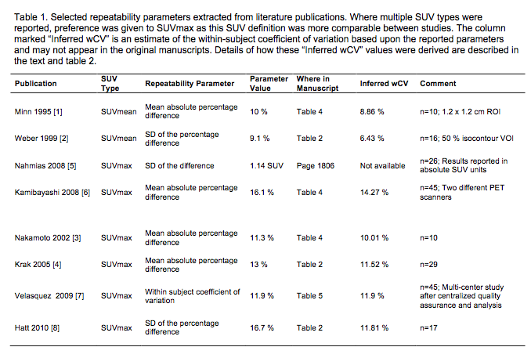

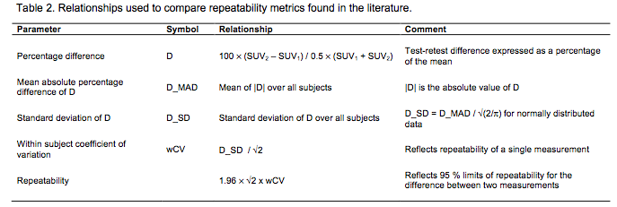

One assumption that was made during these conversions was that the percentage difference (D) between test-retest SUV measurements was normally distributed with zero mean. While this assumption may not be strictly applicable over a wide range of SUVs, it is an assumption that is implicitly being made whenever 95% limits of repeatability are employed [7,8]. Applying this same assumption to the studies that report the mean absolute percentage difference (D_MAD) allows their results to be simply related to the other publications that report the standard deviation by 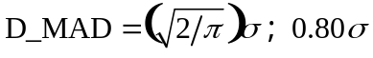, as shown below.

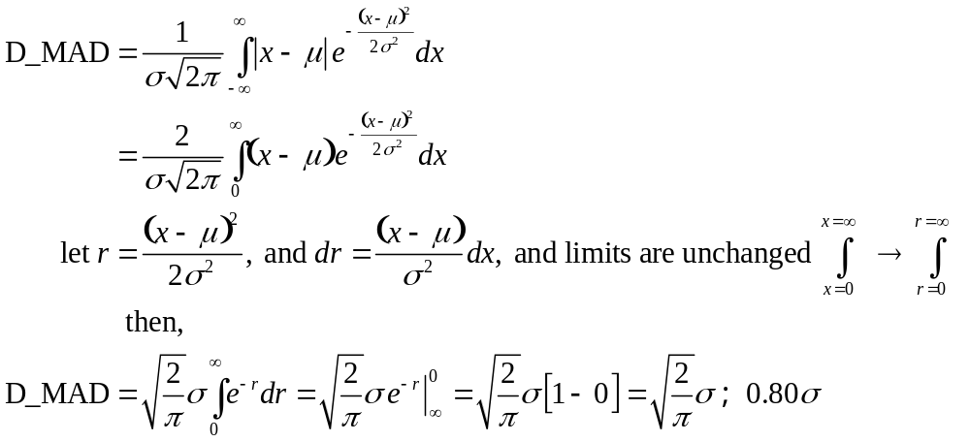

References
1 Minn H, Zasadny KR, Quint LE, Wahl RL. Lung cancer: reproducibility of quantitative measurements for evaluating 2-[F-18]-fluoro-2-deoxy-D-glucose uptake at PET. Radiology, 196, 1 (1995), 167-173.
2 Weber WA, Ziegler SI, Thodtmann R, Hanauske A-R, Schwaiger M. Reproducibility of metabolic measurements in malignant tumors using FDG PET. J Nucl Med, 40, 11 (1999), 1771-1777.
3 Nakamoto Y, Zasadny KR, Minn H, Wahl RL. Reproducibility of common semi-quantitative parameters for evaluating lung cancer glucose metabolism with positron emission tomography using 2-deoxy-2-[18F]fluoro-D-glucose. Mol Imaging Biol, 4 (2002), 171-178.
4 Krak NC, Boellaard R, Hoekstra OS, Twisk JWR, Hoekstra CJ, Lammertsma AA. Effects of ROI definition and reconstruction method on quantitative outcome and applicability in a response monitoring trial. Eur J Nucl Med Mol Imaging, 32, 3 (2005), 294-301.
5 Nahmias C, Wahl LM. Reproducibility of standardized uptake value measurements determined by 18F-FDG PET in malignant tumors. J Nucl Med, 49, 11 (2008), 1804-1808.
6 Kamibayashi T, Tsuchida T, Demura Y, et al. Reproducibility of semi-quantitative parameters in FDG-PET using two different PET scanners: influence of attenuation correction method and examination interval. Mol Imaging Biol, 10 (2008), 162-166.
7 Velasquez LM, Boellaard R, Kollia G, et al. Repeatability of 18F-FDG PET in a multicenter phase 1 study of patients with advanced gastrointestinal malignancies. J Nucl Med, 50, 10 (2009), 1646-1654.
8 Hatt M, Cheze-Le Rest C, Aboagye EO, Kenny LM, Rosso L, Turkheimer FE, Albarghach NM, Metges JP, Pradier O, Visvikis D. Reproducibility of 18F-FDG and 3'-deoxy-3'-18F-fluorothymidine PET tumor volume measurements. J Nucl Med., 51 (2010), 1368-1376.
9 Kumar V, Nath K, Berman CG, Kim J, Tanvetyanon T, Chiappori AA, Gatenby RA, Gillies RJ, Eikman EA.

Variance of SUVs for FDG-PET/CT is greater in clinical practice than under ideal study settings. Clin Nucl Med. 2013 Mar;38(3):175-82. doi: 10.1097/RLU.0b013e318279ffdf. PMID 23354032 [PubMed - in process].

Appendix C: Conventions and Definitions

Convention Used to Represent Profile requirements
Requirements for adhering to this Profile are presented in tables/boxes as shown in the example below. Shaded boxes are intended future requirements, and are not at this time required for adhering to the Profile.
Illustrative example:
Parameter Entity/Actor Normative text: Clear boxes are current requirements
Shaded boxes are intended for future requirements
Lesion Analysis: Multiple Voxels | Analysis Tool | Shall provide tools to measure and report SUVmean and SUVmax normalized to body weight.
Lesion Analysis: Multiple Voxels | Analysis Tool | Shall provide tools to measure and report SUVmean SUVmax and SUVpeak, normalized to body weight or lean body mass.
Items within tables are normative (i.e. required in order to be compliant with the QIBA protocol). The intent of the normative text is to be prescriptive and detailed to facilitate implementation. In general the intent is to specify the final state or output, and not how that is to be achieved.
All other text outside of these tables is considered informative only.

Definitions
18F-FDG or FDG: 2-deoxy-2-(18F)fluoro-D-glucose, a glucose analog, with the positron-emitting radioactive isotope fluorine-18 substituted for the normal hydroxyl group at the 2' position in the glucose molecule. FDG is the most commonly used (>90%) radiotracer in PET imaging.
Accreditation: Approval by an independent body or group for broad clinical usage (requires ongoing QA/QC) e.g. ACR, IAC, TJC (listed below).
AC: Attenuation Correction. Attenuation is a an effect that occurs when photons emitted by the radiotracer inside the body are absorbed by intervening tissue. The result is that structures deep in the body are reconstructed as having falsely low (or even negative) tracer uptake. Contemporary PET/CT scanners estimate attenuation using integrated x-ray CT equipment. While attenuation-corrected images are generally faithful representations of radiotracer distribution, the correction process is itself susceptible to significant artifacts.
Compliance: Meeting the list of requirements described in this document, which are necessary to meet the measurement claims for this QIBA Profile.
CRF: Case Report Form (CRF) is a paper or electronic questionnaire specifically used in clinical trial research. The CRF is used by the sponsor of the clinical trial (or designated CRO etc.) to collect data from each participating site. All data on each patient participating in a clinical trial are held and/or documented in the CRF, including adverse events.
CT: X-ray computed tomography (CT) is a medical imaging technique that utilizes X-rays to produce tomographic images of the relative x-ray absorption, which is closely linked to tissue density.
DICOM: Digital Imaging and Communications in Medicine (DICOM) is a set of standards for medical images and related information. It defines formats for medical images that can be exchanged in a manner that preserves the data and quality necessary for clinical use.
Dose: Can refer to either radiation dose or as a jargon term for 'total radioactivity'. For example, 10 mCI of 18F-FDG is often referred to as a 10 mCi dose.
FDG: See 18F-FDG.
LBM: Lean Body Mass is calculated by subtracting body fat weight from total body weight. The Lean body mass (LBM) has been described as an index superior to total body weight for prescribing proper levels of medications and for assessing metabolic disorders.
mCi: millicuries. A non-SI unit of radioactivity, defined as 1 mCi = 3.7 × 10^7 decays per second. Clinical FDG-PET studies inject (typically) 5 to 15 mCi of 18F-FDG.
MBq: megabequerel. An SI-derived unit of radioactivity defined as 1.0 × 10^6 decays per second.
Metabolic Response / Metabolic Disease. A classification based on the visible level of FDG uptake associated with malignant solid tumors. There are several specific classifications depending on the criteria used:
- CMR: Complete Metabolic Response. A complete resolution of FDG-PET uptake within the tumor volume so that it is indistinguishable from the surrounding normal tissue.
- PMR: Partial Metabolic Response. A reduction in FDG uptake. The thresholds used for this determination depend on the criteria used. Two such criteria are the EORTC [Young, 1999] and PERCIST [Wahl, 2009] proposals.
- PMD: Progressive Metabolic Disease. An increase in FDG uptake relative to a predefined threshold.
- SMD: Stable Metabolic Disease. No change in FDG uptake relative to predefined thresholds.
PERCIST: PET Response Criteria for Solid Tumors [Wahl, 2009]. A framework proposed for using FDG-PET imaging as a cancer therapy response criteria for solid tumors. Proposed as a more accurate alternative to RECIST for several types of solid tumors.
PET: Positron emission tomography (PET) is a tomographic imaging technique that produces an image of the in vivo distribution of a radiotracer, typically FDG.
PET/CT: Positron emission tomography / computed tomography (PET/CT) is a medical imaging system that combines in a single gantry system both Positron Emission Tomography (PET) and an x-ray Computed Tomography (CT) scanners, so that images acquired from both devices can be taken nearly-simultaneously.
Profile: A QIBA Profile is a document that describes a specific performance Claim and how it can be achieved. A Profile consists of one or more Claims and associated Details.
- Claims: tell a user what can be accomplished by following the Profile.
- Details: tell a vendor what must be implemented in their product; and tell a user what procedures are necessary.
QA: Quality Assurance. Proactive definition of the process or procedures for task performance. The maintenance of a desired level of quality in a service or product, esp. by means of attention to every stage of the process of delivery or production.
QC: Quality Control. Specific tests performed to ensure target requirements of QA program are met. Typically by testing a sample of the output against the specification.
Qualification: Approved by an independent body or group for either general participation in clinical research (ACRIN-CQIE , SNM-CTN others) or for a specific clinical trial (requires ongoing QA/QC). This includes CROs, ACRIN, SNM-CTN, CALGB and other core laboratories.
RECIST: Response Evaluation Criteria in Solid Tumors (RECIST). A set of published rules that define when cancer patients improve ("respond"), stay the same ("stabilize"), or worsen ("progression") during treatments. Based on anatomical size changes of solid tumors. Commonly used but also controversial.
ROI: Region of interest. A region in an image that is specified in some manner, typically with user-controlled graphical elements that can be either 2D areas or 3D volumes. These elements include, but not limited to, ellipses, ellipsoids, rectangles, rectangular volumes, circles, cylinders, polygons, and free-form shapes. An ROI can also defined by a segmentation algorithm that operates on the image. Segmentation algorithms include, but are not limited to, fixed-value thresholding, fixed-percentage thresholding, gradient edge detection, and Bayesian methods. With the definition of an ROI, metrics are then calculated for the portion of the image within the ROI. These metrics can include, but are not limited to, mean, maximum, standard deviation, and volume or area. Note that the term ROI can refer to a 2D area on a single image slice or a 3D volume. In some cases the term ROI is used to refer to 2D area and the term volume of interest (VOI) is used to refer to a 3D volume. In this Profile the term ROI is used to refer to both 2D areas and 3D volumes as needed.
SUV: Standardized uptake value. A measure of relative radiotracer uptake within the body. Typically defined for a time point t as 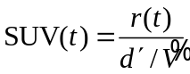, where r(t) is the measured radioactivity concentration within the ROI (typically in units of kBq/ml), d' is the decay-corrected injected radioactivity (or 'dose'), and 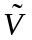 is a surrogate for the distribution volume. Typically patient weight or lean body mass are used for .
Notes:
- The SUV can change over time, so measuring r(t) at a consistent time point is recommended.
- Either body weight or lean body mass are used for a surrogate for the distribution volume, so the SUV units are g/ml (Section 3.4.3)
- For a uniform distribution of radiotracer, the SUV everywhere would be exactly 1 g/ml.
- The measured SUV statistic is typically one of the following:
  - SUVmean: The average SUV within the ROI.
  - SUVmax: The maximum SUV within the ROI.
  - SUVpeak: The average SUV within a fixed-sized ROI, typically a 1 cm diameter sphere. The spheres location is adjusted such that the average SUV is maximized.
  - TLG: Total lesion glycolysis. The summed SUV within the ROI.
TOF: Time of Flight (TOF) is a PET imaging technique utilizing differential annihilation photon travel times to more accurately localize the in vivo distribution of a radiotracer.
UPICT: Uniform Protocols For Imaging in Clinical Trials (UPICT). A RSNA-QIBA initiative that seeks to provide a library of annotated protocols that support clinical trials within institutions, cooperative groups, and trials consortia. The UPICT protocols are based on consensus standards that meet a minimum set of criteria to ensure imaging data quality.
VOI: Volume of interest. See definition for ROI.

Organizations
AAPM: The American Association of Physicists in Medicine is a member society concerned with the topics of medical physics, radiation oncology, imaging physics. The AAPM is a scientific, educational, and professional organization of over 8,000 medical physicists.
ACR: The 36,000 members of |include radiologists, radiation oncologists, medical physicists, interventional radiologists, nuclear medicine physicians and allied health professionals.
ACRIN: The American College of Radiology Imaging Network (ACRIN) is a program of the American College of Radiology and a National Cancer Institute cooperative group. Focused on cancer-related research in clinical trials.
CLIA: Clinical Laboratory Improvement Amendments: Accreditation system for establishing quality standards for laboratory testing.
CQIE: The Centers of Quantitative Imaging Excellence (CQIE) program was developed by ACRIN in response to a solicitation for proposals issued in December 2009 by SAIC-Frederick on behalf of the National Cancer Institute (NCI). The primary objective of the CQIE Program is to establish a resource of ‘trial ready’ sites within the NCI Cancer Centers Program that are capable of conducting clinical trials in which there is an integral molecular and/or functional advanced imaging endpoint.
CRO: Contract Research Organization A commercial or not-for-profit organization designated to perform a centralized and standardized collection, analysis, and/or review of the data generated during a clinical trial. Additional activities which may be performed by an imaging core lab include training and qualification of imaging centers for the specific imaging required in a clinical trial, development of imaging acquisition manuals, development of independent imaging review charters, centralized collection and archiving of images received from study sites, performing pre-specified quality control checks/tests on incoming images and development and implementation of quality assurance processes and procedures to ensure that images submitted are in accord with imaging time points specified in the study protocol and consistent with the quality required to allow the protocol-specified analysis /assessments
CTN: The Clinical Trials Network (CTN) was formed by SNMMI in 2008 to facilitate the effective use of molecular imaging biomarkers in clinical trials.
EANM: The European Association of Nuclear Medicine (EANM) constitutes the European umbrella organization of nuclear medicine in Europe
EARL: EANM Research Ltd (EARL) was formed by EANM in 2006 to promote multicentre nuclear medicine and research.
ECOG-ACRIN: A National Cancer Institute cooperative group formed from the 2012 merger of the Eastern Cooperative Oncology Group (ECOG) and the American College of Radiology Imaging Network (ACRIN).
EORTC: The European Organization for Research and Treatment of Cancer or EORTC is an international non-profit organization that develops, coordinates, and stimulates cancer laboratory and clinical research in Europe.
EMA: European Medicines Agency is a European Union agency for the evaluation of medicinal products. Roughly parallel to the U.S. Food and Drug Administration (FDA), but without FDA-style centralization.
FDA: Food and Drug Administration is responsible for protecting and promoting public health in the U.S. through the regulation and supervision of food safety, tobacco products, dietary supplements, prescription and over-the-counter pharmaceutical medications, vaccines, biopharmaceuticals, blood transfusions, medical devices, electromagnetic radiation emitting devices, and veterinary products.
IAC: The Intersocietal Accreditation Commission (IAC) provides accreditation programs for Vascular Testing, Echocardiography, Nuclear/PET, MRI, CT/Dental, Carotid Stenting and Vein Center.
MITA: The Medical Imaging & Technology Alliance is a division NEMA that develops and promotes standards for medical imaging and radiation therapy equipment. These standards are voluntary guidelines that establish commonly accepted methods of design, production, testing and communication for imaging and cancer treatment products.
NCRI: National Cancer Research Institute. The National Cancer Research Institute (NCRI) is a UK-wide partnership between the government, charity and industry which promotes co-operation in cancer research among the 22 member organizations for the benefit of patients, the public and the scientific community.
NEMA: National Electrical Manufacturers Association is a forum for the development of technical standards by electrical equipment manufacturers.
NIST: National Institute of Standards and Technology is a measurement standards laboratory which is a non-regulatory agency of the United States Department of Commerce.
QIBA: Quantitative Imaging Biomarkers Alliance. The Quantitative Imaging Biomarkers Alliance (QIBA) was organized by RSNA in 2007 to unite researchers, healthcare professionals and industry stakeholders in the advancement of quantitative imaging and the use of biomarkers in clinical trials and practice.
RSNA: Radiological Society of North America (RSNA). A professional medical imaging society with more than 47,000 members, including radiologists, radiation oncologists, medical physicists and allied scientists. The RSNA hosts the world’s largest annual medical meeting.
SNMMI: Society of Nuclear Medicine and Molecular Imaging (formerly called the Society of Nuclear Medicine (SNM)). A nonprofit scientific and professional organization that promotes the science, technology and practical application of nuclear medicine and molecular imaging. SNMMI represents 18,000 nuclear and molecular imaging professionals worldwide. Members include physicians, technologists, physicists, pharmacists, scientists, laboratory professionals and more
TJC: The Joint Commission (TJC) accredits and certifies health care organizations and programs in the United States.
USP: United States Pharmacopeial Convention establishes written and physical (reference) standards for medicines, food ingredients, dietary supplement products and ingredients in the U.S.

Appendix D: Model-specific Instructions and Parameters
The presence of specific product models/versions in the following tables should not be taken to imply that those products are fully compliant with the QIBA Profile. Compliance with a Profile involves meeting a variety of requirements of which operating by these parameters is just one. To determine if a product (and a specific model/version of that product) is compliant, please refer to the QIBA Conformance Document for that product.

D.1. Image Acquisition Parameters
The following technique tables list acquisition parameter values for specific models/versions that can be expected to produce data meeting the requirements of Section 3.6.4 ('Phantom Imaging').
These technique tables may have been prepared by the submitter of this imaging protocol document, the clinical trial organizer, the vendor of the equipment, and/or some other source. (Consequently, a given model/version may appear in more than one table.) The source is listed at the top of each table.
Sites using models listed here are encouraged to consider using these parameters for both simplicity and consistency. Sites using models not listed here may be able to devise their own acquisition parameters that result in data meeting the requirements of Section 3.6.4 and conform to the considerations in Section 4. In some cases, parameter sets may be available as an electronic file for direct implementation on the imaging platform.

D.2. Quality Assurance Procedures
Examples of recommend quality assurance procedures are shown for specific GE, Philips, and Siemens PET/CT scanners in the tables below.
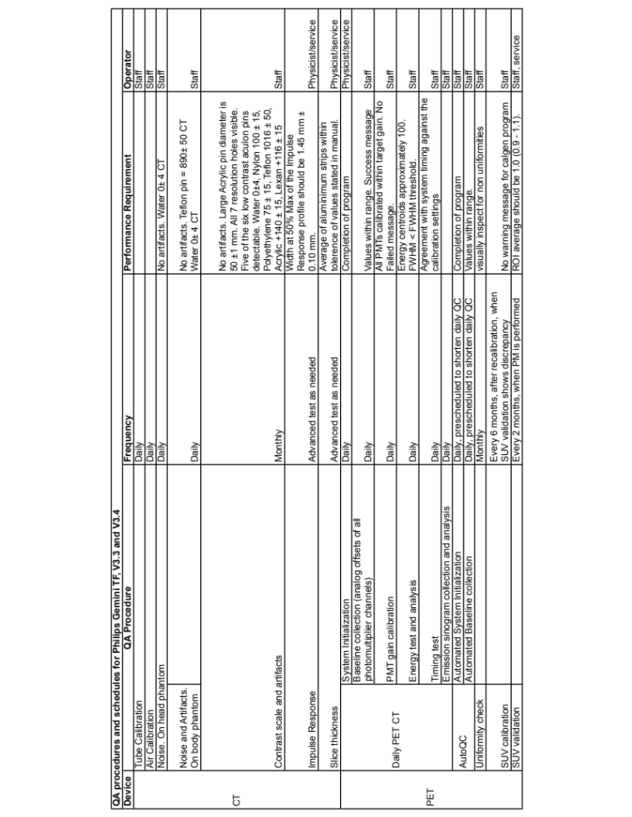
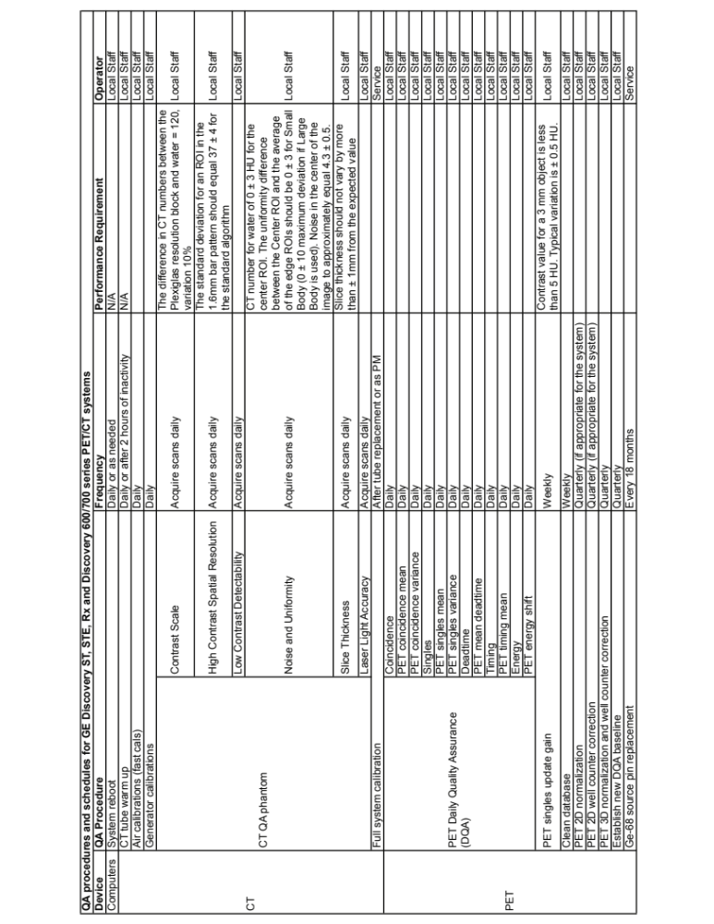

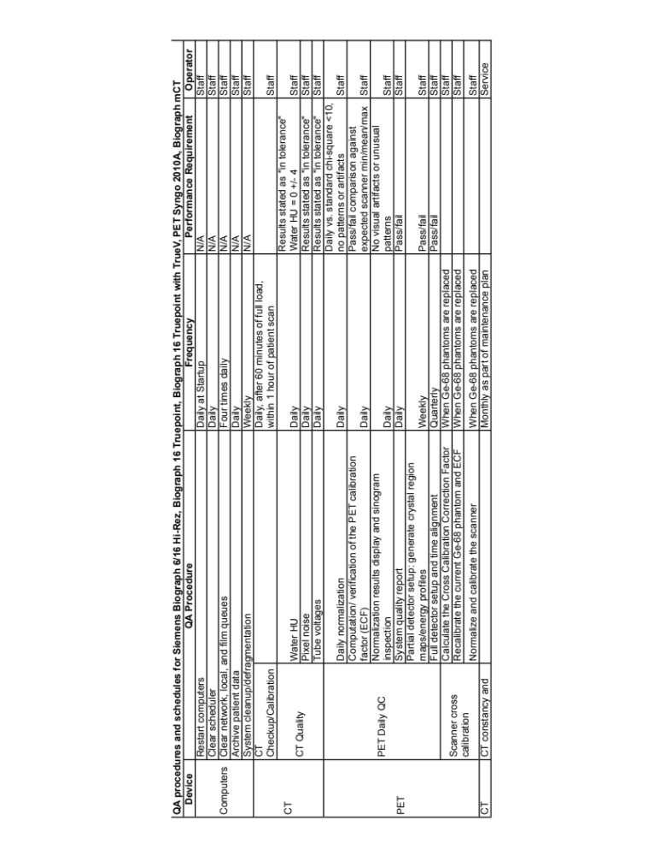

Appendix E: Data Fields to be Recorded in the Common Data Format Mechanism
The list below comprises meta-information (i.e. in addition to image values of kBq/ml) that is necessary for quantitatively accurate (i.e. known and minimal uncertainties) of PET SUVs. The intent here is to list what information should be captured rather than the mechanism itself. The format and corresponding mechanism of data capture/presentation is currently unspecified, but ranges from paper notes, to scanned forms or electronic data records, to direct entry from the measurement equipment (i.e., the PET/CT scanner or auxiliary measurement devices such as the dose calibrator) into pre-specified DICOM fields. Ideally all of the specified meta-data will be captured by direct electronic entry to DICOM fields, after suitable modification of the DICOM format for PET imaging.
The concept endorsed here is that the needed meta-data is identified. Through revisions of this Profile, the DICOM standard, and technology the meta-data is inserted into the analysis stream (Figure 3) in a more direct manner and technology and accepted standards evolve.
- The needed information, where feasible, is listed in order from least frequently changing to most frequently changing.
- In all cases note whether measurements are made directly or estimated. If the latter case, note the source of information and the date and time (e.g. if subject cannot be moved from bed to measure weight or height).
Data fields to be recorded:
- Site specific
- Site information (include name and/or other identifiers)
- Scanner make and model
- Hardware Version numbers
- Software Version numbers
- Confirmation that scanner used was previously qualified (or not)
- Protocol specific
- PET
  - Duration per bed
  - Bed overlap
  - Acquisition mode (2D or 3D)
  - Reconstruction method
- CT technique
- Scanner specific QA/QC
- Most recent calibration factors (scanner)
- Scanner daily check values
- most recent clock check
- most recent scanner QA/QC
- Subject exam specific
- Height
- Weight
- Fasting time assessment
- Blood glucose concentration and time of sampling
- Pre- and post-injection assayed activities and times of assay
- Injection time
- Site of injection (and assessment of infiltration)
- Net injected activity (calculated including decay correction)
- Uptake time

Appendix F: Testing PET/CT Display and Analysis Systems with the FDG-PET/CT Digital Reference Object
The PET/CT Digital Reference Object (DRO) is a synthetically generated set of DICOM image files of known voxel values for positron emission tomography (PET) and x-ray computed tomography (CT). The PET/CT DRO is intended to test the computation of standardized uptake values (SUVs) by PET/CT display stations. It is also intended to test region of interest (ROI) calculations and alignment between the PET and CT images. This is motivated by vendor-specific variations in PET DICOM formats used for SUVs. The development of the PET/CT DRO is supported by the Quantitative Imaging Biomarker Alliance (QIBA).
The primary goals and objectives of the PET/CT Digital Reference Object are to support the QIBA FDG-PET 'Technical Validation' efforts for Profile development. This will be done by (1) evaluation and validation of SUV calculations in PET images, (2) evaluation and validation of ROI calculations and (3) providing a common reference standard that can be adopted and modified by PET/CT scanner and display station manufacturers.
The PET and CT components of the Images of the DRO are each a set of DICOM format files, one file per image slice. Each set of files are typically grouped as a stack to form an image volume. Representative sections through the CT and PET image volumes are shown below.  The synthetic test object is based on, but is not identical to, the NEMA NU-2 PET test phantom [J Nucl Med, vol. 43 no. 10 1398-1409, 2002]. The PET object has added 'test voxels' together with 2D and 3D 'test patterns'. In each object, the thickness of the exterior shell is 3 mm, the thickness of the hot sphere walls is 1 mm, and the thickness of the lung | 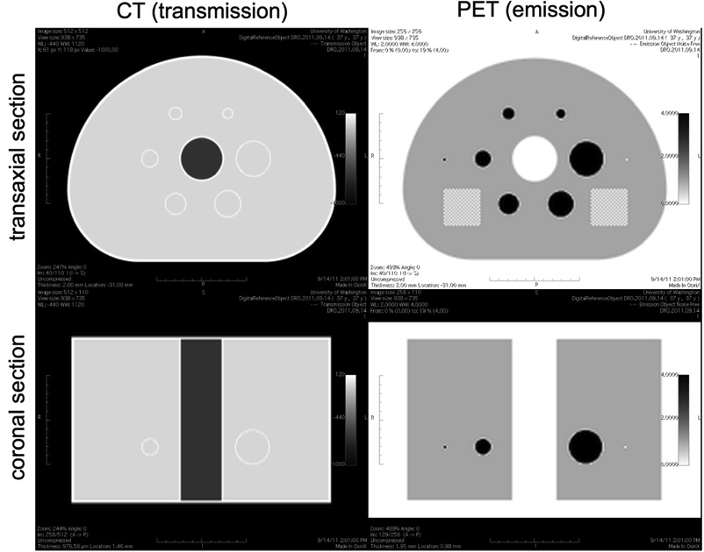
insert wall is 2mm.

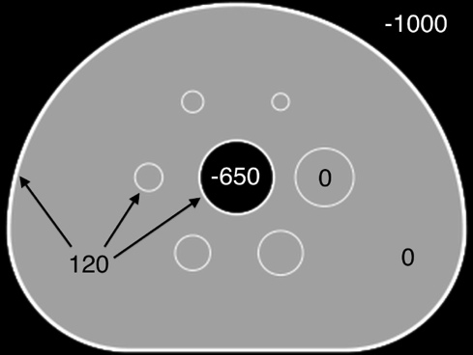 | 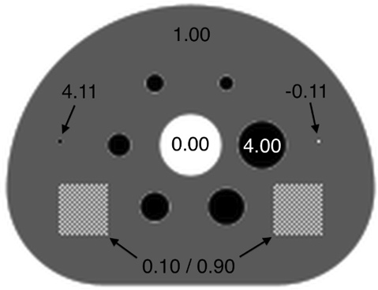
The CT DRO showing Hounsfield Units for each structure. | The PET DRO with the SUVbw values of each structure.
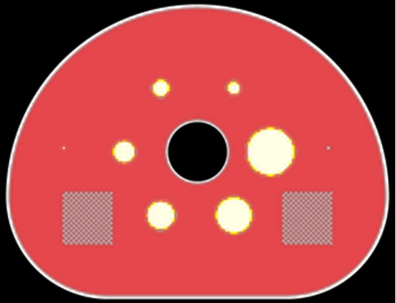 | 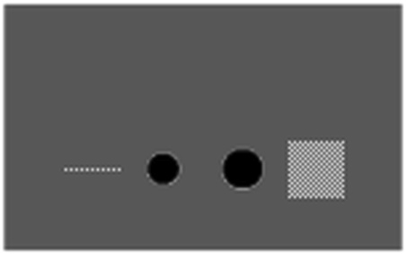
Image fusion of the CT and PET DROs showing perfect alignment | Coronal view of the PET DRO showing the 2D test pattern in slice 40 (left) as well as the 3D cubic test pattern (right)

Structure of the CT and PET DROs.
The CT Object
The CT object is 512 × 512 × 110 voxels, and is stored in 110 DICOM files named 000001.dcm through 000110.dcm , numerically ordered so that 000001.dcm corresponds to slice 1 in the image volume.
The CT object has a reconstruction diameter of 500 millimeters and an axial extent of 220 millimeters, resulting in a voxel size of 500/512 × 500/512 × 2 (0.9765625 × 0.9765625 × 2.0) millimeters³.
The interior of the phantom body and the interiors of the hot spheres have voxels with values of 0 Hounsfield Units (HU), simulating water in the body and the interior of the hot spheres. The shell of the body, lung insert wall, and hot sphere walls have voxels set to 120 HU, simulating polymethylmethacrylate. The voxels interior to the lung insert are set to -650 HU, simulating lung attenuation material. The voxels exterior of the phantom body are set to -1000 HU, simulating air. These values are indicated in the above figure. NOTE: Partial volume effects will alter the voxel values near the borders of different regions.

The PET Object
The PET object consists of a 256 × 256 × 110 voxel image volume stored in 110 DICOM files named 000001.dcm through 000110.dcm, similar to the CT object described above.
The PET object has a reconstruction diameter of 500 millimeters and an axial extent of 220 millimeters, resulting in a voxel size of 500/256 × 500/256 × 2 (1.953125 × 1.953125 × 2.0) millimeters³.
The voxels interior to the phantom body are set to an SUV value of 1.00. The voxels interior to the six hot spheres are set to an SUVbw value of 4.00. The voxels corresponding to the polymethylmethacrylate shell and the exterior of the phantom body and interior to the lung insert are set to an SUVbw value of 0.00. NOTE: Partial volume effects will alter the voxel values near the borders of different regions.
There are two test voxels in slice 40 of the DRO. The test voxel furthest from the largest hot sphere in slice 40 is set to an SUVbw value of 4.11. The test voxel closest to the largest hot sphere in slice 40 is set to an SUVbw value of -0.11. NOTE: There is no polymethylmethacrylate shell surrounding the test voxels in the PET object, and no partial volume effects surrounding the test voxels. An SUV less than zero is possible when using PET image reconstruction methods such as analytic filtered back projection.
There are two test patterns in the PET DRO, a square (2D) checkerboard pattern in slice 40, and a cubic (3D) checkerboard pattern centered in slice 40. The 3D cubic test pattern appears closest to the largest hot sphere in an axial view of slice 40.
Each test pattern consists of a checkerboard of voxels with alternating SUVbw values of 0.10 and 0.90 Both the 2D square and 3D cubic test patterns have edge measurements of 40 mm. The SUVbw values of each region of the PET DRO are shown in the above figure.
Users of the DRO are asked to download the package, import the PET and CT objects into their viewing software, perform region of interest (ROI) analyses, and submit the results back to this website.

Procedure
Users of the Digital Reference Object are requested to:
1. Download the DRO (or import from CD) and the user report form.
2. Verify the DRO files are present.
3. Import the DRO into the viewing software.
4. Perform ROI analysis of the DRO.
5. Submit the completed report and store a copy locally.
Report Form - Page 1
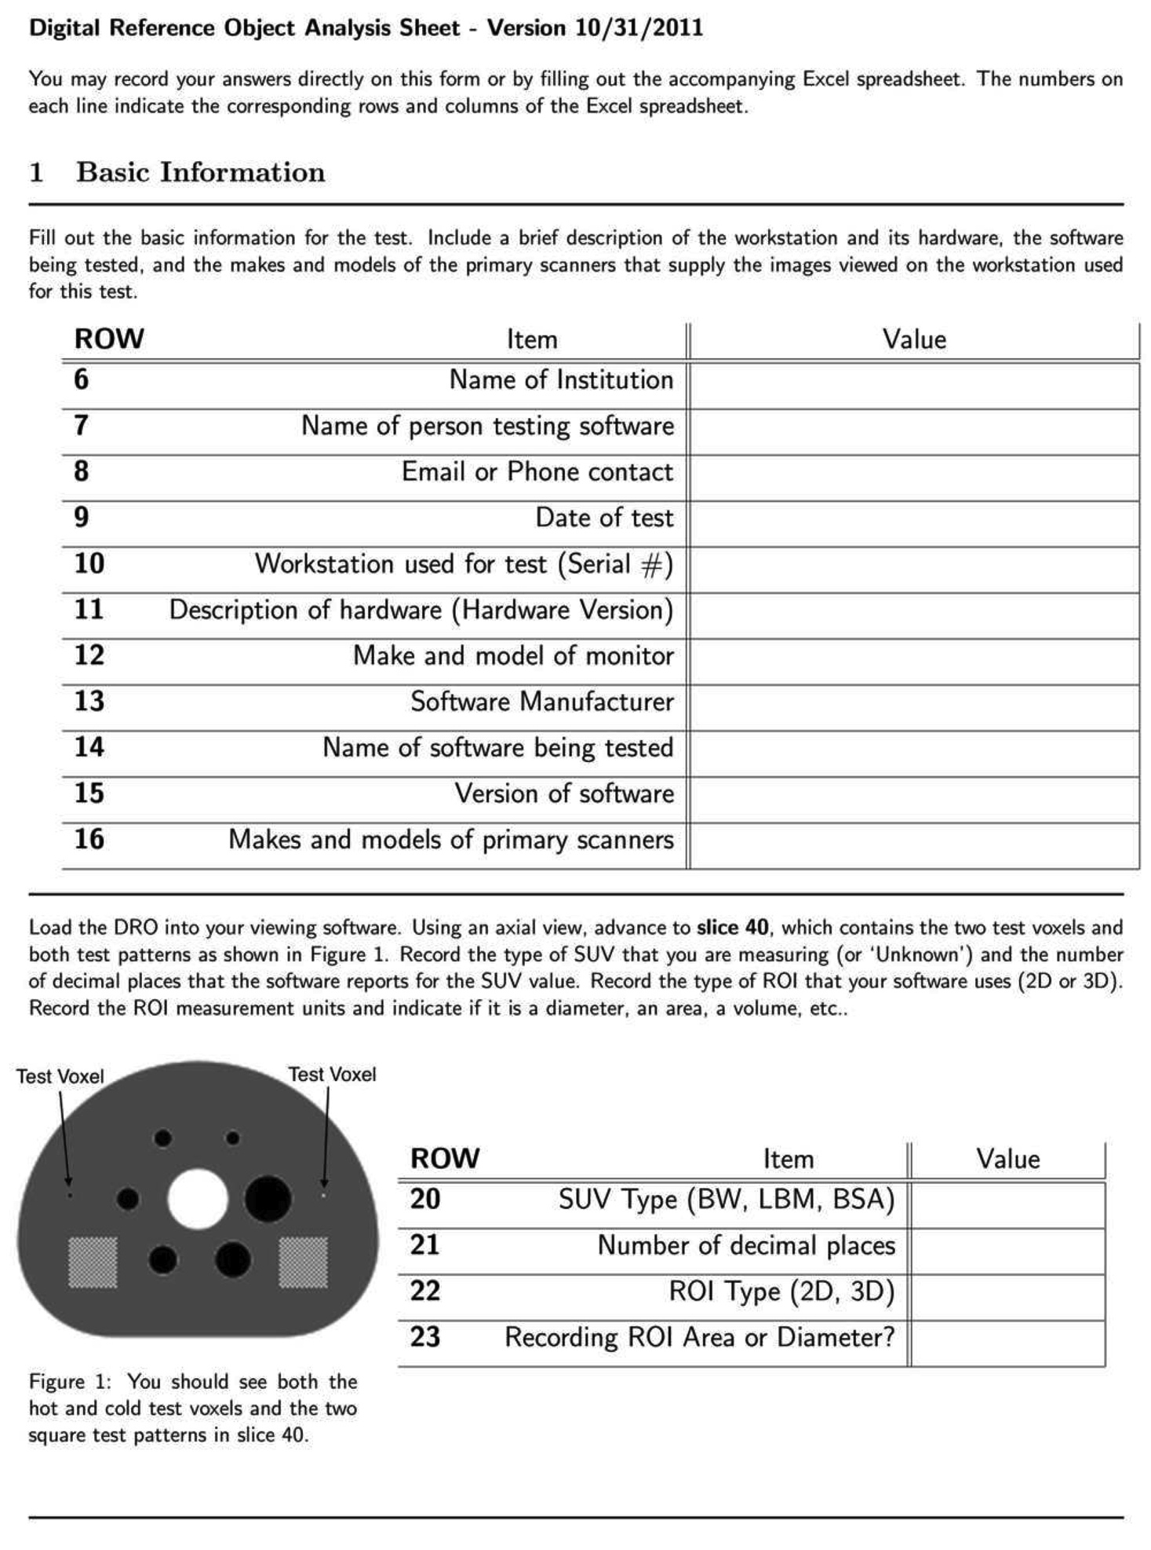
Report Form - Page 2

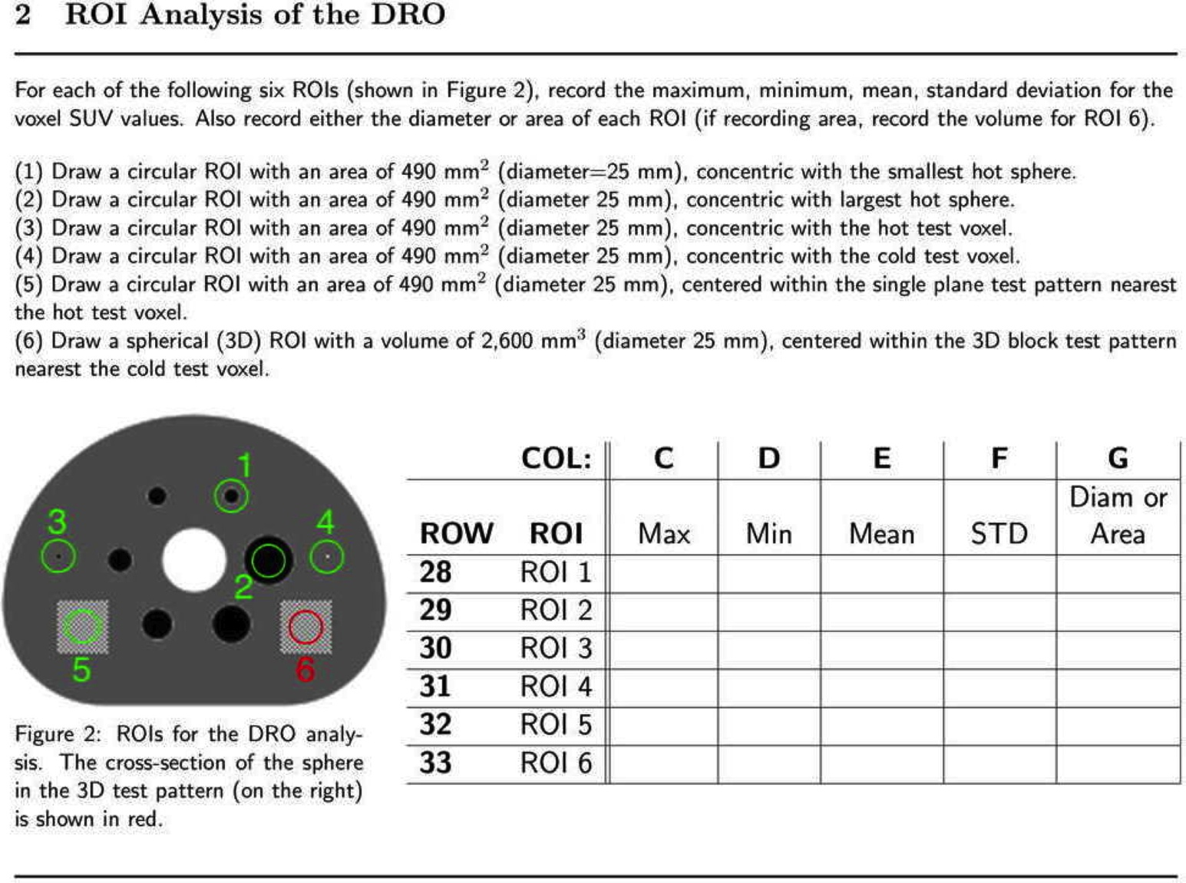

Appendix G: Vendor-neutral Pseudo-codes for SUV Calculation
G.1 Generic version
This appendix contains the consensus opinion on the generic form of SUV calculation from PET DICOM images. A generic pseudo-code is used with "//" signifying the beginning of a comment field to the end of the line. This version assumes the PET IOD is being used and not the Enhanced PET IOD: units are BQML, no private data elements required, series time is OK. Updated as of September 28, 2012. The most up to date version is maintained on the QIBA FDG-PET Wiki page (http://qibawiki.rsna.org/index.php?title=Standardized_Uptake_Value_SUV). Note that this is based on our most complete understanding at this time, but requires careful validation if implemented. In particular, it is strongly recommended not to use Series Date and Series Time for decay correction.
// SUV cannot be calculated if any of the specified DICOM attributes are missing or empty or zero
if Corrected Image (0x0028,0x0051) contains ATTN and DECAY and Decay Correction (0x0054,0x1102) is START {
if Units (0x0054,0x1001) are BQML {
half life = Radionuclide Half Life (0x0018,0x1075) in Radiopharmaceutical Information Sequence (0x0054,0x0016) // seconds
if Series Date (0x0008,0x0021) and Time (0x0008,0x0031) are not after Acquisition Date (0x0008,0x0022) and Time (0x0008,0x0032) {
scan Date and Time = Series Date and Time
start Time = Radiopharmaceutical Start Time (0x0018,0x1072) in Radiopharmaceutical Information Sequence (0x0054,0x0016)
// start Date is not explicit … assume same as Series Date; but consider spanning midnight
decay Time = scan Time – start Time // seconds
// Radionuclide Total Dose is NOT corrected for residual dose in syringe, which is ignored here …
injected Dose = Radionuclide Total Dose (0x0018,0x1074) in Radiopharmaceutical Information Sequence (0x0054,0x0016) // Bq
decayed Dose = injected Dose * pow (2, -decay Time / half life)
weight = Patient's Weight (0x0010,0x1030) // in kg
SUVbwScaleFactor = (weight * 1000 / decayed Dose)
// Rescale Intercept is required to be 0 for PET, but use it just in case
// Rescale slope may vary per slice (GE), and cannot be assumed to be constant for the entire volume
SUVbw = (stored pixel value in Pixel Data (0x7FE0,0x0010) + Rescale Intercept (0x0028,0x1052))* Rescale Slope (0x0028,0x1053) * SUVbwScaleFactor // g/ml
}
}
}

G.2 Robust version
This appendix contains the consensus opinion on the most robust form of SUV calculation from PET DICOM images. Updated as of September 28, 2012. The most up to date version is maintained on the QIBA FDG-PET Wiki page (http://qibawiki.rsna.org/index.php?title=Standardized_Uptake_Value_SUV). Note that this is based on our most complete understanding at this time, but requires careful validation if implemented. In particular, it is strongly recommended not to use Series Date and Series Time for decay correction.

// SUV cannot be calculated if any of the specified DICOM attributes are missing or empty or zero
if Corrected Image (0x0028,0x0051) contains ATTN and DECAY and Decay Correction (0x0054,0x1102) is START {
if Units (0x0054,0x1001) are BQML {
half life = Radionuclide Half Life (0x0018,0x1075) in Radiopharmaceutical Information Sequence (0x0054,0x0016) // seconds
if Series Date (0x0008,0x0021) and Time (0x0008,0x0031) are not after Acquisition Date (0x0008,0x0022) and Time (0x0008,0x0032) {
scan Date and Time = Series Date and Time
}
else { // may be post-processed series in which Series Date and Time are date of series creation unrelated to acquisition
if GE private scan Date and Time (0x0009,0x100d,“GEMS_PETD_01”) present {
scan Date and Time = GE private scan Date and Time (0x0009,0x100d,“GEMS_PETD_01”)
}
else {
// else may be Siemens series with altered Series Date and Time
// either check earliest of all images in series (for all bed positions) (wrong for case of PETsyngo 3.x multi-injection)
scan Date and Time = earliest Acquisition Date (0x0008,0x0022) and Time (0x0008,0x0032) in all images of series
or
// back compute from center (average count rate ) of time window for bed position (frame) in series (reliable in all cases)
// Acquisition Date (0x0008,0x0022) and Time (0x0008,0x0032) are the start of the bed position (frame)
// Frame Reference Time (0x0054,0x1300) is the offset (ms) from the scan Date and Time we want to the average count rate time
if (Frame Reference Time (0x0054,0x1300) > 0 && Actual Frame Duration (0018,1242) > 0) {
frame duration = Actual Frame Duration (0018,1242) / 1000 // DICOM is in ms; want seconds
decay constant = ln(2) / half life
decay during frame = decay constant * frame duration
average count rate time within frame = 1/decay constant * ln(decay during frame / (1 – exp(-decay during frame)))
scan Date and Time = Acquisition Date (0x0008,0x0022) and Time (0x0008,0x0032)
- Frame Reference Time (0x0054,0x1300) /1000 + average count rate time within frame
}
}
}
start Time = Radiopharmaceutical Start Time (0x0018,0x1072) in Radiopharmaceutical Information Sequence (0x0054,0x0016)
// start Date is not explicit … assume same as Series Date; but consider spanning midnight
decay Time = scan Time – start Time // seconds
// Radionuclide Total Dose is NOT corrected for residual dose in syringe, which is ignored here …
injected Dose = Radionuclide Total Dose (0x0018,0x1074) in Radiopharmaceutical Information Sequence (0x0054,0x0016) // Bq
decayed Dose = injected Dose * pow (2, -decay Time / half life)
weight = Patient's Weight (0x0010,0x1030) // in kg
SUVbwScaleFactor = (weight * 1000 / decayed Dose)
}
else if Units (0x0054,0x1001) are CNTS {
SUVbwScaleFactor = Philips private scale factor (0x7053,0x1000,“ Philips PET Private Group”)
// if (0x7053,0x1000) not present, but (0x7053,0x1009) is present, then (0x7053,0x1009) * Rescale Slope
// scales pixels to Bq/ml, and proceed as if Units are BQML
}
else if Units (0x0054,0x1001) are GML {
SUVbwScaleFactor = 1.0 // assumes that GML indicates SUVbw instead of SUVlbm
}
}
// Rescale Intercept is required to be 0 for PET, but use it just in case
// Rescale slope may vary per slice (GE), and cannot be assumed to be constant for the entire volume
SUVbw = (stored pixel value in Pixel Data (0x7FE0,0x0010) + Rescale Intercept (0x0028,0x1052))* Rescale Slope (0x0028,0x1053) * SUVbwScaleFactor // g/ml

Appendix H: Concensus Formula for Computing Lean-Body-Mass Normalization for SUVs
It is important that the PET community is consistent in its computation of SUV_{LBM}, particularly in light of the recent article by Wahl et al. (1) that proposes using SUV_{LBM} as part of the PERCIST criteria to monitor treatment response.
Two different formulas for estimating male Lean Body Mass-normalized SUV (SUV_{LBM}) are currently being used in the PET community. The two variations of the formula for estimating LBM for males are as follows:
LBM(male) = (1.10 x Weight) - 128 x (Weight / Height)² [1]
LBM(male) = (1.10 x Weight) - 120 x (Weight / Height)² [2]
Where the units for weight are kg, and the units for height are cm. Only one formula is being used for the calculation of female LBM (2,3):
LBM(female) = (1.07 x Weight) - 148 x (Weight / Height)² [3]
Both versions for estimating male lean body mass (equation 1 from Hallynck et al. (2) and equation 2 from Morgan and Bray (3)) are based on the original work of James (4), which in turn were derived from a fit of (weight/height²) to percentage body fat as measured by skin fold measurements. Equation 1 is the version widely used by the pharmacology community and can be considered the 'correct' version (5-7).
The second version of the equation [2] can be traced back to an article by Morgan and Bray (3), in which the formula presented by Hallynck et al. (2) is likely misquoted, since the article (2) is referenced elsewhere in Morgan and Bray (3) without discussion of the difference in formulas where 120 was substituted for 128 as a coefficient. The first incorporation of this formula for computing LBM into SUV calculations was described in Sugawara et al (8), which cites the Morgan and Bray paper (3). It is this version of the formula for males, with 120 as the coefficient, that has been sometimes quoted in the PET literature. Sugawara et al (8) used only data for female patients, which cites the formula for estimating female LBM by Morgan and Bray (3), which in turn matches the Hallynck et al. (2) paper.
Although the impact of this difference in coefficient is relatively minor for patients with a normal body mass index (BMI (kg/m²) = (weight/height²), it does vary as a function of the patient’s weight / height ratio. For example, for a patient of height 180 cm and weight 75 kg (BMI: 23) the value of SUV_{LBM} as computed by the two formula would differ by less than 1.5 % for regions with an SUV_{LBM} of ~1. However, for a male patient of the same height but weighing 150 kg (BMI: 46), the difference in SUV_{LBM} for the same regions would be ~7 %.
In comparing equations [1] and [2], it is recommended that equation [1] be used in preference to equation [2]. However, although the James (2) is the most commonly used data source for equations estimating LBM, it is well known that it is incorrect for extreme BMI values (5-7). Janmahasatian et. al (5) have proposed alternative equations for LBM:
LBM(male) (kg) = 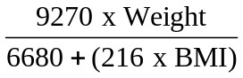 [4]
LBM(female) (kg) = 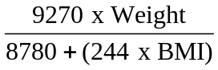 [5]
These revised formulas for LBM have achieved some acceptance in the pharmacology community (6,7), and future versions of this Profile may recommend equations [4] and [5] instead of equations [1] and [3]. There are also continuing efforts to come up with more accurate methods for estimating LBM, through direct measurement on a per-patient basis using CT (9). However, the different methods providing estimates of LBM typically have unknown levels of bias and variance. Thus consistency and standardization are likely to yield larger improvements in study power for clinical trials, when compared to potential improvements in accuracy of LBM estimation.
References
1. Wahl, R., Heather, J., Kasamon, Y., Lodge, M. (2009) From RECIST to PERCIST: Evolving Considerations for PET Response Criteria in Solid Tumours. JNM 50(5); 122S-150S.
2. Hallynck TH, Soep HH, Thomis JA, Boelaert J, Daneels R, Dettli L. (1981) Should clearance be normalized to body surface or lean body mass. Br J clin Pharmac 11: 523-526.
3. Morgan, D., Bray K. (1994) Lean Body Mass as a predictor of drug dosage: Implications for Drug Therapy. Clinical Pharmacokinetics 26(4); 292-307.
4. James, W. (1976) Research on Obesity. London. Her Majesty’s Stationary Office.
5. Janmahasatian S, Duffull SB, Ash S, Ward LC, Byrne NM, Green B. Quantification of lean bodyweight. Clin Pharmacokinet 44(10):1051-1065, 2005. PMID: 16176118.
6. Han PY, Duffull SB, Kirkpatrick CM, Green B. Dosing in obesity: a simple solution to a big problem. Clin Pharmacol Ther 82(5):505-508, 2007. PMID: 17952107.
7. Hanley MJ, Abernethy DR, Greenblatt DJ. Effect of obesity on the pharmacokinetics of drugs in humans. Clin Pharmacokinet 49(2):71-87, 2010. PMID: 20067334.
8. Sugawara, Y., Zasadny, K., Neuhoff, A., Wahl, R. (1999) Reevaluation of the SUV for FDG: Variations with body weight and methods for correction. Radiology 213; 521-525.
9. Chan T. Computerized method for automatic evaluation of lean body mass from PET/CT: comparison with predictive equations. J Nucl Med 53(1):130-137, 2012. PMID: 22128325.

