

Profile: DCEMRI Quantification
Version 0.24
May 25 2011

Table of Contents
I. Executive Summary 3
II. Clinical Context and Claims 3
Claim: 4
III. Profile Details 4
3. Subject Scheduling 4
4. Subject Preparation 5
5. Imaging-related Substance Preparation and Administration 6
7. Imaging Procedure 7
8. Image Post-processing 11
9. Image Analysis and Parametric image formation 11
9. Image Analysis 14
10. Parametric image analysis 18
11. Archival and Distribution of Data 20
12. Quality Control 20
12.1.1 DCE-MRI Acquisition Scanner 21
12.1.3 MR Technologists or other Site Personnel performing DCE-MRI studies 22
12.1.4 MR Radiologists or other anatomic experts 22
12.1.5 Site compliance with protocol requirements 22
13. Imaging-associated Risks and Risk Management 26
IV. Compliance 27
Acquisition Scanner 27
Contrast Inject Device 27
Software Analysis 27
Performing Site 27
References 28
Appendices 30
Appendix A: Acknowledgements and Attributions 30
Appendix C: Conventions and Definitions 31
Appendix D: Documents included in the imaging protocol (e.g., CRFs) 32
Appendix E: Associated Documents 32
Appendix F: Spreadsheet on reproducibility data 32
Appendix G: Model-specific Instructions and Parameters 34

I. Executive Summary
The RSNA QIBA Dynamic Contrast Enhanced Magnetic Resonance Imaging (DCE-MRI) Technical Committee is composed of scientists representing the imaging device manufacturers, image analysis laboratories, biopharmaceutical industry, academia, government research organizations, and professional societies, among others. All work is classified as pre-competitive. The goal of the DCE-MRI committee is to define basic standards for DCE-MRI measurements and quality control that enable consistent, reliable and fit-for-purpose quantitative transfer constant (K^{trans} (1)) and blood normalized initial area under the gadolinium concentration curve (IAUGC_{BN} (2)) results across imaging platforms, clinical sites, and time.

This effort is motivated by the emergence of DCE-MRI as a method with potential to provide predictive, prognostic and/or pharmacodynamic biomarkers for cancer (3-11). Remarkably, the results demonstrating this potential have been obtained despite considerable variation in the methods used for acquisition and analysis of the DCE-MRI data. This suggests there are substantial physiological differences (i.e., benign vs. malignant, non-responsive vs. responsive tumors, before and after treatment) underlying these observations. Thus, there appears to be a promising future for use of DCE-MRI for both clinical research and in routine clinical practice. However, in order to fulfill this promise it is essential that common quantitative endpoints are used and that results are independent of imaging platforms, clinical sites, and time.

For the application of DCE-MRI in the development of anti-angiogenic and anti-vascular therapies, there is a consensus (12) on which quantitative endpoints should be employed: K^{trans} and IAUGC_{BN}. Hence, the initial focus of the DCE-MRI committee is on these biomarkers. Although there have been general recommendations on how to standardize DCE-MRI methodology(12, 13), there are no guidelines sufficient to ensure consistent, reliable and fit-for-purpose quantitative DCE-MRI results across imaging platforms, clinical sites, and time. Hence, in this profile, basic standards for site and scanner qualification, subject preparation, contrast agent administration, imaging procedure, image post-processing, image analysis, image interpretation, data archival and quality control are defined to provide that guidance.
Summary of Clinical Trial Usage
This technique offers a robust, reproducible measure of microvascular parameters associated with human cancers based on kinetic modeling of dynamic MRI data sets. The rigor and details surrounding these data are described throughout the text of this document in various sub-sections.

II. Clinical Context and Claims
One application of DCE-MRI where considerable effort has been focused on quantitative endpoints is its use to provide pharmacodynamic biomarkers for the development of novel therapeutic (in specific anti-angiogenic) agents targeting the tumor blood supply (4, 9, 14-25). A growing understanding of the underlying molecular pathways active in cancer has led to the development of novel therapies targeting VEGFR, EGFR-tk, PI3K, mTOR , Akt and other pathways. Unlike the conventional cytotoxic chemotherapeutic agents, many of the molecularly-targeted agents are cytostatic, causing inhibition of tumor growth rather than tumor regression. One example is anti-angiogenesis agents, which are presumed to act through altering tumor vasculature and reducing tumor blood flow and/or permeability. In this context, conventional endpoints, such as tumor shrinkage, may not be the most effective means to measure therapeutic responses. Other functional MR imaging acquisition and analysis applications (e.g. BOLD, R2* perfusion) yield several important candidate imaging biomarkers that can predict and monitor targeted treatment response and to document pharmacodynamic response. However, these are not within the scope of this document. DCE-MRI represents an MRI-based method to assess the tumor microvascular environment by tracking the kinetics of a low-molecular weight contrast agent intravenously administered to patients.
The emerging importance of angiogenesis as a cancer therapy target makes assays of vascularity important to clinical research and future clinical practice related to targeted cancer therapy. There are multiple literature reports of the application of DCE-MRI to predict and detect changes associated with angiogenesis targeted therapy (4, 9, 15, 17, 19, 20, 24, 25) . Further, there is interest in the application of quantitative DCE-MRI to characterize enhancing lesions as malignant in several organ systems, including breast and prostate.
In this context, K^{trans} and IAUGC_{BN} can provide evidence of the desired physiologic impact of these agents in Phase 1 clinical trials. For some agents, e.g., VEGFR-targeted agents, evidence of substantially reduced K^{trans} and IAUGC_{BN} is necessary, but not sufficient, for a significant reduction in tumor size (16, 17) . For other agents, e.g., vascular-targeted agents, evidence of a substantial vascular effect may not be associated with a reduction in tumor size (9), but is still essential for effective combination with other agents. In either case, lack of a substantial vascular effect indicates a more potent agent is needed, while evidence for a substantial vascular effect indicates further development is appropriate.
Utilities and Endpoints for Clinical Trials
DCE-MRI is currently not the standard of care in many centers conducting clinical trials In oncology. Since these centers often do not have expertise in DCE-MRI and more than one center is typically involved, therefore effort and precision are required ensure consistent, reliable and fit-for-purpose quantitative DCE-MRI results. Hence, the guidelines provided in this profile will ensure that not only are the relative changes induced by treatment are informative, but that absolute changes can be compared across these studies.

Claim:
Quantitative microvascular properties, specifically K^{trans} (transfer constant) and blood normalized initial area under the gadolinium concentration curve (IAUGC_{BN}), can be measured from DCE-MRI data obtained at 1.5T using low molecular weight extracellular gadolinium-based contrast agents within a 20% test-retest coefficient of variation for solid tumors at least 2 cm in diameter.

Profile specified for use with: , for the following indicated biology: , and to serve the following purpose: .
patients with malignancy
primary or metastatic disease
therapeutic response

III. Profile Details

3. Subject Scheduling
Subject Selection Criteria related to Imaging
• Absolute contraindications to MRI are not within the scope of this document. Suffice it to say that local policies for contraindications for absolute MRI safety should be followed.

• Lesions that are selected for DCE-MRI analysis should not be within 10 cm of metal prostheses, e.g., spinal hardware, hip prostheses, metallic surgical staples, etc.

• Patient selection criteria may be guided by the Eastern Cooperative Oncology Group (ECOG) status (See Appendix 2) for full description of ECOG performance status). In specific, patients meeting ECOG status >= 2 will not be eligible for participation in the study because, historically, this patient profile has shown poor ability to meet the demands of the examination.

• The QIBA DCE-MRI committee acknowledges that there are potential and relative contraindications to MRI in patients suffering from claustrophobia. Methods for minimizing anxiety and/or discomfort are at the discretion of the physician caring for the patient.

• The QIBA DCE-MRI committee acknowledges that there are potential risks associated with the use of gadolinium-based contrast media. The default recommendations for intravenous contrast that follow assume there are no known contraindications in a particular patient other than the possibility of an allergic reaction to the gadolinium contrast agent. The committee assumes that local standards for good clinical practices (GCP) will be substituted for the default in cases where there are known risks.

• Recent FDA guidelines (http://www.fda.gov/Drugs/DrugSafety/ucm223966.htm#aprooved), outline the safety concerns associated with using gadolinium based contrast agents in patients with impaired renal function. The DCE-MRI committee echoes these recommendations and advises reference to these standards when choosing patients in order to determine eligibility for entry into a DCE-MRI clinical trial.

• Patients will not be eligible if they have received ANY gadolinium based contrast agent within 24 hrs.

3.1. Timing of Imaging Tests within the Treatment Calendar
The DCE-MRI Technical Committee believes that all baseline evaluations should be ideally be within 14 days. Otherwise the resulting functional tumor characterization may not reflect the status of the tumor prior to initiation of therapy. The interval between follow up scans within patients may be determined by current standards for GCP or the rationale driving a clinical trial of a new treatment
3.2. Timing Relative to confounding Activities (to minimize “impact”)
DCE-MRI examinations should not be performed within 14 days of a biopsy.

4. Subject Preparation
There are no specific patient preparation procedures for the MRI scans described in this protocol. There are specifications for other procedures that might be acquired contemporaneously, such as requirements for fasting prior to FDG PET scans or the administration of oral contrast for abdominal CT. Those timing procedures may be followed as indicated without adverse impact on these guidelines
4.1. Prior to Arrival
The local standard of care for acquiring MRI scans may be followed. For example, patients may be advised to wear comfortable clothing, leave jewelry at home, etc.
4.2. Upon Arrival
Staff shall prepare the patient according to the local standard of care. Patients should be comfortably positioned, in appropriate attire to minimize patient motion and stress (which might affect the imaging results) and any unnecessary patient discomfort.
4.3 Preparation for Exam
Beyond a clear, simple language description of the image acquisition procedure, no exam preparation is specified beyond the local standard of care for MRI with contrast.

5. Imaging-related Substance Preparation and Administration
5.1. Substance Description and Purpose
The literature which supports the claim is based on the utilization of an extracellular gadolinium based contrast agent. Although it is known that there is a small degree of protein binding associated with many commercially available extracellular gadolinium contrast agents, (26), these are comparable amongst the various vendors. Contrast agents with fundamentally different degrees of protein binding, (e.g., Gadobenate and Gadofosveset) are not addressed by this profile. The committee therefore recommends using an extracellular based gadolinium based contrast agent.
5.2. Dose Calculation and/or Schedule
Contrast Agent Dose is Based On Creatinine Clearance: (renal function)

• The patient’s renal creatine clearance should be obtained, and estimated glomerular filtration rate (eGFR) determined through well-known and adopted formulas. (27)
• The decision whether to administer contrast will be based on GCP and the policies adopted at the institution performing the examination.
• The dose of the Gadolinium contrast agent should be 0.1 mmol/kg.
5.3. Timing, Subject Activity Level, and Factors Relevant to Initiation of Image Data Acquisition
Contrast injection should occur after the following imaging sequences have been acquired (See Section 6):
• Anatomic imaging for localizing tumors
• Variable flip angle imaging for native tissue (pre-gadolinium injection) T_{1,0} map calculation
Contrast injection should occur after at least 5 baseline acquisitions from the imaging volume have been acquired.
5.4. Administration Route
Each subject should have an intravenous catheter (no smaller than 20 gauge), which should be ideally placed in the right antecubital fossa. Injection through a port-a-catheter or permanent indwelling catheter is not recommended. What is critical is that the same injection site be used for repeat studies, if at all possible.
5.5. Rate, Delay and Related Parameters / Apparatus
Contrast agent and saline flush should be administered in a dynamic fashion with an MR-compatible power injector.
- At baseline and at each subsequent time-point in any longitudinal study, the same dose of contrast and rate of contrast administration should be performed.
- The rate of administration should be rapid enough to ensure adequate first-pass bolus arterial concentration of the contrast agent (generally 2-4 ml/sec)
- The contrast agent should be flushed with between 20 and 30 ml of normal saline injected at the same rate as the contrast agent.
5.6. Required Visualization / Monitoring, if any
No particular visualization or monitoring is specified beyond the local standard of care for MRI with contrast.

7. Imaging Procedure
This section describes the imaging protocols and procedure for conducting a DCE-MRI exam. Suitable localizer (scout) images must be collected at the start of exam and used to confirm correct coil placement as well as selection of appropriate region to image. This will be followed by routine non-contrast agent-enhanced sequences to delineate the number, location, and limits of tumor extension. Exact protocols for these imaging sequences may be determined by the local imaging norms.
• Localizer
• Anatomic sequences T1, T2 weighted imaging
• Variable Flip angle (VFA) T1 weighted imaging (T1 fitting)
• 3D Gradient echo volumetric imaging (dynamic imaging)
7.1. Required Characteristics of Resulting Data
The DCE-MRI portion of the exam will consist of two components, both acquired using the same 3D fast spoiled gradient recalled echo sequence, or equivalent, and scan locations:

(a) A variable flip angle series, for pre-contrast agent native tissue T_{1,0} mapping.
• Ensure TR and TE values stay constant for all flip angles,
• Ensure that the machine gain settings are not reset automatically (using automated pre-scan features) between each flip angle acquisition so that system gain settings are identical for each flip angle acquisition.
• Flip angles: The range of # of flip angles supported in the literature varies from 2-7.
• Number of signal averages (NSA or NEX) > 2.

(b). DCE-MRI Protocol: Pulse Sequence:
• Pulse Sequence: 3D fast spoiled gradient recalled echo or equivalent
• Coils: Transmit: Body coil; Receive: Body coil or phased array receive coil
No parallel imaging options
No magnetization preparation schemes

Imaging plane - The acquisition plane should include the lesion of interest and a feeding vessel with in-plane flow.

Frequency encoding direction: The frequency encoding direction should be adjusted so as to minimize motion artifact. This decision will be based on the location of the tumor being interrogated and its relationship to moving structures.

Parameter | Compliance Levels
TE
  Acceptable | 2.0-2.5ms
  Target | 1.5-2.0ms
  Ideal | <1.5ms

Parameter | Compliance Levels
TR
  Acceptable | 5-7ms
  Target | 3-5ms
  Ideal | < 3ms

Temporal resolution: The temporal resolution should be less than 10 sec.

Flip angles: Smaller flip angles will lead to potential saturation of the signal intensity vs. gadolinium concentration, particularly in vessels. Note should be made that SAR limits may affect the maximum allowable flip angle. Operators should use the maximal allowed flip angle when SAR limitations occur. Flip angles ranging from 25-35 degrees are recommended in order to minimize saturation effects and to avoid specific absorption rate (SAR) problems.

Receiver Bandwidth: Greater or equal to ±31.25 kHz (or ~250 Hz/pixel)

Field of View (FOV) and Partial Fourier (“fractional echo” and/or reduced phase-encoding FOV) as needed to meet temporal resolution requirements

Number of Slices: Acceptable: ≥10 prior to zero fill. Ideal: as many as possible while maintaining ideal temporal resolution.

Slice thickness: Ideal: <5 mm, Target: 5.1-6 mm, Acceptable: 6.1-8 mm

Matrix: 256 x 160 (before applying rectangular FOV) – in order to meet 1-2mm in-plane spatial resolution

Number of acquisitions (phases): Sufficient to allow acquisition of at least 5 minutes of post injection data plus at least 5 phases acquired before contrast agent injection (baseline images).

Digitized bit depth: The maximum dynamic range should be utilized, e.g., “extended dynamic range” or equivalent.

Temporal resolution < 10sec.

7.1.1. Data Content
All data should be in DICOM format.
7.1.2. Data Structure
All VFA data should be clearly labeled as individual series, one per flip angle, or contained in a single series with the data order clearly defined.

All DCE-MRI data should be contained in a single series.
7.1.3. Data Quality
A quality review, confirming that all imaging parameters were correct, data structure is correct, etc., before the data are submitted for analysis.
7.2. Imaging Data Acquisition
7.2.1. Subject Positioning
Patient and coil positioning:

• When the general location of the target tumor(s) is known prior to DCE-MRI, for example glioma or local breast cancer evaluation, the patient set up for the MRI should be based on standard operating procedures for patient positioning and coil placement for clinical MRI of that body part.

• When the subject under investigation may have uncertain tumor location(s), as is common in the setting of patients undergoing therapy for metastatic disease, it will often be necessary for the DCE-MRI study to be planned with reference to the most recent pre-DCE-MRI imaging (often a CT study). From this study, tumor burden and location should be assessed. Optimally, review of actual imaging by a radiologist involved in the DCE-MRI study planning should be made. At times, if such images are not available for direct review, review of imaging reports (CT, PET) detailing extent of disease is mandatory, both to confirm eligibility (presence of at least one “imageable” lesion) and to identify the preferred anatomic regions for DCE-MRI (chest, abdomen, pelvis, extremity). Review of prior diagnostic imaging may also be helpful to confirm cystic or necrotic nature of certain lesions, assessments which may be challenging at the time of DCE-MRI planning based solely on T1- and/or T2-weighted image sets. When multiple potential target lesions are available, the location of the most suitable lesion(s) should be noted. The most suitable lesion will depend on size, location relative to areas of pulsatile or respiratory artifacts, and presence or absence of necrosis or cystic areas.

• DCE-MRI subject should be placed appropriately in the scanner in order to best image the lesion of interest (e.g. supine for head/neck/thorax/abdomen/pelvis and prone within a breast coil for breast studies).

• When patient condition allows, placement of the arms over the head may avoid undesirable wrap artifact for temporally optimized 3D spoiled gradient echo sequences used for chest and abdomen lesions. However, these positions often cannot be sustained by patients without excessive discomfort. In such cases, arms placed anteriorly over the chest or at the sides may be preferable. For larger patients, side-down arm positioning may require adjustment of the DCE-MRI imaging FOV to avoid undesirable wrap artifact. Appropriate coil placement per area of examination (head, neck, breast, extremity) is then done. For lesions in the chest, abdomen, or pelvis, a torso array coil is then placed in the area of target lesion(s). Ideally, both anterior and posterior coils are centered over the expected target lesion location.

• Tumor size and location on longitudinal studies should be considered in the design of an analysis scheme. Recall that the claims of this profile are only applicable to lesions greater than or equal to 2cm. If the lesion is large in proportion to the volume imaged by DCE-MRI, precautions should be taken to maximize the possibility that the same portion of the lesion will imaged on longitudinal studies. In general, this requires careful scan location set up on follow-up studies in order to match the same anatomic positions imaged in target organs on earlier studies. However, because of differences in patient angulation on follow-up studies the same anatomic locations may not be imaged on each study. In this case, an analysis scheme that discards image data from locations that are not included in the imaged volume (after end slice elimination) of all relevant studies is favored. This can be accomplished by registration of images obtained from the dynamic sequences of all studies (for example, images obtained by averaging all dynamic images obtained at the same location) to high-resolution anatomic images obtained (for example) at the initial time point.

• Tumors that are predominantly solid without significant necrosis or cystic characteristics would be considered the ideal choice of tumor for analysis. Tumors with extensive hemorrhage, or completely cystic or necrotic lesions are considered non-ideal and should be excluded from consideration.

• Tumor locations should be chosen to minimize the effects of excessive respiratory or pulsatile motion. Ideally, these would include the soft tissues of the extremities, retroperitoneum, and posterior chest wall. Although areas with some respiratory motion (e.g. kidneys, adrenal glands/lateral retroperitoneum, lateral chest wall, pancreas, lung apices, neck) are considered acceptable, lesions within the hila, pericardium and lateral segment of the left lobe of the liver are not ideal because of their significant compromise secondary to respiratory motion.

7.2.2. Instructions to Subject During Acquisition
The patient will be instructed to perform slow, steady breathing during the examination.
7.2.3. Timing/Triggers
All examinations will be performed in slow free breathing state. Timing parameters for the bolus injection of contrast agent will occur after the acquisition of no less than 5 baseline volume scans.
7.2.4. Model-specific Parameters
Appendix G.1 lists acquisition parameter values for specific models/versions that can be expected to produce data meeting the requirements of Section 7.1.
7.3. Imaging Data Reconstruction
All imaging data reconstruction will be performed per vendor specification and will involve Fourier transformation of Cartesian data. No user-selected smoothing or other post-processing will be performed so as to insure the integrity of the data for image analysis.
7.3.1. Platform-specific Instructions
Appendix G.2 lists reconstruction parameter values for specific models/versions that can be expected to produce data meeting the requirements of Section 7.2.

8. Image Post-processing
There are no specific image post-processing requirements in this profile. No user-selected post-processing filters or image normalization methods should be used prior to data analysis as described in the next steps. If phased-array receiver coils are used, image combination and reconstruction should be according to standard manufacturer algorithms.

9. Image Analysis and Parametric image formation
Analysis of DCE-MRI data is carried out in a series of distinct steps:

• Generate a native tissue T_{1,0} map using the VFA data.
• When required, apply time-series motion correction to the dynamic data.
• Convert DCE-MRI signal intensity data, SI(t), to gadolinium concentration ([Gd](t)).
• Calculate a vascular input function.
• Identify the region or regions of interest in the dynamic data.
• Calculate the DCE-MRI imaging biomarker parameters, K^{trans} and IAUGC_{BN}.
Each of these steps is addressed in detail below.
9.1. Input Data to Be Used
Processed magnitude images will be utilized for image analysis for input into the kernals described in the following sections
9.2. Methods to Be Used
Generate a native tissue (pre-contrast agent) T1 Map
The intent of this step is to provide a complete map of pre-contrast T1 values for the imaged slab. These values will then be used in the signal formation model based conversion of changes in signal intensity to gadolinium concentration. The slice locations, orientation and resolution of these images should be prescribed identically to the dynamic series, and this series should be acquired immediately prior to the dynamic series. The output of this step is an image of T1 values, which can be co-registered to the dynamic series and used in subsequent calculations. The T1 values at each voxel location are calculated as follows [1]:
1. Create a vector x containing the signal intensity at each flip angle divided by the tangent of the flip angle.
2. Create a vector y containing the signal intensity at each flip angle divided by the sine of the flip angle.
3. For the n acquired flip angles create a set of points (x0,y0)… (xn,yn).
4. Fit a line with slope s to the set of points defined in Step 3.
5. T1 = -TR/ln(s).

The use of non-linear curve fitting methods (for example, simplex or Levenberg-Marquard techniques) to extract T1 from the signal intensities theoretically may be more robust to noise than the linearized solution presented above. Non-linear techniques may be used if they are validated using test images to perform no worse for then the solution above in the expected range of T1, equilibrium magnetization, and noise of tumors and vessels to be imaged.

Apply Motion Correction to the Dynamic Data
The intent of this step is to correct for patient motion that occurs between acquired phases of the dynamic data due to respiration, swallowing, and other involuntary movements. This step is not intended to correct ghosting artifacts that can occur along the phase encoding direction within a particular image due to patient motion during acquisition. These artifacts are more or less intractable unless the motion is regular and easily modeled, and are best addressed by adjusting the phase/frequency encoding scheme to minimize their impact on structures of interest. In general, simple rigid shift or affine transform based registration methods will not be adequate for this step, due to the fact that the movement in question is typically limited to specific regions within the image – for example, the liver in a coronal scan of the abdomen may move substantially with respiration while the bulk of the body remains relatively motionless. Fully deformable registration methods based on optical flow may provide good results in some cases (28, 29) . However, these methods will frequently fail for the phases immediately surrounding the contrast injection. Semi-automated registration in which a user identifies the target tumor and only information drawn from that region is used to generate phase-to-phase shifts provides an alternative approach. This allows rigid shift methods using mutual information (30), which tend to be more robust than optical flow methods, to be employed. Finally, registration may be carried out manually or using simple shift registration techniques (21). Data corrupted with motion must be either corrected prior to analysis or discarded for subsequent pharmacokinetic analysis.

Convert SI(t) in the Dynamic Data to [Gd](t)
The intent of this step is to convert the arbitrary signal intensity units in the dynamic data into units of gadolinium concentration. This step should be applied after the regions of interest for analysis have been defined, but prior to the calculation of vascular parameters. Two methods for accomplishing this are defined below.

Conversion Using a Signal Formation Model Gadolinium concentration at each image pixel is given by (eq. 1):
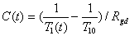
Here T_{1,0} is the pre-contrast T1 at that pixel, obtained from T1 map from Section 8.2, and R_{gd} is the relaxivity of Gd (obtained from manufacturer’s specifications).
T₁(t) can be derived from the SPGR imaging equation and is given by the following expressions (eqs 2-4): Let
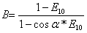
where α is the flip angle, TR is the repetition time, and S(t) and S(0) are the signal intensities at time t and averaged pre-contrast baseline, respectively, in the DCE-MRI sequence (eq 5). Then,
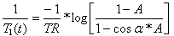
Calculate an Vascular Input Function
The intent of this step is to generate an accurate, patient-specific vascular input function to serve as an input to the vascular model. One way to accomplish this is to have an analyst draw a manual ROI within an artery, and use the mean enhancement curve within that ROI as the subject-specific VIF, as described by Vonken et al. (31). It has been demonstrated previously that this method has significant variability associated with it (32), due primarily to the spatially- and temporally-varying flow artifacts found in major arteries. A better option is to make use of an automated search technique to generate a locally optimal VIF. Several methods of accomplishing this have been described previously (33, 34)(35).

Identify Regions of Interest in the Dynamic Data
The intent of this step is to define the boundaries of the tumors of interest in the dynamic data in order to determine which voxels will contribute to the parameter set for each tumor. This step will generally be carried out by a trained and qualified radiologist using either manual tracing or a semi-automated boundary identification tool. (32)

Calculate the Vascular Parameters
The intent of this step is to generate the parameter set that will be used to characterize the tissues of interest. Parameters will be calculated based on the standard Tofts model (34), which is derived from the Kety equations (36). The vascular bed is modeled as a linear system, such that (eq 6):
with impulse response h(t) given by (eq 7):
where K^{trans} is the volume rate constant between blood plasma and extra-cellular extra-vascular space (EES) and k_{ep} is the rate constant between the EES and blood plasma. Given the tissue uptake curve, C_{t}(t), and the VIF, C_{p}(t) , K^{trans} and k_{ep} are estimated using a gradient-descent energy minimization scheme, by using already established Levenberg-Marquardt or Minpack-1 curve fitting algorithms, both of which require adequate baseline sampling(37) . Delay correction should be performed to shift the VIF curve to match the arrival time of the tumor curve prior to curve fitting.

A full parameter set will be calculated for each voxel within the defined tumor boundaries. Parameters may be reported out either as mean and median values per tumor or as histograms.

The blood normalized IAUGC_{BN} is measured from the area under the concentration curve up to 90 seconds post injection, normalized by dividing the area under the vascular input function curve also up to 90 seconds post injection. The following values serve as guidelines

9. Image Analysis
Analysis of DCE-MRI data is carried out in a series of distinct steps:

• Generate a native tissue T_{1,0} map using the VFA data.
• When required, apply time-series motion correction to the dynamic data.
• Convert DCE-MRI signal intensity data, SI(t), to gadolinium concentration ([Gd](t)).
• Calculate a vascular input function.
• Identify the region or regions of interest in the dynamic data.
• Calculate the DCE-MRI imaging biomarker parameters, K^{trans} and IAUGC_{BN}.
Each of these steps is addressed in detail below.
9.1. Input Data to Be Used
Processed magnitude images will be utilized for image analysis for input into the kernals described in the following sections
9.2. Methods to Be Used
Generate a T1 Map
The intent of this step is to provide a complete map of pre-contrast T1 values for the imaged slab. These values will then be used in the signal formation model based conversion of changes in signal intensity to gadolinium concentration. The slice locations, orientation and resolution of these images should be prescribed identically to the dynamic series, and this series should be acquired immediately prior to the dynamic series. The output of this step is an image of T1 values which can be co-registered to the dynamic series and used in subsequent calculations. The T1 values at each voxel location are calculated as follows [1]:
1. Create a vector x containing the signal intensity at each flip angle divided by the tangent of the flip angle.
2. Create a vector y containing the signal intensity at each flip angle divided by the sine of the flip angle.
3. For the n acquired flip angles create a set of points (x0,y0)… (xn,yn).
4. Fit a line with slope s to the set of points defined in Step 3.
5. T1 = -TR/ln(s).

The use of non-linear curve fitting methods (for example, simplex or Levenberg-Marquard techniques) to extract T1 from the signal intensities theoretically may be more robust to noise that the linearized solution presented above. Non-linear techniques may be used if they are validated using test images to perform no worse for then the solution above in the expected range of T1, equilibrium magnetization and noise of tumors and vessels to be imaged.

Apply Motion Correction to the Dynamic Data
The intent of this step is to correct for patient motion that occurs between acquired phases of the dynamic data due to respiration, swallowing, and other involuntary movements. This step is not intended to correct ghosting artifacts that can occur along the phase encoding direction within a particular image due to patient motion during acquisition. These artifacts are more or less intractable unless the motion is regular and easily modeled, and are best addressed by adjusting the phase/frequency encoding scheme to minimize their impact on structures of interest. In general, simple rigid shift or affine transform based registration methods will not be adequate for this step, due to the fact that the movement in question is typically limited to specific regions within the image – for example, the liver in a coronal scan of the abdomen may move substantially with respiration while the bulk of the body remains relatively motionless. Fully deformable registration methods based on optical flow may provide good results in some cases (28, 29) . However, these methods will frequently fail for the phases immediately surrounding the contrast injection. Semi-automated registration in which a user identifies the target tumor and only information drawn from that region is used to generate phase to phase shifts provides an alternative approach. This allows rigid shift methods using mutual information (30), which tend to be more robust than optical flow methods, to be employed. Finally, registration may be carried out manually or using simple shift registration techniques (21). Data corrupted with motion must be either corrected prior to analysis or discarded for subsequent pharmacokinetic analysis.

Convert SI(t) in the Dynamic Data to [Gd](t)
The intent of this step is to convert the arbitrary signal intensity units in the dynamic data into units of gadolinium concentration. This step should be applied after the regions of interest for analysis have been defined, but prior to the calculation of vascular parameters. Two methods for accomplishing this are defined below.
Method A: Conversion Using a Signal Formation Model Gadolinium concentration at each image pixel is given by )(eq 1):
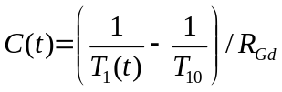 Eq. 1
Here T₁₀ is the pre-contrast T₁ at that pixel, obtained as described above, and R_{Gd} is the relaxivity of Gd (obtained from contrast agent manufacturer’s specifications).
T₁(t) can be derived from the SPGR imaging equation (neglecting T2* effects) and is given by the following expressions (eqs 2-4): Let
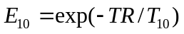 Eq. 2
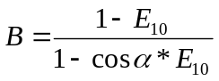 Eq. 3
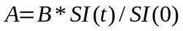 Eq. 4

where α is the flip angle, TR is the repetition time, and SI(t) and SI(0) are the signal intensities at time t and pre-contrast baseline respectively in the DCEMRI sequence (eq 5). Then,
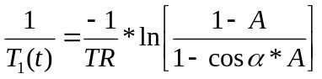 Eq. 5

Method B: Conversion Using a Look-Up Table

This method is motivated by the concern that inaccuracies in T1 mapping and/or co-registration of initial T1 values to the dynamic data may introduce excessive variability into the final calculated parameters. If this method is used, it is not necessary to acquire the T1 mapping data described above. This method assumes a high degree of response uniformity, and so may be limited in cases where phased array coils are used. In general it is recommended to use the inherent body coil for both transmit and receive when using this method. It should also be noted that the use of this method will introduce a uniform bias in the estimation of quantitative parameters which will impact absolute measurements, but will not affect quantification of change, for example from one exam to another. This method has been shown to yield better test-retest reproducibility than T1-based quantification method(14) [Reference: Ashton JMRI 2008, Frederickson ASCO 2011]

This method requires that a phantom containing a range of concentrations of gadolinium and a range of baseline T1 values (generally obtained via different concentrations of copper sulfate or a similar compound) is scanned using the dynamic protocol on each scanner that will be used for the study. Data from these phantoms can then be used to construct a look-up table relating baseline T1, signal delta, and gadolinium concentration. In order to create this look-up table, a linear correlation is performed between the difference of signal intensity between that in a phantom concentration sample and a sample with no gadolinium concentration (used as x-axis values) and the nominal R1 (1/T1) of the concentration sample. The resulting slope m then be used to estimate Gd concentration C using the equation C = m * [SI(t) - SI(0)], where SI(t) is the signal intensity in the dynamic data for a given time point t, and SI(0) is the signal intensity in the same location at baseline (before contrast agent injection).

Calculate an Vascular input Function
The intent of this step is to generate an accurate, patient-specific vascular input function to serve as an input to the vascular model. One way to accomplish this is to have an analyst draw a manual ROI within an artery, and use the mean enhancement curve within that ROI as the subject-specific VIF, as described by Vonken et al. (31). It has been demonstrated previously that this method has significant variability associated with it (32), due primarily to the spatially- and temporally-varying flow artifacts found in major arteries. A better option is to make use of an automated search technique to generate a locally optimal VIF. Several methods of accomplishing this have been described previously (33, 34) .(35)

The signal for the vascular input function can then be converted into concentration using either Method A or B as described above.

In some cases, data driven vascular input functions may be difficult to measure accurately due to anatomy, motion, flow effects, and T2* effects. In these situations, alternative methods of using population averaged vascular input functions, or reference tissue based vascular input functions may be used. These methods in general lead to poorer characterization of subject-specific physiology and lead to poorer reproducibility.

Identify Regions of Interest in the Dynamic Data
The intent of this step is to define the boundaries of the tumors of interest in the dynamic data in order to determine which voxels will contribute to the parameter set for each tumor. This step will generally be carried out by a trained and qualified radiologist using either manual tracing or a semi-automated boundary identification tool. (32)

Calculate the Vascular Parameters
The intent of this step is to generate the parameter set which will be used to characterize the tissues of interest. Parameters will be calculated based on the standard Tofts model (34), which is derived from the Kety equations (36). The vascular bed is modeled as a linear system, such that (eq 6):
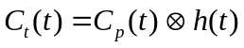 Eq. 6
with impulse response h(t) given by (eq 7):
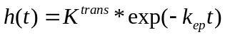 Eq. 7
where K^{trans} is the volume rate constant between blood plasma and extra-cellular extra-vascular space (EES) and k_{ep} is the rate constant between the EES and blood plasma. Given the tissue uptake curve C_{t}(t) and the VIF C_{p}(t) , K^{trans} and k_{ep} are estimated using a gradient-descent energy minimization scheme, by using already established Levenberg-Marquardt or Minpack-1 curve fitting algorithms, both of which require adequate baseline sampling(37) . Delay correction should be performed to shift the VIF curve to match the arrival time of the tumor curve prior to curve fitting.
A full parameter set will be calculated for each voxel within the defined tumor boundaries. Parameters may be reported out either as mean and median values per tumor or as histograms.
The blood normalized IAUGC_{BN} is measured from the area under the concentration curve up to 90 seconds post injection, normalized by dividing the area under the vascular input function curve also up to 90 seconds post injection.
9.4. Platform-specific Instructions
Appendix G.4 lists image analysis parameter values for specific models/versions that can be expected to produce data meeting the requirements of Section 9.

10. Parametric image analysis
Derivation of quantitative parameters characterizing the response associated with a lesion of interest from parameter maps is a multistep process, most, if not all, of which are being studied by on-going research. There are several choices that can be made at any of these steps, and the effect of these choices on the validity of results and variability of parametric maps has not yet been fully characterized.

Central site analysis.
10.1. Input Data to Be Used
The input data that will be utilized will be in the form of concentration curves, and parametric maps of K^{trans} and IAUGC_{BN} from which ROI analysis can be performed. One shortcoming of the 3D fast spoiled gradient recalled echo technique used to acquire the dynamic images is that initial and end slice locations give inaccurate results due to wraparound artifact and variability in excitation profile. The extent of this wraparound artifact is dependent on slice-oversampling and other vendor specific techniques. Image analysis can begin by removing areas that are subjectively compromised by wraparound artifact. One method that can be used to determine which slices to discard is to closely examine the T₁ maps obtained at the initial and end slice locations. Marked non-physiologic overestimations of T₁ on initial and end slices are indicative of artifact.
10.2. Methods to Be Used
The following methodology for image interpretation of parametric maps should be performed in order to ensure complete reproducible and interpretable results.

Tumor ROI Definition.
• The first step in the extraction of quantitative parameters (K^{trans} or IAUGC_{BN}) associated with a particular neoplastic or other lesion is to segment this lesion from adjacent tissues. Which techniques of segmentation are ideal or even acceptable for a given application is the subject of on-going research, but it is clear that the segmentation techniques used must be tailored to the particular organ system being studied with DCE-MRI. The following guidelines are proposed:

• The committee does not recommend an analysis scheme where an operator defines a lesion by placing regions of interest directly on parameter maps as that will introduce bias into the results

• Less subjective results can be obtained by using correlative imaging to define the lesion. These correlative images may be obtained at the same imaging session but not directly related to the DCE-MRI images. (For example, a T2-weighted image of an organ, which clearly delineates lesions and their boundaries, may be used.) Correlative images should be obtained in the same imaging plane as the DCE-MRI series, with similar FOV and spatial resolution, if feasible. In this scenario, a registration step will likely be required (see 9.2)

• An alternative approach, which may be helpful if the lesion is well delineated on contrast-enhanced T1-weighted MRI, is to create summation images (images obtained by adding together images obtained on the dynamic series for each slice location). The average images can be used to segment the lesion on one or more slices, and because these segmentations are (in the absence of patient or organ motion) registered to the dynamic series, the segmentations can be used to directly extract lesion-based parameters from parametric maps.

• Because of the presence of image noise on source images of the dynamic series, along with time-dependent changes in signal intensity which may blur or even obliterate the border between lesion and background tissue, analysis schemes in which lesions are segmented independently on each image of the dynamic series should be avoided where possible. In the case of moving organs, it may be necessary to segment the lesion of interest on early (preferably, before the arrival of the contrast bolus) or late dynamic images and estimate the position of the segmented lesion in intermediate time points.

• Although lesions can be segmented using manual techniques, several techniques are available that allow a semi-automated approach to be used. The training of operator or operators in performing segmentations should be documented, preferably with training sets.

Registration of segmentations and parameter maps.

Unless the segmentations are derived from relatively motion-free or motion-corrected dynamic images (for example, summary images) image registration techniques may need to be used to place the segmentations and parameter maps into a single anatomic framework (see Section 9.2). The choice of registration technique to be used depends upon the organ system being imaged; the details of this are beyond the scope of this document. In performing registration techniques, either images aligned with the parametric maps or correlative images upon which the segmentation was performed are used as the target image for registration. The registered images are then interpolated from the source images. In interpolating parameter maps to match correlative images, tri-linear techniques are favored to avoid artifacts that may be associated with more advanced interpolation techniques.

Extraction of values for statistical comparison

To derive values for statistical comparison from K^{trans} or IAUGC_{BN} parameter maps, median, mean and standard deviation of the pixel values should be calculated, and the median is considered the primary figure of merit. In a patient with multiple lesions due to metastatic disease, each lesion should be reported and tracked separately. In a patient with multiple lesions due to recurrent local tumor (for example, recurrent glioblastoma) per-patient figures of merit should be reported by aggregating the results of the multiple lesions.

Choice of time point for segmentation.

As a rule, the K^{trans} or IAUGC_{BN} at a given time point should be extracted using tumor ROIs segmented from the same imaging examination. However, in the situation where anti-angiogenic therapies are evaluated and post-therapy imaging is performed within 72 hours of initial treatment with the anti-angiogenic agent, it is acceptable to use a recent (within 1 week) pre-therapy time point to provide the segmentation used to define the lesion on the immediate post-therapy imaging session. In this case, it is presumed that changes in the appearance of lesions on immediate post-therapy study are due to immediate decreases in permeability or blood flow rather than decrease in lesion volume.

In settings where analysis is performed retrospectively, all time points should be made available to the reader simultaneously to allow for consistency in choice of tumor(s) for segmentation, and to ensure that similar regions of large tumors have been sampled and segmented. In the case of manual VIF segmentation, such workflow analyses also allow for greater standardization of the region of the aorta or other artery used in the analysis. In such settings, the reader should be blinded to the nature of each time point, so that inherent bias in tumor and/or VIF segmentation does not influence the results.

11. Archival and Distribution of Data
Archival and data distribution procedures are recommended so that all analysis results can be recomputed for verification and validation purposes. In addition to saving of all original images in DICOM formats, the following information must be archived along with the image data:
11.1. Post-Processed Data
VIF: Detailed specification of the vascular input function selection. This may include a binary mask of pixels selected for arterial input function, or may consist of a tabulated text file containing RAS coordinates co-ordinates of the VIF pixel locations.

Registration: Recorded parameters and user inputs required for image registration, if used. Time-series image registration may be used to align data spatially over time. Any parameters which control the performance of the registration algorithm (metric used, optimization parameters, user click points/sub regions used for alignment, etc) must be stored in suitable format. It is preferred to save the registration transform parameters so that identical registration can be reproduced in a multi-center environment.
11.6. Analysis Results
All regions of interest where analysis is performed and statistics are computed should be saved. In addition, all computed maps – K^{trans} and IAUGC_{BN}, should be saved in DICOM and DICOM secondary capture modes. K^{trans} min⁻¹ * 10000.
11.7. Interpretation Results
See 11.6

12. Quality Control
The following section deals with all aspects of quality control in DCE-MRI studies. This includes selecting and qualifying an MRI imaging center, MRI personnel, and specific MRI scanners. In addition, the use of phantom imaging (prior to study initiation and ongoing) is discussed. Finally, post image acquisition quality assessment is detailed. Details of these processes will vary for investigator-initiated single site studies versus sponsor-driven multi site studies.

Mechanisms for appropriate patient and tumor selection, image acquisition, and post processing are discussed throughout the document.
12.1. Selection of appropriate imaging centers for DCE-MRI studies
Typically sites are selected for DCE-MRI due to their competence in clinical oncology and access to a sufficiently large patient population under consideration. Sites must also be highly competent in clinical MRI techniques appropriate to the area(s) of anatomy to be imaged during the DCE-MRI study. In order to ensure high quality DCE-MRI results, it is essential to implement procedures that ensure quality assurance of the scanning equipment and reliable image acquisition methodology. These processes must be set-up at the outset, and followed throughout the duration of the study. An site “imaging capability assessment” prior to site selection is therefore a requirement for any DCE-MRI study. This will include assessment of:
- appropriate imaging equipment and quality control processes
- appropriate injector equipment and contrast media
- experienced MR technologists or technical MR experts
- experienced MR radiologists or other anatomic experts
- procedures to assure imaging protocol compliance during the trial

12.1.1 DCE-MRI Acquisition Scanner
DCE-MRI studies as developed in this profile require a 1.5 T MR scanner. The scanner software version should be identified and tracked across time, with updates and changes in scanner software noted during the course of a trial.

Proper receiver coil maintenance must be performed to ensure adequate coil performance. Alternate receiver coil systems must be available in the event that coil malfunction is identified prior to or during a DCE-MRI study.

The MRI scanner and receiver coils must undergo routine quality assurance and quality control processes (including preventive maintenance schedules) appropriate for clinical MRI applications. In addition, in order to assure adequate quantitative MR imaging results, additional quality control measures are required, as discussed below.

It is beneficial to identify and qualify more than one 1.5T MRI scanner at the site, if such are available for study use. This will ensure that if the primary MRI scanner is temporarily unavailable, the DCE-MRI study may proceed on a secondary .

12.1.2 DCE-MRI Acquisition Scanner

A power injector is required for all DCE-MRI studies. The power injector needs to be properly serviced and calibrated.

12.1.3 MR Technologists or other Site Personnel performing DCE-MRI studies
MR technologists or other imaging expert(s) performing DCE-MRI procedures should be MR certified according to local regulations or institutional requirements. These individuals should have prior experience in conducting dynamic contrast enhanced imaging. The personnel should also be experienced in clinical study related imaging and should be familiar with good clinical practices (GCP). Competence in the performance of DCE-MRI should never be limited to a single individual at the imaging center, as scheduled and unplanned personnel absences are to be expected in the course of a DCE-MRI trial.

12.1.4 MR Radiologists or other anatomic experts
As tumor identification and selection is a critical component of the DCE-MRI study, sites performing DCE-MRI must have access to highly qualified MRI radiologists or other experts in MRI anatomic assessment. These individuals must be available during each DCE-MRI study to confirm adequate tumor selection and slab placement. In some settings, (e.g. brain tumors), it may be feasible for tumor identification and slab placement to be performed by the MR technologist, with oversight by a neuro-radiologist. In other cases (e.g. wide-spread metastatic disease in the chest, abdomen, or pelvis), it is accepted that a radiologist or other anatomic specialist must be available to identify tumor locations prior to contrast injection. It is expected that more than one anatomic specialist be available at a site performing should the primary anatomic specialists not be available for a given study.

12.1.5 Site compliance with protocol requirements
Imaging centers participating in DCE-MRI trials must adhere to accepted standards of quality control in imaging studies. This include processes to identify patients who are participants in research studies, personnel familiar with local IRB and other regulatory practices, familiarity with source documentation, and reporting of protocol deviations and adverse events. Imaging centers must be able to document their compliance with DCE-MRI procedures in order to facilitate central quality control and auditing processes. Centers participating in multi-siter trials must be familiar with protocol-directed methods for image transfer of HIPAA-compliant anonymized imaging data, properly annotated, to central analytic laboratories.

12.2 Site qualification process

12.2.1 Site readiness

Site readiness for DCE-MRI should be documented prior to the initiation of the DCE-MRI trial. In single-site studies initiated by in-house investigators, imaging procedures should be reviewed with the DCE-MRI team prior to study initiation. In multi-site studies, site readiness assessment can begin with a simple questionnaire completed as a pre-qualification step. A subsequent site visit prior to DCE-MRI study initiation is recommended. During the site visit, study related imaging procedures and protocols are discussed. Ideally, all DCE-MRI scan parameters are reviewed and entered at the MR scanner at the time of the study visit. In some cases, initial phantom scanning can be performed during the site visit to familiarize local MR personnel with proper phantom handling, set-up, and scanning.

12.2.2 Scanner qualification

MR scanners should be identified based on their vendor, model, and machine name. Hardware specifications (maximum gradient strength, slew rate, etc.) should be documented. Software versions in place at the time of trial initiation, and at all upgrades should be documented as well. Local receive coils to be used should be noted, with quality checks per local institutional methods documented. Power injector models should be noted, including date of most recent calibration.

    - Phantom imaging

To qualify the MRI scanner, a phantom imaging process is required. The QIBA DCE-MRI phantom, or a similar multi-compartment phantom with range of R1 relaxation rate values appropriate for DCE-MRI should be utilized. With the exceptions noted below, imaging of the phantom should otherwise be performed using the same R1 mapping and DCE-MRI acquisitions that are to be used in the clinical research protocol. Coil placement should approximate that which would be used by the site for the typical patient and anatomy of interest.

Regardless of the intended imaging plane(s) for subjects in DCE-MRI studies, coronal imaging plane is recommended for phantom imaging in order to allow for uniformity of the phantom compartment slice cross-section profile. However, if oblique plane imaging is to be performed in the course of the DCE-MRI study, an additional set of scans with a 45% obliquity should be obtained, as gradient hardware may lead to altered acquisition parameters in the setting of oblique plane prescription.

    - Phantom imaging data analysis

Phantom data should be analyzed in a uniform method by a centralized DCE-MRI image analysis center. Assurance should be made by the central site that the phantom scan orientation is correct, and appropriate image rotations or inversions may be required (and documented by the image analysis center).

For all phantom image tests, a single central slice is utilized. Uniform ROI circles are placed within each phantom compartment, avoiding the edges of the compartments where signal intensity may be altered by Gibbs lines or other artifacts. Mean and standard deviation of the signal intensities within each ROI should be noted. There are three categories of DCE-MRI phantom data analysis: signal stability, signal linearity, and R1 precision. In all cases, analysis should use a single central slice of the phantom data for analysis.

12.2.4.1. Signal stability

The signal stability test is performed using the DCE-MRI acquisition method to be used for the dynamic gadolinium enhanced imaging. The duration of this scan should be at least 6 minutes to test magnet stability. A single R1 compartment with adequate SNR (10:1 or higher) is required. The mean SI in the ROI is then plotted over time. The plot should be linear and horizontal with no upward or downward trends. The rms noise calculation should be similar across all aspects of the scan.

Marked deviations or drift of signal intensity over time indicate magnet instability, and should initiate a thorough evaluation of the magnet by the on-site MR physicist or site engineer prior to use in the DCE-MRI trial. The source of magent instability should be determined and corrected prior to use in the DCE-MRI trial.

12.2.4.2 Signal linearity

In cases where signal intensity differences are to be used as a marker of tumor gadolinium concentration (see section X), the linearity of MRI signal intensity with respect to R1 over a range of R1 values is required. While published guidelines on the allowed deviation from linearity do not exist, a linear correlation coefficient between SI and R1 of 0.9 or higher is expected.

If a good linear correlation between SI and R1 is not achieved, it is recommended that the receive coil array used for phantom imaging be evaluated to ensure that coil failure was not a cause of the abnormal results. The phantom image may be repeated with a different local coil array, or with the body coil as receiver to further evaluate this issue.

If linearity of SI vs. R1 is still not achieved, it is recommended that the phantom scan be repeated with a larger flip angle, in order to increase the relative T1 weighting of the images.

12.2.4.3 R1 precision

If T1-dependent analysis is intended for the DCE-MRI study, the fidelity of T1 measurement should be assessed based on the phantom imaging. As uncertainty in the measurement of T1 is an important contributor to concentration measurement bias (38), the measured phantom R1 values based on the VFA method [insert equation here?] should be compared within the known R1 values calibrated based on non-flip angle dependent methods (such as IR-prepped imaging). Simulation studies suggest that variation in the R1 value by greater than 15% form actual may severely affect the reliability of the DCE-MRI quantification when T1-dependent modeling of tumor gadolinium concentration in DCE-MRI studies is used.

If accurate R1 values can not be reproduced, it is recommended that T1-dependent modeling not be performed.

    - Ongoing MRI scanner quality control

The phantom scans and analysis should be repeated at regular intervals, such as every 3 months, during the course of the study. Any changes to scanner equipment, including major hardware changes or any software version change, need to be documented and will result in the need for imaging qualification renewal prior to repeat imaging. In particular, it is strongly recommended that patients undergoing longitudinal study be scanned on the same MRI system with the same software version whenever possible. Sites performing DCE-MRI studies should be informed of planned software upgrades, when possible deferring such upgrades until serial imaging of all currently enrolled patients is complete.

    - Use of Human test subjects

Given the complexities of local site regulatory environments, it is recognized that the use of human test subjects to qualify DCE-MRI imaging scanners and sites may not be feasible. In such cases, it is strongly encouraged that the initial patients accrued on a DCE-MRI trial at each site be considered a “test subject” and that the data for that patient not be analyzed with the remainder of the cohort. Central analysis of the initial patient data will then serve to finalize the qualification of the DCE-MRI center.

12.3. Quality Control of DCE-MRI studies
12.3.1 Determination of suitable tumor lesions

Patients suitable for DCE-MRI analysis must possess at least one tumor >=2cm, well removed from areas subject to large degrees of cardiac pulsatility artifact, that is not largely cystic of necrotic. Determination of patient eligibility is usually based on pre-enrollment imaging (often CT or clinical MRI) which then serves as a baseline study for subsequent assessments for tumor response or progression. The site radiologist then reviews these images prior to enrollment to ascertain the location of the most suitable tumor lesion(s) for analysis.

12.3.2 Selection of target lesion

Once the MRI scan commences, the radiologist or anatomic expert will review the pre-gadolinium imaging to identify putative target lesions. The DCE-MRI study then proceeds with slap placement and T1 mapping/dynamic enhanced imaging once the target lesion is identified. Sites should strive inspect these images to ensure absence of substantial artifacts (e.g. phase wrap, pulsatility) overlying the target lesion, with protocol specified adjustments to patient positioning and slab placement prior to continuing the DCE-MRI study. Once the final slab placement is confirmed, grid line overlays of the DCE-MRI slab on routine anatomic imaging (usually axial plane) is recommended to facilitate DCE-MRI slab placement on subsequent visits.

12.3.3 Determination of subjects unsuitable for DCE-MRI analysis

Despite best efforts and protocol adherence, on occasion, a patient enrolled and imaged in DCE-MRI study will be found to be ineligible for subsequent analysis. Reasons for eliminating patients for analysis include:

- Lack of a tumor of suitable size in the usable DCE-MRI imaging volume
- Unacceptable pulsatility, wrap, or metallic artifact involving all tumors in the usable DCE-MRI imaging volume
- All target lesions in the DCE-MRI imaging volume determined to be largely cystic or necrotic

Determination of patient eligibility should be made by an independent reviewer who is blinded to other attributes of patient data, including (when applicable) randomization arm/drug treatment, toxicity, and clinical outcomes. Decisions on eligibility should be made on the basis of visual image assessment prior to analysis of DCE-MRI data. Quantitative criteria for defining tumors that are largely cystic or necrotic (such as percentage of pixels with enhancement above a certain threshold) should be defined in the protocol to avoid bias in decisions to eliminate patients form further DCE-MRI assessment.

12.3.4 Determination of DCE-MRI exams unsuitable for DCE-MRI analysis

In addition, individual DCE-MRI examinations may be deemed nonanalyzable based on a variety of technical deviations. These may include:

- Failure of gadolinium injection
- Gross patient motion not correctable with motion correcting algorithms
- Failure of the imaging site to replicate the imaging parameters within acceptable standards of deviation from protocol specifications
- Failure of the imaging site to replicate anatomic DCE-MRI slab placement
- Whenever possible, all anticipated instances where individual DCE-MRI data will be removed from analysis

Whenever possible, all anticipated instances where individual DCE-MRI data will be removed from analysis should be prespecified in the DCE-MRI protocol.

12.3.5 Editing of DCE-MRI exams prior to DCE-MRI analysis

It is recognized that DCE-MRI analysis requires post-processing of the DCE-MRI image sets. Most frequently, data sets will be subject to automated or semi-automated motion compensation schemes to eliminate or minimize the effects of image motion of subsequent DCE-MRI analysis. The methodology used for such post processing should be documented, ideally in the DCE-MRI protocol or the standard operating procedures of the central analysis laboratory. Motion correction matrices keyed to each temporal phase may be documented as part of the analysis routine, in order to facilitate replication of the data analysis when required.

In the course of post processing, individual phases of the DCE-MRI exam may be found to be severely compromised by image blur or degraded by other artifacts (such as random noise spikes). Judicious selection of phases to be eliminated for analysis may be made by the central analysis team, provided that the decision to eliminate such phases is determined prior to data analysis. Elimination of baseline or early post gadolinium phases is discouraged as such post processing may substantially alter the subsequent analysis. Data documenting these forms of post-processing should be maintained by the imaging analysis laboratory.

13. Imaging-associated Risks and Risk Management
MR safety considerations are to be established individually at each institution according to each institutions' radiology departmental guidelines and institutional review board (IRB) considerations to include policy guidelines on the following:
(1) laboratory screening for renal dysfunction prior to gadolinium based contrast administration
(2) contrast administration in pregnant patients and in patients who are lactating
(3) policy on patients receiving gadolinium based agents who have a positive history of a previous adverse event or events to iodinated or gadolinium based contrast agents to include serious and non-serious adverse events. The American College of Radiology Manual on Contrast Media Version 7 2010 can serve as a referenced guideline for each institutional policy development. This manual reflects policy statements previously released by the Food and Drug Administration (FDA) in the United States and its counterpart in the European Union, The Committee for Medicinal Products for Human Use (CHMP).

IV. Compliance
Typically clinical sites are selected due to their competence in oncology and access to a sufficiently large patient population under consideration. For DCE-MRI use as quantitative imaging biomarker it is essential to put some effort into an imaging capability assessment prior to final site selection for a specific trial. For imaging it is important to consider the availability of:
- appropriate imaging equipment and quality control processes,
- appropriate injector equipment and contrast media,
- experienced MR technologists for the imaging procedure, and
- processes that assure imaging protocol compliant image generation at the correct point in time.

Acquisition Scanner
1.5 T MR machines with 55-70 cm bores need to be available. The scanner needs to be under quality assurance and quality control processes (including preventive maintenance schedules) appropriate for quantitative MR imaging applications, which may exceed the standard requirements for routine clinical imaging or for MR facility accreditation purposes. The scanner software version should be identified and tracked across time. It might be beneficial to identify and qualify a second scanner at the site, if available. If this is done prior to the study start there will be no difficulties later on in case the first scanner is temporarily unavailable. Practically speaking sites are encouraged to perform longitudinal treatment trials on one instrument.

Contrast Inject Device
A power injector is required for DCE-MRI studies. It needs to be properly serviced and calibrated.

Software Analysis
When a site is performing parametric image analysis and interpretation, a DCE-MRI tool that complies with the Toft’s model should be utilized. In addition, for multi-institutional trials a central reading site is assumed.

Performing Site
MR technologists running DCE-MRI procedures should be MR certified according to local regulations. The technologists should have prior experience in conducting dynamic contrast enhanced imaging. The person should be experienced in clinical study related imaging and should be familiar with good clinical practices (GCP). A qualified backup person is needed that should fulfill the same requirements. Contact details for both technologists should be available in case of any questions.

Imaging qualification process:

The above-mentioned details can be obtained using a simple questionnaire as a pre-qualification step. If appropriate equipment and personnel are available, a site visit is recommended. During the site visit, study related imaging protocols are discussed and, ideally, all scan parameters are entered at the MR scanner.

To qualify the scanner, a phantom imaging process is strongly recommended. The QIBA DCE-MRI phantom, or a similar multi-compartment phantom with range of relaxation rate (T₁₀) values appropriate for the DCE-MRI study to be performed, should be used if the Profile Claim given above is to be assured. Data should be acquired from the multi-compartment phantom using the same T1 mapping and DCE-MRI acquisitions that will be used in the proposed clinical application or clinical research protocol (see Section 6).

The phantom scans should be repeated on a regular interval (e.g 3 months) during the course of the study. Ongoing image quality inspection on a per scan basis is essential. Any changes to scanner equipment, including major hardware changes or any software version change, need to be documented and will result in the need for imaging qualification renewal.

Site Analysis qualification:

The data analysis procedures to be used in the DCE-MRI application should be used to analyze the T1 mapping data and results compared to the known T1 values of the various compartments. As uncertainty in the measurement of T1 is an important contributor to concentration measurement bias (38), the measured values should compare within 15 % of the known values over a T1 range of approximately 50-1000 ms. The DCE-MRI data obtained from the phantom should be analyzed to confirm the correct temporal resolution and to provide SNR measurements and signal intensity vs. T₁₀ characteristics for the specific DCE-MRI acquisition protocol.

Significant variations in any of these parameters during the course of an ongoing longitudinal study can affect the resulting imaging biomarker determinations, in the case of this specific claim K^{trans} and IAUGC_{BN}, and such changes can readily occur if there are major changes in the scanner hardware or software, e.g., an update to the pulse sequence used for the DCE-MRI and/or T1 measurements or to the gradient subsystem.
All results shall be documented and, if they pass the established acceptance values, will constitute the site qualification documentation for the DCE-MRI procedure. This process ensures study specific training of the site personnel and needs to be documented and signed.

References

1. Tofts PS, Brix G, Buckley DL et al. Estimating kinetic parameters from dynamic contrast-enhanced T(1)-weighted MRI of a diffusable tracer: standardized quantities and symbols. J Magn Reson Imaging 1999; 10, 223-232.
2. Evelhoch JL. Key factors in the acquisition of contrast kinetic data for oncology. J Magn Reson Imaging 1999; 10, 254-259.
3. Ah-See ML, Makris A, Taylor NJ et al. Early changes in functional dynamic magnetic resonance imaging predict for pathologic response to neoadjuvant chemotherapy in primary breast cancer. Clin Cancer Res 2008; 14, 6580-6589.
4. Drevs J, Siegert P, Medinger M et al. Phase I clinical study of AZD2171, an oral vascular endothelial growth factor signaling inhibitor, in patients with advanced solid tumors. J Clin Oncol 2007; 25, 3045-3054.
5. Esserman L, Hylton N, Yassa L, Barclay J, Frankel S, Sickles E. Utility of magnetic resonance imaging in the management of breast cancer: evidence for improved preoperative staging. J Clin Oncol 1999; 17, 110-119.
6. Hawighorst H, Weikel W, Knapstein PG et al. Angiogenic activity of cervical carcinoma: assessment by functional magnetic resonance imaging-based parameters and a histomorphological approach in correlation with disease outcome. Clin Cancer Res 1998; 4, 2305-2312.
7. Hylton N. Dynamic contrast-enhanced magnetic resonance imaging as an imaging biomarker. J Clin Oncol 2006; 24, 3293-3298.
8. O'Connor JP, Jackson A, Parker GJ, Jayson GC. DCE-MRI biomarkers in the clinical evaluation of antiangiogenic and vascular disrupting agents. Br J Cancer 2007; 96, 189-195.
9. Rosen MA, Schnall MD. Dynamic contrast-enhanced magnetic resonance imaging for assessing tumor vascularity and vascular effects of targeted therapies in renal cell carcinoma. Clin Cancer Res 2007; 13, 770s-776s.
10. Solin LJ, Orel SG, Hwang WT, Harris EE, Schnall MD. Relationship of breast magnetic resonance imaging to outcome after breast-conservation treatment with radiation for women with early-stage invasive breast carcinoma or ductal carcinoma in situ. J Clin Oncol 2008; 26, 386-391.
11. Zahra MA, Hollingsworth KG, Sala E, Lomas DJ, Tan LT. Dynamic contrast-enhanced MRI as a predictor of tumour response to radiotherapy. Lancet Oncol 2007; 8, 63-74.
12. Leach MO, Brindle KM, Evelhoch JL et al. Assessment of antiangiogenic and antivascular therapeutics using MRI: recommendations for appropriate methodology for clinical trials. Br J Radiol 2003; 76 Spec No 1, S87-91.
13. NCI. Recommendations for MR measurement methods at 1.5 Tesla and endpoints for use in Phase 1/2a trials of anti-cancer therapeutics affecting tumor vascular function. Dynamic contrast MRI (DCE-MRI) guidelines resulted from the NCI CIP MR Workshop on Translational Research in Cancer. MR Workshop on Translational Research 2004;
14. Ashton E, Raunig D, Ng C, Kelcz F, McShane T, Evelhoch J. Scan-rescan variability in perfusion assessment of tumors in MRI using both model and data-derived arterial input functions. J Magn Reson Imaging 2008; 28, 791-796.
15. Dowlati A, Robertson K, Radivoyevitch T et al. Novel Phase I dose de-escalation design trial to determine the biological modulatory dose of the antiangiogenic agent SU5416. Clin Cancer Res 2005; 11, 7938-7944.
16. Ferl GZ, Xu L, Friesenhahn M, Bernstein LJ, Barboriak DP, Port RE. An automated method for nonparametric kinetic analysis of clinical DCE-MRI data: application to glioblastoma treated with bevacizumab. Magn Reson Med 2010; 63, 1366-1375.
17. Flaherty KT, Rosen MA, Heitjan DF, Gallagher ML, Schwartz B, Schnall MD, O'Dwyer PJ. Pilot study of DCE-MRI to predict progression-free survival with sorafenib therapy in renal cell carcinoma. Cancer Biol Ther 2008; 7, 496-501.
18. Galbraith SM, Lodge MA, Taylor NJ, Rustin GJ, Bentzen S, Stirling JJ, Padhani AR. Reproducibility of dynamic contrast-enhanced MRI in human muscle and tumours: comparison of quantitative and semi-quantitative analysis. NMR Biomed 2002; 15, 132-142.
19. Liu G, Rugo HS, Wilding G et al. Dynamic contrast-enhanced magnetic resonance imaging as a pharmacodynamic measure of response after acute dosing of AG-013736, an oral angiogenesis inhibitor, in patients with advanced solid tumors: results from a phase I study. J Clin Oncol 2005; 23, 5464-5473.
20. Morgan B, Thomas AL, Drevs J et al. Dynamic contrast-enhanced magnetic resonance imaging as a biomarker for the pharmacological response of PTK787/ZK 222584, an inhibitor of the vascular endothelial growth factor receptor tyrosine kinases, in patients with advanced colorectal cancer and liver metastases: results from two phase I studies. J Clin Oncol 2003; 21, 3955-3964.
21. Ng CS, Raunig DL, Jackson EF et al. Reproducibility of perfusion parameters in dynamic contrast-enhanced MRI of lung and liver tumors: effect on estimates of patient sample size in clinical trials and on individual patient responses. AJR Am J Roentgenol 2010; 194, W134-40.
22. Padhani AR, Hayes C, Landau S, Leach MO. Reproducibility of quantitative dynamic MRI of normal human tissues. NMR Biomed 2002; 15, 143-153.
23. Roberts C, Issa B, Stone A, Jackson A, Waterton JC, Parker GJ. Comparative study into the robustness of compartmental modeling and model-free analysis in DCE-MRI studies. J Magn Reson Imaging 2006; 23, 554-563.
24. Stevenson JP, Rosen M, Sun W et al. Phase I trial of the antivascular agent combretastatin A4 phosphate on a 5-day schedule to patients with cancer: magnetic resonance imaging evidence for altered tumor blood flow. J Clin Oncol 2003; 21, 4428-4438.
25. Wedam SB, Low JA, Yang SX et al. Antiangiogenic and antitumor effects of bevacizumab in patients with inflammatory and locally advanced breast cancer. J Clin Oncol 2006; 24, 769-777.
26. Wang Y, Spiller M, Caravan P. Evidence for weak protein binding of commercial extracellular gadolinium contrast agents. Magn Reson Med 2010; 63, 609-616.
27. Ledermann HP, Mengiardi B, Schmid A, Froehlich JM. Screening for renal insufficiency following ESUR (European Society of Urogenital Radiology) guidelines with on-site creatinine measurements in an outpatient setting. Eur Radiol 2010; 20, 1926-1933.
28. B H, B S. Determining optical flow. Artificial intelligence 1981;
29. Sharp GC, Kandasamy N, Singh H, Folkert M. GPU-based streaming architectures for fast cone-beam CT image reconstruction and demons deformable registration. Phys Med Biol 2007; 52, 5771-5783.
30. Pluim JP, Maintz JB, Viergever MA. Mutual-information-based registration of medical images: a survey. IEEE Trans Med Imaging 2003; 22, 986-1004.
31. Vonken EJ, van Osch MJ, Bakker CJ, Viergever MA. Measurement of cerebral perfusion with dual-echo multi-slice quantitative dynamic susceptibility contrast MRI. J Magn Reson Imaging 1999; 10, 109-117.
32. Ashton E, McShane T, Evelhoch J. Inter-operator variability in perfusion assessment of tumors in MRI using automated AIF detection. Med Image Comput Comput Assist Interv 2005; 8, 451-458.
33. Rijpkema M, Kaanders JH, Joosten FB, van der Kogel AJ, Heerschap A. Method for quantitative mapping of dynamic MRI contrast agent uptake in human tumors. J Magn Reson Imaging 2001; 14, 457-463.
34. Tofts PS, Kermode AG. Measurement of the blood-brain barrier permeability and leakage space using dynamic MR imaging. 1. Fundamental concepts. Magn Reson Med 1991; 17, 357-367.
35. E A. System and method for Identifying Optimized Blood Signal in Medical Images to Eliminate Flow Artifacts. 2007;
36. S K. Peripheral blood flow measurement. Methods in Medical research 1960; 8,
37. Ahearn TS, Staff RT, Redpath TW, Semple SI. The use of the Levenberg-Marquardt curve-fitting algorithm in pharmacokinetic modelling of DCE-MRI data. Phys Med Biol 2005; 50, N85-92.
38. Schabel MC, Parker DL. Uncertainty and bias in contrast concentration measurements using spoiled gradient echo pulse sequences. Phys Med Biol 2008; 53, 2345-2373.
39. Oken MM, Creech RH, Tormey DC, Horton J, Davis TE, McFadden ET, Carbone PP. Toxicity and response criteria of the Eastern Cooperative Oncology Group. Am J Clin Oncol 1982; 5, 649-655.

Appendices

Appendix A: Acknowledgements and Attributions
I. Executive Summary Jeffrey Evelhoch
II.Clinical Context and Claims Mitchell Schnall
III. Profile Details
- Reserved (included above)
- Reserved (relevance restricted to Protocol)
- Reserved (relevance restricted to Protocol)
- Subject Scheduling Alex Guimaraes
- Subject Preparation Alex Guimaraes
- Imaging-related Substance Preparaion and Administration Alex Guimaraes
- Individual Subject Imaging-related Quality Control
- Imaging Procedure Ed Jackson/Sandeep Gupta
- Image Post-processing Sandeep Gupta
- Image Analysis Ed Ashton
- Image interpretation Dan Barboriak
- Archival and Distribution of Data Sandeep Gupta
- Quality Control Mark Rosen
- Imaging associated Risks and Risk Management Orest Boyko

Appendix C: Conventions and Definitions
List of Abbreviations
- VIF: Vascular input function
- DCE-MRI: Dynamic contrast enhanced magnetic resonance imaging
- ECOG: Eastern Cooperative Oncology Group
- eGFR: estimated Glomerular Filtration Rate
- Gd-DTPA: Gadolinium – diethylene triamine pentaacetic acid
- IAUGCBN: Initial area under the Gadolinium concentration blood normalized
- Ktrans: permeability transfer constant
- QIBA: Quantitative Imaging Biomarkers Alliance
- ROI: Region of Interest
- VEGF: Vascular Endothelial Growth Factor
- VFA: Variable Flip angle
- VIF: Vascular input function

ECOG Performance Status Descriptions, by grade: (39)
0: Fully active, able to carry on all pre-disease performance without restriction
1: Restricted in physically strenuous activity but ambulatory and able to carry out work of a light or sedentary nature, e.g., light house work, office work
2: Ambulatory and capable of all selfcare but unable to carry out any work activities. Up and about more than 50% of waking hours
3: Capable of only limited selfcare, confined to bed or chair more than 50% of waking hours
4: Completely disabled. Cannot carry on any selfcare. Totally confined to bed or chair
5: Dead

Appendix D: Documents included in the imaging protocol (e.g., CRFs)
N/A

Appendix E: Associated Documents
N/A

Appendix F: Spreadsheet on reproducibility data

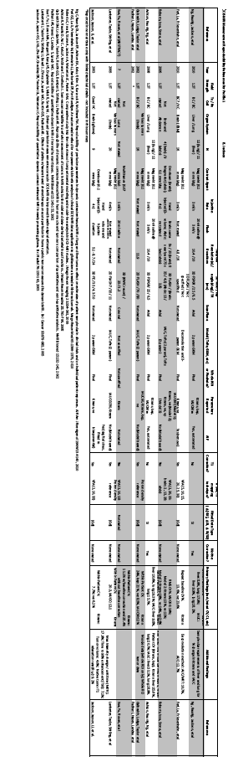

Appendix G: Model-specific Instructions and Parameters
The presence of specific product models/versions in the following tables should not be taken to imply that those products are fully compliant with the QIBA Profile. Compliance with a profile involves meeting a variety of requirements of which operating by these parameters is just one. To determine if a product (and a specific model/version of that product) is compliant, please refer to the QIBA Conformance Document for that product. G.1. Image Acquisition Parameters The following technique tables list acquisition parameter values for specific models/versions that can be expected to produce data meeting the requirements of Section 7.1.
These technique tables may have been prepared by the submitter of this imaging protocol document, the clinical trial organizer, the vendor of the equipment, and/or some other source. (Consequently, a given model/version may appear in more than one table.) The source is listed at the top of each table.
Sites using models listed here are encouraged to consider using these parameters for both simplicity and consistency. Sites using models not listed here may be able to devise their own acquisition parameters that result in data meeting the requirements of Section 7.1 and conform to the considerations in Section 13.
In some cases, parameter sets may be available as an electronic file for direct implementation on the imaging platform.

Siemens
QIBA DCE-MRI Abdominal Protocol for VA30 Software

David Purdy 5/17/11
Based on protocol from the University of Pennsylvania

parameter | value | notes
Routine tab
slabs | 1
distance factor | irrevelant
position | as needed
orientation | coronal
phase enc. dir. | R >> L
rotation | 0.0 deg
phase oversampling | 0%
slice oversampling | 0%
slices per slab | 26 | Reconstructed images, interpolated by zero-filling. The slab thickness is 4.25 x 26 = 110.5 mm
FoV read | 400
FoV phase | 81.3% | 325 mm
slice thickness | 4.25 mm | For 3-D, this is the slice spacing. The true slice thickness is this number divided by the slice resolution, in this case 4.25 / 0.62 = 6.85 mm.
TR | 5.03 ms
TE | 1.9 ms
averages | 1 | NEX
concatenations | 1
filter | none
coil elements | as needed
Contrast tab
flip angle | 30 deg
fat suppression | none
water supp. | none
Dixon | no
save original images | on
averaging mode | short term
reconstruction | magnitude
measurements | 40
measurement series | each measurement
pause after measurement | 0 sec
Resolution tab
base resolution | 256 | readout pixel size 1.56 mm
phase resolution | 62% | phase pixel size 2.52 mm
slice resolution | 62% | Controls zero-filling in slice. If no partial Fourier processing is used, 16 partitions are acquired. The raw matrix is padded with 10 zeros to reconstruct 26 slices: 16 / 0.62 = 26.  Divide the slice spacing by the slice resolution to get the slice thickness: 4.25 / 0.62 = 6.85 mm
phase partial Fourier | choose 7/8ths here or below (slice) | If 7/8ths is chosen, partial Fourier processing is used to reduce the number of acquired lines to:  256 x 0.62 x 0.813 x 7/8 = 113
slice partial Fourier | choose 7/8ths here or above (phase) | If 7/8ths is chosen, 14 partitions are acquired to provide the data for 16. Ten additional zeros are added to reconstruct 26 slices.
interpolation | on | In-plane zero-filling to 512 x 512.
PAT mode | none | No SENSE or GRAPPA
matrix coil mode | as needed
image filter | off
distortion correction | off | also called “large FoV filter”
prescan normalize | off
normalize | off | Acts on individual slices, so must be turned off.
raw filter | off
elliptical filter | off
Geometry card
multi-slice mode | irrelevant
series | irrelevant
special sat. | none
(remainder) |  | May be ignored.
System Card
shim mode | standard
save uncombined | off
adjust with body coil | off
Physio card
1st signal/mode | none
rsp. control | off
Inline card
3D centric reordering | off
(remainder) | off
Sequence card
introduction | off
dimension | 3D
elliptical scanning | off
asymmetric echo | allowed, weak
contrasts | 1
bandwidth | 250 Hz/pixel | Corresponds to ± 32 KHz.
optimization | min TE
RF pulse type | normal
gradient mode | fast | (delete text in this cell)
excitation | slab-sel.
RF spoiling | on | For the FLASH sequence.
Tool Tips |  | Roll the cursor over the appropriate item to view these.
readout echo position | 38% | Roll over “echo asymmetry.”
matrix size | 129 x 256 | Roll over “phase resolution.” This size includes the effects of reduced pixel resolution and rectangular FoV.
slab thickness | 110 mm
pulse sequence | fl3d_vibe | Roll over the pulse sequence abbreviation.

SNR protocol: change measurements to 8 and flip angle to 15º.
Variable flip angle protocol for T₁: one measurement, 4 averages, and flip angles of 2º, 5º, 10º, 15º, 20º, 25º, and 30º.

QIBA DCE-MRI Abdominal Protocol for VB15, VB17, and VD11 Software
5/19/11
These are the 400 Hz/pixel protocols recommended by the factory.

parameter | value | notes
Routine tab
slabs | 1
distance factor | irrelevant
position | as needed
orientation | coronal
phase enc. dir. | R >> L
rotation | 0.0 deg
phase oversampling | 0%
slice oversampling | 0%
slices per slab | 26 | Reconstructed images, interpolated by zero-filling. The slab thickness is 4.25 x 26 = 110.5 mm
FoV read | 400
FoV phase | 81.3% | 325 mm
slice thickness | 4.25 mm | For 3-D, this is the slice spacing. The true slice thickness is this number divided by the slice resolution, in this case,  4.25 / 0.62 = 6.85 mm.
TR | 3.61 ms  3.91 ms  4.76 ms | VD11, Aera  VB17, Espree  VB15B, Verio
TE | 1.49 ms  1.48 ms  1.43 ms | VD11, Aera  VB17, Espree  VB15B, Verio
averages | 1 | NEX
concatenations | 1
filter | none
coil elements | as needed
Contrast tab
flip angle | 30 deg
fat suppression | none
water suppression | none
Dixon | no
save original images | on
averaging mode | short term
reconstruction | magnitude
measurements | 50 | as needed
measurement series | each measurement
pause after measurement | 0 sec | for all measurements
Resolution tab
base resolution | 256 | readout pixel size 1.56 mm
phase resolution | 62% | phase pixel size 2.52 mm
slice resolution | 62% | Controls zero-filling in slice.  Sixteen partitions are acquired. The raw matrix is padded with 10 zeros to reconstruct 26 slices:  16 / 0.62 = 26  Divide the slice spacing by the slice resolution to get the slice thickness: 4.25 / 0.62 = 6.85 mm
phase partial Fourier | off | No further reduction in the number of acquired lines:  256 x 0.62 x 0.813 = 129
slice partial Fourier | off | No further reduction in the number of acquired partitions (16).
interpolation | on | In-plane zero-filling to 512 x 512.
PAT mode | none | No SENSE or GRAPPA
matrix coil mode | as needed
image filter | off
distortion correction | off
prescan normalize | off
normalize | off | Acts on individual slices, so must be turned off.
B₁ filter | off
raw filter | off
elliptical filter | off
POCS | off
Geometry card
multi-slice mode | irrelevant
series | irrelevant
special sat. | none
Set-n-Go Protocol | off
inline composing | off
System Card
shim mode | tune up
save uncombined | off
adjust with body coil | off
confirm freq. adjustment | off
Physio card
1st signal/mode | none
resp. control | off
Inline card
3D centric reordering | off
(remainder) | off
Sequence card
introduction | off
dimension | 3D
elliptical scanning | off
asymmetric echo | allowed, weak
contrasts | 1
bandwidth | 400 Hz/pixel | Corresponds to ± 51.2 KHz.
optimization | min TE
RF pulse type | normal
gradient mode | fast  normal  fast | VD11, Aera  VB17, Espree  VB15B, Verio
excitation | slab-sel.
RF spoiling | on | For the FLASH sequence.
Tool Tips |  | Roll the cursor over the appropriate item to view these.
readout echo position | 38% | Roll over “echo asymmetry.”
matrix size | 129 x 256 | Roll over “phase resolution.” This size includes the effects of reduced pixel resolution and rectangular FoV.
slab thickness | 110 mm
pulse sequence | fl3d_vibe | Roll over the pulse sequence abbreviation.

SNR protocol: change measurements to 8 and flip angle to 15º.
Variable flip angle protocol for T₁: one measurement, 4 averages, and flip angles of 2º, 5º, 10º, 15º, 20º, 25º, and 30º.

GE
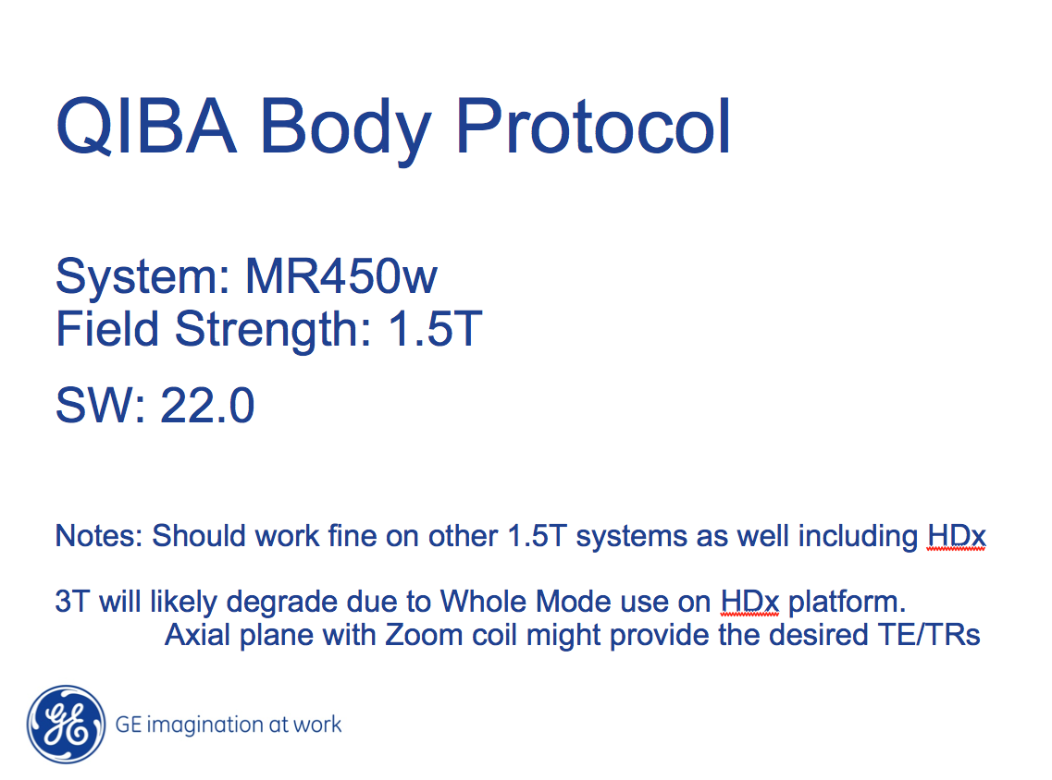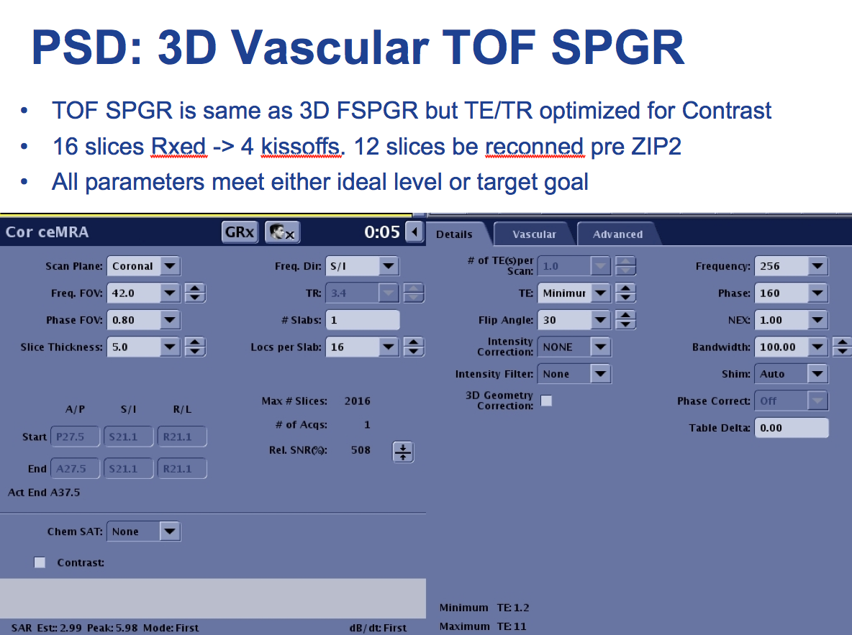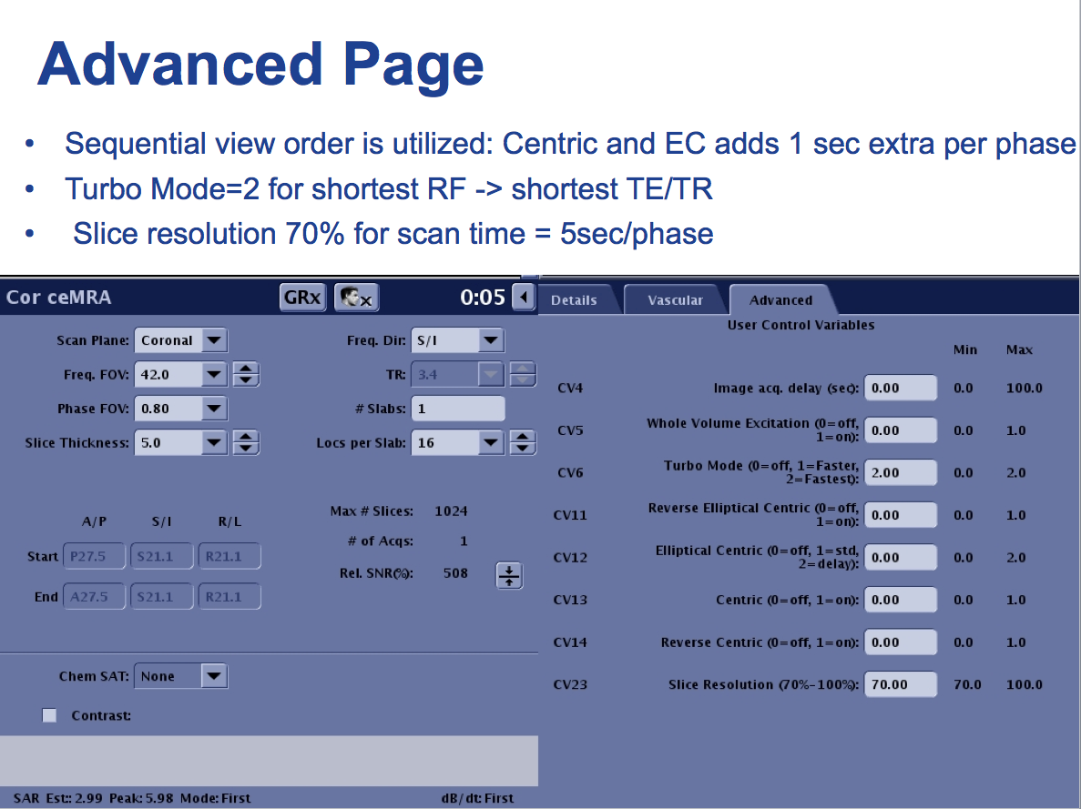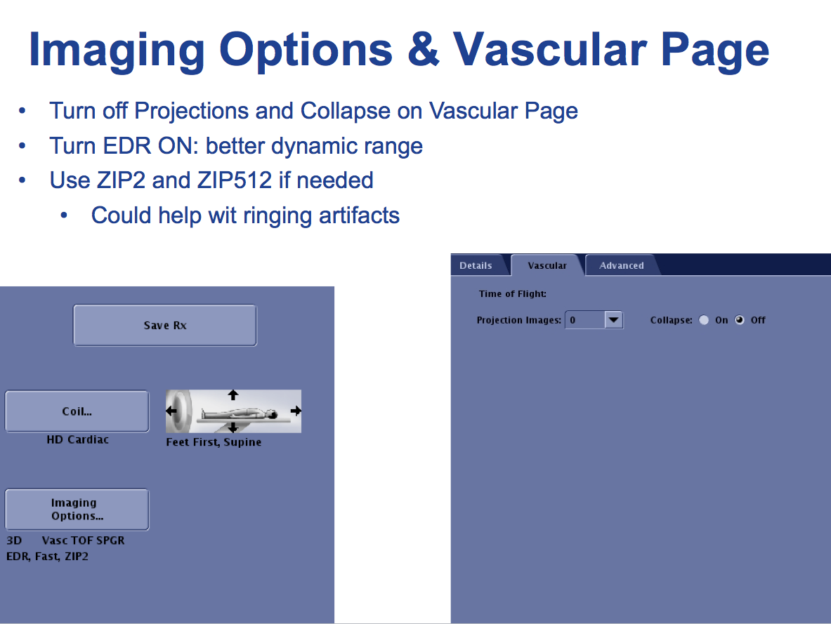

Phillips
Philips Achieva 1.5T (edited on release 2.6):

##############################################################################################
Pulse Sequence: 3D T1 FFE

NEX = NSA: 2 (change accordingly as needed for ratio map or variable flip angle series)

flip angles: 30, 25, 20, 15, 10, 2 (watch that shortest TR/TE remain constant, or swith to user defined if needed)

coils: SENSE-body or SENSE-Torso-XL

slice orientation: coronal (for abdomen. for head: axial, adjust FOV as needed)

Foldover direction: RL
Foldover supprsion: yes

slice oversampling: user defined: 1

TE/TR: set to shortest, actual values will be: 5.0/2.4 ms (verify it stays constant with changing flip angle)

temporal resolution = dynamic scan time: 8.4 sec (for NSA 2)

receiver bandwidth – corresponding parameter: water fat shift: maximum (313 Hz/pixel for current parameters)

FOV: FH 420 mm, RL 340 mm, AP 48 mm (for head: 250 AP, 220 RL)
voxel size: FH 1.64 mm, RL 2.1 mm, AP 2 mm (FOV/voxel size ratio yielding matrix: 256x162 for abdominal)
(note, FOV and voxel size are adjustable parameters, corresponding matrix is displayed in info page)

overcontiguous slices: yes (acquired slice thickness 4 mm, interpolated into 2)
number of slices: 24 (interploated – 12 acquired)

SENSE: no, CLEAR: no
halfscan: yes, factor Y 0.65, factor Z = 0.8

Dynamic study: individual
dynamic scans: 42 (giving total scan duration of 05:50)
dynamis scan times: user defined > set 6th dynamic to manual (for injection after 5th dynamic,
leave all other on shortest)
###############################################################################################

