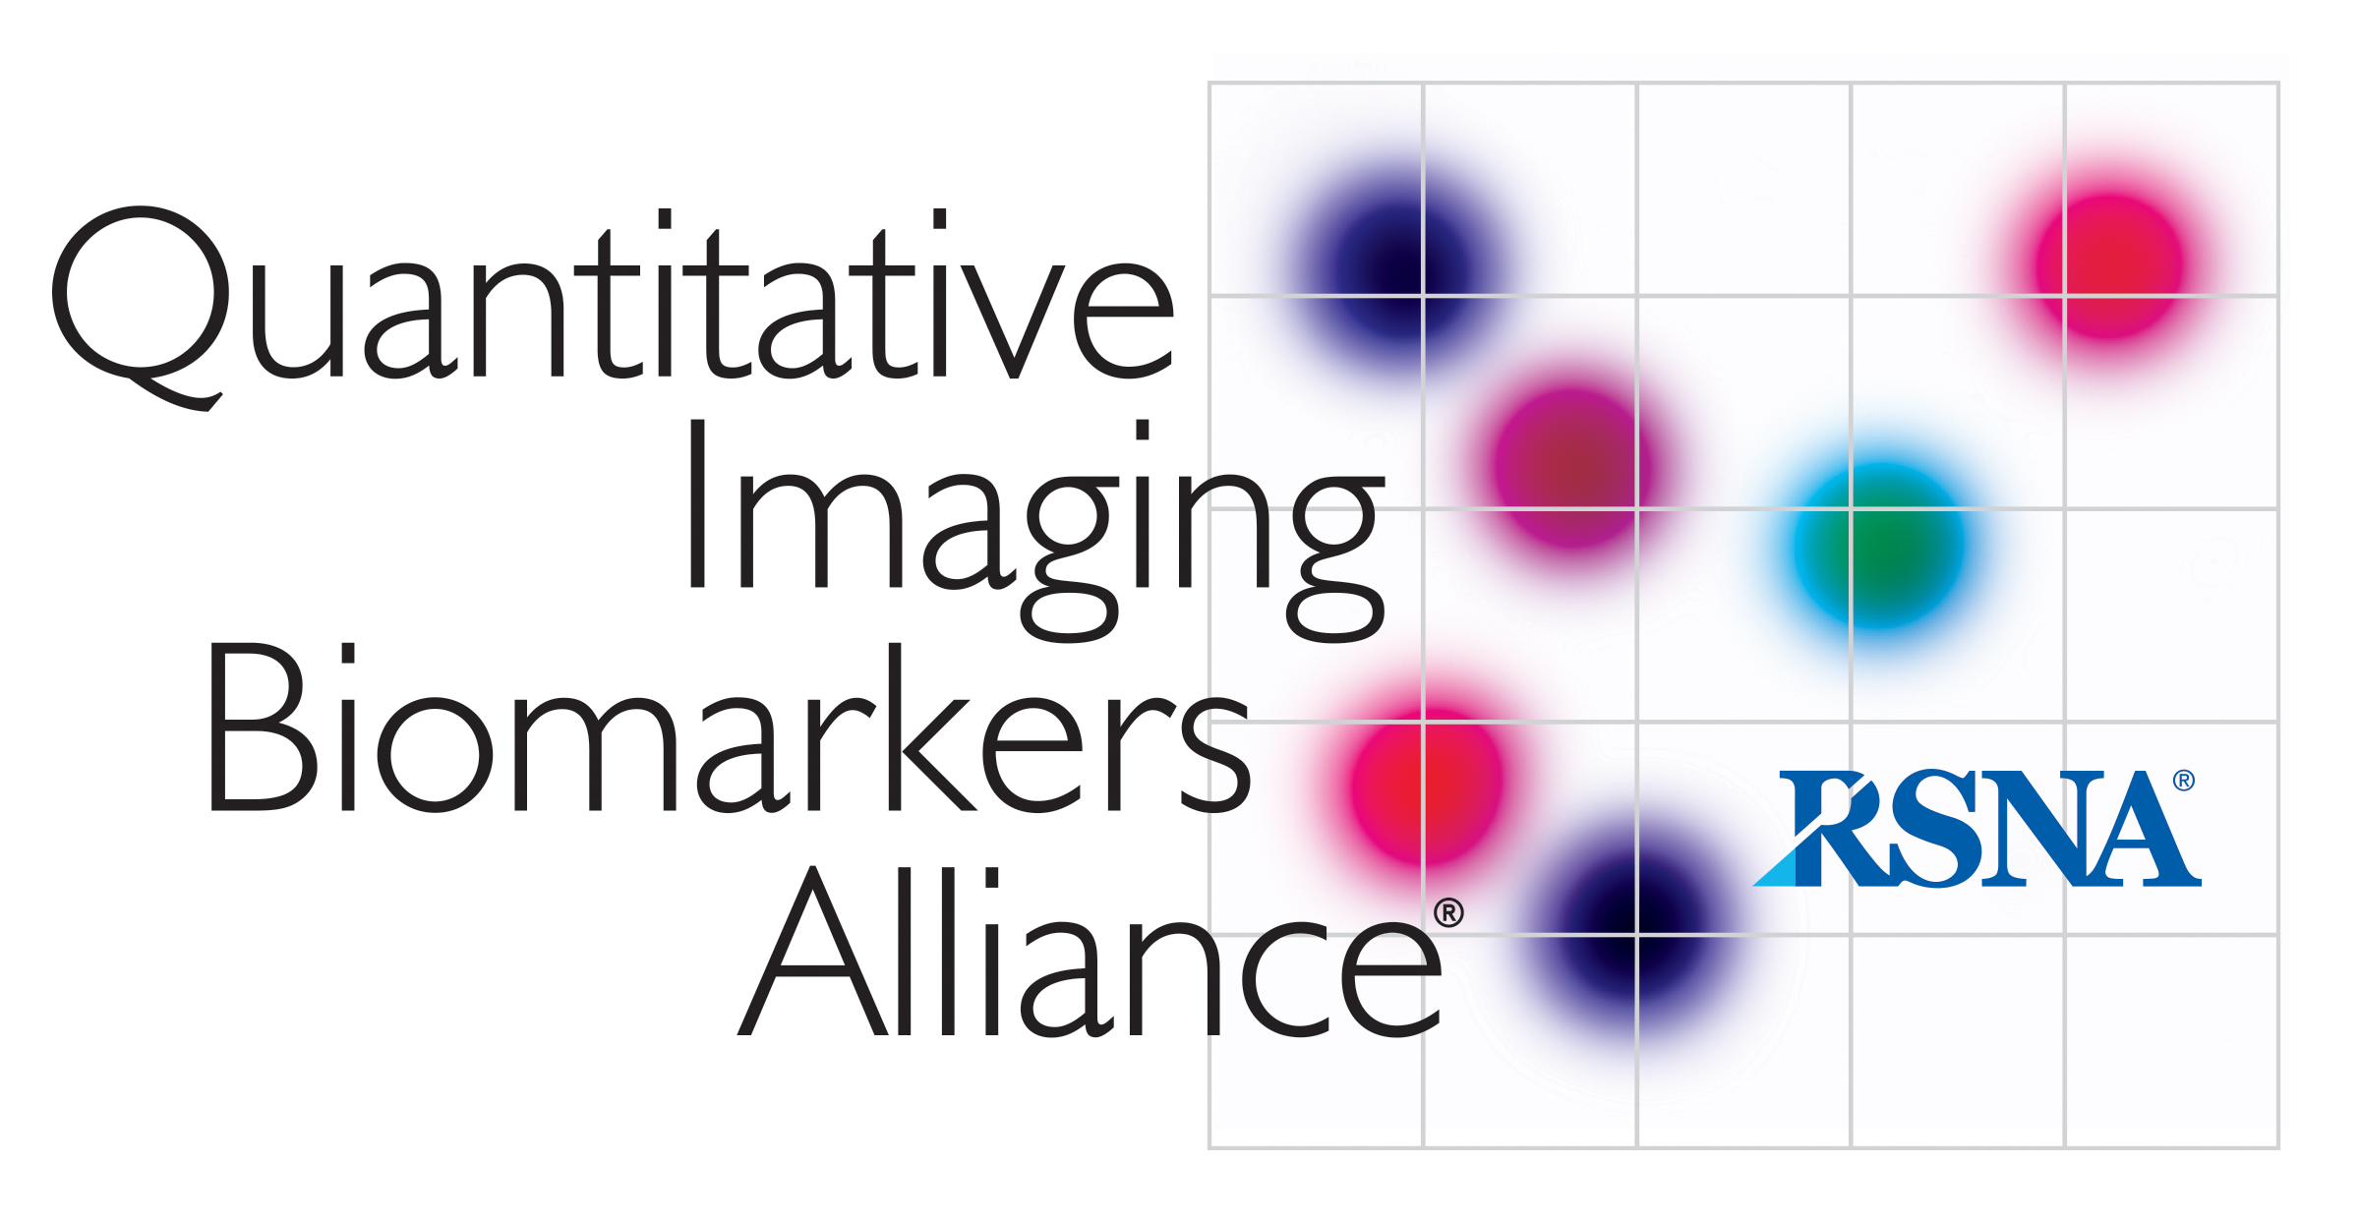
AIUM/QIBA
Ultrasound Volume Blood Flow Biomarker

MINUTES 2019-12-04

Attendance:
J. Jago, O. Kripfgans, M. Lockhart, M. Robbin, J. Rubin, R. Tadross, M. Yoshitaka

I. Overview
- Status of QIBA project
  - Manuscript under review
  - No current project work
  - No monetary support from QIBA/NIBIB
- Future support
  - General QIBA type investigations may be questionable. Outreach to NIH to inquire about focus of NIBIB support.
  - Specific applications are still an option and are used. Examples include carotid, AV fistulas and umbilical flow.
II. Vendor specific approaches
- QIBA showed possibility of implementation on a range of commercial scanners
- Continued work on vendor sponsored investigations

