

Profile: DCEMRI Quantification
Version .20
May 16 2011

Table of Contents
I. Executive Summary 3
II. Clinical Context and Claims 3
Claim 1: **short description 4
III. Profile Details 5
0. Reserved (included above) 5
1. Reserved (relevance restricted to Protocol) 5
2. Reserved (relevance restricted to Protocol) 5
3. Subject Scheduling 5
4. Subject Preparation 7
5. Imaging-related Substance Preparation and Administration 8
6. Individual Subject Imaging-related Quality Control 10
7. Imaging Procedure 10
8. Image Post-processing 15
9. Image Analysis 16
10. Image Interpretation 19
11. Archival and Distribution of Data 22
12. Quality Control 23
13. Imaging-associated Risks and Risk Management 27
IV. Compliance 28
Acquisition Scanner 28
Contrast Inject Device 29
Software Analysis Tool 29
Performing Site 29
References 30
Appendices 30
Appendix A: Acknowledgements and Attributions 30
Appendix B: Background Information 30
Appendix C: Conventions and Definitions 31
Appendix D: Documents included in the imaging protocol (e.g., CRFs) 32
Appendix E: Associated Documents 32
Appendix F: TBD 33
Appendix G: Model-specific Instructions and Parameters 35

I. Executive Summary
The DCE-MRI technical committee is composed of scientists representing the imaging device manufacturers, image analysis laboratories, biopharmaceutical industry, academia, government research organizations, and professional societies, among others. All work is classified as pre-competitive. The goal of the DCE-MRI committee is to define basic standards for DCE-MRI measurements and quality control that enable consistent, reliable and fit-for-purpose quantitative K^{trans} ^{[1]} and IAUGC ^{[2]} results across imaging platforms, clinical sites, and time.

This effort is motivated by the emergence of DCE-MRI as a method with potential to provide predictive, prognostic and/or pharmacodynamic biomarkers for cancer ^{[3-11]}. Remarkably, the results demonstrating this potential have been obtained despite considerable variation in the methods used for acquisition and analysis of the DCE-MRI data. This suggests there are substantial physiological differences (i.e., benign vs. malignant, non-responsive vs. responsive tumors, before and after treatment) underlying these observations. Thus, there appears to be a promising future for use of DCE-MRI for both clinical research and in routine clinical practice. However, in order to fulfill this promise, it is essential that common quantitative endpoints are used and that results are independent of imaging platforms, clinical sites, and time.
For the application of DCE-MRI in the development of anti-angiogenic and anti-vascular therapies, there is a consensus ^{[12]} on which quantitative endpoints should be employed: Ktrans and IAUGC_{BN}. Hence, the initial focus of the DCE-MRI committee is on these biomarkers. Although there have been general recommendations on how to standardize DCE-MRI methodology^{[12, 13]} , there are no guidelines sufficient to ensure consistent, reliable and fit-for-purpose quantitative DCE-MRI results across imaging platforms, clinical sites, and time. Hence, in this profile, basic standards for site and scanner qualification, subject preparation, contrast agent administration, imaging procedure, image post-processing, image interpretation, data archival and quality control are defined to provide that guidance. This Profile is applicable to individual patient management as well as being used for clinical trials.
Summary of Clinical Trial Usage as described in assimilated protocol "Protocol: DCEMRI Quantification"
This technique offers a robust, reproducible measure of microvascular parameters associated with human cancers based on kinetic modeling of dynamic MRI data sets. The rigor and details surrounding these data are described throughout the text of this document in various sub-sections.

II. Clinical Context and Claims
One application of DCE-MRI where considerable effort has been focused on quantitative endpoints is its use to provide pharmacodynamic biomarkers for the development of novel chemotherapeutic (in specific anti-angiogenic) agents targeting the tumor blood supply ^{[4, 9, 14-25]}. A growing understanding of the underlying molecular pathways active in cancer has led to the development of novel therapies targeting VEGF, EGFR-tk, PI3-k, mTOR , Akt and other pathways. Unlike the conventional cytotoxic chemotherapeutic agents, many of the molecularly-targeted agents are cytostatic, causing inhibition of tumor growth rather than tumor regression. One example is anti-angiogenesis agents, which are presumed to act through altering tumor vasculature and reducing tumor blood flow. In this context, conventional endpoints such as tumor shrinkage may not be the most effective means to measure therapeutic responses. Functional imaging is an important candidate biomarker to predict and monitor targeted treatment response and to document pharmacodynamic response.
Dynamic contrast enhanced magnetic resonance imaging (DCE-MRI) represents an MRI-based method to assess tumor vascularity by tracking the kinetics of a low-molecular weight contrast agent intravenously administered to patients that highlights the tumor vasculature. The emerging importance of angiogenesis as a cancer therapy target makes assays of vascularity important to clinical research and future clinical practice related to targeted cancer therapy. There are multiple literature reports of the application of DCE-MRI to predict and detect changes associated with angiogenesis targeted therapy ^{[4, 9, 15, 17, 19, 20, 24, 25]} . Further, there is interest in the application of quantitative DCE-MRI to characterize contrast enhancing lesions as malignant in several organ systems including breast and prostate.
In this context, Ktrans and/or IAUGC_{BN} can provide evidence of the desired physiologic impact of these agents in Phase 1 clinical trials. For some agents (e.g., VEGF-targeted), evidence of substantially reduced Ktrans and/or IAUGC_{BN} is necessary, but not sufficient for a significant reduction in tumor size ^{[16, 17]} . For other agents (e.g., vascular-targeted), evidence of a substantial vascular effect may not be associated with a reduction in tumor size ^{[9]}, but is still essential for effective combination with other agents. In either case, lack of a substantial vascular effect indicates a more potent agent is needed, while evidence for a substantial vascular effect indicates further development is appropriate.
Utilities and Endpoints for Clinical Trials
In oncology, Phase 1 trials are generally conducted at 1-3 centers with the ability to recruit patients and conduct the complicated clinical study protocols associated with early development studies. Since these centers often do not have expertise in DCE-MRI and more than one center is typically involved, considerable effort is required to ensure consistent, reliable and fit-for-purpose quantitative DCE-MRI results are obtained reliably at all clinical sites over the duration of the trial. When these trials are sponsored by the biopharmaceutical industry, imaging core labs (also known as imaging contract research organizations, iCROs) are contracted to provide that effort. However, their approaches are proprietary and, in the absence of established guidelines, they are likely to differ among imaging core labs. When the trials are not industry-sponsored, they are generally conducted at a single site with considerable expertise in DCE-MRI. However, the drive for innovation all but ensures that there will be significant differences between academic sites. Hence, the guidelines provided in this profile will ensure that not only are the relative changes induced by treatment are informative, but that absolute changes can be compared across these studies.

Claim: **short description
Quantitative microvascular properties, specifically Ktrans (endothelial transfer constant) and blood normalized initial area under the gadolinium concentration curve (IAUGC_{BN}), can be measured from DCE-MRI data obtained at 1.5T using low molecular weight gadolinium-based contrast agents within a 20% test-retest coefficient of variation for solid tumors at least 2 cm in diameter.
Profile specified for use with: , for the following indicated biology: , and to serve the following purpose: .
patients with malignancy
primary or metastatic disease
therapeutic response
**Introduce the specific read-outs with free form text.
Measurement or Categoric Result | Performance Levels Achieved under Bull's Eye Conditions
Ktrans
  If Activities are Performed at Acceptable Level | **e.g., 20%
  If Activities are Performed at Target Level | **e.g., 10%
  If Activities are Performed at Ideal Level | **e.g., 5%
IAUGC_{BN}

III. Profile Details
**Provide a graphical depiction that describes the marker at a technical level.

0. Reserved (included above)

1. Reserved (relevance restricted to Protocol)
Management of Pre-enrollment Imaging Tests
The principal investigator or co-investigators at the particular sites will be responsible for reviewing pre-enrollment imaging (e.g. CT or MRI examinations) that have been a component of routine clinical care. These data will serve as the requisite information to choose the target lesion(s) that will be used for DCE analysis upon enrollment However, only image acquisition and processing protocols that conform to, or exceed, the minimum design specifications described in this protocol are sufficient for quantifying tumor vascular parameters with the precision of measurement specified in the profile claims document.

Timing of Imaging Tests within the Treatment Calendar
The DCE MRI committee believes that all baseline evaluations should be ideally be within 14 days, but no longer than 30 days prior to the initiation of therapy. Otherwise the resulting functional tumor characterization may not reflect the status of the tumor prior to initiation of therapy. The interval between follow up scans within patients may be determined by current standards for good clinical practice or the rationale driving a clinical trial of a new treatment

2. Reserved (relevance restricted to Protocol)

3. Subject Scheduling
Utilities and Endpoints of the Imaging protocol within the Clinical Trial
This technique offers a robust, reproducible measure of microvascular parameters associated with human cancers based on kinetic modeling of dynamic MRI data sets. The rigor and details surrounding these data are described throughout the text of this document in various sub-sections.

Subject Selection Criteria related to Imaging
• Absolute contraindications to MRI are not within the scope of this document. Suffice it to say that local policies for contraindications for absolute MRI safety should be followed.

• Lesions that are selected for DCE-MRI analysis should not be within 10 cm. of metal prostheses (i.e. spinal hardware, hip prostheses, metallic surgical staples, etc…)

• Patient selection criteria will include and be guided by the Eastern Cooperative Oncology Group (ECOG) status (See Appendix 2) for full description of ECOG performance status). In specific, patients meeting ECOG status >= 2 will not be eligible for participation in the study, because historically, this patient profile has shown poor ability to meet the demands of the examination.

• The QIBA DCE-MRI committee acknowledges that there are potential and relative contraindications to MRI in patients suffering from claustrophobia. Methods for minimizing this risk are at the discretion of the physician caring for the patient.

• The QIBA DCE-MRI committee acknowledges that there are potential risks associated with the use of gadolinium-based contrast media. The default recommendations for intravenous contrast that follow assume there are no known contraindications in a particular patient other than the possibility of an allergic reaction to the gadolinium contrast agent. The committee assumes that local standards for good clinical practices (GCP) will be substituted for the default in cases where there are known risks.

• Recent FDA guidelines (http://www.fda.gov/Drugs/DrugSafety/ucm223966.htm#aprooved), outline the safety concerns associated with using gadolinium based contrast agents in patients with impaired renal function. The DCE-MRI committee echoes these recommendations and advises reference to these standards when choosing patients in order to determine eligibility for entry into a DCE-MRI clinical trial.

• Patients will not be eligible if they have received ANY Gadolinium based contrast agent within 24 hrs.

• If a tumor is selected for study within the lung, or upper abdomen that has motion secondary to diaphragmatic excursion during respiration, then any patient that cannot hold their breath for at least 20 seconds will not be eligible.
3.1. Timing Relative to Index Intervention Activity
The DCE MRI committee believes that all baseline evaluations should be ideally be within 14 days, but no longer than 30 days prior to the initiation of therapy. Otherwise the resulting functional tumor characterization may not reflect the status of the tumor prior to initiation of therapy. The interval between follow up scans within patients may be determined by current standards for good clinical practice or the rationale driving a clinical trial of a new treatment

Index Intervention Activity | Timing
DCE-MRI timing
  Acceptable | 30 days
  Target | 21 days
  Ideal | 14 days
3.2. Timing Relative to confounding Activities (to minimize “impact”)
DCE-MRI examinations should not be performed within 7 days of a biopsy
Confounding Activity | Timing
Acceptable | 30 days
Target | 21 days
Ideal | 14 days

3.3. Scheduling Ancillary Testing
N/A

4. Subject Preparation
There are no specific patient preparation procedures for the MRI scans described in this protocol. There are specifications for other procedures that might be acquired contemporaneously, such as requirements for fasting prior to FDG PET scans or the administration of oral contrast for abdominal CT. Those timing procedures may be followed as indicated without adverse impact on these guidelines
4.1. Prior to Arrival
The local standard of care for acquiring MRI scans may be followed. For example, patients may be advised to wear comfortable clothing, leave jewelry at home, etc.
4.2. Upon Arrival
Staff shall prepare the patient according to the local standard of care.
• Patients should be assessed for any removable metal objects on their bodily surfaces that will be in the field of view.
• Patients should be "comfortably positioned", in "comfortable clothes to minimize patient motion and stress (which might affect the imaging results) and any unnecessary patient discomfort.
4.2.1. Confirmation of subject compliance with instructions
N/A
4.2.2. Ancillary Testing
Ancillary testing such as blood draws, etc…, will be based upon the specific hypotheses being tested.
4.2.3. Preparation for Exam
Beyond a clear, simple language description of the image acquisition procedure, no exam preparation is specified beyond the local standard of care for MRI with contrast.

5. Imaging-related Substance Preparation and Administration
The DCE-MRI committee acknowledges that the use of intravenous contrast material is often medically indicated for the diagnosis and staging of cancer in many clinical settings.
5.1. Substance Description and Purpose
a. An extracellular gadolinium based contrast agent will be utilized. Although it is known that there is a small degree of protein binding associated with many commercially available extracellular gadolinium contrast agents, ^{[26]}, these are comparable amongst the various vendors. Contrast agents, with fundamentally different degrees of protein binding (e.g. Gadobenate and Gadofosveset) cannot be utilized, however, secondary to inability of the model to account for the degree of protein binding.

5.2. Dose Calculation and/or Schedule
Contrast Agent Dose Reduction Based On Creatinine Clearance: (renal function)
b. Patient’s renal creatine clearance should be obtained, and estimated glomerular filtration rate (eGFR) determined in adults through well known and adopted formulas.
i. If eGFR < 60 ml/min/1.73 m2, then the subject should withdraw from the study.
Parameter | Compliance Levels
eGFR
  Acceptable | > 60 ml/min/1.73m2
  Target | > 60 ml/min/1.73m2
  Ideal | > 60 ml/min/1.73m2
Parameter | Compliance Levels
dose
  Acceptable | > 60 ml/min/1.73m2
  Target | > 60 ml/min/1.73m2
  Ideal | > 60 ml/min/1.73m2
5.3. Timing, Subject Activity Level, and Factors Relevant to Initiation of Image Data Acquisition
Contrast injection should occur after the following imaging sequences have been acquired (See Section 6):
• Anatomic imaging for localizing tumors
• Variable flip angle imaging for R1 map calculation
Contrast injection should occur after at least 5 baseline volume imaging stacks have been acquired.
5.4. Administration Route
• Each subject should have an intravenous catheter with a gauge no smaller than 20 gauge which should be ideally placed in the right antecubital fossa. Injection through a port-a-catheter, or permanent indwelling catheter is not allowed. What is critical is that the same location be used for repeat studies, if at all possible.
Parameter | Compliance Levels
Iv gauge
  Acceptable | 20 gauge
  Target | 18 gauge
  Ideal | 16 gauge
Parameter | Compliance Levels
Iv location
  Acceptable | Dorsum of right hand
  Target | Right antecubital fossa
  Ideal | Right antecubital fossa
5.5. Rate, Delay and Related Parameters / Apparatus
• Contrast agent should be administered in a dynamic fashion, preferably with a power injector.
• At baseline and at each subsequent time-point, the same dose of contrast and rate of contrast administration should be performed as clinically safe.
• The rate of administration should be rapid enough to ensure adequate first-pass bolus arterial concentration of the contrast agent (generally 2-4 mL/sec)
• Saline flush should be between 20 and 30cc of normal saline injected at the same rate as the contrast agent injection.
**Describe the rate, delay, and related parameters or apparatus. Place needed requirements.
Parameter | Compliance Levels
Injection rate
  Acceptable | 2 mL/sec
  Target | 3 mL/sec
  Ideal | 4 mL/sec
Parameter | Compliance Levels
Subsequent i.v. location
  Acceptable | Dorsum of right hand
  Target | Right antecubital fossa
  Ideal | Right antecubital fossa
5.6. Required Visualization / Monitoring, if any
No particular visualization or monitoring is specified beyond the local standard of care for MRI with contrast

5.7. Quality Control
See 12.2

6. Individual Subject Imaging-related Quality Control
See 12.3

7. Imaging Procedure
This section describes the imaging protocols and procedure for conducting a DCE-MRI exam. Suitable localizer (scout) images must be collected at the start of exam, and used to confirm correct coil placement as well as selection of appropriate region to image. This will be followed by routine non contrast sequences, usually in the axial plane, to delineate number, location, and limits of tumor extension. Exact protocols for these imaging sequences may be determined by the local imaging norms. However, for imaging of areas subject to respiratory motion, care should be made to note the presence or respiratory suspension (end-inspiration vs. end- exhalation) or respiratory gated techniques as these maneuvers may displace the apparent location of tumor(s) relative to fixed non-moving anatomic landmarks.
7.1. Required Characteristics of Resulting Data
The DCE-MRI portion of the exam will consist of two components:
(a) (b) a variable flip angle series, for pre-contrast T1 mapping;b. Variable Flip Angle T1 Mapping Protocol: All parameters the same as dynamic protocol, below, except: Single acquisition phase Ensure TR and TE values stay constant for all flip angles. Flip angles: (see table) Number of signal averages (NSA or NEX): Ideal: (see table) Ensure that machine gain settings are not reset automatically (using automated pre-scan features) between each flip angle acquisition so that system gain settings are identical for each flip angle acquisition.
Parameter | Compliance Levels
Flip angles
  Acceptable | 5 flip angles (2, 10, 15, 20, 30 degree)
  Target | : 6 flip angles (2, 10, 15, 20, 25, 30 degree)
  Ideal | 7 or more (2, 5, 10, 15, 20, 25, 30 degree)
Parameter | Compliance Levels
NEX
  Acceptable | 1
  Target | 2
  Ideal | 4
c. DCE-MRI Protocol: Pulse Sequence:
Pulse Sequence: 3D fast spoiled gradient recalled echo or equivalent
Coils: Body transmit coil, phased array receive coil
No parallel imaging options
No magnetization preparation schemes

Imaging Plane
(thoracic/abdominal/pelvic): Coronal oblique acquisition slab (including appropriate vascular reference vessel(s))
(brain/H&N/extremity): Axial acquisition slab (including appropriate vascular reference vessel(s))

Frequency encoding direction: S-I (Head-feet) frequency for oblique coronal and L-R frequency for axial.

Parameter | Compliance Levels
TE
  Acceptable | 2-2.5ms
  Target | 1.5-2ms
  Ideal | <1.5ms

Parameter | Compliance Levels
TR
  Acceptable | 5-7ms
  Target | 3-5ms
  Ideal | < 3ms

Parameter | Compliance Levels
Temporal Resolution
  Acceptable | 8-10 sec
  Target | 5-8 sec
  Ideal | < 5 sec.

Smaller flip angles will lead to potential saturation of the signal intensity vs. gadolinium concentration, particularly in vessels. Note should be made that SAR limits may affect the maximum allowable flip angle. Operators should use the maximal allowed flip angle when SAR limitations occur.
Parameter | Compliance Levels
Flip angles
  Acceptable | 20-25 degrees
  Target | 25-30 degrees
  Ideal | 30-35 degrees

Receiver Bandwidth: greater or equal to ±31.25 kHz (or ~250 Hz/pixel)

Region appropriate frequency encoding (FE) FOV (recommend 42 x 34 cm for body applications; 22-25 cm for brain/H&N)
~80% phase encoding FOV

Partial Fourier (“fractional echo”) as needed to meet temporal resolution requirements

Number of Slices: Acceptable: >=10 prior to zero fill. Ideal: as many as possible while maintaining ideal temporal resolution.

Slice thickness: Ideal: <5 mm, Target: 5.1-6 mm, Acceptable: 6.1-8 mm
Parameter | Compliance Levels
Acceptable | 6.1-8 mm
Target | 5.1-6mm
Ideal | <5mm

Matrix: 256 x 160 (before applying rectangular FOV)
Number of acquisitions (phases): Sufficient to allow acquisition of at least 5 minutes of post injection data; including at least 5 phases acquired before contrast agent injection (baseline images).

7.1.1. Data Content
see 7.1

7.1.2. Data Structure
see 7.1

7.1.3. Data Quality
see 7.1
7.2. Imaging Data Acquisition
The following sections describe the acquistion of imaging data.
7.2.1. Subject Positioning
Patient and coil positioning:
• When the general location of the target tumor(s) is known prior to DCE-MRI, for example glioma or local breast cancer evaluation, the patient set up for the MRI should be based on standard operating procedures for patient positioning and coil placement for clinical MRI of that body part.
• When the subject under investigation may have uncertain tumor location(s), as is common in the setting of patients undergoing therapy for metastatic disease, it will often be necessary for the DCE-MRI study to be planned with reference to the most recent pre-DCE-MRI imaging (usually CT study). From this study, tumor burden and location should be assessed. Optimally, review of actual imaging by a radiologist involved in the DCE-MRI study planning should be made. At times, if such images are not available for direct review, review of imaging reports (CT, PET) detailing extent of disease is mandatory, both to confirm eligibility (presence of at least one “imageable” lesion) and to identify the preferred anatomic regions for DCE-MRI (chest, abdomen, pelvis, extremity). Review of prior diagnostic imaging may also be helpful to confirm cyctic or necrotic nature of certain lesions, assessments which may be challenging at the time of DCE-MRI planning based solely on T1 and T2 image sets. When multiple potential target lesions are available, the location of the most suitable lesion(s) should be noted. The most suitable lesion will depend on size, location relative to areas of pulsatile or respiratory artfacts, and presence or absence of necrosis or cystic. The schema for choosing the target lesion is provided below
• DCE-MRI subject should be placed supine in the scanner position. Rarely, prone positioning can be used for patients who profess a preference was such positioning to ease their concerns with claustrophobia. Preferably, oral anxiolytics (if not medically contraindicated) can be used for such patients prior to each DCE-MRI study.
• When patient condition allows, placement of arms over the head may avoid undesirable wrap artifact for temporally optimized 3D spoiled gradient echo sequences for chest and abdomen lesions. However, such positioning often cannot be sustained by patients without excessive discomfort. In such cases, arms placed anteriorly over the chest or at the sides may be preferable. For larger patients, side-down arm positioning may require adjustment of the DCE-MRI imaging FOV to avoid undesirable wrap artifact. Appropriate coil placement per area of examination (head, neck, breast, extremity) is then done. For lesions in the chest, abdomen, or pelvis, a torso array coil is then placed in the area of target lesion(s). Ideally, both anterior and posterior coils are centered over the expected target lesion location.
• Tumor size and location on longitudinal studies should be considered in the design of an analysis scheme. Recall that the claims of this profile are only applicable to lesions 2cm or more in size. If the lesion is large in proportion to the volume imaged by DCE-MRI precautions should be taken to maximize the possibility that the same portion of the lesion will imaged on longitudinal studies. In general, this requires careful scan location set up on follow-up studies in order to match the same anatomic positions imaged in target organs on earlier studies. However, because of differences in patient angulation on follow-up studies the same anatomic locations may not be imaged on each study. In this case, an analysis scheme that discards image data from locations that are not included in the imaged volume (after end slice elimination) of all relevant studies is favored. This can be accomplished by registration of images obtained from the dynamic sequences of all studies (for example images obtained by averaging all dynamic images obtained at the same location) to a high resolution anatomic images obtained (for example) at the initial time point
Parameter | Compliance Levels
Tumor size
  Acceptable | 2-3cm
  Target | >6cm or 3-4 cm
  Ideal | 4-6cm
Tumor  Composition
  Acceptable | Predominantly necrotic or cyctic with at least 1 cm LD of solid enhancing/viable tumor. (Unacceptable: completely cyctic or necrotic lesions. Lesions with extensive hemorrhage)
  Target | Predominantly solid, with some cystic change and/or necrosis
  Ideal | Predominantly solid, no cyctic characteristics, little if any necrosis
Tumor  Tumor  Location
  Acceptable | Lesion in area without undo respiratory or pulsatile motion (liver-excluding lat segment left lobe, spleen, lung bases, lateral lungs, upper mediastiunum) (Unacceptable: hilar, para-cardiac medistiumun, lateral segment left lobe of liver.)
  Target | Areas with some respiratory motion (kidneys, adrenal glands/lateral retroperitoneum, lateral chest wall, pancreas, lung apices, neck)
  Ideal | Non-mobile locations (brain, skull, extremity, spine, bony pelvis, deep pelvis soft tissues, central retroperitoneum, posterior chest wall)

7.2.2. Instructions to Subject During Acquisition
In the setting of a mass investigated within an organ that is subject to respiratory motion, the subject will be instructed throughout various portions of the examination to hold their breath for a period no greater than 30 seconds. Ideally, breath hold will be in the end-expiratory phase.

7.2.3. Timing/Triggers
All examinations will be performed in either slow free breathing state, or during breath hold for a period no greater than 30 seconds. Timing parameters for the bolus injection of contrast agent will occur after the acquisition of no less than 5 baseline volume scans.

7.2.4. Model-specific Parameters
Appendix G.1 lists acquisition parameter values for specific models/versions that can be expected to produce data meeting the requirements of Section 7.1.
7.2.5. Archival Requirements for Primary Source Imaging Data
See 11.3
7.2.6. Quality Control
See 12.3
7.3. Imaging Data Reconstruction
All imaging reconstruction will be performed per vendor specification and will involve fourier transformation of Cartesian data. No smoothing or other post-processing will be performed so as to insure the integrity of the data for post-processing analysis.
7.3.1. Input Data to Be Used
N/A

7.3.2. Methods to Be Used
N/A
7.3.3. Required Characteristics of Resulting Data
N/A
7.3.4. Platform-specific Instructions
Appendix G.2 lists reconstruction parameter values for specific models/versions that can be expected to produce data meeting the requirements of Section 7.2.

7.3.5. Archival Requirements for Reconstructed Imaging Data
See 11.4
7.3.6. Quality Control
See 12.4

8. Image Post-processing
There are no specific image post-processing requirements in this profile. No user-selected post-processing filters or image normalization methods should be used prior to data analysis as described in the next steps. If phased-array receiver coils are used, image combining and reconstruction should be according to standard manufacturer algorithms. DCE-MRI data will be signal normalized and converted into estimates of Gd concentration as described later in Section 9.
8.1. Input Data to Be Used
see 8.0

8.2. Methods to Be Used
see 8.0
8.3. Required Characteristics of Resulting Data
see 8.0
8.4. Platform-specific Instructions
Appendix G.3 lists post-processing parameter values for specific models/versions that can be expected to produce data meeting the requirements of Section 8.

8.5. Archival Requirements
See 11.5
8.6. Quality Control
See 12.5

9. Image Analysis
**Introduce the Image Analysis section.
Analysis of DCE-MRI data is carried out in a series of distinct steps:
•
• Generate a T1 map using Variable Flip Angle Images.
• When required, apply time-series motion correction to the dynamic data.
• • Convert SI(t) in the dynamic data to gadolinium concentration ([Gd](t)).
• Calculate a vascular input function.
• Identify the region or regions of interest in the dynamic data.
• Calculate vascular parameters.
Each of these steps is addressed in detail below.
9.1. Input Data to Be Used
Processed magnitude images will be utilized for image analysis for input into the kernals described in the following sections
See 9.2
9.2. Methods to Be Used
**Introduce the section.
Generate a T1 Map
The intent of this step is to provide a complete map of pre-contrast T1 values for the imaged slab. These values will then be used in the signal formation model based conversion of changes in signal intensity to gadolinium concentration. The slice locations, orientation and resolution of these images should be prescribed identically to the dynamic series, and this series should be acquired immediately prior to the dynamic series. The output of this step is an image of T1 values which can be co-registered to the dynamic series and used in subsequent calculations. The T1 values at each voxel location are calculated as follows [1]:
1. Create a vector x containing the signal intensity at each flip angle divided by the tangent of the flip angle.
2. Create a vector y containing the signal intensity at each flip angle divided by the sine of the flip angle.
3. For the n acquired flip angles create a set of points (x0,y0)… (xn,yn).
4. Fit a line with slope s to the set of points defined in Step 3. 5. T1 = -TR/ln(s).
Apply Motion Correction to the Dynamic Data
The intent of this step is to correct for patient motion that occurs between acquired phases of the dynamic data due to respiration, swallowing, and other involuntary movements. This step is not intended to correct ghosting artifacts that can occur along the phase encoding direction within a particular image due to patient motion during acquisition. These artifacts are more or less intractable unless the motion is regular and easily modeled, and are best addressed by adjusting the phase/frequency encoding scheme to minimize their impact on structures of interest. In general, simple rigid shift or affine transform based registration methods will not be adequate for this step, due to the fact that the movement in question is typically limited to specific regions within the image – for example, the liver in a coronal scan of the abdomen may move substantially with respiration while the bulk of the body remains relatively motionless. Fully deformable registration methods based on optical flow may provide good results in some cases ^{[27, 28]} . However, these methods will frequently fail for the phases immediately surrounding the contrast injection. Semi-automated registration in which a user identifies the target tumor and only information drawn from that region is used to generate phase to phase shifts provides an alternative approach. This allows rigid shift methods using mutual information ^{[29]}, which tend to be more robust than optical flow methods, to be employed. Finally, registration may be carried out manually or using simple shift registration techniques ^{[21]}. Data corrupted with motion must be either corrected prior to analysis or discarded for subsequent pharmacokinetic analysis.

Convert SI(t) in the Dynamic Data to [Gd](t)
The intent of this step is to convert the arbitrary signal intensity units in the dynamic data into units of gadolinium concentration. This step should be applied after the regions of interest for analysis have been defined, but prior to the calculation of vascular parameters. Two methods for accomplishing this are defined below.
Conversion Using a Signal Formation Model Gadolinium concentration at each image pixel is given by )(eq 1):
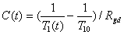
Here T10 is the pre-contrast T1 at that pixel, obtained from T1 map from Section 8.2, and Rgd is the relaxivity of Gd (obtained from manufacturer’s specifications).
T1(t) can be derived from the SPGR imaging equation and is given by the following expressions (eqs 2-4): Let
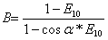
where α is the flip angle, TR is the repetition time, and S(t) and S(0) are the signal intensities at time t and pre-contrast baseline respectively in the DCEMRI sequence (eq 5). Then,
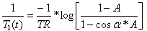
Calculate an Arterial Input Function
The intent of this step is to generate an accurate, patient-specific arterial input function to serve as an input to the vascular model. One way to accomplish this is to have an analyst draw a manual ROI within an artery, and use the mean enhancement curve within that ROI as the subject-specific AIF, as described by Vonken et al. ^{[30]}. It has been demonstrated previously that this method has significant variability associated with it ^{[31]}, due primarily to the spatially- and temporally-varying flow artifacts found in major arteries. A better option is to make use of an automated search technique to generate a locally optimal AIF. Several methods of accomplishing this have been described previously ^{[32, 33]} .^{[34]}
Reference tissue approaches are an alternative for calculating the arterial input function. These methods infer the arterial input function based on the uptake and washout kinetics of contrast media in one or more reference tissues that have well defined physiologic characteristics. This avoids errors associated with measurements of high concentrations of contrast media in arteries during the early phase of the contrast bolus, and also avoids errors due to partial volume effects – since a large volume of homogeneous tissue can be used for these measurements.

Identify Regions of Interest in the Dynamic Data
The intent of this step is to define the boundaries of the tumors of interest in the dynamic data in order to determine which voxels will contribute to the parameter set for each tumor. This step will generally be carried out by a trained and qualified radiologist using either manual tracing or a semi-automated boundary identification tool. ^{[31]}
Calculate the Vascular Parameters
The intent of this step is to generate the parameter set which will be used to characterize the tissues of interest. Parameters will be calculated based on the standard Tofts model ^{[33]}, which is derived from the Kety equations ^{[35]}. The vascular bed is modeled as a linear system, such that (eq 6):
with impulse response h(t) given by (eq 7):
where Ktrans is the volume rate constant between blood plasma and extra-cellular extra-vascular space (EES) and kep is the rate constant between the EES and blood plasma. Given the tissue uptake curve Ct(t) and the AIF Cp(t) , Ktrans and kep are estimated using a gradient-descent energy minimization scheme, by using already established Levenberg-Marquardt or Minpack-1 curve fitting algorithms, both of which require adequate baseline sampling^{[36]} . Delay correction should be performed to shift the AIF curve to match the arrival time of the tumor curve prior to curve fitting.
A full parameter set will be calculated for each voxel within the defined tumor boundaries. Parameters may be reported out either as mean and median values per tumor or as histograms.
The blood normalized IAUGC_{BN} is measured from the area under the concentration curve up to 90 seconds post injection, normalized by dividing the area under the arterial input function curve also up to 90 seconds post injection. The following values serve as guidelines
Parameter | Compliance Levels
Ktrans
  Acceptable | <1 and > 0 min⁻¹
  Target | <1 and > 0 min⁻¹
  Ideal | <1 and > 0 min⁻¹

Parameter | Compliance Levels
Kep
  Acceptable | <10 and > 0 min⁻¹
  Target | <10 and > 0 min⁻¹
  Ideal | <10 and > 0 min⁻¹
9.3. Required Characteristics of Resulting Data
See 9.2
9.4. Platform-specific Instructions
Appendix G.4 lists image analysis parameter values for specific models/versions that can be expected to produce data meeting the requirements of Section 9.
9.5. Archival Requirements
See 11.6
9.6. Quality Control
See 12.6

10. Image Interpretation
Derivation of quantitative parameters characterizing the response associated with a lesion of interest from parameter maps is a multistep process, most if not all of which are being studied by on-going research. There are several choices that can be made at any of these steps, and the effect of these choices on the validity of results and variability of parametric maps has not yet been fully characterized.
10.1. Input Data to Be Used
The input data that will be utilized will be in the form of concentration curves, and parametric maps of K_{trans} and IAGC_{BN} from which ROI analysis can be performed. One shortcoming of the 3D fast spoiled gradient recalled echo technique used to acquire the dynamic images is that initial and end slice locations give inaccurate results due to wraparound artifact and variability in excitation profile. Image analysis can begin by discarding the data on the last 3 slices from each end . One method that can be used to determine which slices to discard is to closely examine the T1 maps obtained at the initial and end slice locations. Marked non-physiologic overestimations of T1 on initial and end slices are indicative of artifact.

**Describe required input data and any necessary validation or adjustments which should be performed on it. May also specify data which should not be used until after the clinical trial interpretation is recorded. (e.g. particular image series or views; before and after processing versions of images to evaluate/validate the effects of processing; analysis results)
Parameter | Compliance Levels (# of slices to be ignored as a result of wrap artifact)
Slices
  Acceptable | 2
  Target | 2
  Ideal | 3

10.2. Methods to Be Used
The following methodology for image interpretation should be performed in order to ensure complete reproducible and interpretable results.
Tumor ROI Definition.
The first step in the extraction of quantitative parameters (Ktrans or IAUGC_{BN}) associated with a particular neoplastic or other lesion is to segment this lesion from adjacent tissues. Which techniques of segmentation are ideal or even acceptable for a given application is the subject of on-going research, but it is clear that the segmentation techniques used must be tailored to the particular organ system being studied with DCE-MRI. The following guidelines are proposed:
• We do not recommend an analysis scheme where an operator defines a lesion by placing regions of interest directly on parameter maps as that will introduce bias into the results
• Less subjective results can be obtained by using correlative imaging to define the lesion. These correlative images may be obtained at the same imaging session but not directly related to the DCE-MRI images (for example, a T2-weighted image of an organ which clearly delineates lesions and their boundaries). Correlative images should be obtained in the same imaging plane as the DCE-MRI series, with simlar FOV and matrices if feasible. In this scenario, a registration step will likely be required (see 9.2)
• An alternative approach which may be helpful if the lesion is well delineated on contrast-enhanced T1-weighted MRI is to create summation images (images obtained by adding together images obtained on the dynamic series for each slice location). The summation images can be used to segment the lesion on one or more slices, and because these segmentations are (in the absence of patient or organ motion) registered to the dynamic series, the segmentations can be used to directly extract lesion-based parameters from parameter maps .
• Because of the presence of image noise on source images of the dynamic series, along with time-dependent changes in signal intensity which may blur or even obliterate the border between lesion and background tissue, analysis schemes in which lesions are segmented independently on each image of the dynamic series should be avoided where possible. In the case of moving organs, it may be necessary to segment the lesion of interest on early (preferably, before arrival of the contrast bolus) or late dynamic images and estimate the position of the segmented lesion in intermediate time points.
• Although lesions can be segmented using manual techniques, several techniques are available that allow a semi-automated approach to be used. These techniques include level-set, watershed, and fuzzy k-means clustering techniques, and are beyond the scope of this document. The training of operator or operators in performing segmentations should be documented, preferably with training sets.
Registration of segmentations and parameter maps.
Unless the segmentations are derived from relatively motion-free or motion-corrected dynamic images (for example, summary images) image registration techniques may need to be used to place the segmentations and parameter maps into a single anatomic framework (see Section 9.2). The choice of registration technique to be used depends upon the organ system being imaged; the details of this are beyond the scope of this document. In performing registration techniques, either images aligned with the parameter maps or correlative images upon which the segmentation was performed are used as the target image for registration. The registered images are then interpolated from the source images. In interpolating parameter maps to match correlative images, tri-linear techniques are favored to avoid artifacts that may be associated with more advanced interpolation techniques.
An alternative strategy would be to perform the segmentation on the orginal images prior to parameter calculation, which may obviate the need for sophisticated registration.

Extraction of values for statistical comparison
To derive values for statistical comparison from Ktrans or IAUGC_{BN} parameter maps, each pixel value within the tumor ROI as applied to the parameter map (after elimination of end slices) should be considered. Median, mean and standard deviation of the pixel values should be calculated, and the median is considered the primary figure of merit. Situations requiring special consideration are listed, as follows:
i. Whole lesion curve analysis. As an alternative to analysis of pixel-by-pixel parameter maps, an analysis technique in which a single concentration-time curve within a lesion is extracted and a single Ktrans or IAUGCBN is calculated and reported is acceptable if specifically justified by data quality or lesion motion .
ii. Multiple lesions. In a patient with multiple lesions due to metastatic disease, each lesion should be reported and tracked separately. In a patient with multiple lesions due to recurrent local tumor (for example, recurrent glioblastoma) per-patient figures of merit should be reported by aggregating the results of the multiple lesions.
Choice of time point for segmentation.
As a rule, the Ktrans or IAUGCBN at a given time point should be extracted using tumor ROIs segmented from the same imaging examination. However, in the situation where anti-angiogenic therapies are evaluated and post-therapy imaging is performed within 72 hours of initial treatment with the anti-angiogenic agent, it is acceptable to use a recent (within 1 week) pre-therapy time point to provide the segmentation used to define the lesion on the immediate post-therapy imaging session. In this case, it is presumed that changes in the appearance of lesions on immediate post-therapy study are due to immediate decreases in permeability or blood flow rather than decrease in lesion volume .
In settings were analysis is performed retrospectively, all time points should be made available to the reader simultaneously to allow for consistency in choice of tumor(s) for segmentation, and to ensure that similar regions of large tumors have been sampled and segmented. In the case of manual AIF segmentation, such work flow analyses also allow for greater standardization of the region of the aorta or other artery used in the analysis. In such settings, the reader should be blinded to the nature of each time point, so that inherent bias in tumor and/or AIF segmentation does not influence the results.

10.3. Required Characteristics of Resulting Data
n/a
10.4. Platform-specific Instructions
Appendix G.5 lists image interpretation parameter values for specific models/versions that can be expected to produce data meeting the requirements of Section 9.
10.5. Archival Requirements
See 11.7
10.6. Quality Control
See 12.7

11. Archival and Distribution of Data
**Introduce the section.
Archival and data distribution procedures are recommended so that all analysis results can be recomputed for verification and validation purposes. In addition to saving of all original images in DICOM formats, the following information must be archived along with the image data:
11.1. Reserved
11.2. Reserved
11.3. Primary Source Imaging Data
All original images (DCE-MRI) as well as Variable Flip Angle images for T1 mapping should be archived in DICOM format. The data must be properly anonymized according to HIPAA regulations and other patient information protection regulations and can only be distributed after meeting all requirements specified by the local IRB.
11.4. Reconstructed Imaging Data
N/A
11.5. Post-Processed Data
In addition to the images specified above, the following information should also be saved:
i. Detailed specification of the input function selection. This may include a binary mask of pixels selected for arterial input function, or may consist of a tabulated text file containing RAS coordinates co-ordinates of the AIF pixel locations.
ii. Saving all parameters and users input required for image registration if used. Time-series image registration may be used to align data spatially over time. Any parameters which control the performance of the registration algorithm (metric used, optimization parameters, user click points/sub regions used for alignment, etc) must be stored in suitable format. It is preferred to save the registration transform parameters so that identical registration can be reproduced in a multi-center environment.
11.6. Analysis Results
All regions of interest where analysis is performed and statistics are computed should be saved. In addition, all computed maps – Ktrans and IAUGC, should be saved in DICOM and DICOM secondary capture modes. K_{trans} and K_{ep} will be reported in units of min⁻¹ * 1000.
11.7. Interpretation Results
See 11.6

12. Quality Control
**Introduce the section.
The following sections describe quality control for human subject and phantom data and are detailed in 12.2.3.2. Please see below. .
12.1. QC Associated with the Site
see 12.3.2
12.1.1. Quality Control Procedures
see 12.3.2
12.1.2. Reserved
12.1.3. Reserved
12.2. QC Associated with Imaging-related Substance Preparation and Administration
see 12.3.2
12.3. QC Associated with Individual Subject Imaging
see 12.3.2
12.3.1. Phantom Imaging and/or Calibration
see 12.3.2

12.3.2. Quality Control of the Subject Image and Image Data
**Introduce the section.
Tumor selection and Image QC prior to the DCE-MRI scan
Axial imaging pre-gadolinium should be performed using available sequences per institutional routine. Imaging in an end-expiratory breath-held position is encouraged, especially when imaging the chest or upper abdomen. Both T1 and T2 imaging should be performed and inspected to identify putative target lesions that may be unacceptable for DCE-MRI due to the presence of previously unidentified cystic or hemorrhagic areas.
Once the target lesion is identified, the DCE-MRI volume (oblique coronal or oblique sagittal slab) should be prescribed, using the axial T1W or T2W slice through the center of the target lesion, with the center of the slab bisecting both the target tumor and the representative artery (usually the aorta). ). It is recommended for central laboratory quality assessment that the grid lines representing each slice of the DCE-MRI 3D slab be overlaid on this representative pre-Gad T1 or T2 image, and saved as a separate series for exportation with the remainder of the DCE-MRI study. This overlay image should serve as a guide for reproducible placement of the DCE-MRI 3D slab at subsequent patient visits.
A representative 3D SPGR sequence is then obtained using the local torso array coils. Breath-hold (end-expiration) imaging is recommended to minimize the artifact from this image set. This sequence should be inspected for additional artifact (especially phase wrap) to identify whether such artifact occur in areas that overlap either the target tumor lesion or the arterial vessel. As the image contrast in this sequence is often low, an anatomic expert should be available to aid the technologist in this assessment. If unacceptable wrap is seen, adjustments to the imaging protocol (increase in the FOV, decrease in the degree of rectangular phase reduction—if allowed without unacceptable increase in temporal resolution) should be undertaken with repeat imaging. Patient repositioning may also be attempted at this point to reduce artifacts. If, despite all effort, an acceptable DCE-MRI 3D slab image set cannot be obtained, then an alternate target tumor should be selected, if possible .
Centralized post acquisition DCE-MRI quality control and assessment
In practice, DCE-MRI image sets must be assessed for quality before quantitative analyses are performed. While it is beyond the scope of this profile to detail estimates of DCE-MRI technical “success” in clinical practice or in clinical trial settings, it is recognized that within a clinical trial cohort, a fraction of DCE-MRI data sets may be considered suboptimal due to errors in patient selection, DCE-MRI exam prescription, magnet performance during the DCE-MRI study, or other factors, any or all of which may lead to spurious errors in quantification of tumor Ktrans or IAUCG. Recognition of these factors will mitigate reporting of spurious DCE-MRI changes in patients, and will facilitate DCE-MRI technical assessment.
In both technical assessment and early phase clinical trials, censuring of data for reporting should be discouraged, as this may lead to overt or inadvertent biases in the ensuing results. However, it may be appropriate to assess individual data sets for overall technical success. In such cases, in vivo results—be they for reproducibility assessment, prognostic factors, or response to therapeutic interventions—may be reported for both the entire cohort (analogous to an intention-to-treat reporting) and for the subset of subject with technically “adequate” studies. The remainder of this section refers to methods for evaluating the technical adequacy of data sets.
A) Confirming patient/lesion suitability for DCE-MRI
As discussed in section XX above, patients suitable for DCE-MRI analysis must possess at least one tumor of sufficient size. This requires that there be at least one tumor (designated the DCE-MRI target lesion) with a longest diameter >=2cm in anatomically fixed locations (defined in section XX) or >=3cm or greater in anatomically non-fixed areas. Furthermore, the target lesion for DCE-MRI analysis should be well removed from areas subject to large degrees of cardiac pulsatility artifact (e.g., hilar/subhilar lung regions, lateral left lobe of the liver), as these artifacts may yield unacceptable signal intensity fluctuations, rendering DCE-MRI quantitative imaging biomarkers of questionable validity.
Depending on the specifications of individual protocols, use of target lesions that violate specified acceptable target lesion attributes should be rejected. In rare instances, a second non-target lesion meeting requirements for target lesion status may be visible within the analyzable DCE-MRI volume. In such cases, these lesions may be analyzed as a substitute for the intended DCE-MRI target lesion.
B) Confirming fidelity of DCE-MRI exam prescription
The DCE-MRI exam includes a set of images used to quantify baseline (pre-gadolinium) tumor R1 (1/T1) values (termed T1 mapping series), a second set used for removal of local coil influences and a dynamic gadolinium enhanced series. These series must adhere to required prescription constraints in order for DCE-MRI quantification to be valid.
Unless specifically indicated (e.g., flip angle variation in a T1-mapping series), all imaging parameters (e.g., TR, TE) and the slab imaging geometry must be held constant thoughout the DCE-MRI series. Gross deviations from accepted parameter values or geometric prescription will cause the quantification to be invalid. Furthermore, automatic gain recalibration must be disabled to ensure that signal intensities are scaled similarly throughout the exam prescription.
The DCE-MRI series must also be assessed for adequate quality. The dynamic enhanced series must be run with adequate temporal resolution (discussed in section XX) to ensure accurate quantification of the arterial input function and tumor enhancement curve. Baseline (pre-gadolinium) imaging of sufficient duration must be obtained to ensure that the correct baseline tumor signal intensity is obtained. The total scan duration must also be adequate to ensure sampling of the tumor enhancement curve.
C) Fidelity of contrast administration
During the dynamic enhanced imaging, the gadolinium bolus must be adequately administered. Bolus administration is required to for adequate dynamic range of contrast enhancement. For longitudinal DCE-MRI studies, the type and dose of gadolinium contrast must remain the same. Deviations form this may require rejection of a subset of patient exams for analysis
D) Fidelity of DCE-MRI slab placement
For axial slab placement (brain, neck, extremities) the DCE-MRI slab should be centered with the center of the target tumor. For torso imaging, the oblique coronal slab should bisect the target tumor and the representative arterial vessel used to evaluate the arterial input function (usually the descending thoracic or abdominal aorta). In the event that the center slice of the slab does not bisect these two structures, the slab must be wide enough such that the center of both the target tumor and the aorta do not lie in the last 2 slices at the edge of the slab . The number of acceptable slices will therefore depend on the number of slices in the slab prescription. If 12 slices are prescribed, then the tumor and the aorta must be identified between slices 3 and 10.
E) Reproducibility of DCE-MRI study prescription
Repeat DCE-MRI examination, whether for determination of test-retest reproducibility of DCE-MRI quantification or for evaluation of change in tumor DCE-MRI characteristics in the setting of an anti-tumor therapy, must be performed with strict adherence to protocol characteristics as defined by the initial imaging session. The following parameters should be assessed in evaluating the adequacy of the DCE-MRI study
1. Patient positioning should be similar between the two sessions. Prone positioning for alleviation of claustrophobia should not be undertaken unless such positioning was performed at the initial session. Arm positioning (by sides or above the head) should adhere to original positioning. Number of and placement of local receive coils should be stable between DCE-MRI studies.
2. Patients should be land-marked in a near-identical manner as performed for the initial scan. Stability of patient landmarking should be assessed by evaluation of the location of a specific fixed area of anatomy (such as a certain spinal level or other rigid osseous landmark). The z-position of this landmark should not deviate by more than XX mm between the two (or more) examinations.
3. Study parameters should not have varied between the two sessions. Specifically, the TR, flip angle(s), and DCE-MRI slab acquisition parameters should be identical. When oblique slab prescription is utilized, the obliquity of the slab prescription should be as close as possible to that used in the original study.

4. Reproducibility of slab geometry placement by the technologist should be assessed via evaluation of the DCE-MRI image sets. Slice location overlays on representative axial images should be used to determine if the 3D oblique slab was positioned reproducibly. While slight variations in slab obliquity are expected and acceptable, the relationship between the slab and the center of the target lesion and artery should be relatively constant for each DCE-MRI session. In addition, z-centering of the slab should be constant between studies, as gross variation in z-positing of the center of the slab relative to the tumor and artery may lead to unacceptable deviations in signal intensities as portions of the image extend toward the ends of the magnet bore. For larger bore magnet systems, the tumor center should be within XX mm of isocenter in the z position. For short bore magnets, the position of the tumor in relation to isocenter should be XX mm.

12.4. QC Associated with Image Reconstruction
As the DCE-MRI study optimizes contrast and temporal resolution, volumetric coverage during the DCE-MRI study is minimized. Such MRI prescriptions may lead to image artifacts, including wrap (aliasing). These artifacts should be relatively constant during the MRI study. Such artifacts are acceptable as long as they do not interfere with the evaluation of signal intensity for the target DCE-MRI lesion and/or the arterial vessel or reference tissue. Fixed aliasing artifacts across any of these structures will render the DCE-MRI image set non-analyzable
Motion artifacts are inevitable in the DCE-MRI studies. As the dynamic enhanced study is performed during free respiration, tumors located in the chest and upper abdomen will undergo motion during the study, and as such, respiratory artifacts will be present. However, the magnitude of these artifacts should be such that they do not obscure the tumor or representative arterial vessel during the course of the dynamic enhanced imaging. If individual time points demonstrate such artifacts, they should be discarded from the dynamic enhanced series.
Additional artifacts, due to magnet instability or random electronic noise may also be seen during the course of DCE-MRI imaging studies. The DCE-MRI series should be assessed for such artifacts. Gross patient motion artifacts may also be encountered in the course of a DCE-MRI study. Such artifacts arise when the patient undergoes voluntary or involuntary shifting of position during the DCE-MRI study. All DCE-MRI image sets should be assessed for evidence of such motion. If gross motion within or between DCE-MRI series is noted, the DCE-MRI series should be rejected as non-analyzable.
One method for assessing for random magnet instability or gross patient artifacts is to evaluate the dynamic signal intensity of a region of interest in non-enhancing adipose tissue in the posterior aspect of the patient, as this area of anatomy should be relative motion-free during the course of the dynamic enhanced imaging. If the signal intensity is seen to deviate by more than 10% of the mean signal intensity, then either random machine noise or gross patient motion should be suspected. If the deviation is transient (e.g., noise “spike”) the time point or points affected may be discarded and the remainder of the DCE-MRI series evaluated. If the deviation is fixed over a portion of the dynamic enhanced image set, this is usually a sign of gross patient motion. Such data sets should be rejected as non-analyzable. The following requirements are placed on QC associated with image reconstruction.
12.5. QC Associated with Image Processing
n/a
12.6. QC Associated with Image Analysis
**Introduce the section.
It is expected that within a given cohort, a subset of DCE-MRI studies may provide poor quantified data due to errors discussed above. In general, protocols including DCE-MRI assessment should discuss specific methods for handling and reporting such data sets. It is the opinion of the committee that no data sets should be deemed quantitative DCE-MRI “failures” without explicit documentation of the reasons for such failure. Furthermore, depending on the nature of the study endpoints, DCE-MRI analysis should proceed when feasible for all such data sets, regardless of image QC measures. In such cases, result reporting my include cohort-wide and subset analysis, the latter including only those data sets that meet pre-specified quality control standards. At a minimum, the number of DCE-MRI cases and patients excluded from analysis, and the reasons for such exclusions, should be specified in all result reporting.
12.7. QC Associated with Interpretation

n/a

13. Imaging-associated Risks and Risk Management
MR safety considerations are to be established individually at each institution according to each institutions' radiology departmental guidelines and institutional review board (IRB) considerations to include policy guidelines on (1) laboratory screening for renal dysfunction prior to gadolinium based contrast administration (2) contrast administration in pregnant patients and in patients who are lactating (3) policy on patients receiving gadolinium based agents who have a positive history of a previous adverse event or events to iodinated or gadolinium based contrast agents to include serious and non-serious adverse events. The American College of Radiology Manual on Contrast Media Version 7 2010 can serve as a referenced guideline for each institutional policy development. This manual reflects policy statements previously released by the Food and Drug Administration (FDA) in the United States and its counterpart in the European Union, The Committee for Medicinal Products for Human Use (CHMP).
13.1. Radiation Dose and Safety Considerations
MR safety considerations are to be established individually at each institution according to each institutions' radiology departmental guidelines and institutional review board (IRB) considerations to include policy guidelines on (1) laboratory screening for renal dysfunction prior to gadolinium based contrast administration (2) contrast administration in pregnant patients and in patients who are lactating (3) policy on patients receiving gadolinium based agents who have a positive history of a previous adverse event or events to iodinated or gadolinium based contrast agents to include serious and non-serious adverse events. The American College of Radiology Manual on Contrast Media Version 7 2010 can serve as a referenced guideline for each institutional policy development. This manual reflects policy statements previously released by the Food and Drug Administration (FDA) in the United States and its counterpart in the European Union, The Committee for Medicinal Products for Human Use (CHMPThe following requirements are placed regarding radiation dose and safety considerations.
13.2. Imaging Agent Dose and Safety Considerations
The following set of requirements extends what has been stated in the protocol.
See above
13.3. Imaging Hardware-specific Safety Considerations
see 13.1
13.4. Reserved
13.5. Reserved

IV. Compliance
Typically clinical sites are selected due to their competence in oncology and access to a sufficiently large patient population under consideration. For DCE-MRI use as quantitative imaging biomarker it is essential to put some effort into an imaging capability assessment prior to final site selection for a specific trial. For imaging it is important to consider the availability of:
- appropriate imaging equipment and quality control processes,
- appropriate injector equipment and contrast media,
- experienced MR technologists for the imaging procedure, and
- processes that assure imaging protocol compliant image generation at the correct point in time.

Acquisition Scanner
1.5 T MR machines with 55-70 cm bores need to be available. The scanner needs to be under quality assurance and quality control processes (including preventive maintenance schedules) appropriate for quantitative MR imaging applications, which may exceed the standard requirements for routine clinical imaging or for MR facility accreditation purposes. The scanner software version should be identified and tracked across time. It might be beneficial to identify and qualify a second scanner at the site, if available. If this is done prior to the study start there will be no difficulties later on in case the first scanner is temporarily unavailable.

Contrast Inject Device
A power injector is required for DCE-MRI studies. It needs to be properly serviced and calibrated.

Software Analysis Tool
Vendor specific software analysis tools will be utilized, provided that they comply with the Toft’s model, and have the capabilities detailed in section 9.

Performing Site
MR technologists running DCE-MRI procedures should be MR certified according to local regulations. The technologists should have prior experience in conducting dynamic contrast enhanced imaging. The person should be experienced in clinical study related imaging and should be familiar with good clinical practices (GCP). A qualified backup person is needed that should fulfill the same requirements. Contact details for both technologists should be available in case of any questions.
Imaging qualification process: The above mentioned details can be obtained using a simple questionnaire as a pre-qualification step. If appropriate equipment and personnel are available, a site visit is recommended. During the site visit, study related imaging protocols are discussed and, ideally, all scan parameters are entered at the MR scanner.
To qualify the scanner, a phantom imaging process is strongly recommended. The QIBA DCE-MRI phantom, or a similar multi-compartment phantom with range of relaxation rate (R1) values appropriate for the DCE-MRI study to be performed, should be used if the Profile Claim given above is to be assured. Data should be acquired from the multi-compartment phantom using the same T1 mapping and DCE-MRI acquisitions that will be used in the proposed clinical application or clinical research protocol (see Section 6). The data analysis procedures to be used in the DCE-MRI application should be used to analyze the T1 mapping data and results compared to the known T1 values of the various compartments. As uncertainty in the measurement of T1 is an important contributor to concentration measurement bias [Schabel & Parker, 2008, inserted in bibliography], the measured values should compare within 15 % of the known values over a T1 range of approximately 50-1000 ms. The DCE-MRI data obtained from the phantom should be analyzed to confirm the correct temporal resolution and to provide SNR measurements and signal intensity vs. R1 characteristics for the specific DCE-MRI acquisition protocol.
Significant variations in any of these parameters during the course of an ongoing longitudinal study can affect the resulting imaging biomarker determinations, in the case of this specific claim Ktrans and IAUGCBN, and such changes can readily occur if there are major changes in the scanner hardware or software, e.g., an update to the pulse sequence used for the DCE-MRI and/or T1 measurements or to the gradient subsystem.
All results shall be documented and, if they pass the established acceptance values, will constitute the site qualification documentation for the DCE-MRI procedure. This process ensures study specific training of the site personnel and needs to be documented and signed.
The phantom scans should be repeated every 3 months during the course of the study. Ongoing image quality inspection on a per scan basis is essential. Any changes to scanner equipment, including major hardware changes or any software version change, need to be documented and will result in the need for imaging qualification renewal.

References

1. Tofts, P. S. et al. Estimating kinetic parameters from dynamic contrast-enhanced T(1)-weighted MRI of a diffusable tracer: standardized quantities and symbols. (1999). J Magn Reson Imaging 10:223-232
2. Evelhoch, J. L. Key factors in the acquisition of contrast kinetic data for oncology. (1999). J Magn Reson Imaging 10:254-259
3. Ah-See, M. L. et al. Early changes in functional dynamic magnetic resonance imaging predict for pathologic response to neoadjuvant chemotherapy in primary breast cancer. (2008). Clin Cancer Res 14:6580-6589
4. Drevs, J. et al. Phase I clinical study of AZD2171, an oral vascular endothelial growth factor signaling inhibitor, in patients with advanced solid tumors. (2007). J Clin Oncol 25:3045-3054
5. Esserman, L. et al. Utility of magnetic resonance imaging in the management of breast cancer: evidence for improved preoperative staging. (1999). J Clin Oncol 17:110-119
6. Hawighorst, H. et al. Angiogenic activity of cervical carcinoma: assessment by functional magnetic resonance imaging-based parameters and a histomorphological approach in correlation with disease outcome. (1998). Clin Cancer Res 4:2305-2312
7. Hylton, N. Dynamic contrast-enhanced magnetic resonance imaging as an imaging biomarker. (2006). J Clin Oncol 24:3293-3298
8. O'Connor, J. P. et al. DCE-MRI biomarkers in the clinical evaluation of antiangiogenic and vascular disrupting agents. (2007). Br J Cancer 96:189-195
9. Rosen, M. A. and Schnall, M. D. Dynamic contrast-enhanced magnetic resonance imaging for assessing tumor vascularity and vascular effects of targeted therapies in renal cell carcinoma. (2007). Clin Cancer Res 13:770s-776s
10. Solin, L. J. et al. Relationship of breast magnetic resonance imaging to outcome after breast-conservation treatment with radiation for women with early-stage invasive breast carcinoma or ductal carcinoma in situ. (2008). J Clin Oncol 26:386-391
11. Zahra, M. A. et al. Dynamic contrast-enhanced MRI as a predictor of tumour response to radiotherapy. (2007). Lancet Oncol 8:63-74
12. Leach, M. O. et al. Assessment of antiangiogenic and antivascular therapeutics using MRI: recommendations for appropriate methodology for clinical trials. (2003). Br J Radiol 76 Spec No 1:S87-91
13. NCI Recommendations for MR measurement methods at 1.5 Tesla and endpoints for use in Phase 1/2a trials of anti-cancer therapeutics affecting tumor vascular function. Dynamic contrast MRI (DCE-MRI) guidelines resulted from the NCI CIP MR Workshop on Translational Research in Cancer. (2004). MR Workshop on Translational Research
14. Ashton, E. et al. Scan-rescan variability in perfusion assessment of tumors in MRI using both model and data-derived arterial input functions. (2008). J Magn Reson Imaging 28:791-796
15. Dowlati, A. et al. Novel Phase I dose de-escalation design trial to determine the biological modulatory dose of the antiangiogenic agent SU5416. (2005). Clin Cancer Res 11:7938-7944
16. Ferl, G. Z. et al. An automated method for nonparametric kinetic analysis of clinical DCE-MRI data: application to glioblastoma treated with bevacizumab. (2010). Magn Reson Med 63:1366-1375
17. Flaherty, K. T. et al. Pilot study of DCE-MRI to predict progression-free survival with sorafenib therapy in renal cell carcinoma. (2008). Cancer Biol Ther 7:496-501
18. Galbraith, S. M. et al. Reproducibility of dynamic contrast-enhanced MRI in human muscle and tumours: comparison of quantitative and semi-quantitative analysis. (2002). NMR Biomed 15:132-142
19. Liu, G. et al. Dynamic contrast-enhanced magnetic resonance imaging as a pharmacodynamic measure of response after acute dosing of AG-013736, an oral angiogenesis inhibitor, in patients with advanced solid tumors: results from a phase I study. (2005). J Clin Oncol 23:5464-5473
20. Morgan, B. et al. Dynamic contrast-enhanced magnetic resonance imaging as a biomarker for the pharmacological response of PTK787/ZK 222584, an inhibitor of the vascular endothelial growth factor receptor tyrosine kinases, in patients with advanced colorectal cancer and liver metastases: results from two phase I studies. (2003). J Clin Oncol 21:3955-3964
21. Ng, C. S. et al. Reproducibility of perfusion parameters in dynamic contrast-enhanced MRI of lung and liver tumors: effect on estimates of patient sample size in clinical trials and on individual patient responses. (2010). AJR Am J Roentgenol 194:W134-40
22. Padhani, A. R. et al. Reproducibility of quantitative dynamic MRI of normal human tissues. (2002). NMR Biomed 15:143-153
23. Roberts, C. et al. Comparative study into the robustness of compartmental modeling and model-free analysis in DCE-MRI studies. (2006). J Magn Reson Imaging 23:554-563
24. Stevenson, J. P. et al. Phase I trial of the antivascular agent combretastatin A4 phosphate on a 5-day schedule to patients with cancer: magnetic resonance imaging evidence for altered tumor blood flow. (2003). J Clin Oncol 21:4428-4438
25. Wedam, S. B. et al. Antiangiogenic and antitumor effects of bevacizumab in patients with inflammatory and locally advanced breast cancer. (2006). J Clin Oncol 24:769-777
26. Wang, Y., Spiller, M. and Caravan, P. Evidence for weak protein binding of commercial extracellular gadolinium contrast agents. (2010). Magn Reson Med 63:609-616
27. B, H. and B, S. Determining optical flow. (1981). Artificial intelligence
28. Sharp, G. C. et al. GPU-based streaming architectures for fast cone-beam CT image reconstruction and demons deformable registration. (2007). Phys Med Biol 52:5771-5783
29. Pluim, J. P., Maintz, J. B. and Viergever, M. A. Mutual-information-based registration of medical images: a survey. (2003). IEEE Trans Med Imaging 22:986-1004
30. Vonken, E. J. et al. Measurement of cerebral perfusion with dual-echo multi-slice quantitative dynamic susceptibility contrast MRI. (1999). J Magn Reson Imaging 10:109-117
31. Ashton, E., McShane, T. and Evelhoch, J. Inter-operator variability in perfusion assessment of tumors in MRI using automated AIF detection. (2005). Med Image Comput Comput Assist Interv 8:451-458
32. Rijpkema, M. et al. Method for quantitative mapping of dynamic MRI contrast agent uptake in human tumors. (2001). J Magn Reson Imaging 14:457-463
33. Tofts, P. S. and Kermode, A. G. Measurement of the blood-brain barrier permeability and leakage space using dynamic MR imaging. 1. Fundamental concepts. (1991). Magn Reson Med 17:357-367
34. E, A. System and method for Identifying Optimized Blood Signal in Medical Images to Eliminate Flow Artifacts. (2007).
35. S, K. Peripheral blood flow measurement. (1960). Methods in Medical research 8
36. Ahearn, T. S. et al. The use of the Levenberg-Marquardt curve-fitting algorithm in pharmacokinetic modelling of DCE-MRI data. (2005). Phys Med Biol 50:N85-92
37. Oken, M. M. et al. Toxicity and response criteria of the Eastern Cooperative Oncology Group. (1982). Am J Clin Oncol 5:649-655

Appendices

Appendix A: Acknowledgements and Attributions
I. Executive Summary Jeffrey Evelhoch
II.Clinical Context and Claims Mitchell Schnall
III. Profile Details
- Reserved (included above)
- Reserved (relevance restricted to Protocol)
- Reserved (relevance restricted to Protocol)
- Subject Scheduling Alex Guimaraes
- Subject Preparation Alex Guimaraes
- Imaging-related Substance Preparaion and Administration Alex Guimaraes
- Individual Subject Imaging-related Quality Control
- Imaging Procedure Ed Jackson/Sandeep Gupta
- Image Post-processing Sandeep Gupta
- Image Analysis Ed Ashton
- Image interpretation Dan Barboriak
- Archival and Distribution of Data Sandeep Gupta
- Quality Control Mark Rosen
- Imaging associated Risks and Risk Management Orest Boyko

Appendix B: Background Information
A growing understanding of the underlying molecular pathways active in cancer has led to the development of novel therapies targeting VEGF, EGFR-tk, PI3-k, mTOR , Akt and other pathways. Unlike the conventional cytotoxic chemotherapeutic agents, many of the molecularly-targeted agents are cytostatic, causing inhibition of tumor growth rather than tumor regression. One example is anti-angiogenesis agents, which are presumed to act through altering tumor vasculature and reducing tumor blood flow. In this context, conventional endpoints such as tumor shrinkage may not be the most effective means to measure therapeutic responses. Functional imaging is an important candidate biomarker to predict and monitor targeted treatment response and to document pharmacodynamic response.
Dynamic contrast enhanced magnetic resonance imaging (DCE-MRI) represents an MRI-based method to assess tumor vascularity by tracking the kinetics of a low-molecular weight contrast agent intravenously administered to patients that highlights the tumor vasculature. The emerging importance of angiogenesis as a cancer therapy target makes assays of vascularity important to clinical research and future clinical practice related to targeted cancer therapy. There are multiple literature reports of the application of DCE-MRI to predict and detect changes associated with angiogenesis targeted therapy (Wedam, 2006, Rosen, 2004; Dowlati, 2002; Stevenson, 2003, Morgan et al, JCO 2003, Flaherty et al Cancer Biol Ther 2008, Liu et al JCO 2005, Drevs et al JCO 2007). Further, there is interest in the application of quantitative DCE-MRI to characterize contrast enhancing lesions as malignant in several organ systems including breast and prostate.
QIBA recognizes the potential importance of DCE-MRI as a functional imaging biomarker of angiogenesis. As a result, the DCE-MRI QIBA committee was formed to define the basic standards for DCE-MRI measurements and quality control.
The DCE-MRI technical committee is composed of scientists representing the imaging device manufacturers, image analysis laboratories, biopharmaceutical industry, academia, government research organizations, and professional societies, among others. All work is classified as pre-competitive. The goal of the DCE-MRI committee is to define basic standards for DCE-MRI measurements and quality control that enable consistent, reliable and fit-for-purpose quantitative Ktrans (1) and IAUGCBN (2) results across imaging platforms, clinical sites, and time.
This committee has developed the following profile claim for in vivo DCE-MRI applications based on the recommended standards, protocols, and quality control programs as well as previously published findings [Ng, Ferl, Roberts, Galbraith, Ashton, Padhani] and preliminary measures obtained by the committee.

Appendix C: Conventions and Definitions
Definitions: Review this document and define relevant terms and notations here.
Acquisition vs. Analysis vs. Interpretation: This document organizes acquisition, reconstruction, post-processing, analysis and interpretation as steps in a pipeline that transforms data to information to knowledge. Acquisition, reconstruction and post-processing are considered to address the collection and structuring of new data from the subject. Analysis is primarily considered to be computational steps that transform the data into information, extracting important values. Interpretation is primarily considered to be judgment that transforms the information into knowledge. (The transformation of knowledge into wisdom is beyond the scope of this document.)
Bulls-eye Compliance Levels Acquisition parameter values and some other requirements in this protocol are specified using a “bullseye” approach. Three rings are considered from widest to narrowest with the following semantics:
ACCEPTABLE: failing to meet this specification will result in data that is likely unacceptable for the intended use of this protocol.
TARGET: meeting this specification is considered to be achievable with reasonable effort and equipment and is expected to provide better results than meeting the ACCEPTABLE specification.
IDEAL: meeting this specification may require unusual effort or equipment, but is expected to provide better results than meeting the TARGET.
An ACCEPTABLE value will always be provided for each parameter. When there is no reason to expect better results (e.g. in terms of higher image quality, greater consistency, lower dose, etc.), TARGET and IDEAL values are not provided.
Some protocols may need sites that perform at higher compliance levels do so consistently, so sites may be requested to declare their “level of compliance”. If a site declares they will operate at the TARGET level, they must achieve the TARGET specification whenever it is provided and the ACCEPTABLE specification when a TARGET specification is not provided. Similarly, if they declare IDEAL, they must achieve the IDEAL specification whenever it is provided, the TARGET specification where no IDEAL level is specified, and the ACCEPTABLE level for the rest.
List of Abbreviations
- AIF: Arterial input function
- DCE-MRI: Dynamic contrast enhanced magnetic resonance imaging
- ECOG: Eastern Cooperative Oncology Group
- eGFR: estimated Glomerular Filtration Rate
- Gd-DTPA: Gadolinium – diethylene triamine pentaacetic acid
- AUGCBN:
- Ktrans: permeability transfer constant
- PA:
- QIBA: Quantitative Imaging Biomarkers Alliance
- ROI: Region of Interest
- VEGF: Vascular Endothelial Growth Factor

ECOG Performance Status Descriptions, by grade: ^{[37]}
0: Fully active, able to carry on all pre-disease performance without restriction
1: Restricted in physically strenuous activity but ambulatory and able to carry out work of a light or sedentary nature, e.g., light house work, office work
2: Ambulatory and capable of all selfcare but unable to carry out any work activities. Up and about more than 50% of waking hours
3: Capable of only limited selfcare, confined to bed or chair more than 50% of waking hours
4: Completely disabled. Cannot carry on any selfcare. Totally confined to bed or chair
5: Dead

Appendix D: Documents included in the imaging protocol (e.g., CRFs)
**(Material the site needs to submit)
**Subject preparation
**Imaging agent dose calculation
**Imaging agent
**Image data acquisition
**Inherent image data reconstruction / processing
**Image analysis
**Interpretation
**Site selection and Quality Control
**Phantom Imaging and Calibration

Appendix E: Associated Documents
**e.g. the Imaging Charter, Site Manual, Standard Operating Procedures, etc.

Appendix F: Spreadsheet on reproducibility data

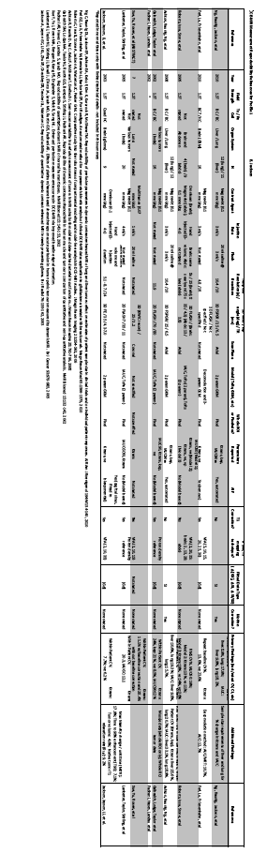

Appendix G: Model-specific Instructions and Parameters
The presence of specific product models/versions in the following tables should not be taken to imply that those products are fully compliant with the QIBA Profile. Compliance with a profile involves meeting a variety of requirements of which operating by these parameters is just one. To determine if a product (and a specific model/version of that product) is compliant, please refer to the QIBA Conformance Document for that product. G.1. Image Acquisition Parameters The following technique tables list acquisition parameter values for specific models/versions that can be expected to produce data meeting the requirements of Section 7.1.
These technique tables may have been prepared by the submitter of this imaging protocol document, the clinical trial organizer, the vendor of the equipment, and/or some other source. (Consequently, a given model/version may appear in more than one table.) The source is listed at the top of each table.
Sites using models listed here are encouraged to consider using these parameters for both simplicity and consistency. Sites using models not listed here may be able to devise their own acquisition parameters that result in data meeting the requirements of Section 7.1 and conform to the considerations in Section 13.
In some cases, parameter sets may be available as an electronic file for direct implementation on the imaging platform.

Siemens

GE
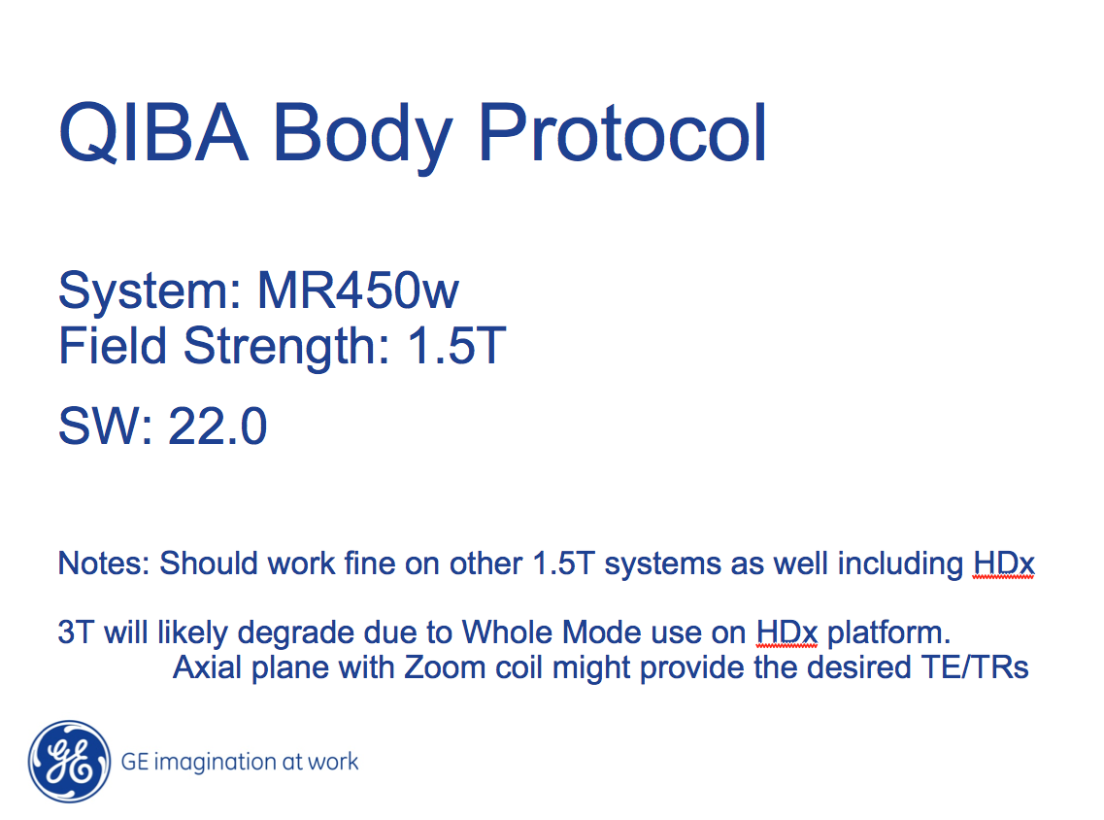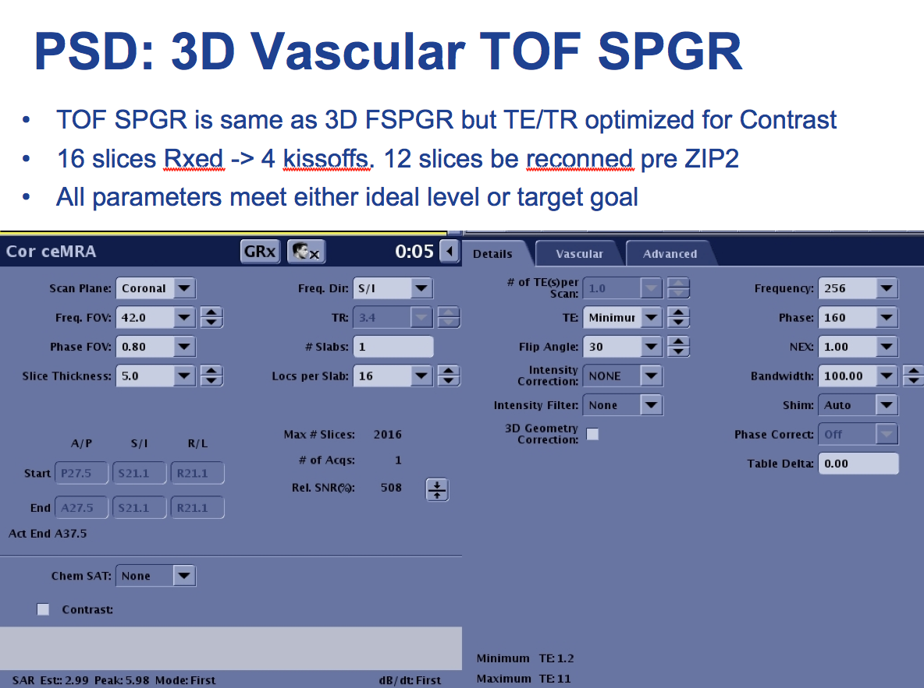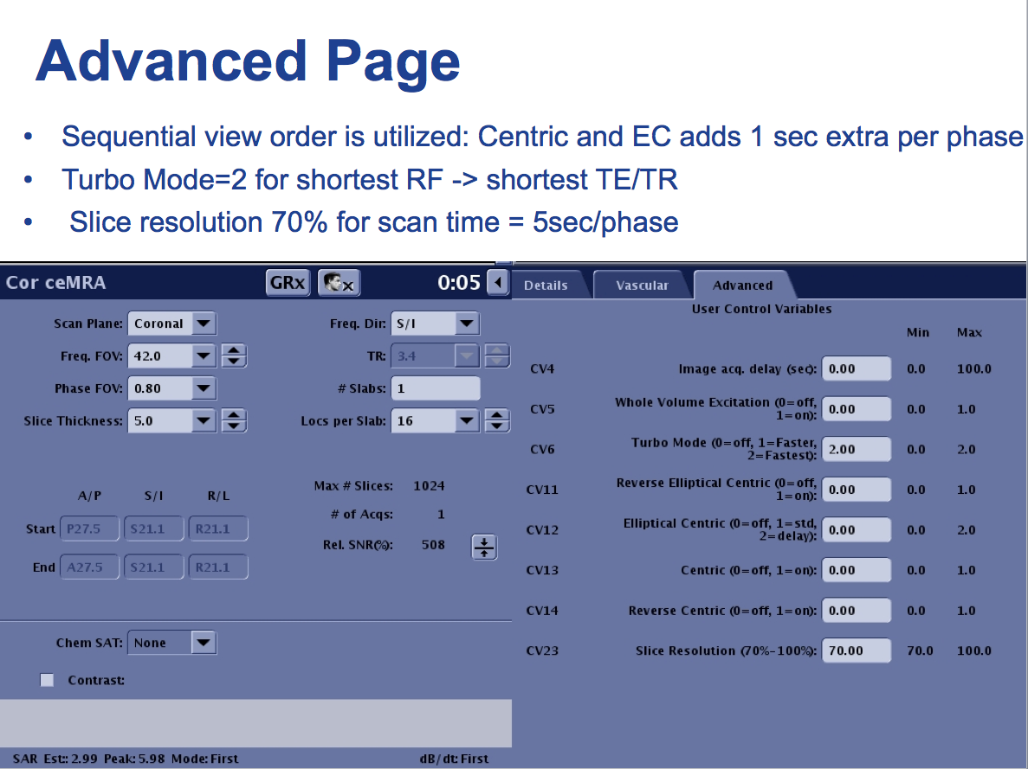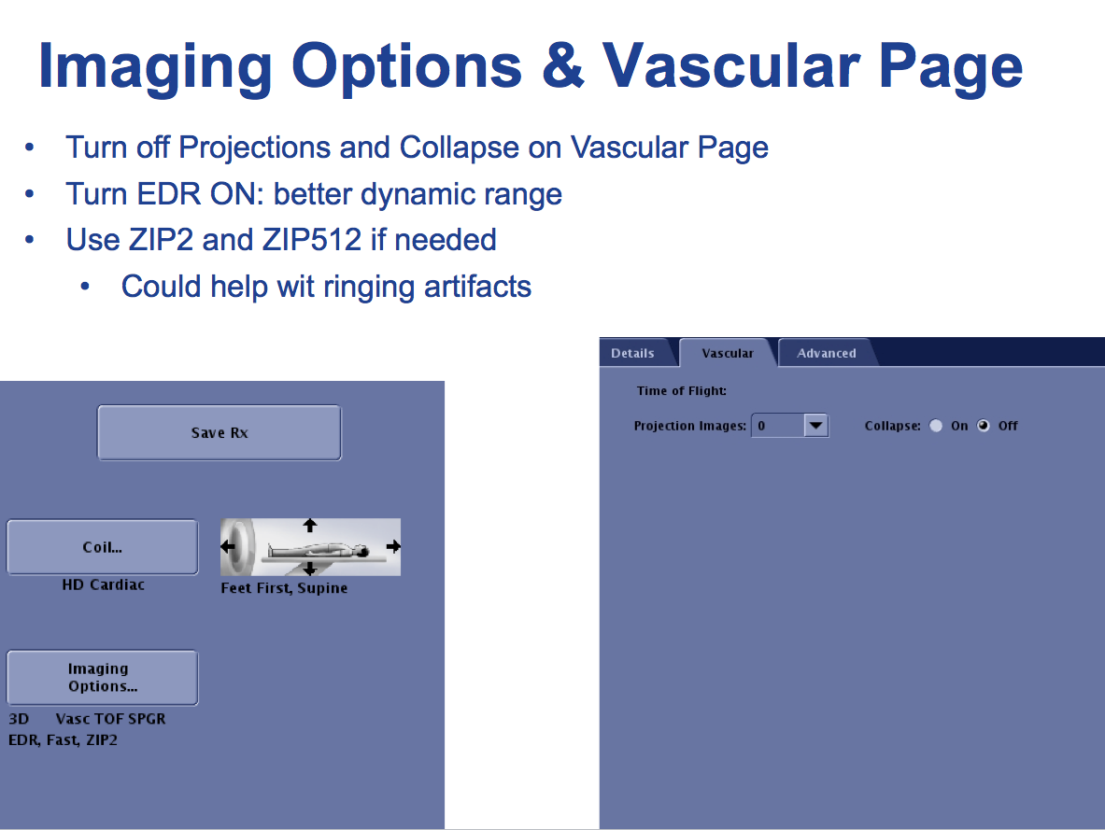

Phillips
Philips Achieva 1.5T (edited on release 2.6):

##############################################################################################
Pulse Sequence: 3D T1 FFE

NEX = NSA: 2 (change accordingly as needed for ratio map or variable flip angle series)

flip angles: 30, 25, 20, 15, 10, 2 (watch that shortest TR/TE remain constant, or swith to user defined if needed)

coils: SENSE-body or SENSE-Torso-XL

slice orientation: coronal (for abdomen. for head: axial, adjust FOV as needed)

Foldover direction: RL
Foldover supprsion: yes

slice oversampling: user defined: 1

TE/TR: set to shortest, actual values will be: 5.0/2.4 ms (verify it stays constant with changing flip angle)

temporal resolution = dynamic scan time: 8.4 sec (for NSA 2)

receiver bandwidth – corresponding parameter: water fat shift: maximum (313 Hz/pixel for current parameters)

FOV: FH 420 mm, RL 340 mm, AP 48 mm (for head: 250 AP, 220 RL)
voxel size: FH 1.64 mm, RL 2.1 mm, AP 2 mm (FOV/voxel size ratio yielding matrix: 256x162 for abdominal)
(note, FOV and voxel size are adjustable parameters, corresponding matrix is displayed in info page)

overcontiguous slices: yes (acquired slice thickness 4 mm, interpolated into 2)
number of slices: 24 (interploated – 12 acquired)

SENSE: no, CLEAR: no
halfscan: yes, factor Y 0.65, factor Z = 0.8

Dynamic study: individual
dynamic scans: 42 (giving total scan duration of 05:50)
dynamis scan times: user defined > set 6th dynamic to manual (for injection after 5th dynamic,
leave all other on shortest)
###############################################################################################

