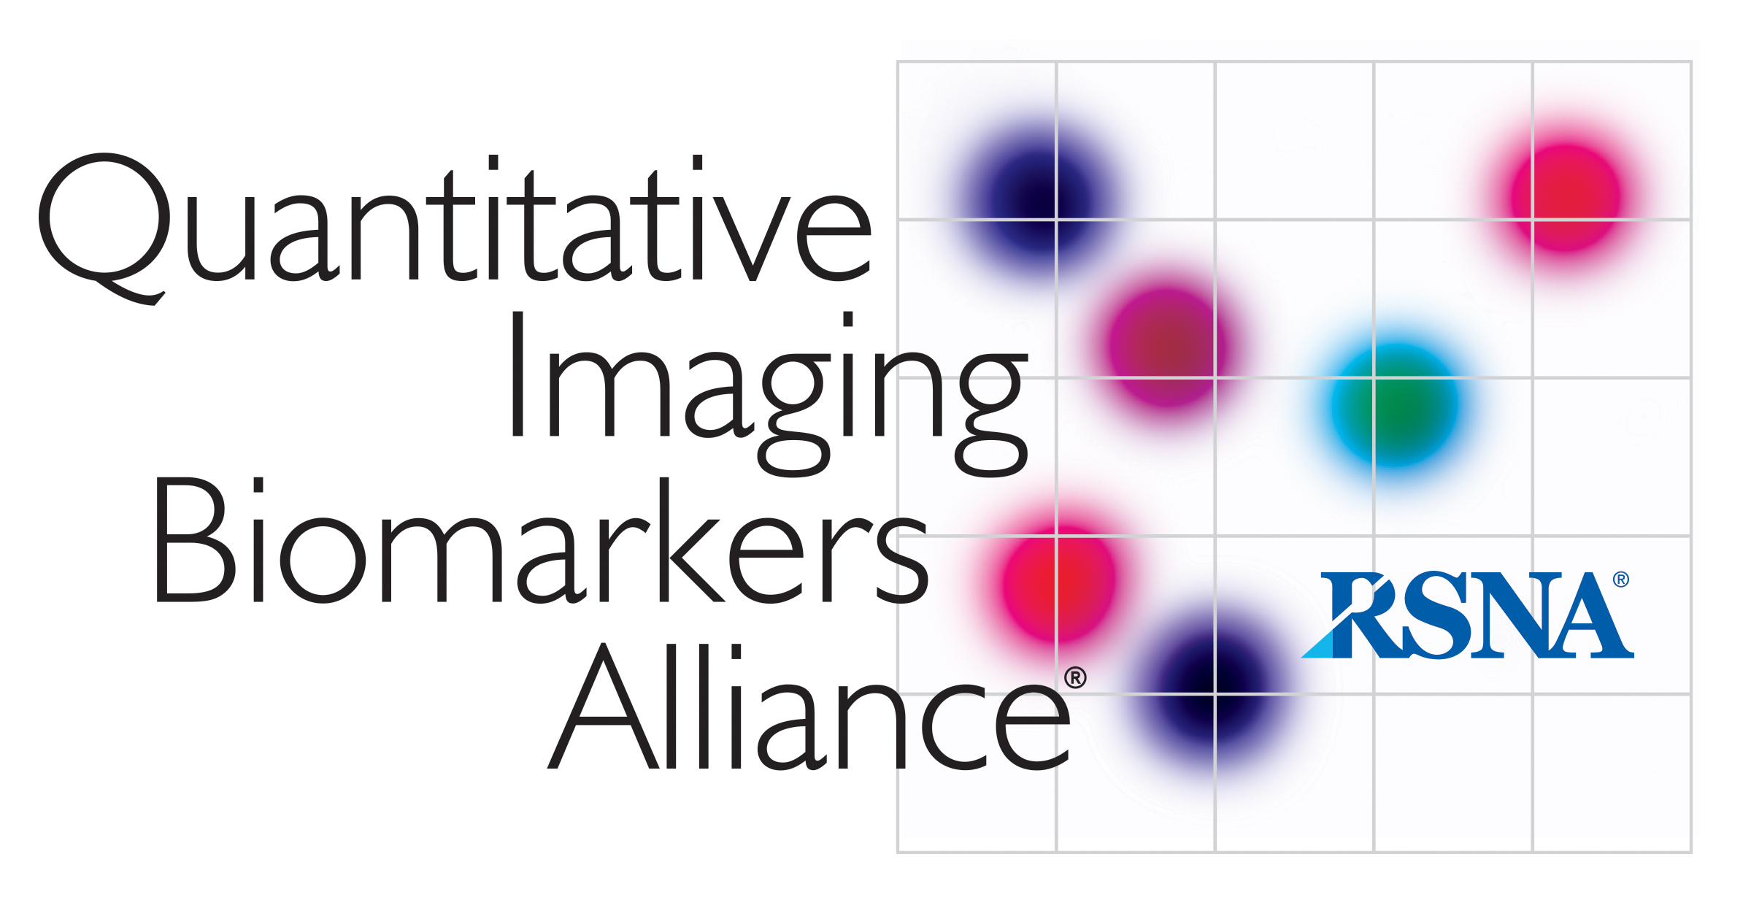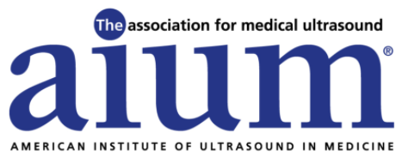

AIUM/QIBA
Ultrasound Volume Blood Flow Biomarker

Summary 09-June-2021

Attendees: Brian Fowlkes, Jim Azazebski, Jing Gao, Stephen Pinter, Cristel Baiu, Jim Jago, Jonathan Rubin, Mark Lockhart, Megan Russ, Michelle Robbin, Nicole Lafata, Oliver Kripfgans, Paul Carson, Shriram Sethuraman
AIUM Staff: Therese Cooper

- Review of Previous Call Summary – 03-MAY-2021

- Action Items
  - Discussion of 2D spectral Doppler in QIBA Phantom
    - Need to examine conditions in the acquisition to determine if data is useful. Also tests being performed in conjunction with project at Baylor. Brian reviewed what the need was…. Stephen reviewed the data and has not had a chance to work on this.
  - Abstracts for Ground Work Studies. Brian suggested flow phantom modeling as a potential ground work study. Again, if you have an idea for an abstract let Brian know.
  - Brian showed results from Dr. Zonnebeld to the group. Not the same format as other information in the profile but does provide interobserver comparison for volume flow measurement before and after dialysis access placement. Brachial artery flows are high with unknown measurement bias. Brian would like to ask the author if he can do this in terms of the coefficient of variation. Brian asks for the physicians to provide comments. Brian will continue to work some more on this and request alternative format from the lead author. (Dr. Zonneveld mentioned before that he is willing to do some analysis and Brian will continue to communicate with him.)

- Review of Flow Phantom Modeling

- Update on VBF Profile Discussions
  - Review of current draft and updates from Profile Task Group
    - Modifications to phantom
      - Changes in tubing trajectory
      - Changes in maximum volume flow rate
      - Elimination of stenosis
    - Modifications to figures on partial volume
    - Modifications to selected sections of text.
    - Review of outstanding comments.

- Matters Arising

Next Profile meeting is June 23, 2021
Next full BC meeting is July 5, 2021 (Need to shift as this is the Independence Day holiday.)

