Project Description:

Tissue perfusion is affected in a wide range of pathologies including neoplasms, inflammation, and ischemia. A quantitative biomarker of perfusion therefore would be widely useful for assessment of multiple clinical situations. Although Doppler evaluation of blood flow is used as an assessment of blood perfusion it is not sufficient, as it does not reflect the blood flow at the microcirculatory level.

As a non-invasive technique with no renal or hepatic toxicity, contrast-enhanced ultrasound (CEUS) has the advantages of real-time imaging, easy repeatability, and wide availability. Further, microbubble contrast agents are a pure blood pool agent (intravascular tracer), thus providing blood flow information at the capillary level. Many potential patients for this technique have chronic disease, especially neoplastic or inflammatory, often necessitating multiple scans over a long time interval. Thus this technique would limit the radiation exposure from multiple CT scans (a topic of considerable concern particularly among pediatric patients) and possible toxicity from multiple injections of gadolinium-based MRI contrast agents.

Quantitative CEUS has been evaluated by several groups and demonstrated to be clinically useful. However, successful groups have standardized to a single system configuration and agent for their studies. For the clinical benefits to be applied widely and for specific contrast kinetic measures to become biomarkers, standardization of the exact method, equipment, and software is required. Thus widespread use has been limited in quantitative measurements. The ultimate goal of this proposal is to standardize quantitative CEUS to use as a biomarker of perfusion and thus of tumor response to therapy for colorectal and other liver metastases, hepatocellular carcinoma (HCC), and for inflammatory bowel disease. The first year of this study will concentrate on the basics using a tissue-mimicking flow phantom to evaluate the Lumason CEUS contrast agent and 2-3 scanners with CEUS software. Once we have understanding of the basics a follow-up clinical study in the clinical areas mentioned above will be performed. It is anticipated that we will collaborate with the QIBA CT and MRI groups working on similar quantitative contrast measurements. The execution of this project will set the basis for transforming quantitative CEUS into a clinical biomarker of perfusion and tumor response to therapy. The standardized methods and approach will then lead to clinical translation and wider use.

Primary objectives, deliverables and timeline:

The primary objectives are geared to the standardization of quantitative CEUS methods and approaches necessary to measure flow characteristics. There are two main approaches for CEUS quantification of perfusion based on indicator dilution: (a) bolus injection for wash-in/washout analysis and (b) infusion for destruction replenishment analysis. We propose to use (a) due to its simplicity, wider use in the clinic, and number of previous studies that have already been published with this technique. The phantom studies will be used to simulate
1. Measuring flow in the macro- and micro-circulation
2. Blood volume (vascular density) in a ROI in a tumor

Bolus injection for wash-in/ Infusion for destruction-
Washout analysis replenishment analysis
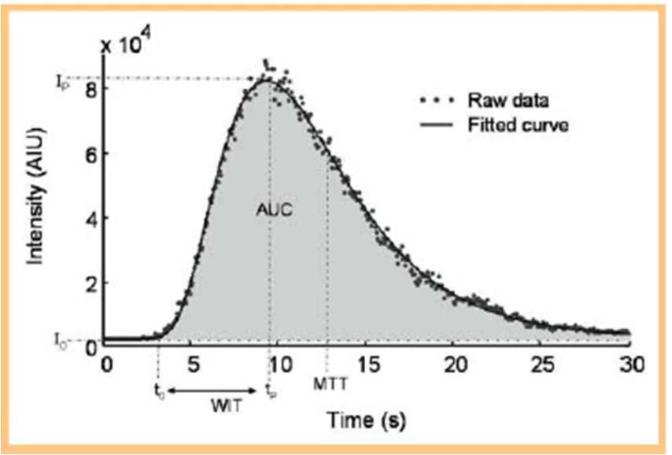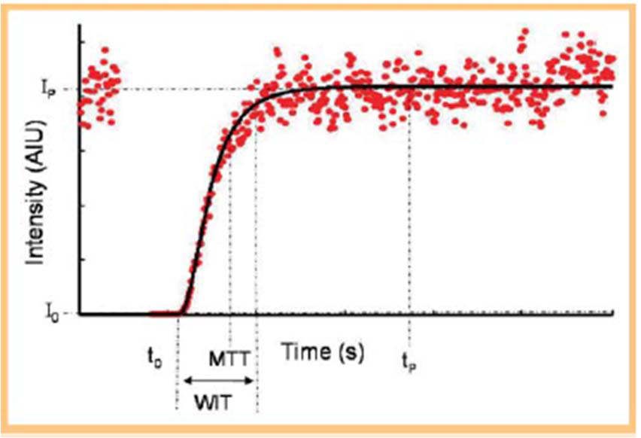

Clinical problems that need to be overcome (but are not present in the simple flow phantom) include unknown arterial input function, microflow regulation in the body, HA and PV contributions change with treatment, patient immune response and drug resistance. Instrument/technology software issues also exist (that are also present in the simple flow phantom) such as image system microbubble sensitivity, agent handling, image data linearization, signal saturation, acoustic shadowing due to microbubbles, curve fitting, and flow parameters extraction.

Phase 1 of this study is to determine the temperature dependence of the stability and characteristics of ultrasound contrast agents (including the issues discussed in the previous paragraph). Experiments will be conducted from room temperature to body temperature to assess changes in stability and acoustic properties to determine if phantom measurements need to be made at body temperature for appropriate translation to clinical practice.

Phase 2 will measure and establish
(a) bubble detection (contrast to tissue ratio) and tissue (linear signal) suppression in dB for imaging
(b) Linearization scheme of image data (removing the logarithmic compression of the imaging system).
(c) Quantify flow characteristics in a single tube. This includes the range of velocities that can be measured with CEUS depending on the tube diameter .
We will use 3 ways to measure flow rates and compare the results: (1) volumetric, by simply measuring flow over time; (2) with Doppler by measuring velocity and calculating the flow based on the tube diameter; and (3) with CEUS by creating time-intensity curves and extracting bolus washi-in/washout parameters (peak intensity-PI, area under the curve-AUC, mean transit time-MTT, and rise time-RT).

The following single tube flow phantom consisting of a peristaltic pump, bubble trap, mixing chamber, and silicon tubing.

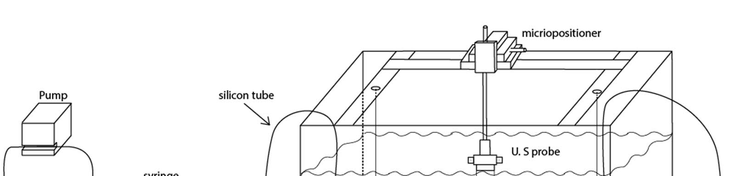
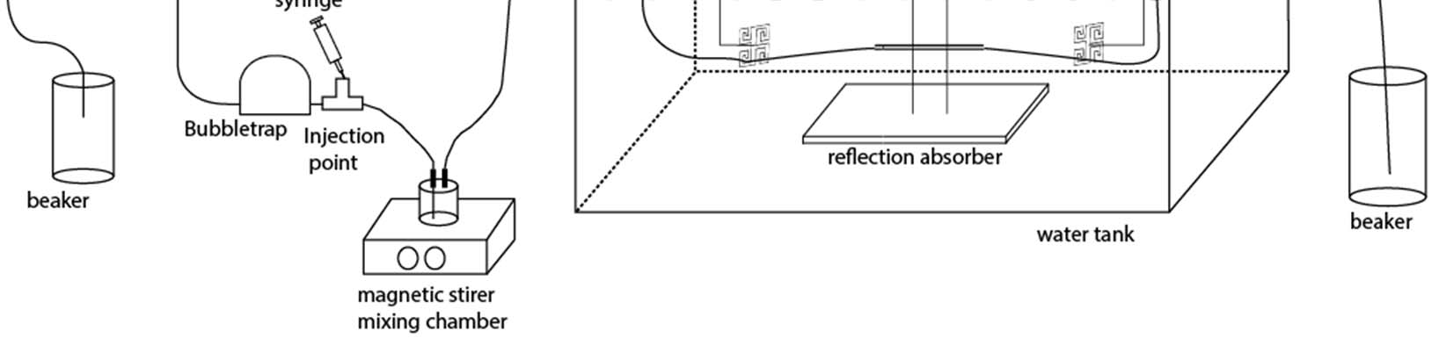
Four different tube diameters will be utilized (1, 2, 4, 8mm). The mixing chamber dilutes the bolus and mimics the heart/lungs mixing. There is a long section of tubing (not shown in the schematic) after the mixing chamber to further spread the bolus and give it shape characteristics similar to those of time-intensity curves taken from clinical data.

The objectives and deliverables using this phantom are:

Objective | Motivation | Deliverable
1. Establish settings for the scanners participating in the QIBA initiative for good microbubble imaging for quantification. This includes the following: minimize contrast agent destruction, maximize tissue cancellation, avoid signal saturation, avoid acoustic shadowing. | Standardization of ultrasound equipment so clinical measurement made on various machines will provide similar results | Provide a profile for optimal clinical CEUS use. This includes optimal settings per scanner: nonlinear mode, highest nondestructive MI, analog/digital gain, dynamic range (compression)
2. Establish and validate linearization scheme (native data vs empiric) | Select one of several schemes presently being evaluated for standardization | Provide recommended linearization scheme
3. Select appropriate quantification software | Select one (or more) of several programs presently available (or develop our own) for standardization | Provide list with recommended Quantification software
4. Select appropriate indicator dilution model (e.g., lognormal, LDRW) | For standardization | Provide recommended indicator dilution model
5. Measure relative flow rate in 8, 4, 2, 1 mm tubing for flow rates 10-1000ml/min (lower flow rates in the smaller tubes and higher in the larger) | To determine the range of measurements that can be made accurately with CEUS – which clinical situations can CEUS be appropriate for | Provide a validated range of flow rates and vessel sizes that CEUS can make accurate measurements
6. Compare CEUS results with volumetric flow measurements (and Doppler) for validation | Determine the accuracy of CEUS for flow measurements | Provide accuracy of CEUS flow rates compared to other standards

Timeline

Duration | Activity
Month 1-2 | Build and test flow phantom at different sites
Month 1-4 | Evaluate and further develop quantification software (linearization, curve fitting, image loops, parameter extraction)
Month 2-6 | Evaluate and optimize clinical scanners for perfusion quantification (bubble sensitivity, tissue suppression, bubble destruction, imaging parameters)
Month 4-10 | Confirm linear range of intensity-concentration relationship (per system per bubble)
Month 8-12 | Perform and validate flow rate measurements in all tube diameters
Month 12 | Compile and deliver report with all results

