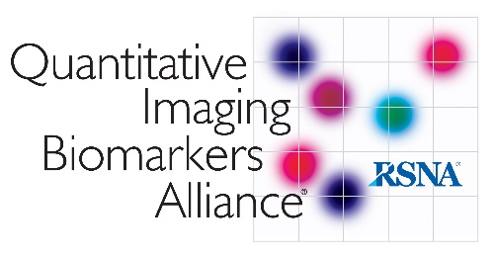
[DATE]

[CONTACT NAME AND ADDRESS]

Dear [CONTACT NAME]:
The Quantitative Imaging Biomarkers Alliance (QIBA®) was created by RSNA in 2007 with a mission to improve the value and practicality of quantitative imaging biomarkers by reducing variability across devices, sites, patients, and time. By design, the focus of QIBA efforts has been well-aligned with the needs identified by the pharmaceutical industry and clinical trial groups: to substantially minimize the bias and variance in imaging biomarker data such that fewer numbers of clinical trial subjects are required for a given statistical power and measurement effect size. The importance of standardizing image-based clinical trial biomarkers can be seen in the respective Guidance to industry by the FDA. https://tinyurl.com/y6shtvqx

Currently, 20 QIBA Profiles are under development and 2 have reached the “Technically Confirmed Stage” – a maturity level that is deemed appropriate for a Profile to be used in clinical trials.

However, due to the expiration of funding from the NIBIB (National Institute of Biomedical Imaging and Bioengineering), QIBA needs your financial support to continue its mission. While the QIBA Biomarker Committee members and Profile authors are all volunteers with diverse, expert backgrounds (radiologists, scientists, engineers, statisticians, and individuals from regulatory agencies, government standards agencies, iCROs, and various facets of the imaging and pharmaceutical industries), funding is needed to support groundwork projects, such as test-retest studies, which are difficult to fund with other mechanisms and were previously funded by NIBIB, as well as the development of digital phantoms to test scanner performance. Groundwork projects are critical for both the advancement of Profiles to the Technically Confirmed stage and for new Profile development.

Financial support can be in the form of a one time or annual donation to the RSNA QIBA program or targeted grants to fund groundwork projects for a specific Profile. In addition, depending on interest and funding support, QIBA can be a key driver to develop a “Conformance Certification Mark Program” whereby sites, equipment, analysis protocols and, most importantly, the resulting data, can be certified for a specific QIBA Profile – an ideal way to create “quality data” for subsequent population-based analysis that is so critical for effective evidence-based medicine reporting.

The attached PDF document provides more information on a selection of potential QIBA projects that would benefit from your support.

Please click here for more detailed project proposals:
In appreciation of support, QIBA sponsors will be recognized by having the name of their company and company logo published on the QIBA Wiki and at the QIBA booth and poster area at the RSNA Scientific Assembly and Annual Meeting.

Thank you for your consideration of this request, and please don’t hesitate to contact any of the individuals listed below if there are any questions or comments.

Sincerely,
Edward F. Jackson, QIBA Chair
Alexander Guimaraes, MD, PhD, QIBA Vice Chair
Gudrun Zahlmann, PhD, QIBA Sustainability Implementation Group Chair

For any questions or further information, please contact QIBA at qiba@rsna.org.

Members of the QIBA Sustainability Implementation Group:
Alexander Guimaraes, MD, PhD | Oregon Health & Science University | guimaraa@ohsu.edu
Edward F. Jackson, PhD | University of Wisconsin, School of Medicine & Public Health | efjackson@wisc.edu
Annette Schmid, PhD | Takeda Pharmaceuticals | annette.schmid@takeda.com
Anne M. Smith, PhD | Siemens Medical Solutions USA, Inc. | anne.m.smith@siemens-healthineers.com
Daniel C. Sullivan, MD | Duke University | daniel.sullivan@duke.edu
Richard L. Wahl, MD, FACR | Mallinckrodt Institute of Radiology, Washington University in St. Louis | wahlr@mir.wustl.edu
Gudrun Zahlmann, PhD | Independent Consultant | gudrun.zahlmann@ieee.org
RSNA / QIBA Staff | Radiological Society of North America (RSNA / QIBA) | QIBA@rsna.org

References:
- FDA Guidance for Industry: Clinical Trial Endpoint Process Standards

- FDA Guidance for Industry: Technical Performance Assessment of Quantitative Imaging in Device Premarket Submissions, Draft guidance 2019

