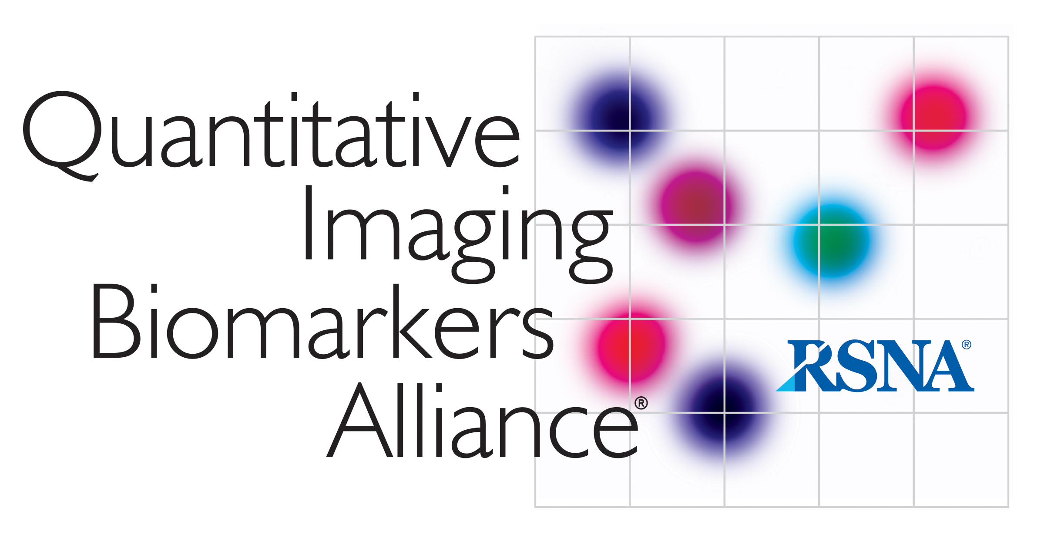

AIUM/QIBA
Ultrasound Volume Blood Flow Biomarker

Summary 01-March-2021

Attendees: Brian Fowlkes, Jim Zagzebski, John Rubin, Stephen Pinter, Paul Carson, Michelle Robbin, Mark Lockhart, Nicole Lafata, Oliver Kripfgans, Megan Russ, Jim Jago, Jing Gao, Todd Erpelding, CY Lee, Ravi Managuli, Shriram Sethuraman, Rimon Tadross
AIUM Staff: Therese Cooper, Haylea Weiss

- Review of Previous Call Summary – 01-Feb-2021. Approved

- Action Items (in red)
  - Discussion of 2D spectral Doppler in QIBA Phantom
    - Considerable discussion of these data at last meeting with concerns about the acquisition methodology for the 2D spectra. Need to examine conditions in the acquisition to determine if data is useful. Stephen still working on this.
  - Abstracts for Ground Work Studies. Ideas for an abstract let Brian know.

- Update on VBF Profile Discussions
  - Review of current draft
    - Distributed for comment on Feb. 16.
    - Comments requested for Mar. 1. A few comments did come back.
    - Brian reviewed how to get to the VBF materials in Basecamp and the working draft can be accessed and viewed in OneDrive. Reminder to add your name in the comment fields so that we can see who made the comment.
    - Abbreviations: Suggestion made to expand the definitions a bit. CV and wCV was added. Suggestions are okay if other abbreviations should be added.
    - Discussed language in Executive Summary. Added language on line 139-140 to indicate that the performance target is application specific, but based on the examination of the applications in this profile, performance is ± 20% which is consistent with claim 2.
    - Michelle gave a brief overview of the reason she added a section high resistance volume flow measurement. See lines 177-182.
      - Paul will send the new suggested language Michelle and she can revise as needed.
    - Discussed the edit to define what “X” is. Disclaimer on the claim added to explain what the claim is based on. See line 232.
    - Brian mentioned he recently found out that in some of the dialysis machines there is a reverse flow technique that estimates volume flow in access. There might be an opportunity to compare to a reference in the case of AV fistulas.
    - Michelle to send Brian the name of senior author who published on volume flow measurements in clinical study.
    - Michelle will check for the reference to the national guidelines.
    - Changed the engineer to clinical engineer
    - Qualification language was altered and reviewed.
    - Feedback needed on clinical training.

- Matters Arising

Next VBF BC meeting April 5, 2021.

